Supplementary Appendix

This appendix has been provided by the authors to give readers additional information about their work.
Supplement to: Early Multimodal Vasopressor Strategy in Septic Shock: Results of the TRICYCLE Randomized Controlled Trial.

Table of Contents
Study Interventions 3
Classic Stepwise Shock Management (Control group) 3
Balanced Multimodal Shock Management (Tricycle group) 4
Figure S1. Vasopressor titration regimen in the Tricycle group. 6
Table S1. Conversion to Norepinephrine Equivalent. 7
Comparison of Protocol-Specified and Final Reported Outcomes 8
Table S2. Comparison of protocol-specified and final reported outcomes. 8
Sensitivity Analyses 11
Table S3. Primary and right-censored mixed-effects sensitivity analysis accounting for the renin assay upper quantification limit. 11
Table S4. Primary and random-slope sensitivity analysis of longitudinal renin trajectories. 12
Table S5. Comparison of primary and sensitivity analyses of the linear-mixed effects including fluid balance after multiple imputation. 13
Table S6. Primary and sensitivity analyses of ΔSOFA, with sensitivity analysis excluding patients who died during the first 72 hours. 14
Association Between Renin Trajectories and Clinically Relevant Outcomes 15
Table S7. Association between renin trajectories and clinically relevant outcomes, overall and by treatment group. 15
Availability of Longitudinal Renin, Lactate and NEE Data 16
Table S8. Availability of renin measurements over time. 16
Table S9. Availability of lactate measurements over time. 17
Table S10. Availability of required NEE dose over time. 18
Additional Study Data 19
Figure S2. Mean arterial pressure during first 72 hours after randomization. 19
Figure S3. Heart rate during first 72 hours after randomization. 20
Table S11. Available variables contributing to the ΔSOFA score. 21
Table S12. Vasopressor and adjunctive therapy by treatment group. 22
Table S13. Site enrollment by country. 23
Supplementary References 24

Study Interventions
Patients who met all the inclusion criteria and had a vasopressor requirement of ≥ 0.15 μg/kg/min equivalent of norepinephrine base were eligible for trial enrollment. Patients were enrolled within 12 hours after admission to the ICU and within 24 hours after the diagnosis of septic shock.

Classic Stepwise Shock Management (Control group)
Regimen: Norepinephrine base was increased in dosages of 0.05-0.1 μg/kg/min up to 0.5 μg/kg/min. Vasopressin was administered when norepinephrine base was in the range of 0.25-0.5 μg/kg/min. If MAP remained< 65 mmHg, norepinephrine base was uptitrated above the dose of 0.5 μg/kg/min until MAP ≥ 65 mmHg. Maximum norepinephrine base dose was at the discretion of the clinical team. Initiation of additional vasoactive drugs (epinephrine, Ang II, methylene blue, or dopamine) or inotropes (dobutamine, levosimendan or milrinone) was at the discretion of the clinical team. In case of persistent hypotension, the addition of Ang II was permitted if norepinephrine base dose exceeded 0.5 μg/kg/min and vasopressin was already administered at the dose of 0.03 IU/min. Rescue therapy for hypotensive episodes was norepinephrine base.
If MAP was ≥ 75 mmHg norepinephrine base was tapered in decrements of 0.05 μg/kg/min to maintain MAP ≥ 65 mmHg. If the patient was receiving combined norepinephrine base and vasopressin and the dose of norepinephrine base exceeded 0.5 μg/kg/min, norepinephrine base was decreased in decrements of 0.05 μg/kg/min to maintain MAP ≥ 65 mmHg. Once the dose of norepinephrine base was lower than 0.5 μg/kg/min the discontinuation of vasopressin was at the discretion of the clinical team. Before discontinuation, vasopressin was first tapered to 0.015 IU/min. MAP ≥ 65 mmHg was maintained until 72 h after randomization and thereafter per the clinical team’s guidance.

Balanced Multimodal Shock Management (Tricycle group)
Regimen (Figure S1): Early, simultaneous start of equipotent doses of norepinephrine base, Ang II and vasopressin at a cumulative dose equivalent to 0.15 μg/kg/min of norepinephrine base. Increments of 0.05 μg/kg/min of equipotent doses of all three vasopressors every 3-5 minutes were made until MAP ≥ 65 mmHg was reached. Vasopressin was administered at a starting dose of 0.015 IU/min and a maximum dose of 0.03 IU/min. Ang II was administered at a starting dose of 20 ng/kg/min and a maximum dose of 100 ng/kg/min. The maximum dose of Ang II was 80 ng/kg/min during the first 3 hours of treatment.
If MAP was ≥ 75 mmHg decrements of 0.05 μg/kg/min of equivalent doses of all three vasopressors were made until the dose of Ang II was reduced to the starting dose of 20 ng/kg/min. If MAP was ≥ 75 mmHg despite infusion of starting doses of all three vasopressors, vasopressin and norepinephrine base were weaned off. After weaning off norepinephrine base and vasopressin, Ang II was used in a maintenance dose of 2.5-20 ng/kg/min until weaned off. If the patient required vasopressor support of ≥ 0.15 μg/kg/min equivalent of norepinephrine base after 72 h we have continued with infusion of norepinephrine base, Ang II and vasopressin. If the patient required vasopressor support of ≤ 0.15 μg/kg/min equivalent of norepinephrine base after 72 h, vasopressin and/or Ang II were weaned off and the patient received only norepinephrine base.
If MAP was < 65 mmHg despite predefined maximum doses of all three vasopressors, norepinephrine base was uptitrated to achieve MAP ≥ 65 mmHg. Maximum norepinephrine base dose was at the discretion of the clinical team. Initiation of additional vasoactive drugs (epinephrine, methylene blue, or dopamine) or inotropes (dobutamine, levosimendan or milrinone) was at the discretion of the clinical team. Rescue therapy for hypotensive episodes was norepinephrine base. MAP ≥ 65 mmHg was maintained until 72 h after randomization and thereafter per the clinical team’s guidance.

Figure S1. Vasopressor titration regimen in the Tricycle group.
Reproduced from (1).
Abbreviations: NE norepinephrine base, AVP arginine vasopressin, Ang II angiotensin II.

Table S1. Conversion to Norepinephrine Equivalent.
Drug | Dose | Norepinephrine equivalent
Angiotensin II | 20 ng/kg/min | 0.05 μg/kg/min
Vasopressin | 0.03 IU/min | 0.075 μg/kg/min
Equipotent doses were calculated from the norepinephrine equivalent score proposed by Kotani et al. (2).

Comparison of Protocol-Specified and Final Reported Outcomes

Table S2. Comparison of protocol-specified and final reported outcomes.
Outcome or analysis | Protocol classification | Analyzed as prespecified in the protocol | Final manuscript presentation | Rationale for deviation
Change in plasma renin concentration 0-72h | Primary | Yes | Prespecified primary outcome | No deviation.
Change in plasma lactate concentration 0-72h | Secondary | Yes | Prespecified secondary outcome | No deviation.
Maximum daily NEE dose | Secondary | No – modified analytical approach | Longitudinal NEE trajectory 0-72h reported as non-prespecified analysis | The availability of repeated NEE measurements throughout the observation period enabled analysis of NEE requirements using a linear-mixed-effects model.
Duration of vasopressor support | Secondary | No | Not reported | Difficulty of interpretation due to high incidence of early mortality as death may shorten the observed duration of vasopressor support.
AKI according to KDIGO criteria | Secondary | No | Not reported | A substantial proportion of patients lacked prior renal function measurements required to reliably establish baseline function and classify according to KDIGO criteria.
Δ SOFA | Secondary | Yes | Prespecified secondary outcome | No deviation.
RRT requirement during ICU stay | Exploratory | Yes | Prespecified exploratory outcome | No deviation.
Survival to ICU discharge | Exploratory | Yes | Prespecified exploratory outcome | Expressed inversely as ICU mortality.
28-day mortality | Exploratory | Yes | Prespecified exploratory outcome | No deviation.
EQ-5D at 90 days | Exploratory | No | Not reported | A substantial proportion of patients were unavailable for follow-up.
Subgroup: AKI-RRT at study inclusion | Prespecified subgroup | No | Not analyzed | Substantial proportion of patients had no prior renal function measurements to reliably establish baseline AKI status; RRT data were available only for overall ICU stay.
Subgroup: RAAS inhibitor/beta-blocker use | Prespecified subgroup | No | Not analyzed | Although beta-blocker use and RAAS inhibitor exposure were documented, the timing of the last dose relative to study inclusion was not consistently available.
Longitudinal NEE trajectory 0-24h | Not prespecified | No | Additional non-prespecified analysis | Clinical experience during trial conduct suggested that changes in vasopressor requirements were most pronounced during the first 24h. The 24-h time window was not prespecified in the published study protocol.
Change in eGFR 0-72h | Not prespecified | No | Additional non-prespecified analysis | Substantial proportion of patients had no prior renal function measurements to establish baseline function, whereas serial renal function measurements were available following study inclusion. Change in eGFR was used to assess renal function during observation period.
Abbreviations: AKI acute kidney injury, eGFR estimated glomerular filtration rate, EQ-5D, EuroQol 5-Dimension, KDIGO Kidney Disease: Improving Global Outcomes, NEE norepinephrine-equivalent dose, RAAS renin–angiotensin–aldosterone system, RRT renal replacement therapy, SOFA Sequential Organ Failure Assessment.

Sensitivity Analyses

Table S3. Primary and right-censored mixed-effects sensitivity analysis accounting for the renin assay upper quantification limit.
Outcome | Analysis | Tricycle group  N = 38 | Control group  N = 41 | P
Renin, % change per hour (95% CI) | Primary | −2.61 (−3.09, −2.11) | −1.67 (−2.14, −1.18) | 0.015
 | Sensitivity | −3.09 (−3.66, −2.52) | −1.73 (−2.28, −1.18) | 0.002
P values are adjusted for multiple comparisons using the Holm method.
Abbreviations: CI confidence interval.

Table S4. Primary and random-slope sensitivity analysis of longitudinal renin trajectories.
Outcome | Analysis | Tricycle group  N = 38 | Control group  N = 41 | P
Renin, % change per hour (95% CI) | Primary | −2.61 (−3.09, −2.11) | −1.67 (−2.14, −1.18) | 0.015
 | Sensitivity | −2.52 (−3.32, −1.71) | −1.73 (−2.52, −0.94) | 0.342
P values are adjusted for multiple comparisons using the Holm method.
Abbreviations: CI confidence interval.

Table S5. Comparison of primary and sensitivity analyses of the linear mixed-effects including fluid balance after multiple imputation.
Outcome | Analysis | Tricycle group  N = 38 | Control group  N = 41 | P
Primary outcome
Renin, % change per hour (95% CI) | Primary | −2.61 (−3.09, −2.11) | −1.67 (−2.14, −1.18) | 0.015
 | Sensitivity | −2.60 (−3.08, −2.10) | −1.66 (−2.14, −1.18) | 0.015
Secondary outcomes
Lactate, % change per hour (95% CI) | Primary | −1.53 (−1.76, −1.29) | −1.01 (−1.24, −0.79) | 0.006
 | Sensitivity | −1.52 (−1.76, −1.29) | −1.02 (−1.24, −0.79) | 0.007
NEE dose (0-72h), % change per hour (95% CI) | Primary | −5.41 (−5.81, −4.99) | −5.19 (−5.59, −4.80) | 0.47
 | Sensitivity | −5.40 (−5.80, −4.99) | −5.19 (−5.58, −4.80) | 0.47
NEE dose (0-24h), % change per hour (95% CI) | Primary | −6.87 (−7.93, −5.80) | −3.03 (−4.08, −1.97) | <0.0004
 | Sensitivity | −6.87 (−7.92, −5.81) | −3.03 (−4.08, −1.97) | <0.0001
P values are adjusted for multiple comparisons using the Holm method.
Abbreviations: CI confidence interval, NEE norepinephrine equivalence.

Table S6. Primary and sensitivity analyses of ΔSOFA, with sensitivity analysis excluding patients who died during the first 72 hours.
Outcome | Analysis | Tricycle group | Control group | P
Δ SOFA, change from baseline, median (IQR) | Primary | −3 (−5.3, −0.75) | 0 (−3.5, 2) | 0.018
 | Sensitivity | −4 (−6, −1.25) | −1 (−4, 1) | <0.001
The primary analysis included 79 patients (Tricycle group N=38; Control group N=41). The sensitivity analysis excluded patients who died during the first 72 hours and included 69 patients (Tricycle group N=32; Control group N=37). In the primary analysis, patients who died before day 3 were assigned a day-3 SOFA score of 24.
Abbreviations: IQR interquartile range, SOFA Sequential Organ Failure Assessment.

Association Between Renin Trajectories and Clinically Relevant Outcomes

Table S7. Association between renin trajectories and clinically relevant outcomes, overall and by treatment group.
Outcome | All patients | P | Tricycle group | P | Control group | P | P for group difference
ICU mortality,  OR (95% CI) | 1.41 (1.13, 1.75) | 0.002 | 1.65 (1.12, 2.43) | 0.012 | 1.29 (1.01, 1.67) | 0.044 | 0.309
28-day mortality,  OR (95% CI) | 1.46 (1.18, 1.82) | <0.001 | 1.59 (1.11, 2.27) | 0.011 | 1.38 (1.05, 1.81) | 0.020 | 0.532
RRT during ICU stay,  OR (95% CI) | 1.61 (1.23, 2.10) | <0.001 | 1.85 (1.16, 2.94) | 0.01 | 1.47 (1.07, 2.03) | 0.017 | 0.434
ΔSOFA,  Spearman ρ | 0.37 | 0.001 | 0.30 | 0.074 | 0.42 | 0.006 | 0.578
For binary outcomes, ORs represent the change in odds of the respective outcome per 1 %-point/h slower decline in renin concentrations.
For ΔSOFA, positive Spearman’s ρ indicates that slower renin decline was associated with less improvement in SOFA score.
Analyses of ICU mortality, 28-day mortality, and ΔSOFA included 77 patients (Tricycle group N=37; Control group N=40) with at least two available renin measurements. The RRT analysis included 75 patients (Tricycle group N=36; Control group N=39) after additionally excluding two patients with preexisting CKD on RRT.
Abbreviations: OR Odds ratio, CI confidence interval, RRT renal replacement therapy, SOFA Sequential Organ Failure Assessment.

Availability of Longitudinal Renin, Lactate and NEE Data

Table S8. Availability of renin measurements over time.
 | Tricycle group (N = 38) |  |  | Control group (N = 41)
Time (h) | Available, n (%) | Death, n (%) | Missing other, n (%) | Available, n (%) | Death, n (%) | Missing other, n (%)
0 | 38 (100.0%) | 0 (0%) | 0 (0%) | 41 (100.0%) | 0 (0%) | 0 (0%)
12 | 37 (97.4%) | 0 (0%) | 1 (2.6%) | 36 (87.8%) | 0 (0%) | 5 (12.2%)
24 | 34 (89.5%) | 2 (5.3%) | 2 (5.3%) | 34 (82.9%) | 2 (4.9%) | 5 (12.2%)
36 | 33 (86.8%) | 2 (5.3%) | 3 (7.9%) | 33 (80.5%) | 3 (7.3%) | 5 (12.2%)
48 | 27 (71.1%) | 5 (13.2%) | 6 (15.8%) | 31 (75.6%) | 4 (9.8%) | 6 (14.6%)
72 | 27 (71.1%) | 6 (15.8%) | 5 (13.2%) | 30 (73.2%) | 4 (9.8%) | 7 (17.1%)
Other missingness reflects unavailable measurements due to laboratory or sampling issues.

Table S9. Availability of lactate measurements over time.
 | Tricycle group (N = 38) |  |  | Control group (N = 41)
Time (h) | Available, n (%) | Death, n (%) | Missing other, n (%) | Available, n (%) | Death, n (%) | Missing other, n (%)
0 | 38 (100.0%) | 0 (0%) | 0 (0%) | 41 (100.0%) | 0 (0%) | 0 (0%)
12 | 38 (100.0%) | 0 (0%) | 0 (0%) | 41 (100.0%) | 0 (0%) | 0 (0%)
24 | 36 (94.7%) | 2 (5.3%) | 0 (0%) | 37 (90.2%) | 2 (4.9%) | 2 (4.9%)
36 | 36 (94.7%) | 2 (5.3%) | 0 (0%) | 36 (87.8%) | 3 (7.3%) | 2 (4.9%)
48 | 31 (81.6%) | 5 (13.2%) | 2 (5.3%) | 33 (80.5%) | 4 (9.8%) | 4 (9.8%)
60 | 26 (68.4%) | 6 (15.8%) | 6 (15.8%) | 26 (63.4%) | 4 (9.8%) | 11 (26.8%)
72 | 26 (68.4%) | 6 (15.8%) | 6 (15.8%) | 31 (75.6%) | 4 (9.8%) | 6 (14.6%)
Other missingness reflects unavailable measurements due to laboratory or sampling issues.

Table S10. Availability of required NEE dose over time.
 |  | Tricycle group (N = 38) |  |  | Control group (N = 41)
Time (h) | Available, n (%) |  | Death, n (%) | Missing other, n (%) | Available, n (%) | Death, n (%) | Missing other, n (%)
0 | 38 (100.0%) |  | 0 (0%) | 0 (0%) | 41 (100.0%) | 0 (0%) | 0 (0%)
4 | 37 (97.4%) |  | 0 (0%) | 1 (2.6%) | 40 (97.6%) | 0 (0%) | 1 (2.4%)
8 | 37 (97.4%) |  | 0 (0%) | 1 (2.6%) | 40 (97.6%) | 0 (0%) | 1 (2.4%)
12 | 36 (94.7%) |  | 0 (0%) | 2 (5.3%) | 40 (97.6%) | 0 (0%) | 1 (2.4%)
16 | 35 (92.1%) |  | 1 (2.6%) | 2 (5.3%) | 39 (95.1%) | 1 (2.4%) | 1 (2.4%)
20 | 34 (89.5%) |  | 1 (2.6%) | 3 (7.9%) | 38 (92.7%) | 1 (2.4%) | 2 (4.9%)
24 | 33 (86.8%) |  | 2 (5.3%) | 3 (7.9%) | 35 (85.4%) | 2 (4.9%) | 4 (9.8%)
28 | 33 (86.8%) |  | 2 (5.3%) | 3 (7.9%) | 35 (85.4%) | 2 (4.9%) | 4 (9.8%)
32 | 33 (86.8%) |  | 2 (5.3%) | 3 (7.9%) | 34 (82.9%) | 3 (7.3%) | 4 (9.8%)
36 | 33 (86.8%) |  | 2 (5.3%) | 3 (7.9%) | 34 (82.9%) | 3 (7.3%) | 4 (9.8%)
40 | 33 (86.8%) |  | 3 (7.9%) | 2 (5.3%) | 33 (80.5%) | 4 (9.8%) | 4 (9.8%)
44 | 31 (81.6%) |  | 5 (13.2%) | 2 (5.3%) | 33 (80.5%) | 4 (9.8%) | 4 (9.8%)
48 | 30 (78.9%) |  | 5 (13.2%) | 3 (7.9%) | 33 (80.5%) | 4 (9.8%) | 4 (9.8%)
52 | 30 (78.9%) |  | 6 (15.8%) | 2 (5.3%) | 33 (80.5%) | 4 (9.8%) | 4 (9.8%)
56 | 30 (78.9%) |  | 6 (15.8%) | 2 (5.3%) | 33 (80.5%) | 4 (9.8%) | 4 (9.8%)
60 | 30 (78.9%) |  | 6 (15.8%) | 2 (5.3%) | 33 (80.5%) | 4 (9.8%) | 4 (9.8%)
64 | 30 (78.9%) |  | 6 (15.8%) | 2 (5.3%) | 33 (80.5%) | 4 (9.8%) | 4 (9.8%)
68 | 30 (78.9%) |  | 6 (15.8%) | 2 (5.3%) | 34 (82.9%) | 4 (9.8%) | 3 (7.3%)
72 | 30 (78.9%) |  | 6 (15.8%) | 2 (5.3%) | 34 (82.9%) | 4 (9.8%) | 3 (7.3%)
Other missingness reflects unavailable measurements due to documentation or data collection issues. Abbreviations: NEE norepinephrine equivalence.

Additional Study Data

Figure S2. Mean arterial pressure during first 72 hours after randomization.
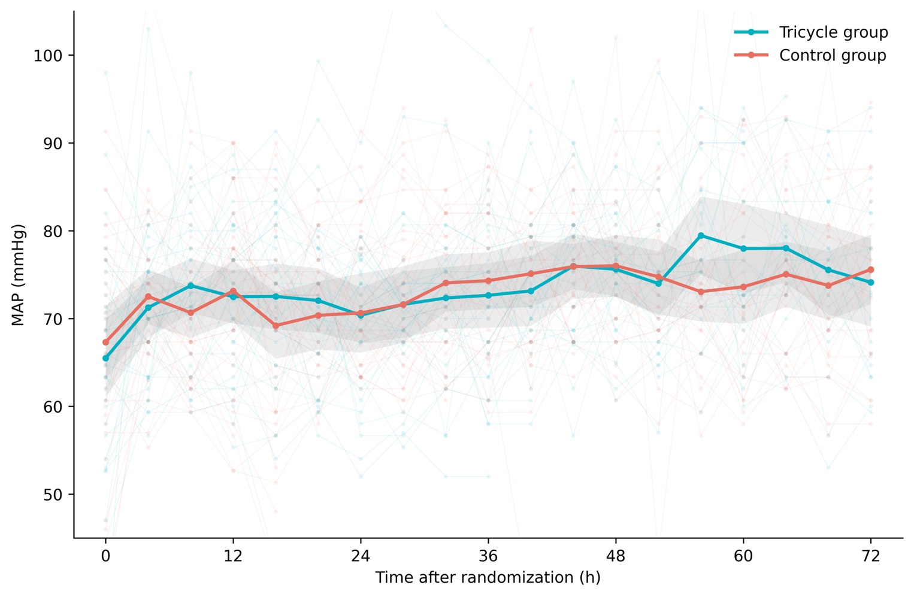
Data are presented as observed means with 95% confidence intervals. MAP data was available in 34 patients in the Tricycle group and 36 patients in the Control group. Abbreviations: MAP mean arterial pressure.

Figure S3. Heart rate during first 72 hours after randomization.
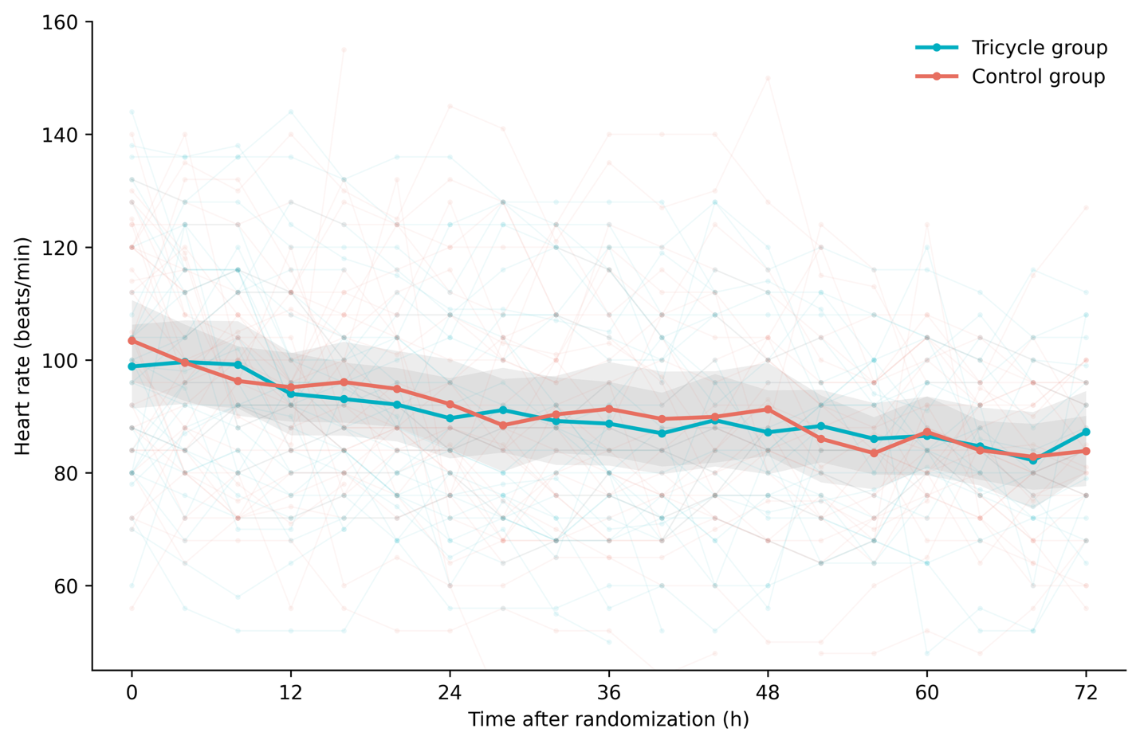
Data are presented as observed means with 95% confidence intervals. Heart rate data was available in 34 patients in the Tricycle group and 36 patients in the Control group.

Table S11. Available variables contributing to the ΔSOFA score.
Variable | Tricycle group | Control group | P
ΔNEE, median (IQR), μg/kg/min | −0.33 (−0.48, −0.21) | −0.21 (−0.37, −0.15) | 0.049
ΔCreatinine, median (IQR), mg/dL | −0.33 (−0.95, 0) | −0.10 (−0.50, 0.65) | 0.166
ΔPlatelets, median (IQR), × 10⁹/L | −35.5 (−67.5, −16.3) | −14 (−64.5, −1) | 0.083
ΔPaO₂/FiO₂ ratio, median (IQR) | 25.5 (−33.9, 108.8) | 10.7 (−28.8, 48.5) | 0.420
Δ indicates the change from baseline to day 3 (day 3 – baseline); worst day 3 values were used for calculations.
Values were calculated only for patients who were alive on day 3 and had available measurements. The primary ΔSOFA analysis included all randomized patients, with patients who died before day 3 assigned a day-3 SOFA score of 24 points.
Individual Glasgow Coma Scale scores and bilirubin levels were not available since only calculated SOFA scores were recorded; the remaining SOFA component variables were available.
Abbreviations: SOFA Sequential Organ Failure Assessment, NEE norepinephrine equivalence, IQR interquartile range, PaO₂/FiO₂ arterial partial pressure of oxygen/fraction of inspired oxygen.

Table S12. Vasopressor and adjunctive therapy by treatment group.
Therapy | Tricycle group  N = 38 | Control group  N = 41 | P
Hydrocortisone and fluid balance
Hydrocortisone use (0-72h), median (IQR), mg/day | 200 (193, 233) | 200 (175, 200) | 0.073
Fluid balance‡ (0-72h), median (IQR), mL/kgRBW | −2.5 (−38, 33.2) | 12.5 (−3.9, 44) | 0.173
Vasopressin therapy
Vasopressin¶ use, n (%) | 38 (100%) | 23 (56.1%) | −
NEE dose at vasopressin initiation, median (IQR), μg/kg/min | − | 0.45 (0.35, 0.50) | −
Additional vasopressors and inotropes
Angiotensin II* use, n (%) | − | 4 (9.8%) | −
Dobutamine, n (%) | 6 (15.8%) | 5 (12.2%) | 0.750
Levosimendan, n (%) | 1 (2.6%) | 0 | 0.481
Milrinone, n (%) | 0 | 0 | 1
Dopamine, n (%) | 0 | 0 | 1
Epinephrine, n (%) | 0 | 0 | 1
Methylene blue, n (%) | 0 | 0 | 1
‡ Data were missing for 7 patients in the Tricycle group and 7 patients in the Control group.
¶ No p value is provided for vasopressin because its administration differed according to assigned treatment strategy.
* No p value is provided for angiotensin II because its administration was part of the treatment strategy in Tricycle group.
Glucocorticoid use is reported in equivalent hydrocortisone dosages (3).
Abbreviations: IQR interquartile range, NEE norepinephrine equivalent, RBW real body weight.

Table S13. Site enrollment by country.
Country | Patients enrolled
Slovenia  Medical Intensive Care Unit, UMC Maribor, n (%)  Infectious Diseases Intensive Care Unit, UMC Maribor, n (%)  Croatia  Division of Intensive Care, University Hospital Centre Zagreb | 51 (65%)  16 (20%)  12 (15%)
Total, n | 79

Supplementary References
- Kalamar Ž, Gorenjak M, Landoni G, Markota A. Early multimodal vasopressor strategy in septic shock (Tricycle)—Study protocol for a randomized controlled clinical trial. Lascarrou JB, ed. PLoS One. 2025;20(8):e0331304. doi:10.1371/journal.pone.0331304.
- Kotani Y, Di Gioia A, Landoni G, Belletti A, Khanna AK. An updated “norepinephrine equivalent” score in intensive care as a marker of shock severity. Crit Care. 2023;27(1):29.
- Meikle AW, Tyler FH. Potency and duration of action of glucocorticoids. The American Journal of Medicine. 1977;63(2):200-207. doi:10.1016/0002-9343(77)90233-9.

