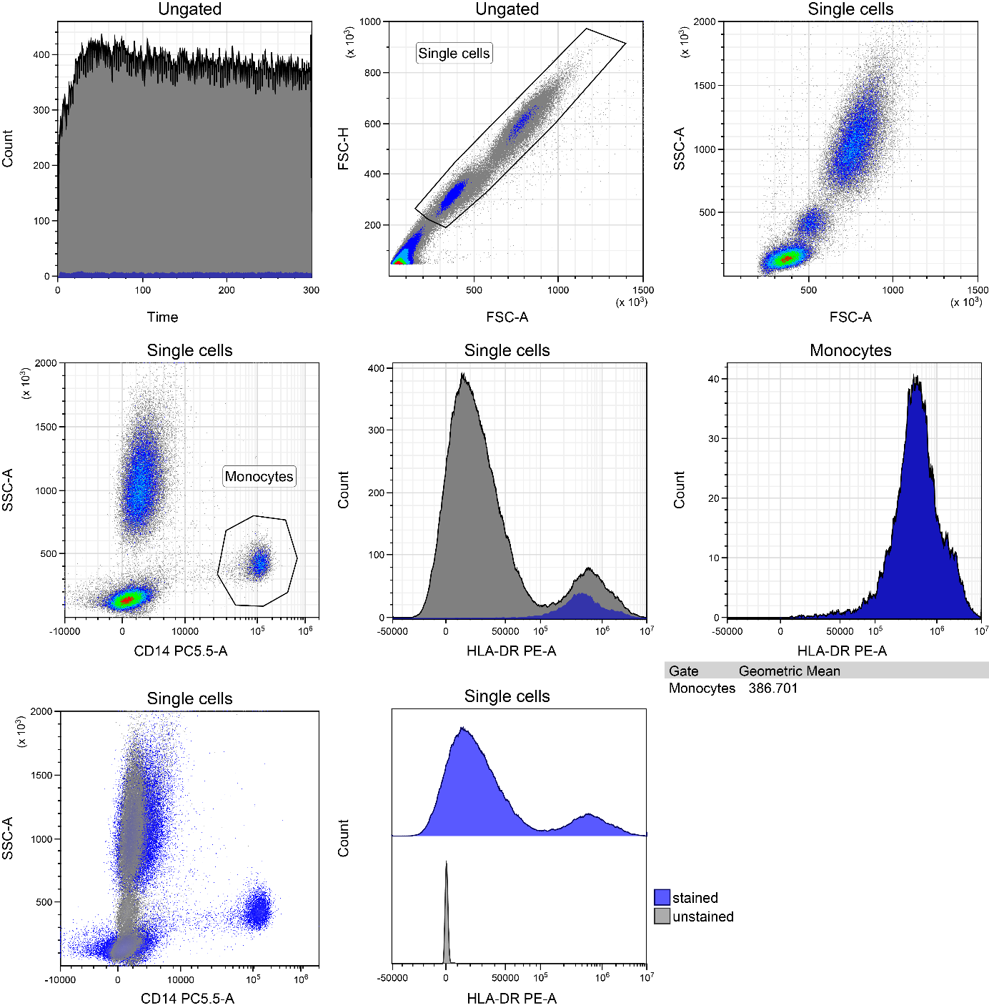
Suppl. figure 1. Gating strategy to analyse HLA-DR expression in monocytes.
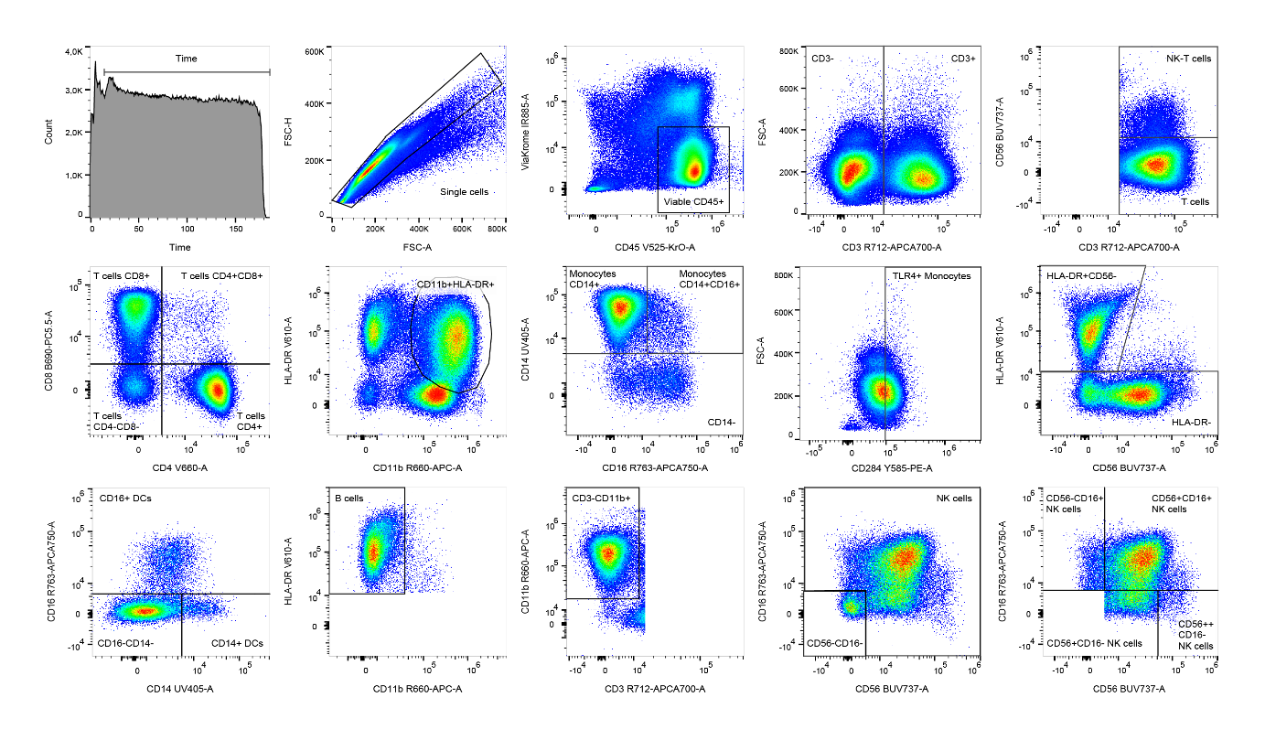
Suppl. figure 2. Gating strategy to analyse monocyte and T cell subsets in peripheral blood.

Suppl. figure 3 A-H. Flow cytometric analysis of monocyte and T cell subsets.

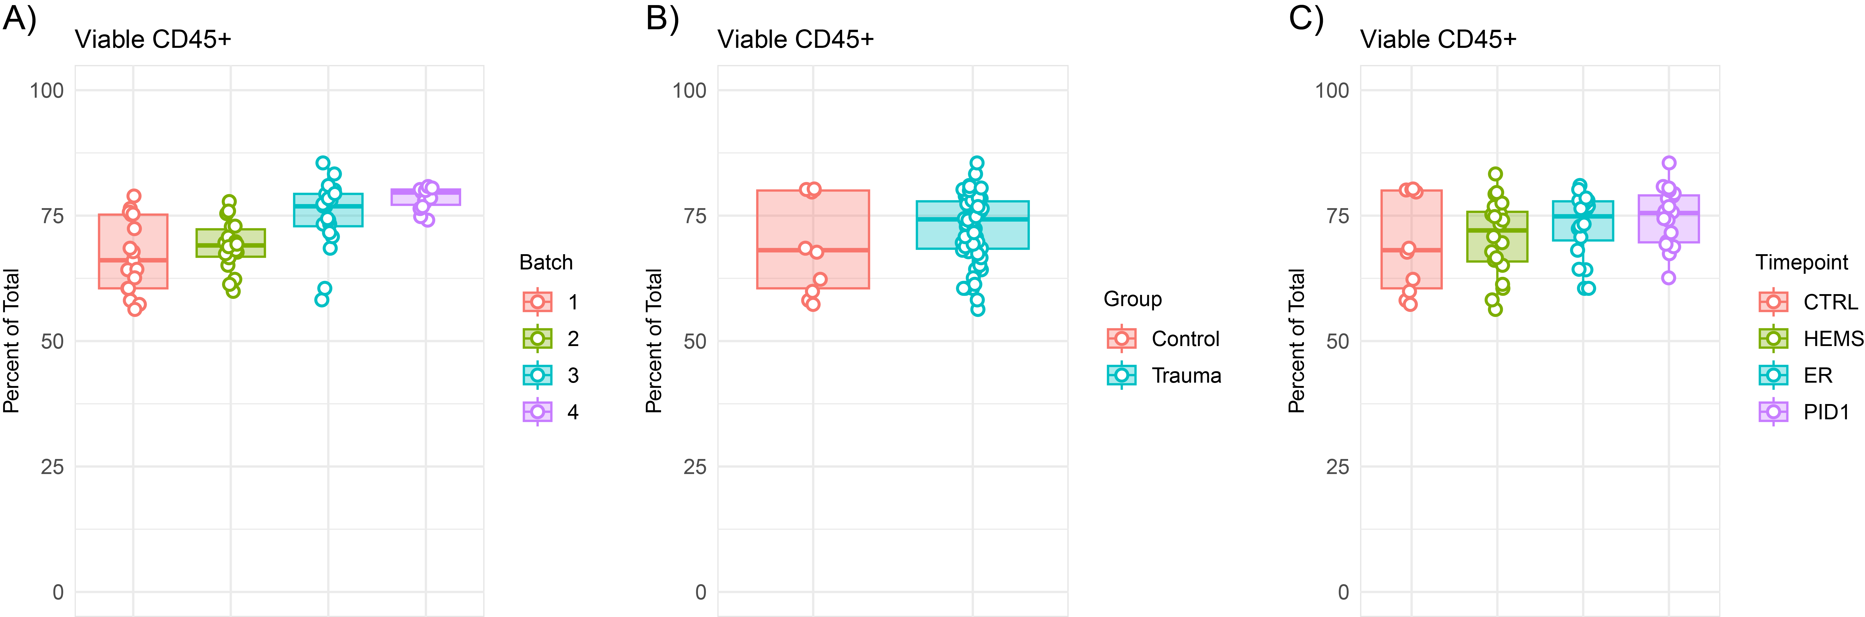
Suppl. figure 4. Post-thaw viability of PBMCs.

Suppl. figure 5. Ex vivo cytokine production of A) interleukin (IL)-1β, B) tumor necrosis factor (TNF), C) IL-6), and D) IL-10 upon whole blood stimulation with Escherichia coli (E. coli lipopolysaccharides (LPS) and interferon-γ (IFN-γ) in polytrauma patients (n = 10) at three timepoints (HEMS: helicopter emergency medical service; ER: emergency room; PID1: post-injury day 1) compared to controls (n = 10). Data are presented as median + interquartile range (IQR). *p < 0.05 versus controls; p < 0.05 for LPS versus LPS + IFN-γ. Correction for multiple testing was not applied.
Suppl. table 1. Baseline characteristics of non-polytrauma and polytrauma patients according to the Newcastle definition (AIS >2 in at least two body regions).
 |  |  | Non-polytrauma  (n = 9) | Polytrauma  (n = 11) | p-value
Patient characteristics | Age (years) |  | 58.0 (36.5 – 76.5) | 53.0 (25.0 – 74.0) | 0.503
Patient characteristics | Male sex |  | 6 (67%) | 8 (73%) | 1.000
 | Body Mass Index (BMI) (kg/m²) |  | 25.7 (22.7 – 26.7) | 24.7 (21.7 – 26.3) | 0.310
 | American Society of Anesthesiologists (ASA) score |  | 1 (1 – 2) | 1 (1 – 2) | 0.677
Injury severity | Injury Severity Score (ISS) |  | 18 (17 – 30) | 29 (26 – 43) | 0.025
 | Abbreviated Injury Score  (AIS) ≥ 3  Head  Neck  Face  Spine  Thorax  Extremities |  | 3 (33%)  0 (0%)  1 (11%)  0 (0%)  3 (33%)  2 (22%) | 10 (91%)  1 (9%)  1 (9%)  1 (9%)  10 (91%)  2 (18%) | 0.017  1.000  1.000  1.000  0.017  1.000
 | Intensive Care Unit (ICU) admission  Mechanical ventilation  Vasopressor therapy  ICU stay (days) |  | 6 (67%)  8 (89%)  4 (3 – 5) | 10 (91%)  11 (100%)  7 (3 – 11) | 0.285  0.450  0.230
 | Receipt of blood transfusion before collection of the final blood sample |  | 4 (44%) | 1 (9%) | 0.127
Outcomes | Hospital stay total (days) |  | 9 (5 – 11) | 18 (3 – 37) | 0.230
 | Re-admission, < 30 days |  | 0 (0%) | 1 (9%) | 1.000
 | Infectious complications (16), < 30 days |  | 2 (22%) | 4 (36%) | 0.642
Mortality | In-hospital mortality |  | 2 (22%) | 3 (27%) | 1.000
 | Mortality <24h |  | 0 (0%) | 1 (9%) | 1.000
 | Cause of death:  Traumatic Brain Injury (TBI)  Circulatory failure |  | 1 (50%)  1 (50%) | 3 (100%)  0 (0%) | 0.400

Suppl. table 2. Immune outcomes of non-polytrauma and polytrauma patients according to the Newcastle definition (AIS >2 in at least two body regions).
 |  |  | Non-polytrauma  (n = 9) | Polytrauma  (n = 11) | p-value
Immune cell counts and functionality | WBC  (x 10³ cells/mL) | HEMS  ER  PID1 | 12.8 (9.0 – 17.0)  15.4 (12.8 – 20.7)  12.8 (9.2 – 15.6) | 9.4 (7.1 – 11.8)  12.2 (11.1 – 13.2)  11.5 (8.9 – 16.4) | 0.261  0.080  0.824
 | Neutrophil count (x 10³ cells/mL) | HEMS  ER  PID1 | 7.3 (6.1 – 10.3)  13.3 (9.6 – 18.0)  11.4 (7.5 – 12.2) | 5.2 (4.5 – 6.9)  10.2 (8.4 – 11.4)  10.1 (7.2 – 14.0) | 0.046  0.152  0.710
 | Lymphocyte count  (x 10³ cells/mL) | HEMS  ER  PID1 | 4.0 (1.8 – 6.3)  1.8 (0.8 – 2.6)  1.4 (0.7 (2.1) | 3.6 (2.3 – 4.2)  1.4 (0.7 – 1.6)  1.1 (0.6 – 1.4) | 0.656  0.331  0.331
 | Monocyte count  (x 10³ cells/mL) | HEMS  ER  PID1 | 0.8 (0.7 – 1.0)  0.7 (0.4 – 0.9)  0.8 (0.6 – 1.2) | 0.6 (0.5 – 0.7)  0.8 (0.5 – 1.1)  1.2 (0.9 – 1.3) | 0.152  0.552  0.175
 | mHLA-DR  (antibodies/cell) | HEMS  ER  PID1 | 27,362 (26,635 – 34,448)  18,667 (14,547 – 20,982)  8,886 (7,900 – 12,675) | 34,038 (21,357 – 40,651)  20,273 (13,314 – 23,495)  9,307 (6,234 – 13,258) | 0.360  0.762  0.897
Plasma biomarkers | HMGB1  (pg/mL) | HEMS  ER  PID1 | 4,110 (2,390 – 6,806)  1,358 (1,204 – 2,607)  776 (288 – 1,053) | 5,274 (2,592 – 7,827)  1,892 (1,210 – 3,014)  378 (302 – 943) | 0.824  0.552  0.552
Plasma biomarkers | HSP70  (pg/mL) | HEMS  ER  PID1 | 36,882 (25,338 – 65,892)  28,444 (24,631 – 50,266)  6,416 (3,115 – 9,408) | 45,595 (23,659 – 80,000)  36,248 (17,274 – 80,000)  8,864 (5,409 – 13,912) | 0.656  0.603  0.295
 | S100A8/A9  (x 10⁶ pg/mL) | HEMS  ER  PID1 | 2.7 (1.6 – 3.0)  2.2 (1.4 – 3.0)  0.85 (0.46 – 2.2) | 1.9 (1.1 – 3.0)  2.0 (0.96 – 3.0)  1.3 (0.79 – 2.2) | 0.656  0.766  0.603
 | IL-6  (pg/mL) | HEMS  ER  PID1 | 8.3 (2.5 – 78.9)  126.0 (49.9 – 203.0)  55.2 (21.4 – 81.8) | 2.9 (0.64 – 19.2)  69.8 (28.0 – 203.0)  46.7 (25.2 – 113.0) | 0.370  0.710  0.603
 | TNF  (pg/mL) | HEMS  ER  PID1 | 19.7 (15.7 – 29.7)  21.1 (15.1 – 26.1)  14.7 (9.0 – 19.2) | 17.9 (10.5 – 21.1)  18.7 (12.7 – 19.4)  16.9 (12.6 – 24.5) | 0.412  0.295  0.331
 | IL-10  (pg/mL) | HEMS  ER  PID1 | 12.0 (4.3 – 167.5)  243.0 (97.1 – 519.0)  17.4 (9.9 – 50.3) | 16.3 (4.1 – 60.7)  145.0 (48.0 – 673.0)  43.4 (15.8 – 86.4) | 1.000  0.656  0.230
 | CRP  (mg/L) | HEMS  ER  PID1 | 1.2 (0.60 – 2.5)  1.1 (0.60 – 2.0)  46.5 (37.9 – 77.6) | 0.80 (0.60 – 4.6)  0.90 (0.60 – 3.4)  55.2 (50.5 – 89.0) | 0.941  0.824  0.331
In vitro cytokine production (LPS) | IL-1β  (pg/mL) | HEMS  ER  PID1 | 2,092 (1,481 – 2,823)  1,417 (625 – 1,738)  2,484 (973 – 6,212) | 1,564 (735 – 3,502)  851 (212 – 2,293)  1,629 (1,142 – 5,441) | 0.656  1.000  0.603
In vitro cytokine production (LPS) | TNF  (pg/mL) | HEMS  ER  PID1 | 212 (148 – 474)  81 (43 – 192)  397 (160 – 585) | 381 (191 – 1,114)  138 (39 – 230)  338 (142 – 446) | 0.456  0.710  0.766
In vitro cytokine production (LPS) | IL-6  (pg/mL) | HEMS  ER  PID1 | 10.483 (7,320 – 13,320)  6,036 (3,895 – 8,651)  18,744 (7,034 – 28,159) | 12,259 (7,260 – 20,883)  12,024 (1,733 – 17,788)  20,411 (16,925 – 35,828) | 0.710  0.331  0.412
In vitro cytokine production (LPS) | IL-10  (pg/mL) | HEMS  ER  PID1 | 523 (259 – 647)  133 (70 – 452)  735 (403 – 1021) | 326 (172 – 810)  412 (63 – 793)  1043 (208 – 1155) | 0.710  0.370  0.456

