Supplementary Material – Appendix 1
Local procedure for esophageal pressure monitoring.

The esophageal catheter was positioned according to our local protocol, as described below (1,2):
- Insert the esophageal catheter (Nutrivent®, Sidam, Modena, Italy) into the stomach through the mouth. Confirm correct gastric placement by observing an increase in gastric pressure during gentle external epigastric compression.
- Inflate the balloon with 4 mL of air, as recommended by the manufacturer. Withdraw the catheter slowly until cardiac artifacts appear on the esophageal pressure (P_{es}) waveform.
- Optimize balloon inflation using the method described by Mojoli et al. (3). Briefly, inflate the balloon with 10 mL of air and then deflate it stepwise in 1-mL increments. Select the balloon volume that produces the greatest change in Pes (ΔP_{es}) during tidal ventilation.
- Verify correct catheter positioning by applying gentle external chest compressions during an expiratory occlusion and measure the absolute changes in airway and esophageal pressures (ΔP_{aw} and ΔP_{es}). A ΔP_{es}/ΔP_{aw} ratio close to 1 (±10%) during the occlusion confirms accurate pleural pressure measurement.
- Measure end-expiratory and end-inspiratory esophageal pressures (P_{es,e} and P_{es,i}) during occlusion. To correct for esophageal wall pressure artifacts, subtract 1 cmH₂O for each milliliter of balloon volume above 1 mL (3).

- Mauri T, Yoshida T, Bellani G, Goligher EC, Carteaux G, Rittayamai N, et al. Esophageal and transpulmonary pressure in the clinical setting: meaning, usefulness and perspectives. Intensive Care Med. sept 2016;42(9):1360‑73.
- Piquilloud, L., Beitler, J.R. & Beloncle, F.M. Monitoring esophageal pressure. Intensive Care Med. June 2024;50:953–956.
- Mojoli F, Iotti GA, Torriglia F, Pozzi M, Volta CA, Bianzina S, et al. In vivo calibration of esophageal pressure in the mechanically ventilated patient makes measurements reliable. Crit Care. 11 avr 2016;20:98.

Supplementary Material – Appendix 2
Calculated variables used in the study

End-expiratory transpulmonary pressure: P_{L,e} = PEEP – P_{eso,e}
End-inspiratory transpulmonary pressure, direct method: P_{L,i} = P_{plat} – P_{eso,i}
End-inspiratory transpulmonary pressure, elastance-derived method: P_{L,i} = P_{plat} x (E_{L} / E_{rs})
Respiratory system compliance: C_{rs} = V_{T} / (P_{plat} – PEEP)
Lung compliance: C_{L} = V_{T} / [(P_{plat} – PEEP) – (P_{eso,i} – P_{eso,e})]
Non-dependent lung compliance: C_{L,ND} = (V_{T} x %V_{T,ND}) / [(P_{plat} – PEEP) – (P_{eso,i} – P_{eso,e})]
Dependent lung compliance: C_{L,D} = (V_{T} x %V_{T,D}) / [(P_{plat} – PEEP) – (P_{eso,i} – P_{eso,e})]

E_{L}: lung elastance, E_{rs}: respiratory system elastance, PEEP: positive end-expiratory pressure, P_{eso,e}: end-expiratory esophageal pressure, P_{eso,i}: end-inspiratory esophageal pressure, P_{plat}: plateau pressure, V_{T}: tidal volume, %V_{T,D}: fraction of tidal distribution of impedance signal in the dependent lung, %V_{T,ND}: fraction of tidal distribution of impedance signal in the non-dependent lung.
Supplementary Material – Appendix 3
Contraindications to Study Procedures

Esophageal balloon catheter
Active upper gastrointestinal bleeding, including bleeding esophageal varices
Recent esophageal trauma
Esophageal tumor
Esophageal diverticulum or ulceration
Recent esophageal surgery
Platelet count < 10,000 cells/µL
Prothrombin time < 30%
Electrical impedance tomography
Pacemakers
Implantable cardiac defibrillators
Unstable rib or spinal fractures
Inability to correctly position the EIT belt (e.g., chest burns, chest drains)
Decremental PEEP trial
Pneumothorax, pneumomediastinum, or bronchopleural fistula
Severe hemodynamic instability (>30% increase in vasopressors requirements within the last 6 hours or norepinephrine > 0.5 µg/kg/min)
Severe hypoxemia (PaO2/FiO2 ratio < 80 mmHg)
Severe or very severe chronic obstructive pulmonary disease according to GOLD criteria (stage III: FEV1 30-50% predicted; stage IV: FEV₁ < 30% predicted)
Known or highly suspected elevated intracranial pressure (>18 mmHg)

EIT: electrical impedance tomography, FiO₂: fraction of inspired oxygen, PaO₂: arterial partial pressure of oxygen, GOLD: global initiative for chronic obstructive lung disease, FEV1: forced expiratory volume in 1 second.

Supplementary Material – Table e1
Association between transpulmonary pressures and EIT-derived alveolar collapse and overdistension.

Analysis |  |  | Spearman’s correlation |  |  |  | Repeated-measures correlation
Analysis |  |  | r | 95% CI | p value |  | rmcorr | 95% CI | p value
P_{L,e} vs. EIT-derived collapse
All PEEP levels |  |  | -0.68 | -0.74 to -0.62 | <0.001 |  | −0.85 | −0.88 to −0.82 | <0.001
Excluding PEEP 4 cmH₂O |  |  | -0.63 | -0.70 to -0.56 | <0.001 |  | −0.82 | −0.85 to −0.78 | <0.001
P_{L,i} vs. EIT-derived overdistension
All PEEP levels |  |  | 0.60 | 0.52 to 0.67 | <0.001 |  | 0.89 | 0.86 to 0.91 | <0.001
Excluding PEEP 20 cmH₂O |  |  | 0.55 | 0.47 to 0.63 | <0.001 |  | 0.87 | 0.84 to 0.90 | <0.001

CI: confidence interval, P_{L,e}: end-expiratory transpulmonary pressure, P_{L,i}: end-inspiratory transpulmonary pressure (elastance-derived method), PEEP: positive end-expiratory pressure, r: Spearman coefficient, rmcorr: repeated-measures correlation.
Supplementary Material – Table e2
Linear mixed-effects models.

Analysis | β | 95% CI | p value
P_{L,e} vs. EIT-derived collapse
All PEEP levels | -2.99 | -3.22 to -2.77 | <0.001
Excluding PEEP 4 cmH₂O | -2.56 | -2.79 to -2.32 | <0.001
P_{L,i} vs. EIT-derived overdistension
All PEEP levels | 1.93 | 1.81 to 2.05 | <0.001
Excluding PEEP 20 cmH₂O | 1.80 | 1.67 to 1.93 | <0.001

CI: confidence interval, P_{L,e}: end-expiratory transpulmonary pressure, P_{L,i}: end-inspiratory transpulmonary pressure (elastance-derived method), PEEP: positive end-expiratory pressure.
Supplementary Material – Table e3
Fisher’s z comparison of Spearman correlation coefficient according to the obesity status, respiratory system elastance, oxygenation, and recruitability.

Comparison | Obese vs. non-obese |  |  |  |  | Low vs. high E_{rs} |  |  |  |  | Low vs. high P_{a}O₂/F_{i}O₂ ratio |  |  |  |  | Low vs. high recruitability
Comparison | r₁ | r₂ | Z score | p value |  | r₁ | r₂ | Z score | p value |  | r₁ | r₂ | Z score | p value |  | r₁ | r₂ | Z score | p value
Correlation between EIT-derived collapse and P_{L,e} | -0.73 | -0.64 | -1.50 | 0.134 |  | -0.64 | -0.73 | -1.53 | 0.126 |  | -0.69 | -0.68 | -0.17 | 0.865 |  | -0.61 | -0.72 | -0.56 | 0.577
Correlation between EIT-derived overdistension and P_{L,i} | 0.74 | 0.55 | 2.92 | 0.004 |  | 0.65 | 0.65 | 0 | >0.99 |  | 0.56 | 0.65 | 1.27 | 0.204 |  | 0.67 | 0.71 | 0.22 | 0.830

E_{rs}: respiratory system elastance, P_{a}O₂/F_{i}O₂: ratio of arterial oxygen partial pressure to fractional inspired oxygen, P_{L,e}: end-expiratory transpulmonary pressure, P_{L,i}: end-inspiratory transpulmonary pressure (elastance-derived method), r: Spearman coefficient, Z: Fisher-transformed correlation coefficient.
Supplementary Material – Table e4
Performance of transpulmonary pressures to discriminate alveolar collapse and overdistension (i.e. 5, 10 or 15% out of the total lung imaged by electrical impedance tomography) in ARDS patients.

Parameters | AUC  [95% CI] | p value | Optimal cut-off (cmH₂O) | Se (%) | Sp (%) | Youden Index | Gray zone  (cmH₂O)
P_{L,e} to discriminate EIT-derived collapse >5% | 0.86  [0.82-0.92] | <0.001 | 2.5 | 72 | 85 | 0.57 | 1.5 to 4.8
P_{L,e} to discriminate EIT-derived collapse >10% | 0.84  [0.80-0.90] | <0.001 | 2.1 | 75 | 80 | 0.55 | 0.2 to 4.5
P_{L,e} to discriminate EIT-derived collapse >15% | 0.83  [0.78-0.90] | <0.001 | 2.1 | 81 | 73 | 0.54 | -0.4 to 4.3
P_{L,i} to discriminate EIT-derived overdistension >5% | 0.81  [0.75-0.88] | <0.001 | 17.4 | 72 | 80 | 0.49 | 13.7 to 21.4
P_{L,i} to discriminate EIT-derived overdistension >10% | 0.80  [0.72-0.87] | <0.001 | 17.5 | 73 | 78 | 0.50 | 13.7 to 23.3
P_{L,i} to discriminate EIT-derived overdistension >15% | 0.80  [0.73-0.88] | <0.001 | 20.7 | 67 | 82 | 0.49 | 15.3 to 24.3

AUC: area under the ROC curve, P_{L,e}: end-expiratory transpulmonary pressure (direct method), P_{L,i}: end-inspiratory transpulmonary pressure (elastance-derived method), Se: sensitivity, Sp: specificity. The gray zone values indicate the transpulmonary pressure values to discriminate collapse or overdistension, with a specificity of at least 90%.

Supplementary Material – Figure e1
Ability of end-inspiratory transpulmonary pressure to detect EIT-derived overdistension exceeding 10% of the lung.

Panel A: evolution of end-inspiratory transpulmonary pressures (grey circle) and EIT-derived alveolar overdistension (blue bar) during the decremental PEEP titration. Data are expressed as mean ± SD. The horizontal dashed lines indicate P_{L,i} of 20 cmH₂O. panel B: scatterplots depicting the correlation (and 95% confidence interval) between P_{L,i} and the percentage of EIT-derived alveolar overdistension. Solid line shows linear regression. Dashed vertical line shows 10% of overdistension lung units out of the total lung imaged by EIT. Dashed horizontal line shows P_{L,i} at 20 cmH₂O – the theoretical threshold value above which the risk of alveolar overdistension increases. Panel C: receiver operating characteristic (ROC) curves for P_{L,i} predicting alveolar overdistension higher than 10%. Panel D: Sensitivity (gray) and specificity (blue) of P_{L,i} for identifying EIT-derived overdistension >10%. The vertical dashed lines indicates the lower and upper limits of the gray zone, within which overdistension could not be reliably discriminated. AUC: area under the ROC curve, P_{L,i}: end-inspiratory transpulmonary pressure (direct method), PEEP: positive end-expiratory pressure.
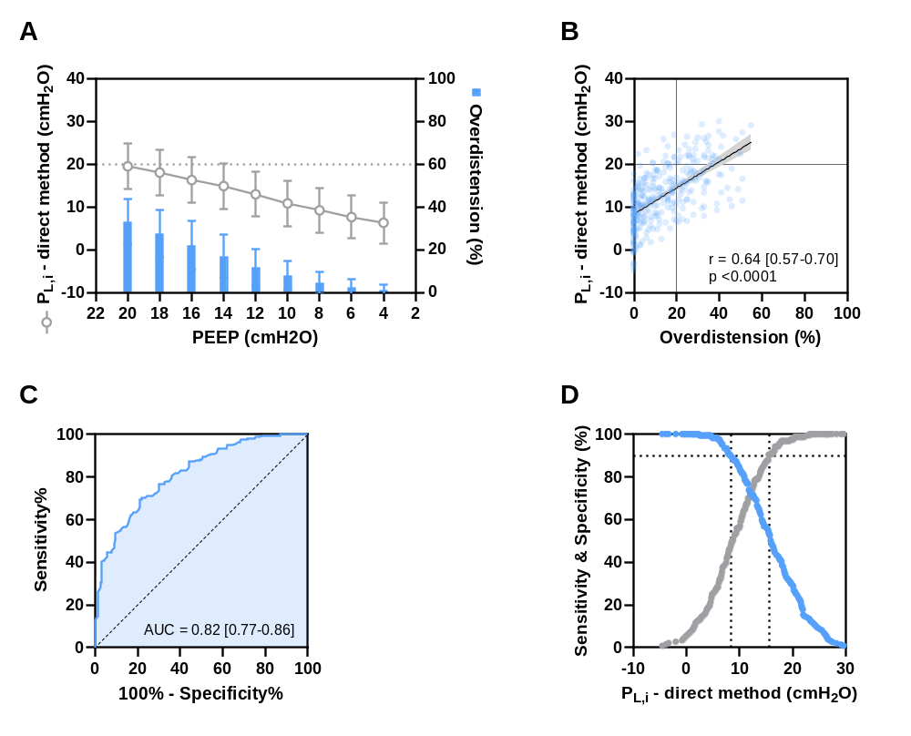
Supplementary Material – Figure e2
Correlation between collapse and end-expiratory transpulmonary pressure according to the obesity status, respiratory system elastance, oxygenation, and recruitability.
Scatterplots depicting the correlation (and 95% confidence interval) between P_{L,e} and the percentage of EIT-derived alveolar collapse according to [Panel A] obesity status (BMI < 30 vs. ≥ 30 kg/m²), [Panel B] E_{rs} (E_{rs} < 29 vs. ≥ 29 cmH₂O/L), [Panel C] P_{a}O₂/F_{i}O₂ ratio (P_{a}O₂/F_{i}O₂ < 153 vs. ≥ 153 mmHg), and [Panel D] potential for lung recruitment (Δcollapse <33 vs. ≥ 33 %). Solid line shows linear regression. Dashed vertical line shows 10% of collapse lung units out of the total lung imaged by EIT. Dashed horizontal line shows P_{L,e} at 0 cmH₂O – the theoretical threshold value beyond which the risk of alveolar collapse increases. Δcollapse: absolute reduction in collapse, E_{rs}: respiratory system elastance, P_{a}O₂/F_{i}O₂: ratio of arterial oxygen partial pressure to fractional inspired oxygen, P_{L,e}: end-expiratory transpulmonary pressure.

A | B | C | D
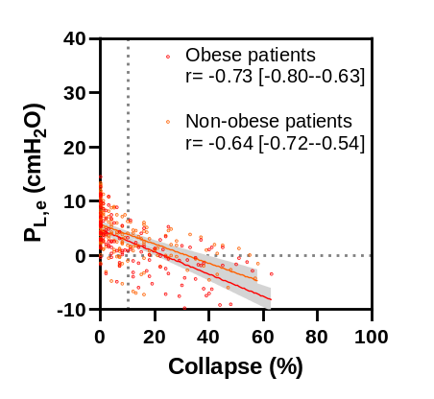 | 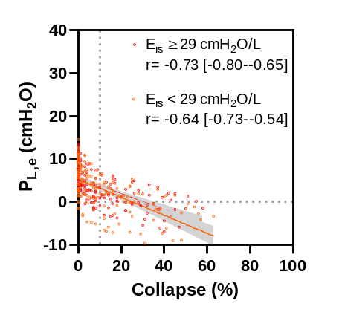 | 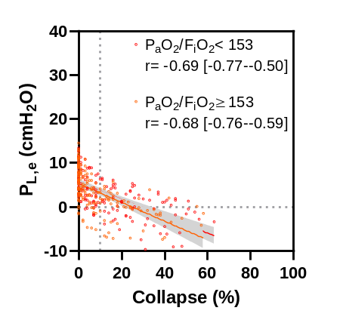 | 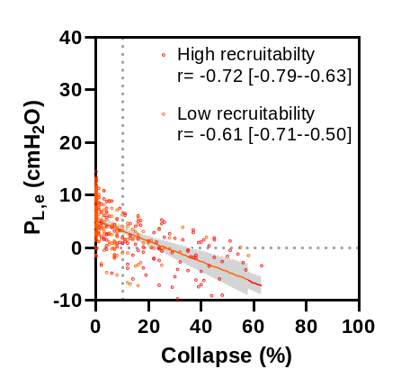
Supplementary Material – Figure e3
Correlation between overdistension and end-inspiratory transpulmonary pressure according to the obesity status, respiratory system elastance, oxygenation, and recruitability.
Scatterplots depicting the correlation (and 95% confidence interval) between P_{L,i} and the percentage of EIT-derived alveolar overdistension according to [Panel A] obesity status (BMI < 30 vs. ≥ 30 Kg/m²), [Panel B] E_{rs} (E_{rs} < 29 vs. ≥ 29 cmH₂O/L), [Panel C] P_{a}O₂/F_{i}O₂ ratio (P_{a}O₂/F_{i}O₂ < 153 vs. ≥ 153 mmHg), and [Panel D] potential for lung recruitment (Δcollapse < 33 vs. ≥ 33 %). Solid line shows linear regression. Dashed vertical line shows 10% of overdistension lung units out of the total lung imaged by EIT. Dashed horizontal line shows P_{L,i} at 20 cmH₂O – the theoretical threshold value above which the risk of alveolar overdistension increases. Δcollapse: absolute reduction in collapse, E_{rs}: respiratory system elastance, P_{a}O₂/F_{i}O₂: ratio of arterial oxygen partial pressure to fractional inspired oxygen, P_{L,i}: end-inspiratory transpulmonary pressure (elastance-derived method).

A | B | C | D
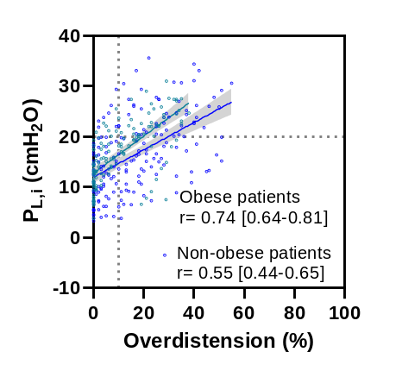 | 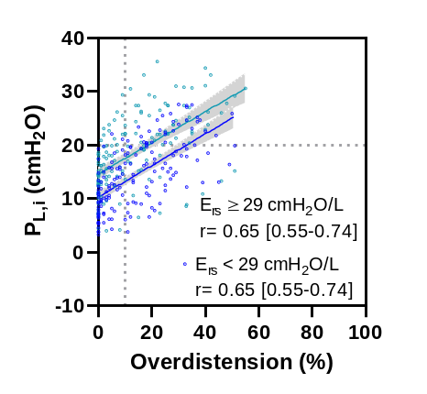 | 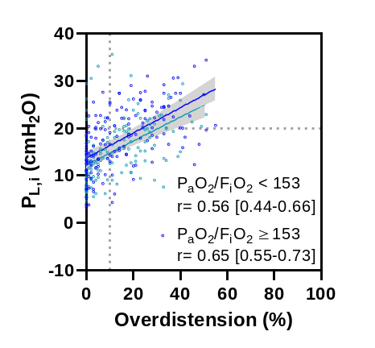 | 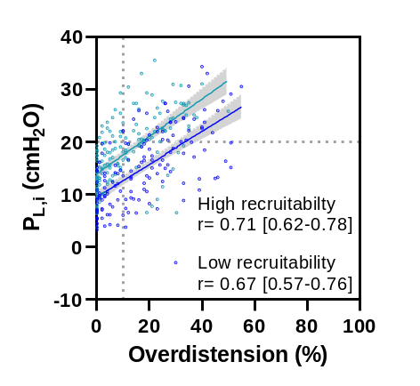

Supplementary Material – Figure e4
Sensitivity analyses using alternative thresholds of 5% and 15% to assess the ability of end-expiratory transpulmonary pressures to detect EIT-derived alveolar collapse.

Panel A-C: receiver operating characteristic (ROC) curves for P_{L,e} predicting alveolar collapse higher than 5% [A], 10% [B], and 15% [C]. Panel D-F: Sensitivity (red) and specificity (gray) of P_{L,e} for identifying EIT-derived collapse higher than 5% [D], 10% [E], and 15% [F]. The vertical dashed lines indicate the lower and upper limits of the gray zone, within which collapse could not be reliably discriminated. AUC: area under the ROC curve, P_{L,e}: end-expiratory transpulmonary pressure.

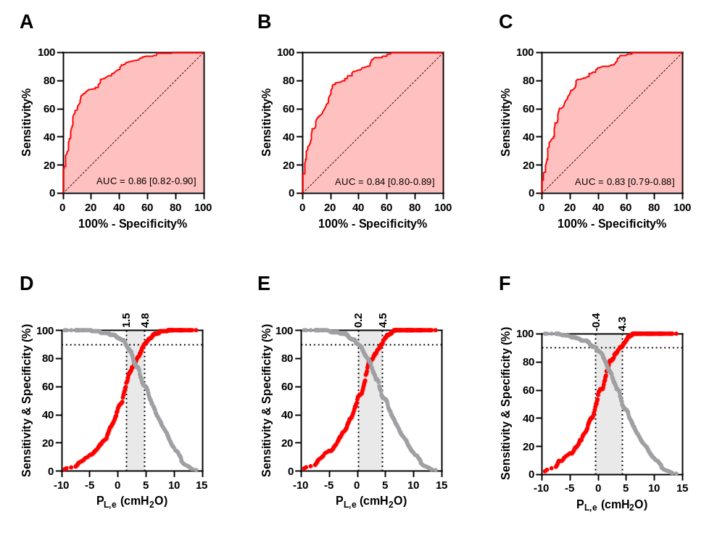
Supplementary Material – Figure e5
Sensitivity analyses using alternative thresholds of 5% and 15% to assess the ability of end-inspiratory transpulmonary pressures to detect EIT-derived alveolar overdistension.

Panel A-C: receiver operating characteristic (ROC) curves for P_{L,i} predicting alveolar overdistension higher than 5% [A], 10% [B], and 15% [C]. Panel D-F: Sensitivity (blue) and specificity (gray) of P_{L,i} for identifying EIT-derived overdistension higher than 5% [D], 10% [E], and 15% [F]. The vertical dashed lines indicate the lower and upper limits of the gray zone, within which overdistension could not be reliably discriminated. AUC: area under the ROC curve, P_{L,i}: end-inspiratory transpulmonary pressure (elastance-derived method).

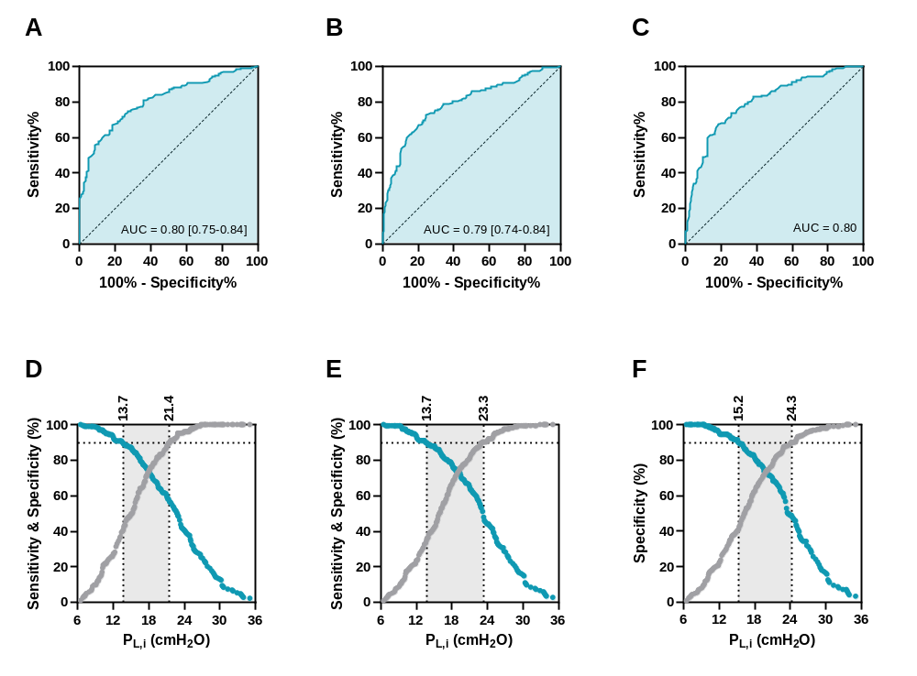
Supplementary Material – Figure e6
Optimal positive end-expiratory pressure according to titration strategies.

Panel A: Cumulative distribution of PEEP values determined by EIT-guided and esophageal pressure-guided strategy (PEEP_{EIT} and PEEP_{Peso}, respectively). Panel B: Correlation between PEEP_{EIT} and PEEP_{Peso}. Each dot represents one patient; the solid line indicates the linear regression with 95% confidence interval (shaded area). Panel C: Bland–Altman analysis showing agreement between PEEP_{EIT} and PEEP_{Peso}. The solid horizontal line represents the mean bias, and dashed lines indicate the 95% limits of agreement. PEEP: positive end-expiratory pressure, SD: standard deviation.

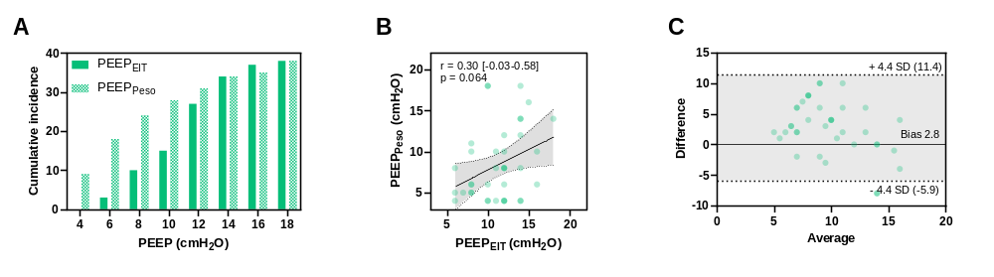
Supplementary Material – Figure e7
Comparisons of positive end-expiratory pressure titration strategies on respiratory mechanics, collapse and alveolar overdistension.

Effect of EIT-guided strategy (PEEP_{EIT}) on (Panels A and D) transpulmonary pressures, (Panels B and E) percentages of EIT-derived collapse and/or overdistension, and (Panels C, F) lung compliances compared to esophageal pressure-guided strategy (PEEP_{Peso}). C_{L,D}: dependent lung compliance, C_{L,ND}: non-dependent lung compliance, P_{L,e}: end-expiratory transpulmonary pressure (direct method), P_{L,i}: end-inspiratory transpulmonary pressure (elastance-derived method).

