Comparison of two automated pupillometry indices in patients with acute brain injury: the prospective multicentre LYNX cohort study
Additional file 1: Supplementary figures and table
Fig. S1 Flowchart of the LYNX study 2
Fig. S2 Distribution of all NPi measurements in patients with acute brain injury (A) and in healthy volunteers (B) 3
Fig. S3 Distribution of all QPi measurements in patients with acute brain injury (A) and in healthy volunteers (B) 4
Fig. S4 Proportion of abnormal NPi measurements (NPi < 3) in patients with acute brain injury (N = 106 patients) 5
Fig. S5 Proportion of abnormal QPi measurements (QPi < 3) in patients with acute brain injury (N = 106 patients) 6
Fig. S6 Number of intracranial hypertension episodes per patient (excluding extreme outlier with 1,162 episodes), N = 79 patients 7
Fig. S7 Distribution of 6-month neurological outcome (GOS-E) in patients with acute brain injury 8
Fig. S8 NPi measurements in healthy volunteers under light (A) and dark (B) ambient conditions 9
Fig. S9 QPi measurements in healthy volunteers under light (A) and dark (B) ambient conditions 10
Fig. S10 NPi and QPi as a function of resting pupil diameter and anaesthetic step in sedated non–brain-injured patients (N = 20) 11
Table S1 Sensitivity analyses using alternative QPi thresholds 12

Fig. S1 Flowchart of the LYNX study
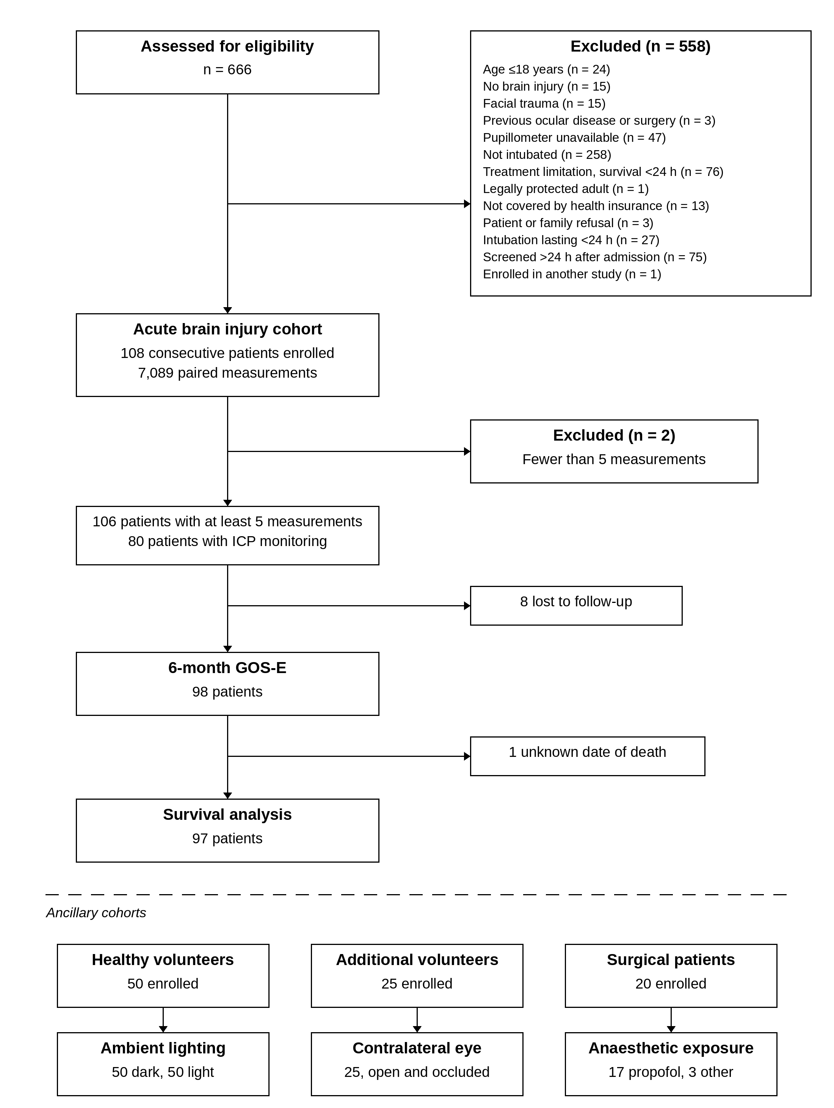
NPi, neurological pupil index; QPi, quantitative pupil index; ICP, intracranial pressure; GOS-E, Glasgow Outcome Scale–Extended. Of 666 patients assessed for eligibility, 558 were not included and 108 consecutive patients were enrolled. Two were excluded from the analysis population because fewer than 5 pupillometry measurements were obtained, following early awakening with shortened sedation and unplanned extubation within 24 hours, leaving 106 patients in the analysis population. Six-month GOS-E was unavailable for 8 patients lost to follow-up despite repeated attempts to reach patients and relatives, leaving 98 patients. Vital status was known for these 98 patients, among whom 34 died; 1 was excluded from the time-to-event analysis because the date of death could not be established, leaving 97 patients for the survival analysis. Intracranial pressure analyses were performed in the 80 patients with ICP monitoring, of whom 1 was excluded as an extreme outlier (1,162 episodes). Each of the 50 healthy volunteers was assessed under both dark and light ambient conditions; a further 25 volunteers were enrolled separately and assessed with the contralateral eye both open and occluded. Among the 20 surgical patients, 17 received propofol and 3 received an alternative hypnotic agent. Healthy volunteers and surgical patients were ancillary cohorts and were not included in the outcome analyses.

Fig. S2 Distribution of all NPi measurements in patients with acute brain injury (A) and in healthy volunteers (B)
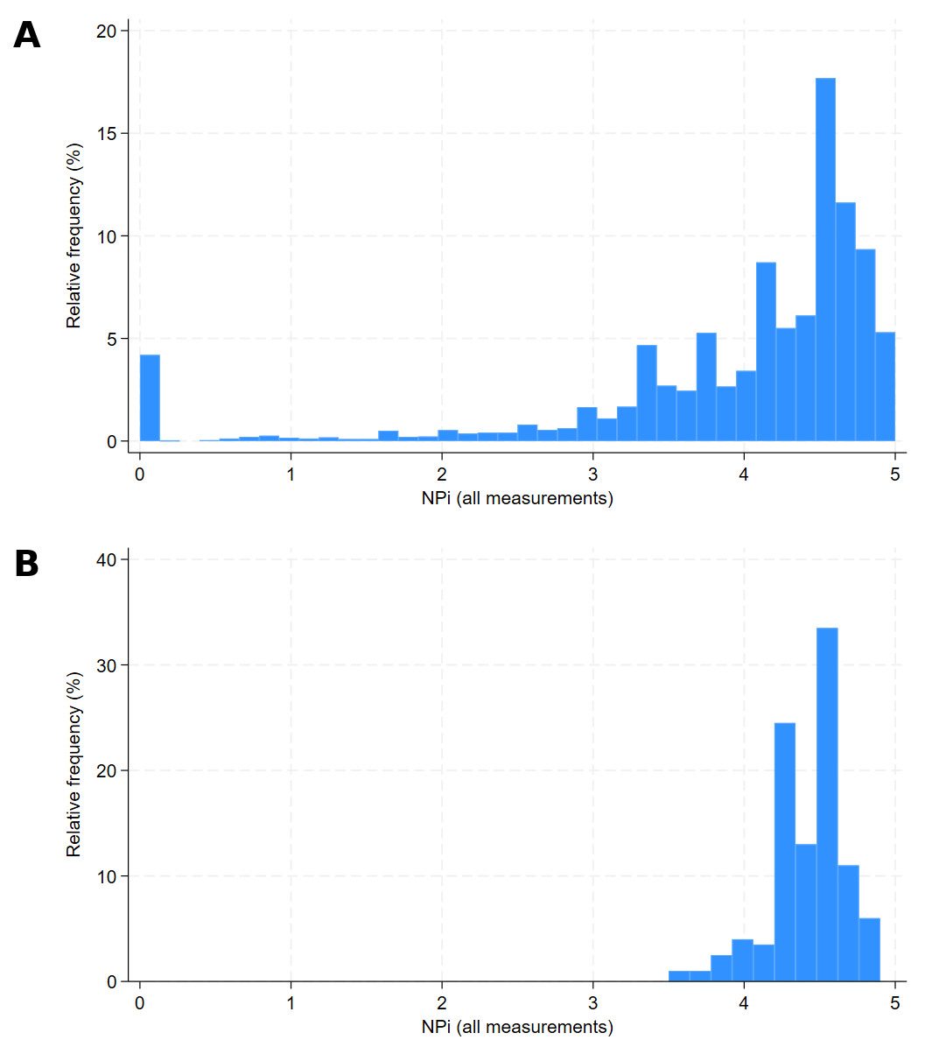
NPi, neurological pupil index. (A) All 7,089 measurements obtained in the 106 brain-injured patients. (B) All 200 measurements obtained in the 50 healthy volunteers. Both panels share the same horizontal axis so that the two populations can be compared directly; note that the vertical scales differ, since the distributions are expressed as relative frequencies within each population.

Fig. S3 Distribution of all QPi measurements in patients with acute brain injury (A) and in healthy volunteers (B)
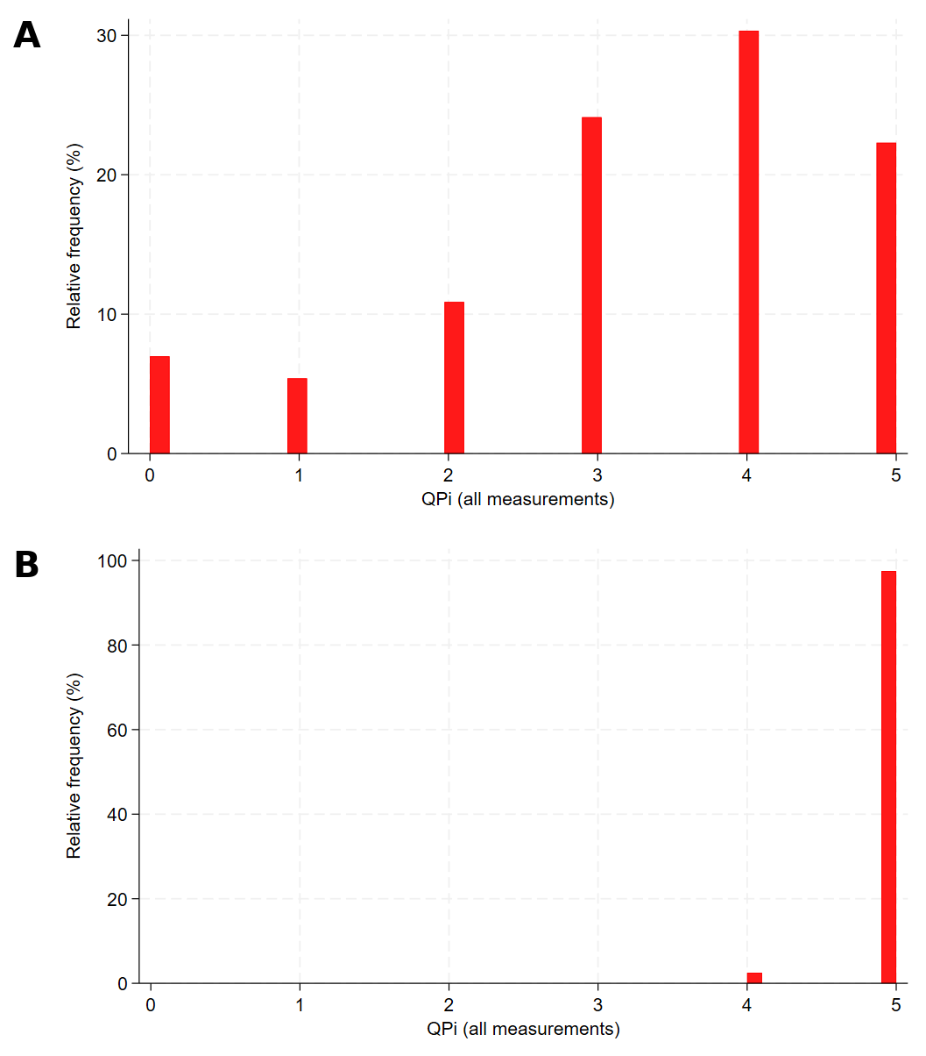
QPi, quantitative pupil index. (A) All 7,089 measurements obtained in the 106 brain-injured patients. (B) All 200 measurements obtained in the 50 healthy volunteers. Both panels share the same horizontal axis; the vertical scales differ. In healthy volunteers the QPi took the value 5 in almost every measurement, with occasional values of 4 and none below 4, whereas measurements in brain-injured patients were distributed across the whole range, including values of 0, 1 and 2.

Fig. S4 Proportion of abnormal NPi measurements (NPi < 3) in patients with acute brain injury (N = 106 patients)
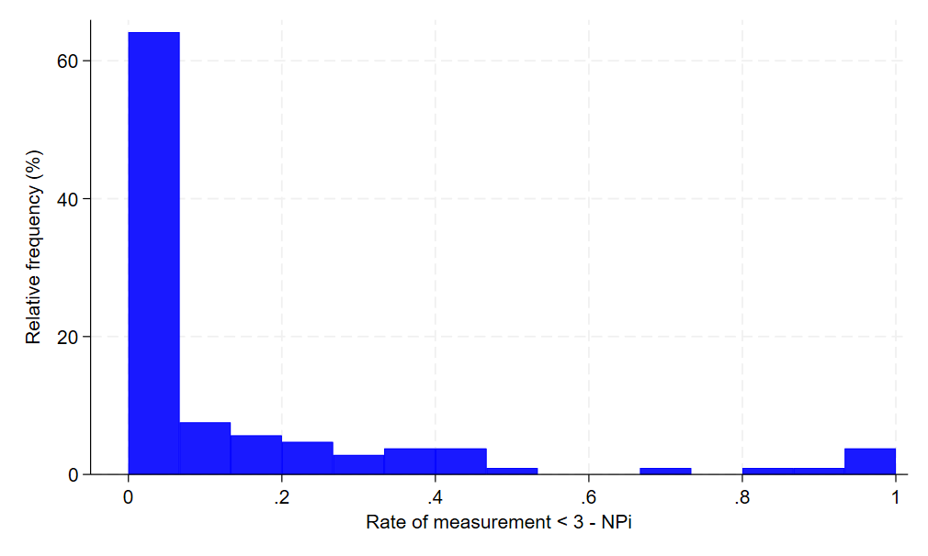

Fig. S5 Proportion of abnormal QPi measurements (QPi < 3) in patients with acute brain injury (N = 106 patients)
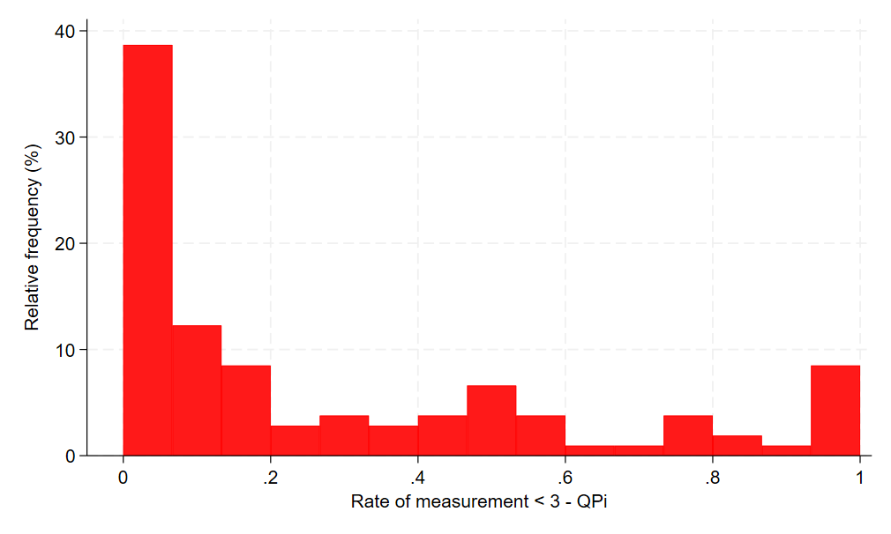

Fig. S6 Number of intracranial hypertension episodes per patient (excluding extreme outlier with 1,162 episodes), N = 79 patients.
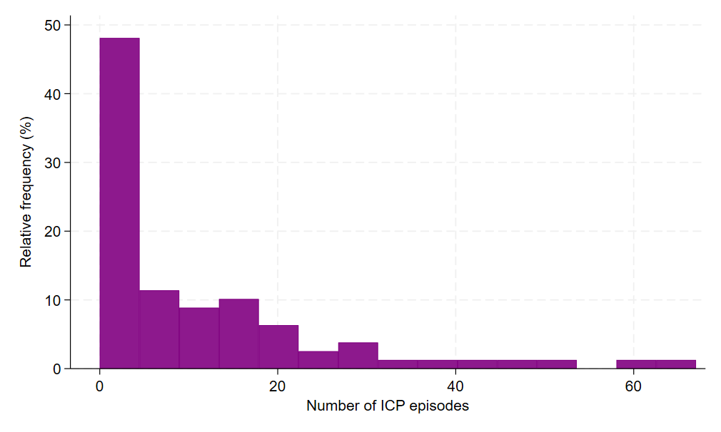

Fig. S7 Distribution of 6-month neurological outcome (GOS-E) in patients with acute brain injury.
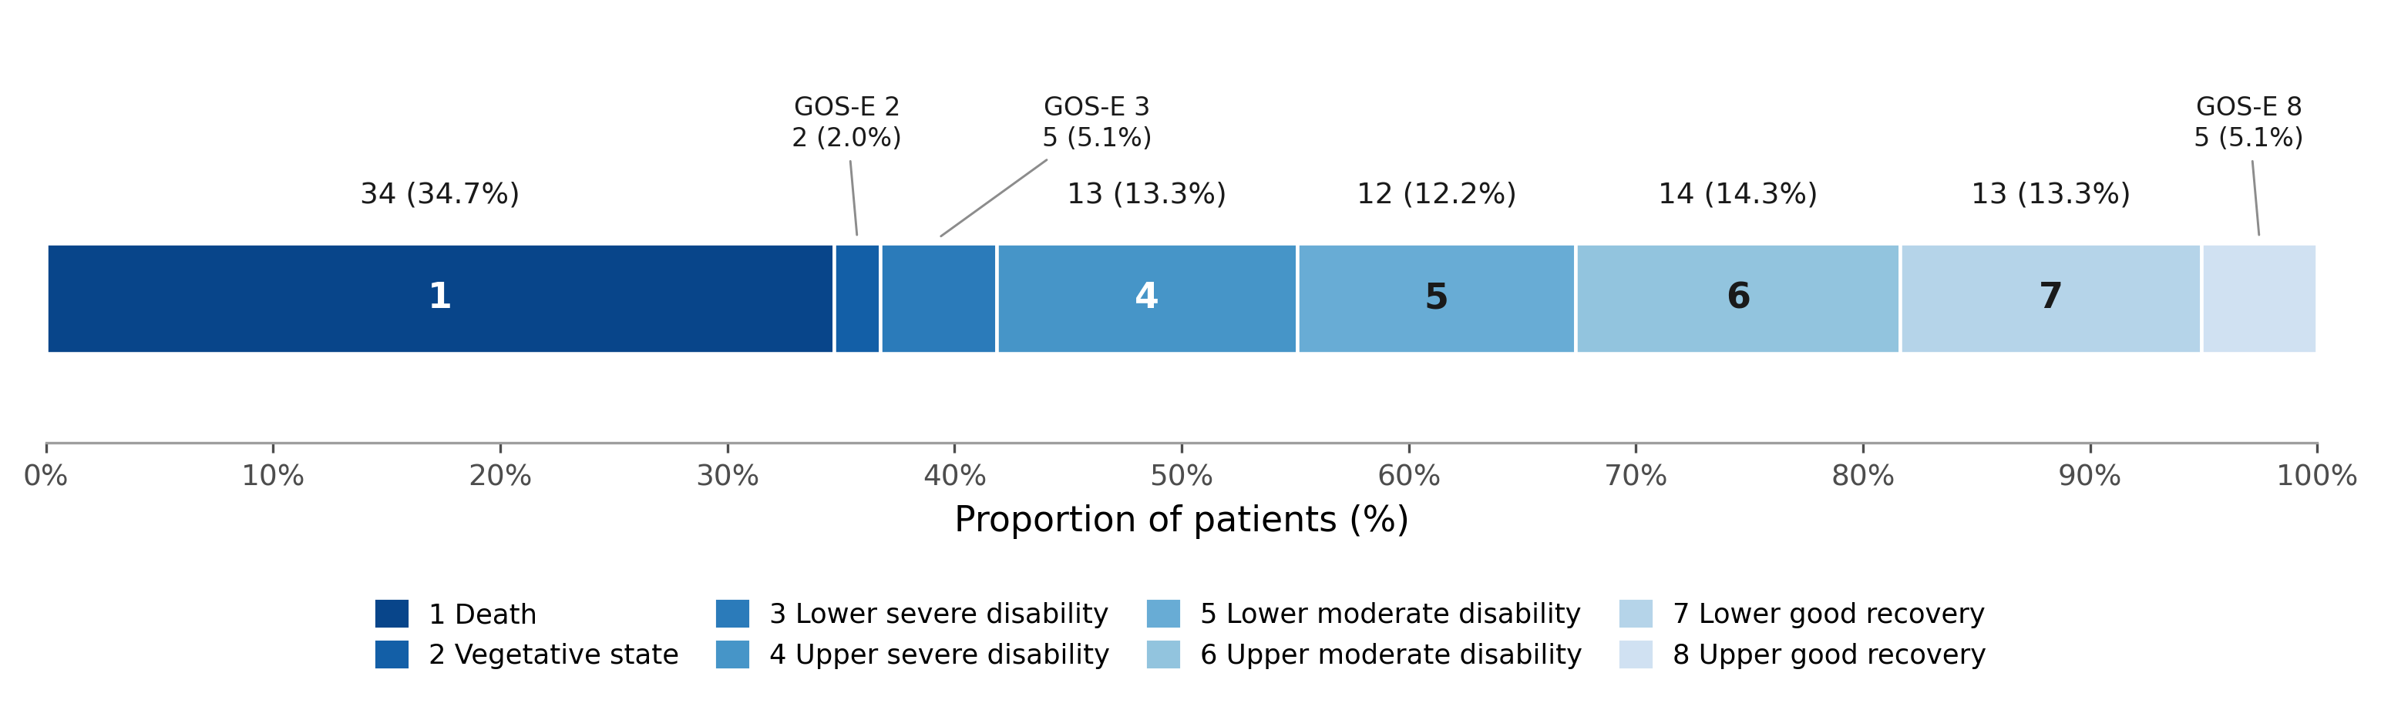
GOS-E, Glasgow Outcome Scale–Extended. The distribution of the eight ordered GOS-E categories is shown as a single horizontal bar summing to 100%, with the number of patients and the corresponding percentage above each segment (N = 98 patients with available 6-month follow-up). Categories 1 and 2 (death and vegetative state) together accounted for 36.7% of the cohort.

Fig. S8 NPi measurements in healthy volunteers under light (A) and dark (B) ambient conditions
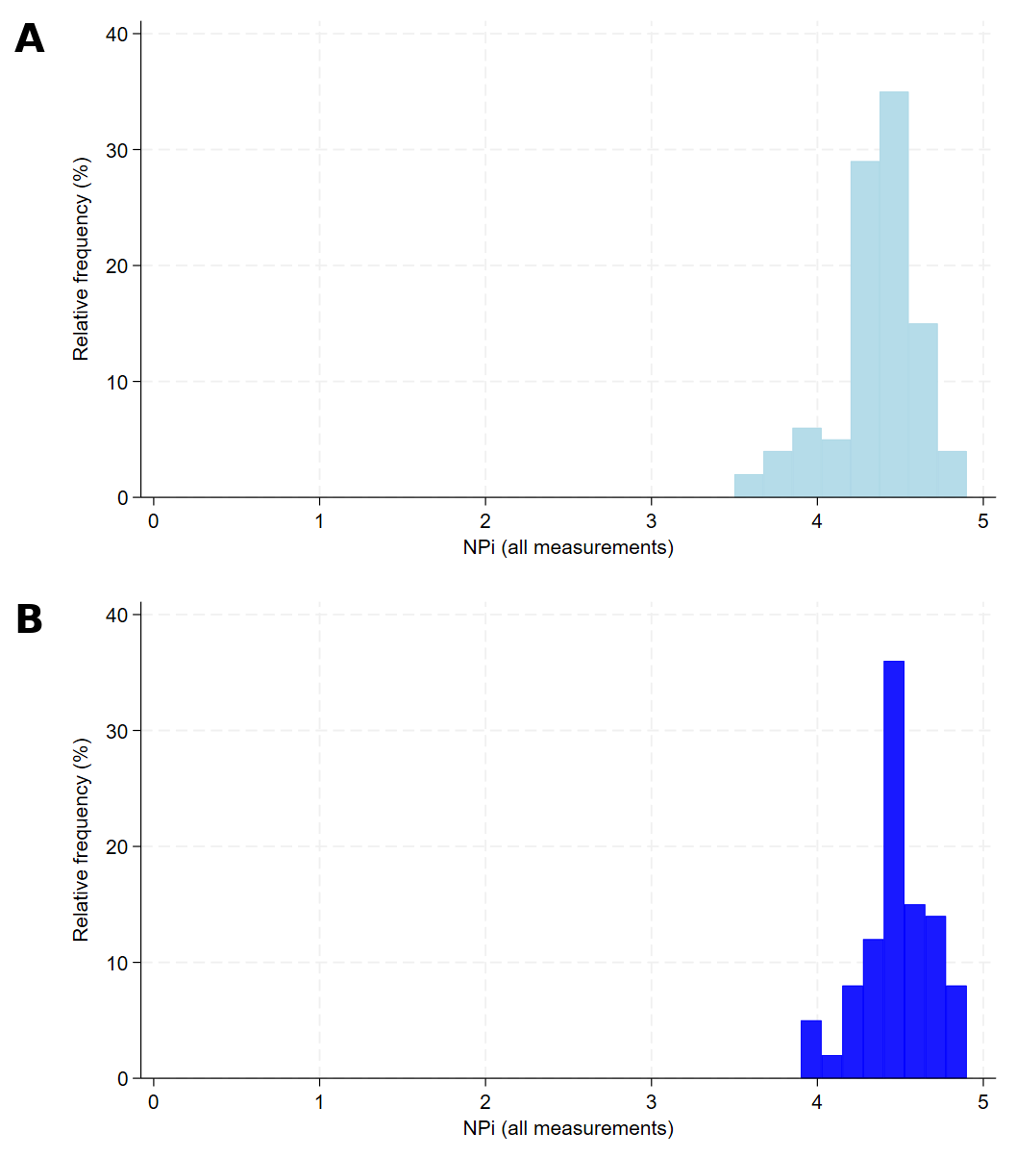
NPi, neurological pupil index. (A) Light condition, 300 lux at the level of the eye. (B) Dark condition, illuminance below the detection threshold of the meter. Each panel comprises 100 measurements obtained in the 50 healthy volunteers.

Fig. S9 QPi measurements in healthy volunteers under light (A) and dark (B) ambient conditions
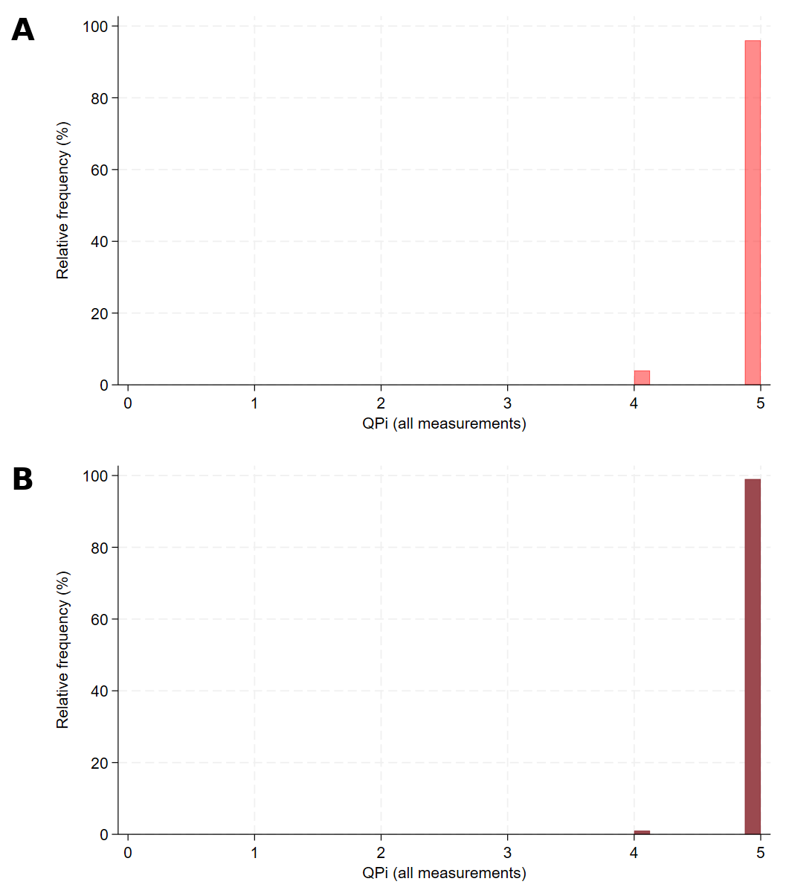
QPi, quantitative pupil index. (A) Light condition, 300 lux at the level of the eye. (B) Dark condition, illuminance below the detection threshold of the meter. Each panel comprises 100 measurements obtained in the 50 healthy volunteers.

Fig. S10 NPi and QPi as a function of resting pupil diameter and anaesthetic step in sedated non–brain-injured patients (N = 20)
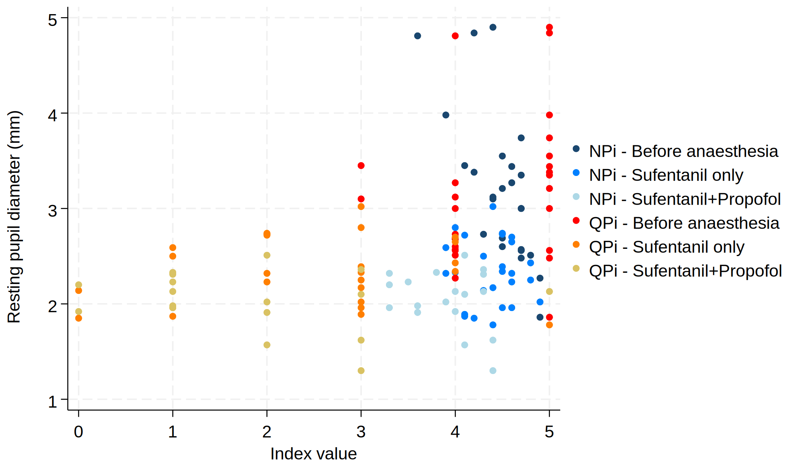
NPi, neurological pupil index; QPi, quantitative pupil index. Each point represents one paired measurement; the horizontal axis shows the value of the index and the vertical axis the resting pupil diameter in millimetres. Measurements are shown at the three anaesthetic steps: before anaesthesia, after sufentanil alone, and after sufentanil plus propofol. Resting pupil diameter decreased from a median of 3.10 mm (IQR 2.57–3.45) before anaesthesia to 2.33 mm (IQR 2.02–2.65) after sufentanil and 2.13 mm (IQR 1.92–2.32) after sufentanil plus propofol. QPi values below 3 were observed almost exclusively at resting diameters below approximately 2.7 mm, whereas NPi values remained at or above 3 across the whole range of diameters.

Table S1 Sensitivity analyses using alternative QPi thresholds
Outcome and model | QPi < 2 | QPi < 3 | QPi < 4
Unfavourable 6-month neurological outcome (GOS-E ≤ 4), multivariable logistic regression, n = 93
OR per 10-percentage-point increase (95% CI) | 2.08 (1.34–3.21) | 1.76 (1.31–2.37) | 1.48 (1.22–1.79)
p value | 0.001 | < 0.001 | < 0.001
At least one episode of intracranial hypertension, univariable logistic regression, n = 80
OR per 10-percentage-point increase (95% CI) | 1.60 (0.98–2.63) | 1.38 (1.04–1.82) | 1.23 (1.03–1.45)
p value | 0.063 | 0.025 | 0.020
Number of episodes of intracranial hypertension, negative binomial regression, n = 79
Coefficient per 10-percentage-point increase (95% CI) | 0.18 (0.05–0.31) | 0.15 (0.05–0.24) | 0.11 (0.03–0.20)
p value | 0.008 | 0.004 | 0.010
Distribution of the proportion of abnormal measurements, N = 106
Median [IQR] | 0.028 [0.000; 0.246] | 0.127 [0.022; 0.500] | 0.514 [0.191; 0.859]
Mean (SD) | 0.164 (0.264) | 0.278 (0.323) | 0.522 (0.353)
CI, confidence interval; GOS-E, Glasgow Outcome Scale–Extended; IQR, interquartile range; OR, odds ratio; QPi, quantitative pupil index; SD, standard deviation. The exposure in each model is the proportion of a patient’s measurements falling below the stated QPi threshold. Multivariable models were adjusted for age, sex, Glasgow Coma Scale score at admission and the presence of a focal neurological deficit. The threshold of 3 corresponds to the value reported in the main manuscript and was transposed from the NPi; thresholds of 2 and 4 are presented as sensitivity analyses. Associations were preserved in direction and magnitude across the three thresholds. The single exception is the logistic model for the occurrence of intracranial hypertension at a threshold of 2, in which the confidence interval crosses unity, most plausibly reflecting a loss of power, since the median proportion of measurements below 2 was only 0.028.

