Supplementary figures and tables

Supplementary Figure 1. directed acyclic graph (DAG)
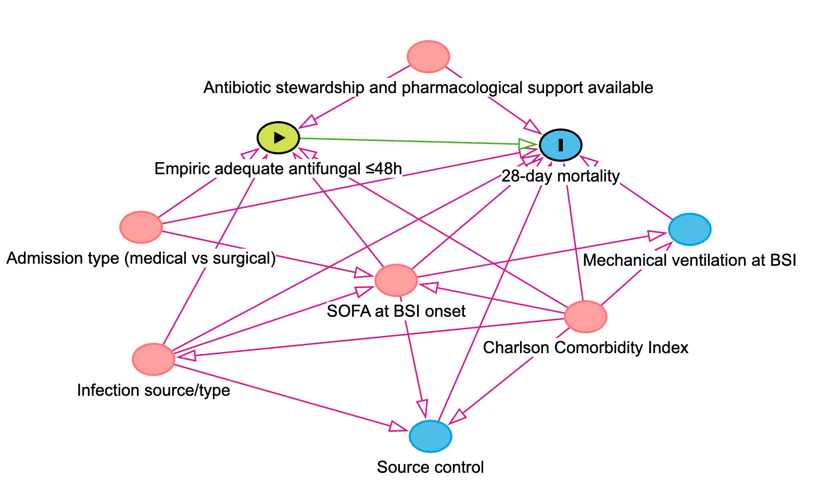
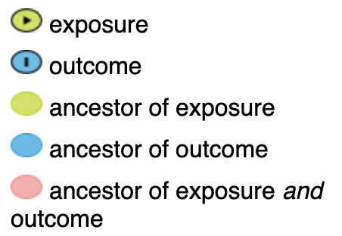
Legend: Directed acyclic graph illustrating the assumed relationships between early adequate antifungal therapy, 28-day mortality, and relevant clinical covariates.

Supplementary Table 1. Description of the 18 patients excluded because of death within the first 2 days
Patient | Age (years) | Sex | Candida species | Treated | If treated
1 | 86 | Male | Candida albicans | No
2 | 56 | Male | Candida auris | No
3 | 54 | Female | Candida sp. | Yes | fluconazole
4 | 78 | Female | Candida parapsilosis complex | No
5 | 79 | Female | Candida albicans | No
6 | 60 | Male | Candida parapsilosis complex | Yes | anidulafungin
7 | 57 | Female | Candida parapsilosis complex | No
8 | 82 | Female | Candida albicans | Yes | micafungin
9 | 31 | Male | Candida krusei | No
10 | 69 | Male | Candida parapsilosis complex | Yes | micafungin
11 | 60 | Female | Candida tropicalis | No
12 | 60 | Male | Candida albicans | No
13 | 57 | Male | Other Candida species | Yes | caspofungin
14 | 44 | Female | Candida parapsilosis complex | No
15 | 32 | Male | Candida albicans | Yes | fluconazole
16 | 26 | Male | Candida albicans | Yes | amphotericin B
17 | 82 | Male | Candida albicans | No
18 | 81 | Male | Candida albicans | Yes | fluconazole

Supplementary Table 2: Center-level ICU characteristics and organization
158 centers
Country | N (%)
Australia | 6 (3.80%)
Bangladesh | 1 (0.63%)
Belgium | 3 (1.90%)
Brazil | 2 (1.27%)
Brunei | 1 (0.63%)
Canada | 3 (1.90%)
China | 5 (3.16%)
Colombia | 1 (0.63%)
Dubai | 1 (0.63%)
Egypt | 1 (0.63%)
France | 18 (11.39%)
Germany | 5 (3.16%)
Greece | 19 (12.03%)
Hong Kong | 1 (0.63%)
India | 3 (1.90%)
Iran | 1 (0.63%)
Israel | 2 (1.27%)
Italy | 6 (3.80%)
Japan | 2 (1.27%)
Kazakhstan | 1 (0.63%)
Lebanon | 1 (0.63%)
Libya | 1 (0.63%)
Malaysia | 3 (1.90%)
Netherlands | 3 (1.90%)
Nigeria | 1 (0.63%)
Poland | 1 (0.63%)
Portugal | 7 (4.43%)
Republic of Ireland | 1 (0.63%)
Republic of Korea | 4 (2.53%)
Romania | 2 (1.27%)
Russian Federation | 1 (0.63%)
Saudi Arabia | 1 (0.63%)
Singapore | 1 (0.63%)
Spain | 13 (8.23%)
Switzerland | 2 (1.27%)
Taiwan | 3 (1.90%)
Thailand | 2 (1.27%)
Turkey | 21 (13.29%)
UK | 8 (5.06%)
Hospital funding
Public | 135 (85.44%)
Private | 23 (14.56%)
ICU Type
Medical | 26 (16.46%)
Surgical | 12 (7.59%)
Mixed | 120 (75.95%)
ICU Structure
Open | 34 (21.52%)
Closed | 124 (78.48%)
Antibiotic stewardship and pharmacological support available
No | 43 (27.22%)
Yes | 115 (72.78%)
Infectious disease specialist availability
No | 12 (7.59%)
Yes | 139 (87.97%)
Missing | 7 (4.43%)

¹Defined based on the availability of aminoglycoside therapeutic drug monitoring (TDM)

Supplementary Figure 2. Details on the time to adequate treatment

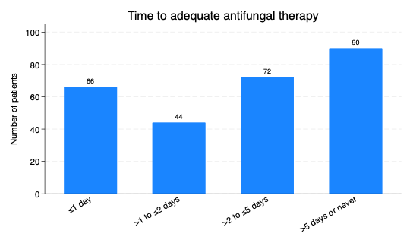
Legend: Distribution of patients according to time from bloodstream infection (BSI) onset to initiation of adequate antifungal therapy. Patients were categorized as receiving adequate therapy within ≤1d, >1 to ≤2 d, >2 to ≤5d, or >5d/never.
Supplementary Figure 3. Love plot showing covariate balance before and after inverse probability of treatment weighting (IPTW)
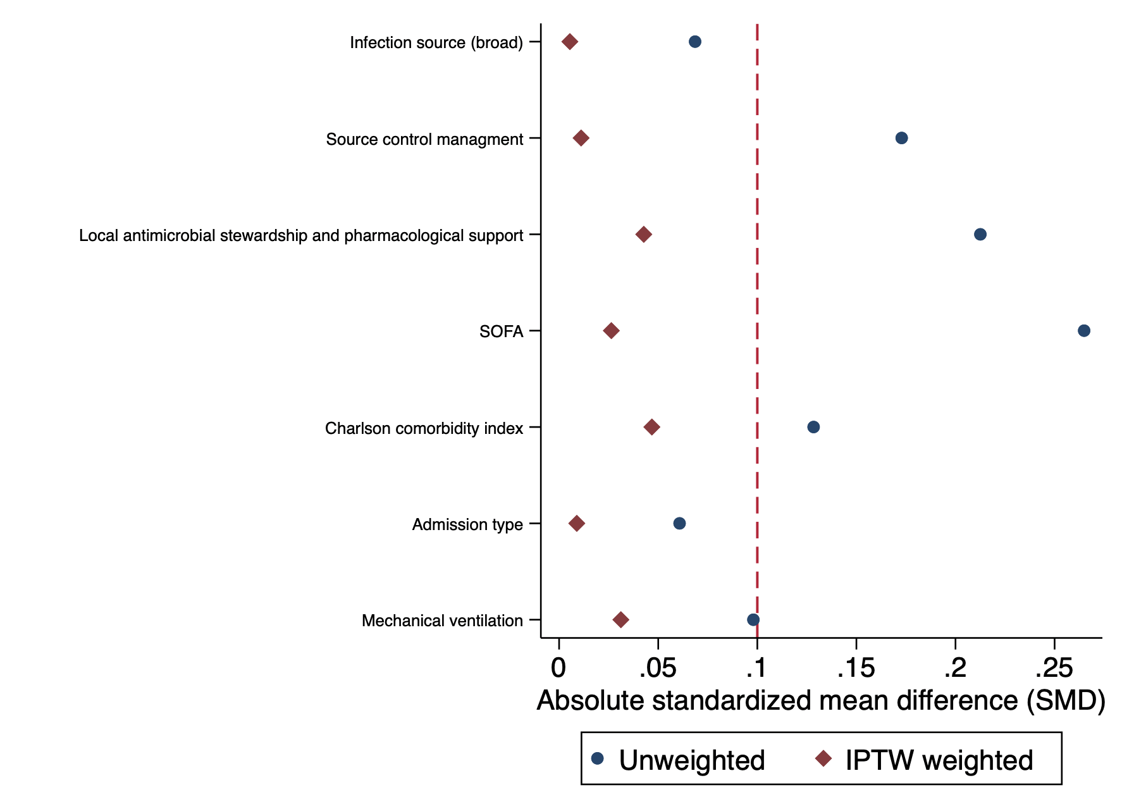
Legend: Standardized mean (SMD) differences are presented for each baseline covariate included in the propensity score model, comparing patients who received early adequate antifungal therapy within 2 days with those who did not. Balance was assessed before and after weighting, with smaller absolute standardized mean differences indicating better covariate balance.

Supplementary Figure 4. Kaplan-Meier survival estimates
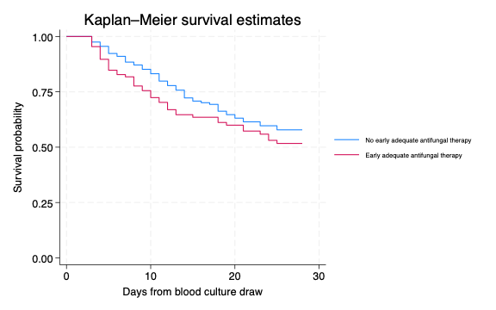

Legend: Kaplan–Meier curves showing 28-day survival in patients who received early adequate empirical antifungal therapy within 2 days after blood culture draw compared with those who did not.

Supplementary Table 3. Univariable and multivariable frailty Cox models assessing the association between early adequate antifungal therapy and 28-day mortality

Variable | HR (95% CI) | p-value
Univariable frailty Cox model
Empiric adequate antifungal <=2d (yes vs no) | 1.27 (0.87–1.88) | 0.219
Multivariable frailty Cox model
Empiric adequate antifungal <=2d (yes vs no) | 1.29 (0.86–1.93) | 0.227
Source control adequacy  -not needed  -required and complete  -required but not achieved | Reference  1.03 (0.58–1.83)  2.11 (1.09–4.09) | 0.913  0.026
Source of infection  Other  Catheter  Abdominal | Reference  1.01 (0.57–1.79)  0.82 (0.43–1.56) | 0.966  0.540
Antibiotic stewardship and pharmacological support available | 0.97 (0.64–1.48) | 0.895
SOFA score | 1.13 (1.07–1.18) | <0.001
Charlson comorbidity index | 1.05 (0.97–1.14) | 0.222
Admission type: Surgical (reference: medical) | 0.70 (0.44–1.12) | 0.139
Multivariable model adjusted for source of infection, therapeutic drug monitoring of aminoglycosides, SOFA score, Charlson comorbidity index and admission type. HR: hazard ratio; CI: confidence interval; SOFA: Sequential Organ Failure Assessment.

Supplementary Table 4. Subgroup analyses using weighted Cox regression for 28-day mortality, stratified by study cohort, hypotension status, Candida species and time to positivity

Eurobact-1, N=81 | HR (95% CI) | p
Weighted Cox model (IPTW)
Empiric adequate antifungal <=2d (yes vs no) | 1.26 (0.57-2.79) | 0.564
Eurobact-2, N=191 | HR (95% CI) | p
Weighted Cox model (IPTW)
Empiric adequate antifungal <=2d (yes vs no) | 1.25 (0.78-1.99) | 0.347
Candida albicans only, N=128 | HR (95% CI) | p
Weighted Cox model (IPTW)
Empiric adequate antifungal <=2d (yes vs no) | 1.42 (0.79-2.54) | 0.243
Other Candida species, N=144 | HR (95% CI) | p
Weighted Cox model (IPTW)
Empiric adequate antifungal <=2d (yes vs no) | 1.07 (0.62-1.87) | 0.799
Candida glabrata only, N=47 | HR (95% CI) | p
Weighted Cox model (IPTW)
Empiric adequate antifungal <=2d (yes vs no) | 0.44 (0.15-1.29) | 0.137
Other Candida species, N=225 | HR (95% CI) | p
Weighted Cox model (IPTW)
Empiric adequate antifungal <=2d (yes vs no) | 1.44 (0.93-2.22) | 0.103
Hypotension* at BSI, N=108 | HR (95% CI) | p
Weighted Cox model (IPTW)
Empiric adequate antifungal <=2d (yes vs no) | 1.58 (0.89-2.81) | 0.116
Absence of hypotension* at BSI, N=146 | HR (95% CI) | p
Weighted Cox model (IPTW)
Empiric adequate antifungal <=2d (yes vs no) | 1.03 (0.57-1.85) | 0.923
Time to positivity >=2 days** | HR (95% CI) | p
Weighted Cox model (IPTW)
Empiric adequate antifungal <=2d (yes vs no) | 1.09 (0.62-1.90) | 0.771
*18 missing
** Patients with a missing date of BSI positivity (n=52) or time to positivity <2 days (n=71) were excluded.

Supplementary Table 5. Sensitivity analysis using a 1-day definition of early adequate antifungal therapy
 | HR (95% CI) | p-value
Univariable Cox model
Empiric adequate antifungal <=1d (yes vs no) | 1.27 (0.81-2.00) | 0.306
Multivariable Cox model¹
Empiric adequate antifungal <=1d (yes vs no) | 1.32 (0.85-2.04) | 0.216
¹Adjusted for source of infection, source control management, availability of antimicrobial stewardship/pharmacological support, SOFA score at BSI, Charlson Comorbidity Index, admission type, and mechanical ventilation at the time of BSI.

