Supplementary Table 1: Predictors for Readmission
Predictor | Odds Ratio (95% CI) | p-value
Age | 1.00 (0.99–1.01) | 0.431
Gender | 1.23 (0.87–1.73) | 0.241
High CCI (≥7) | 1.69 (1.14–2.52) | 0.009
Metastatic disease | 2.88 (0.90–9.19) | 0.074
Diabetes mellitus | 1.11 (0.80–1.56) | 0.529
Chronic kidney disease | 1.36 (0.87–2.13) | 0.176
COPD | 1.01 (0.56–1.82) | 0.986
Stroke | 1.00 (0.09–11.15) | 0.997
Dementia | 1.45 (0.45–4.62) | 0.533

Supplementary Table 2 : Factors Associated with Physical and Mental Quality of Life Outcomes after discharge
Predictor | Level | Physical QoL: Adjusted OR (95% CI) | p-value | Mental QoL: Adjusted OR (95% CI) | p-value
Age category | 45–59 vs <45 | 1.26 (0.58–2.76) | 0.558 | 1.18 (0.52–2.67) | 0.690
Age category | 60–74 vs <45 | 1.15 (0.52–2.56) | 0.731 | 0.95 (0.41–2.20) | 0.899
Age category | ≥75 vs <45 | 1.07 (0.40–2.82) | 0.894 | 0.72 (0.26–2.01) | 0.534
Gender | Male vs Female | 1.10 (0.67–1.81) | 0.706 | 0.98 (0.58–1.65) | 0.939
CCI risk group | Moderate (4–6) vs Low | 0.91 (0.46–1.79) | 0.777 | 1.14 (0.56–2.33) | 0.716
CCI risk group | High (≥7) vs Low | 2.36 (1.02–5.47) | 0.046 | 3.52 (1.48–8.39) | 0.004

Supplementary Figure 1. Kaplan-Meier analysis - Mortality vs Age Group
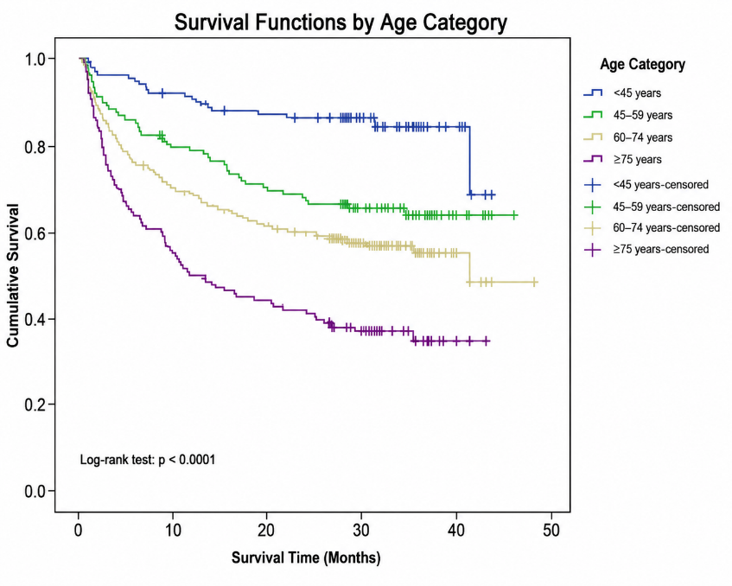
Kaplan–Meier overall survival curves stratified according to age group (<45, 45–59, 60–74, and ≥75 years). Tick marks denote censored observations. Survival distributions were compared using the log-rank test.
Supplementary Figure 2. Kaplan-Meier analysis -Mortality vs CCI Risk Group
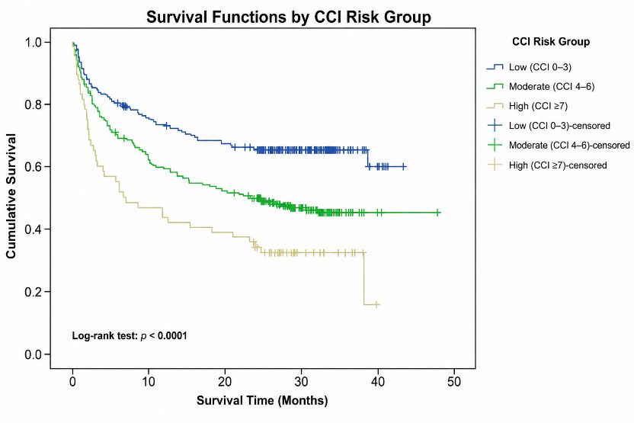
Kaplan–Meier overall survival curves according to Charlson Comorbidity Index (CCI) risk categories (Low: CCI 0–3, Moderate: CCI 4–6, High: CCI ≥7). Tick marks indicate censored observations. Group differences were assessed using the log-rank test

Supplementary Figure 3. Kaplan-Meier analysis - Mortality vs Gender
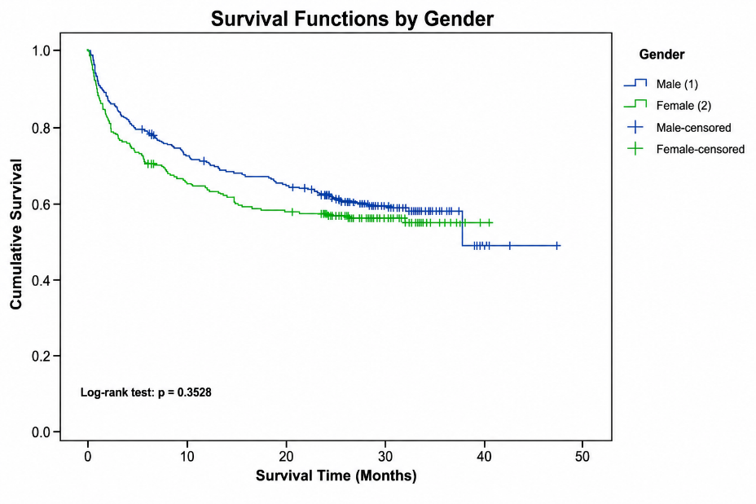
Kaplan–Meier overall survival curves stratified by gender. Tick marks represent censored observations. Differences between groups were evaluated using the log-rank test
.
Supplementary Figure 4. Kaplan-Meier analysis – Readmission vs CCI Risk Group
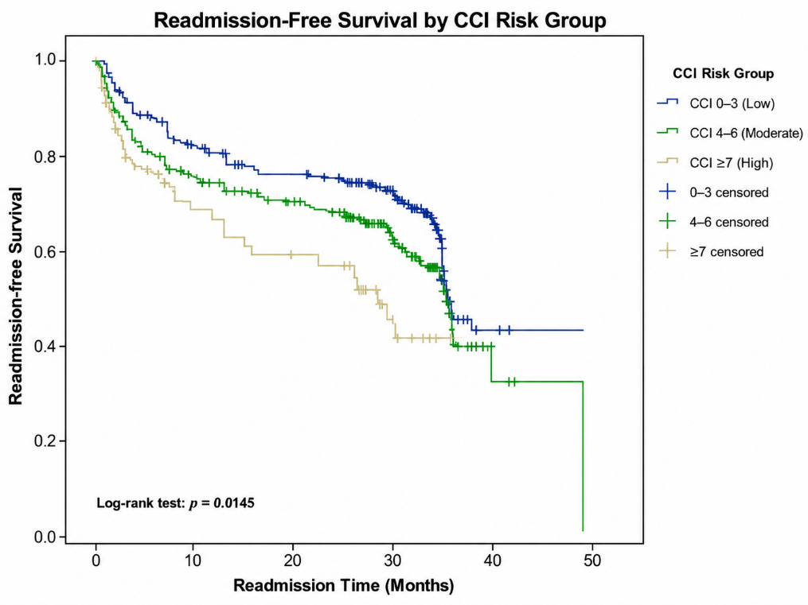
Kaplan–Meier readmission-free survival curves according to Charlson Comorbidity Index (CCI) risk categories (Low: CCI 0–3, Moderate: CCI 4–6, High: CCI ≥7). Tick marks indicate censored observations. Survival distributions were compared using the log-rank test (p = 0.0145).

Supplementary Figure 5. Kaplan-Meier analysis Readmission vs Age
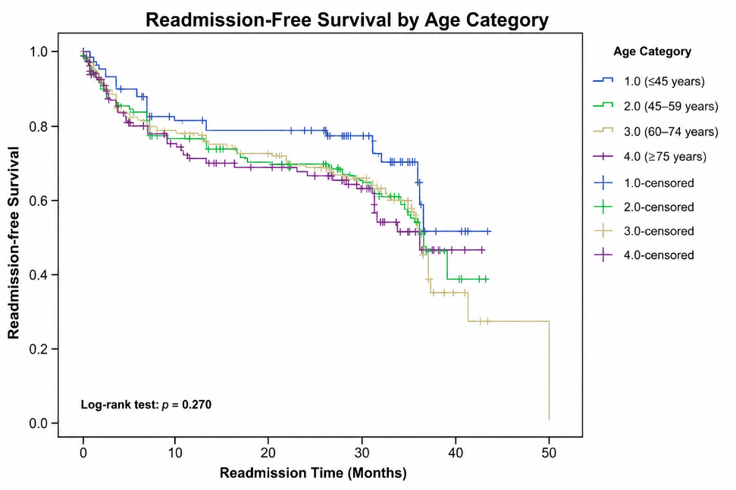
Kaplan–Meier readmission-free survival curves stratified according to age group (<45, 45–59, 60–74, and ≥75 years). Tick marks indicate censored observations. Survival distributions were compared using the log-rank test (p = 0.270).
Supplementary Figure 6. Kaplan-Meier analysis Readmission vs Gender
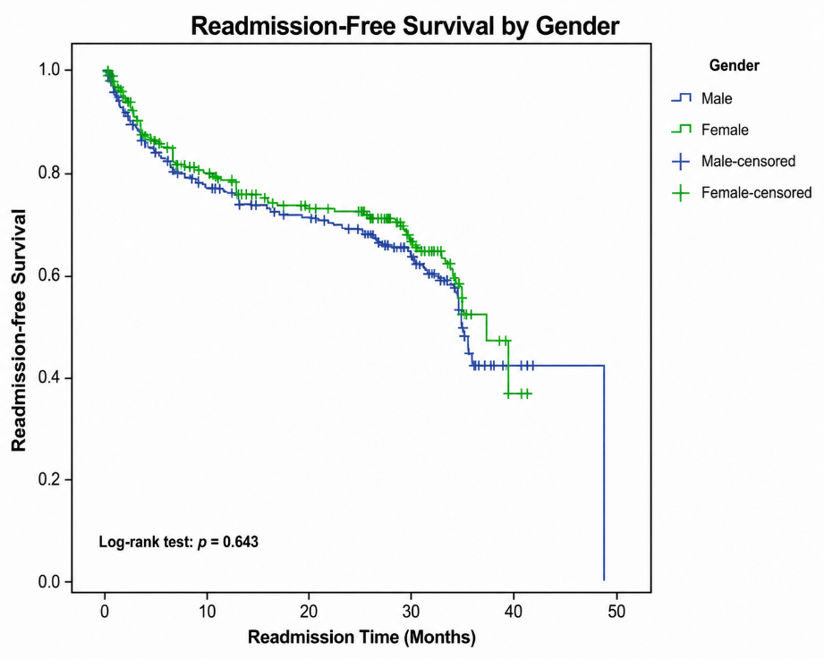
Kaplan–Meier readmission-free survival curves stratified by gender. Tick marks represent censored observations. Differences between groups were assessed using the log-rank test (p = 0.643).

Supplementary Table 3: CRF for Quality of Life
Long-Term Outcome of Sepsis Survivors (LOSS Study)
Patient Information
1. Patient ID Number (Sepsis Registry ID): ________________________
2. Hospital Name: ________________________
3. Principal Investigator Name: ________________________
4. Date of Interview: ____ / ____ / ______
Patient Mortality
5. Current status of patient
☐ Survived
☐ Died
6. If died, date of death: ____ / ____ / ______
7. If known, cause of death: _______________________________________
8. Place of death
☐ Hospital
☐ Home
Readmission
9. Any history of readmission
☐ Yes
☐ No
10. Number of readmissions: ________________________
11. Cause(s) of readmission: _______________________________________
12. Timing of readmission since discharge: ___________________________
13. Readmitted to the same hospital
☐ Yes
☐ No
14. Readmitted to the same ICU
☐ Yes
☐ No
15. Outcome of readmission
☐ Survived
☐ Died
Quality of Life
16. Which of the following quality-of-life domains are affected? (Check all that apply)
☐ Limitations in physical activities because of health problems
☐ Limitations in social activities because of physical or emotional problems
☐ Limitations in usual role activities because of physical health problems
☐ Bodily pain
☐ General mental health (psychological distress and well-being)
☐ Limitations in usual role activities because of emotional problems
☐ Vitality (energy and fatigue)
☐ General health perceptions
17. Any new medical complication since discharge _________
18. Compared with before discharge, how does the patient rate his/her physical quality of life?
☐ Better
☐ Same
☐ Worse
19. Compared with before discharge, how does the patient rate his/her mental quality of life?
☐ Better
☐ Same
☐ Worse

