1. The cut-off point of SUVmax was obtained using the time-dependent ROC. The time-dependent ROC curve for SUVmax in relation to recurrence-free survival yielded the area under the curve of 0.673 (95% CI, 0.588 to 0.753).
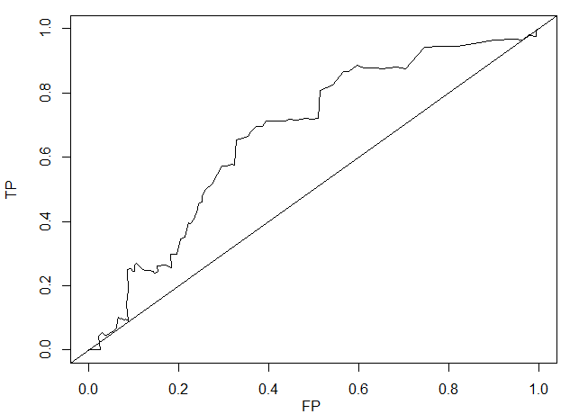
⇒ AUC=0.673(95%CI: 0.5875, 0.7527)

2. Youden’s index was the highest for SUVmax of 4.2. Considering the clinical application, we defined the cutoff of SUVmax as 4.

SUV | Sensitivity | 1-specificity | Youden's index
 | 1.0000 | 1.0000 | 0.0000
0.3 | 0.9981 | 0.9980 | 0.0002
0.8 | 0.9971 | 0.9935 | 0.0035
0.9 | 0.9766 | 0.9940 | -0.0173
1.0 | 0.9792 | 0.9822 | -0.0030
1.1 | 0.9821 | 0.9773 | 0.0049
1.2 | 0.9651 | 0.9635 | 0.0015
1.3 | 0.9685 | 0.9448 | 0.0237
1.4 | 0.9642 | 0.8997 | 0.0645
1.5 | 0.9533 | 0.8555 | 0.0978
1.6 | 0.9460 | 0.8177 | 0.1283
1.7 | 0.9439 | 0.7791 | 0.1648
1.8 | 0.9416 | 0.7452 | 0.1964
1.9 | 0.8759 | 0.7037 | 0.1723
2.0 | 0.8820 | 0.6846 | 0.1974
2.1 | 0.8754 | 0.6490 | 0.2265
2.2 | 0.8768 | 0.6396 | 0.2372
2.3 | 0.8790 | 0.6120 | 0.2671
2.4 | 0.8860 | 0.5951 | 0.2909
2.5 | 0.8660 | 0.5772 | 0.2888
2.6 | 0.8655 | 0.5658 | 0.2997
2.7 | 0.8242 | 0.5416 | 0.2826
2.8 | 0.8083 | 0.5140 | 0.2942
2.9 | 0.7199 | 0.5097 | 0.2102
3.0 | 0.7196 | 0.4984 | 0.2212
3.1 | 0.7203 | 0.4823 | 0.2380
3.2 | 0.7152 | 0.4624 | 0.2528
3.3 | 0.7170 | 0.4439 | 0.2731
3.4 | 0.7124 | 0.4377 | 0.2748
3.5 | 0.7121 | 0.4080 | 0.3041
3.6 | 0.7114 | 0.3944 | 0.3169
3.7 | 0.6963 | 0.3850 | 0.3113
3.8 | 0.6966 | 0.3713 | 0.3253
3.9 | 0.6783 | 0.3600 | 0.3183
4.0 | 0.6640 | 0.3528 | 0.3113
4.1 | 0.6581 | 0.3421 | 0.3160
4.2 | 0.6544 | 0.3267 | 0.3277
4.3 | 0.5762 | 0.3233 | 0.2529
4.4 | 0.5780 | 0.3185 | 0.2595
4.5 | 0.5724 | 0.3055 | 0.2669
4.6 | 0.5738 | 0.2962 | 0.2776
4.7 | 0.5173 | 0.2740 | 0.2433
4.8 | 0.4999 | 0.2603 | 0.2396
4.9 | 0.4786 | 0.2517 | 0.2269
5.0 | 0.4610 | 0.2518 | 0.2092
5.1 | 0.4555 | 0.2434 | 0.2121
5.2 | 0.4392 | 0.2410 | 0.1983
5.3 | 0.4064 | 0.2339 | 0.1726
5.4 | 0.3933 | 0.2265 | 0.1668
5.5 | 0.3953 | 0.2217 | 0.1737
5.6 | 0.3729 | 0.2178 | 0.1551
5.7 | 0.3514 | 0.2138 | 0.1376
5.8 | 0.3465 | 0.2030 | 0.1435
5.9 | 0.2992 | 0.1956 | 0.1036
6.1 | 0.2969 | 0.1822 | 0.1147
6.2 | 0.2571 | 0.1829 | 0.0742
6.3 | 0.2629 | 0.1707 | 0.0922
6.4 | 0.2641 | 0.1614 | 0.1027
6.7 | 0.2618 | 0.1594 | 0.1024
6.8 | 0.2626 | 0.1525 | 0.1101
6.9 | 0.2437 | 0.1527 | 0.0910
7.0 | 0.2413 | 0.1507 | 0.0906
7.1 | 0.2402 | 0.1463 | 0.0939
7.2 | 0.2442 | 0.1435 | 0.1008
7.4 | 0.2475 | 0.1362 | 0.1114
7.5 | 0.2485 | 0.1338 | 0.1147
7.6 | 0.2488 | 0.1246 | 0.1242
7.7 | 0.2462 | 0.1227 | 0.1235
7.8 | 0.2547 | 0.1147 | 0.1401
7.9 | 0.2611 | 0.1116 | 0.1495
8.0 | 0.2682 | 0.1083 | 0.1599
8.1 | 0.2698 | 0.1059 | 0.1639
8.2 | 0.2642 | 0.1020 | 0.1622
8.3 | 0.2454 | 0.1022 | 0.1432
8.4 | 0.2442 | 0.0978 | 0.1464
8.5 | 0.2522 | 0.0945 | 0.1577
8.6 | 0.2492 | 0.0857 | 0.1635
8.7 | 0.1841 | 0.0875 | 0.0966
8.8 | 0.1660 | 0.0853 | 0.0807
8.9 | 0.1413 | 0.0840 | 0.0573
9.0 | 0.0907 | 0.0884 | 0.0023
9.1 | 0.0954 | 0.0810 | 0.0144
9.2 | 0.0935 | 0.0789 | 0.0145
9.3 | 0.0970 | 0.0762 | 0.0208
9.5 | 0.0996 | 0.0713 | 0.0283
9.8 | 0.0973 | 0.0693 | 0.0280
9.9 | 0.1020 | 0.0664 | 0.0356
10.0 | 0.0897 | 0.0635 | 0.0262
10.1 | 0.0669 | 0.0619 | 0.0050
10.2 | 0.0647 | 0.0599 | 0.0048
10.5 | 0.0583 | 0.0539 | 0.0043
10.6 | 0.0561 | 0.0519 | 0.0042
10.8 | 0.0475 | 0.0439 | 0.0035
11.2 | 0.0469 | 0.0372 | 0.0097
11.3 | 0.0444 | 0.0352 | 0.0092
11.4 | 0.0552 | 0.0292 | 0.0260
11.5 | 0.0483 | 0.0256 | 0.0228
12.0 | 0.0449 | 0.0237 | 0.0211
12.2 | 0.0414 | 0.0219 | 0.0195
12.4 | 0.0000 | 0.0251 | -0.0251
12.8 | 0.0000 | 0.0228 | -0.0228
13.1 | 0.0000 | 0.0205 | -0.0205
14.5 | 0.0000 | 0.0183 | -0.0183
14.6 | 0.0000 | 0.0160 | -0.0160
15.5 | 0.0000 | 0.0137 | -0.0137
15.6 | 0.0000 | 0.0114 | -0.0114
15.8 | 0.0000 | 0.0091 | -0.0091
16.7 | 0.0000 | 0.0068 | -0.0068
16.8 | 0.0000 | 0.0046 | -0.0046
19.8 | 0.0000 | 0.0023 | -0.0023
32.9 | 0.0000 | 0.0000 | 0.0000

