Supplementary Figure 1. Means of SUV_{max} according to the intrinsic subtypes

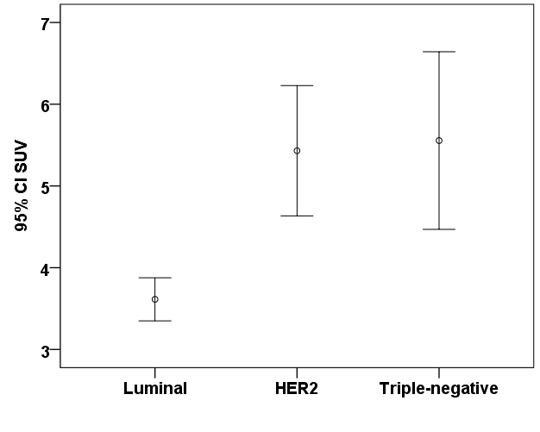

The patients were classified into three intrinsic subtype groups based on four IHC markers: luminal (328, 66%); HER-2 (83, 17%); and triple-negative (85, 17%). One-way ANOVA revealed significant differences in SUV_{max} values between the different subtypes (P < 0.001). To adjust for multiple comparisons, pair-wise tests were performed between subtypes using the Bonferroni test. In these comparisons, the mean SUV_{max} for the luminal subtype was the lowest (3.61 ± 2.43), whereas the mean SUV_{max} for the HER-2 (5.43 ± 3.64) and triple-negative subtypes (5.55 ± 5.04) were comparatively higher.

Supplementary Table 1. Comparison of SUV_{max} according to subtypes
 | Luminal A  (n=328) | HER2  (n=83) | Triple Negative  (n=85) | P *
SUV_{max} |  |  |  | < 0.001
Mean | 3.61 | 5.43 | 5.55
SD | 2.43 | 3.64 | 5.04
 | T†=a | T=b | T=b
SUV_{max}, maximum standardized uptake value; SD, standard deviation; HER2, human epidermal growth factor receptor-2.
* P-value, One-way ANOVA
†The same letters indicate non-significant difference between groups based on the Bonferroni test

