Supplementary Figures and Tables
Figure S1. Validation of image analysis with pathological scores. (left to right): Correlation between pathological scores of tumor cellularity and automated scores of cancer cell to tissue area ratio, cancer cells to all cells ratio; correlation between pathological scores of lymphocytic infiltration and automated scores of lymphocyte to all cells ratio. P-values are given by JT-trend test.

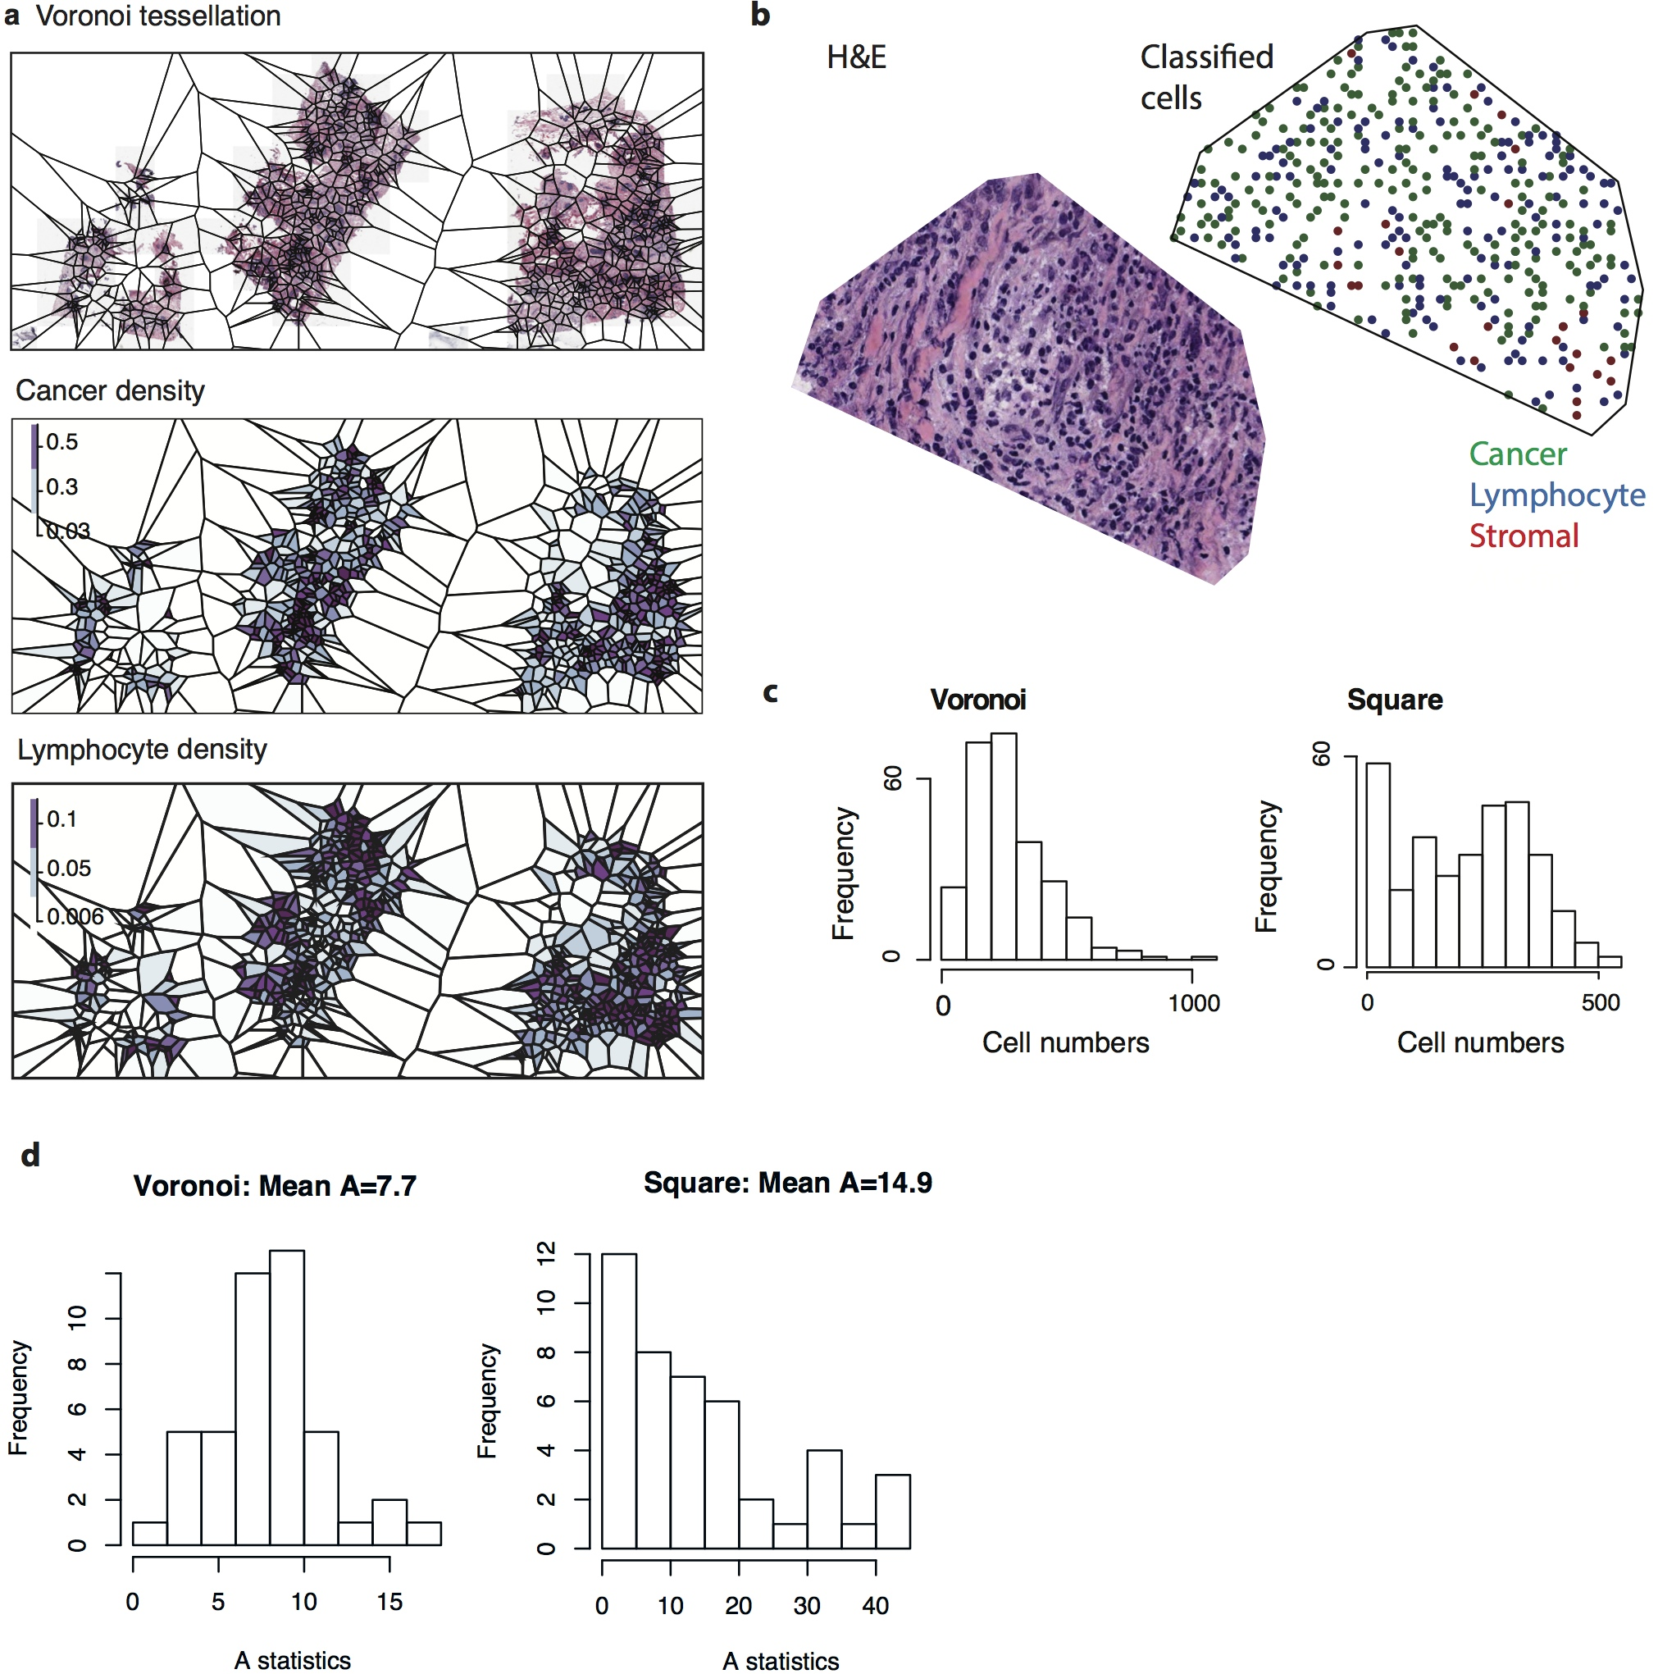
Figure S2. Comparison of Voronoi and Square tessellation. (a) An example of Voronoi polygons in the sample shown in Fig.1. (b) High resolution view of a Voronoi polygon; shown are the H&E and identified cells in the polygon. (c) Distribution of the number of cells in all polygons in this sample. (d) Distribution of the Anderson-Darling A statistics for cell numbers in Voronoi and square polygons of 50 randomly sampled tumors.

Figure S3. Comparing the Morisita-Horn index with Pearson correlation. (a) Scatter plot to show correlation between Pearson correlation calculated with Square and Voronoi tessellation. (b) Scatter plot to show correlation between the Moristia-Horn index calculated with Square and Voronoi tessellation. (c) Kaplan-Meier curves illustrate disease-specific survival probabilities of patient groups in two breast cancer subsets stratified by Pearson correlation or (d) the Morisita-Horn index, calculated using Voronoi tessellation.

Figure S4. Heatmap to show correlation among Pearson correlation and the Morisita-Horn index computed over different scales with square (S) or Voronoi (V) tessellation. Scale size for Voronoi tessellation ranges from 2-100, and for squares ranges from 40-250 per unit, where for both smaller numbers indicate smaller polygons.

Figure S5. Association of immune-cancer correlation with survival according to different spatial scales. –log₁₀ p-values from (a) univariate Cox regression model and (a) multivariate Cox model with node, size and grade for Pearson correlation and the Morisita-Horn index computed over different scales with square (S) or Voronoi (V) tessellation in the validation cohort. (c) –log₁₀ p-values from multivariate Cox model in HER2+ validation cohort.

Figure S6. Optimizing the Morisita index cut-off in the Discovery cohort. For each subtype, left panel: a cut-off was chosen from a range of 20%-80% and correlation with disease-specific survival computed. The dashline marks the significance level of p=0.05; right panel: Kaplan-Meier curves display the difference in survival according to this cutoff.

Figure S7. Immune-cancer colocalization sub-stratifies clinical parameters and lymphocyte abundance, ER status and TP53 mutation status in HER2+ subtype. Kaplan-Meier curves to show differences in disease-specific survival between Her2+ patients stratified by (top, variable alone, bottom: variable plus Morisita index): (a) node metastasis status, (b) tumor size (3 or <3 because there is no difference in survival for size 1 and 2), (c) tumor grade (3 or <3, because there are only 3 Grade 1 patients), (d) lymphocyte abundance (lym), (e) ER status, and (f) TP53 mutation status.

Figure S8. Robustness of prognostic value of Morisita index in HER2-amplified subtype. (a) Percentage of times where Morisita was found to be significant in uni- and multivariate analysis with different amount of patient samples that were selected randomly 1,000 times. (b) Log-rank test p-values of Moristia in multivariate survival analysis of the HER2-amplied samples, Validation cohort, over different spatial scales represented as the square widths used for tessellation.
Figure S9. Intra-slide score variability. Top left: Barplots showing number of samples with consistent/difference classifications between whole-slide scores and estimates using 50% left/right part of the slides (W-L/R cons./differ), as well as consistent/difference classifications between 50% left and right parts of the slide (L-R cons./differ). Top right: Barplots showing number of samples with consistent/difference classifications between whole-slide scores and estimates using 25%/75% slide (W-25%/75% cons./differ), as well as consistent/difference classifications between them. Bottom left: Scattered plots to show absolute differences between the whole-section scores (100%) and 75% slide scores compared with differences between 100% and 25% scores. Each point is a sample. Bottom right: Scattered plots to show absolute differences between the whole-section scores (100%) and 75% slide scores compared with differences between 100% and 50% scores.
Figure S10. Kaplan-Meier curves of the Morisita index estimated using decreasing amount of tissue: A. 75% tissue of the slide, B. 50% tissue on the right hand side, C. 50% tissue on the left hand side, D. 25% tissue.

Table S1. Prognostic value of immune-cancer co-localization measures with Voronoi tessellation using univariate and multivariate Cox regression results in two independent cohorts. Blue sections show results from multivariate regression. Uni-: Univariate Cox regression; Multi-: Multivariate Cox regression including node, size and grade as well as the co-localization measure; HR: Hazard Ratio; CI: lower and higher 95% Confidence Interval; Conc: Concordance. Bold text show p-values of the newly proposed measures.
 |  | Cohort 1 (475 samples) |  |  | Cohort 2 (514 samples)
 |  | HR(CI) | p-value | Conc | HR(CI) | p-value | Conc
Spatial  Cor  (Voronoi) | Uni- | 0.58 ( 0.37 - 0.91 ) | 0.016 | 0.549 | 0.38 ( 0.2 - 0.74 ) | 0.0029 | 0.597
Spatial  Cor  (Voronoi) | Multi-  Multi-node  Multi-size  Multi- grade | 0.52 ( 0.33 - 0.82 )  1.81 ( 1.21 - 2.71 )  1.93 ( 1.36 - 2.72 )  1.85 ( 1.33 - 2.57 ) | 0.0051  0.0038  0.00021  0.00025 | 0.702 | 0.37 ( 0.18 - 0.73 )  2.25 ( 1.19 - 4.26 )  1.96 ( 1.21 - 3.17 )  2.44 ( 1.46 - 4.09 ) | 0.0042  0.013  0.0064  0.00071 | 0.756
Morisita  (Voronoi) | Uni- | 0.59 ( 0.4 - 0.86 ) | 0.0068 | 0.552 | 0.38 ( 0.22 - 0.66 ) | 0.00027 | 0.611
Morisita  (Voronoi) | Multi-  Multi-node  Multi-size  Multi- grade | 0.63 ( 0.43 - 0.92 )  1.77 ( 1.18 - 2.64 )  1.93 ( 1.36 - 2.74 )  1.82 ( 1.31 - 2.53 ) | 0.018  0.0056  0.00023  4.0x10⁻⁴ | 0.699 | 0.39 ( 0.23 - 0.67 )  2.19 ( 1.16 - 4.13 )  1.82 ( 1.14 - 2.92 )  2.58 ( 1.53 - 4.35 ) | 0.00072  0.016  0.012  0.00036 | 0.76

Table S2. Univariate and multivariate Cox regression analysis result with the Morisita index, node, size and grade in the Basal and Luminal B PAM50 subtypes in two cohorts. Uni-: Univariate Cox regression; Multi-: Multivariate Cox regression; HR: Hazard Ratio; CI: lower and higher 95% Confidence Interval; Conc: Concordance; Inf: Infinite number indicating the Cox model didn’t converge. Bold text show significant p-values (<0.05) of the Morisita index. Numbers under subtype names show the number of samples in each subtype, two cohorts combined.

 |  | Cohort 1 |  |  | Cohort 2
 |  | HR(CI) | p-value | Conc | HR(CI) | p-value | Conc
Basal  (164) | Uni-Morisita | 0.54 ( 0.26 - 1.1 ) | 0.086 | 0.574 | 0.97 ( 0.31 - 3.04 ) | 0.96 | 0.518
Basal  (164) | Uni-node | 1.06 ( 0.51 - 2.21 ) | 0.88 | 0.508 | 2.35 ( 0.82 - 6.74 ) | 0.1 | 0.607
Basal  (164) | Uni-size | 2.28 ( 1.26 - 4.15 ) | 0.0062 | 0.639 | 2.37 ( 0.83 - 6.79 ) | 0.11 | 0.627
Basal  (164) | Uni- grade | 1.04 ( 0.25 - 4.35 ) | 0.96 | 0.506 | 103390394.03 ( 0 - Inf ) | 0.1 | 0.583
Basal  (164) | Multi-Morisita | 0.52 ( 0.25 - 1.07 ) | 0.077 | 0.665 | 0.64 ( 0.2 - 2.06 ) | 0.45 | 0.696
Basal  (164) | Multi-node | 0.78 ( 0.37 - 1.65 ) | 0.51 | 0.665 | 1.75 ( 0.61 - 5.02 ) | 0.3 | 0.696
Basal  (164) | Multi-size | 2.5 ( 1.31 - 4.75 ) | 0.0054 | 0.665 | 2.11 ( 0.61 - 7.28 ) | 0.24 | 0.696
Basal  (164) | Multi- grade | 1.55 ( 0.36 - 6.75 ) | 0.56 | 0.665 | 89806379.13 ( 0 - Inf ) | 1 | 0.696
LumB  (263) | Uni-Morisita | 1.41 ( 0.71 - 2.8 ) | 0.33 | 0.55 | 0.59 ( 0.24 - 1.49 ) | 0.26 | 0.569
LumB  (263) | Uni-node | 2.27 ( 1.18 - 4.37 ) | 0.012 | 0.597 | 3.55 ( 1.04 - 12.07 ) | 0.03 | 0.61
LumB  (263) | Uni-size | 1.34 ( 0.7 - 2.55 ) | 0.37 | 0.532 | 1.77 ( 0.78 - 3.99 ) | 0.17 | 0.595
LumB  (263) | Uni- grade | 1.08 ( 0.61 - 1.93 ) | 0.79 | 0.515 | 1.58 ( 0.66 - 3.79 ) | 0.3 | 0.588
LumB  (263) | Multi- Morisita | 1.31 ( 0.65 - 2.64 ) | 0.44 | 0.612 | 0.61 ( 0.24 - 1.55 ) | 0.3 | 0.678
LumB  (263) | Multi-node | 1.94 ( 0.96 - 3.92 ) | 0.066 | 0.612 | 2.85 ( 0.79 - 10.24 ) | 0.11 | 0.678
LumB  (263) | Multi-size | 1.17 ( 0.59 - 2.33 ) | 0.66 | 0.612 | 1.42 ( 0.59 - 3.42 ) | 0.43 | 0.678
LumB  (263) | Multi- grade | 0.96 ( 0.53 - 1.74 ) | 0.9 | 0.612 | 1.28 ( 0.53 - 3.04 ) | 0.58 | 0.678

Table S3. Groups of multivariate Cox proportional hazard analysis of the Morisita index and treatment, known clinical or other variables in HER2-amplified, HER2-amplified & CT-treated, and HER2-amplified & RT-treated patients. Significant p-values are bolded.
HER2+ (128 patients)
 | HR(CI) | p-value | Conc
Morisita | 0.28(0.15-0.54) | 1.3x10⁻⁴ | 0.724
CT | 2.3(1.03-5.13) | 0.042 | 0.724
RT | 1.7(0.8-3.64) | 0.17 | 0.724
HT | 0.84(0.39-1.82) | 0.66 | 0.724
Morisita | 0.26(0.11-0.61) | 0.0054 | 0.713
lym | 1.63(0.71-3.74) | 0.66 | 0.713
ER | 0.52(0.27-1.03) | 0.067 | 0.713
TP53 | 1.27(0.63-2.57) | 0.38 | 0.713
Morisita | 0.26(0.13-0.5) | 7x10⁻⁵ | 0.752
grade | 1.5(0.67-3.35) | 0.32 | 0.752
node | 3.42(1.5-7.79) | 0.0358 | 0.752
size | 2.23(1.28-3.89) | 0.0045 | 0.752
HER2+, CT-treated (58 patients)
 | HR(CI) | p-value | Conc
Morisita | 0.22(0.09-0.53) | 7.5x10⁻⁴ | 0.746
grade | 0.97(0.34-2.73) | 0.95 | 0.746
node | 2.66(0.62-11.47) | 0.19 | 0.746
size | 1.94(0.93-4.05) | 0.079 | 0.746
Morisita | 0.13(0.04-0.42) | 6.5x10⁻⁴ | 0.729
lym | 2.33(0.79-6.87) | 0.12 | 0.729
ER | 0.68(0.22-2.11) | 0.51 | 0.729
TP53 | 0.41(0.16-1.05) | 0.063 | 0.729
HER2+, RT-treated (90 patients)
 | HR(CI) | p-value | Conc
Morisita | 0.22(0.1-0.49) | 2.1x10⁻⁴ | 0.727
grade | 1.54(0.63-3.75) | 0.34 | 0.727
node | 1.83(0.78-4.33) | 0.17 | 0.727
size | 1.9(1.05-3.41) | 0.033 | 0.727
Morisita | 0.15(0.05-0.4) | 1.7x10⁻⁴ | 0.741
lym | 2.44(0.99-6.02) | 0.052 | 0.741
ER | 0.36(0.17-0.8) | 0.012 | 0.741
TP53 | 1.02(0.45-2.32) | 0.96 | 0.741
HER2+, not HT-treated (60 patients)
 | HR(CI) | p-value | Conc
Morisita | 0.19(0.07-0.5) | 9.4x10⁻⁴ | 0.737
grade | 1.22(0.33-4.47) | 0.76 | 0.737
node | 1.88(0.62-5.7) | 0.27 | 0.737
size | 1.96(0.98-3.92) | 0.058 | 0.737
Morisita | 0.11(0.03-0.43) | 0.0014 | 0.754
lym | 1.56(0.56-4.28) | 0.39 | 0.754
ER | 1.9(0.46-7.77) | 0.37 | 0.754
TP53 | 0.33(0.12-0.89) | 0.029 | 0.754

