Supplementary Tables and Figures

Table S1. Clinicopathologic features of breast tumours selected for microarray experiment.

Sample | Genotype | Age  (year) | Stage | T | N | M | Grade | Size  (cm) | Site | Histology
1  2  3  4  5  6  7  8  9  10  11  12  13  14  15  16  17  18  19  20  21  22  23  24  25  26  27  28 | A3B^{wt/wt}  A3B^{wt/wt}  A3B^{wt/wt}  A3B^{wt/wt}  A3B^{wt/wt}  A3B^{wt/wt}  A3B^{wt/wt}  A3B^{wt/wt}  A3B^{wt/wt}  A3B^{del/wt}  A3B^{del/wt}  A3B^{del/wt}  A3B^{del/wt}  A3B^{del/wt}  A3B^{del/wt}  A3B^{del/wt}  A3B^{del/wt}  A3B^{del/del}  A3B^{del/del}  A3B^{del/del}  A3B^{del/del}  A3B^{del/del}  A3B^{del/del}  A3B^{del/del}  A3B^{del/del}  A3B^{del/del}  A3B^{del/del}  A3B^{del/del} | 42  56  62  45  65  50  41  56  62  54  69  41  45  64  45  65  46  64  64  68  66  55  63  47  44  51  47  56 | 2a  2a  3c  3a  2a  2a  1  2a  3a  2a  3c  1  2a  2a  2a  3b  2b  3b  4  3c  3c  3c  2a  2b  2a  2b  2a  2a | 1  2  2  2  2  2  1  1  2  2  2  1  2  2  2  2  2  1  3  4  2  4  1  2  1  2  2  1 | 1  0  3  2  0  0  0  1  2  0  3  0  0  0  0  2  1  2  3  3  3  2  1  1  1  1  0  1 | 0  0  0  0  0  0  0  0  0  0  0  0  0  0  0  0  0  0  1  0  0  0  0  0  0  0  0  0 | 1  2  3  2  2  2  2  2  3  2  3  3  3  2  2  2  2  3  2  2  2  2  2  2  2  2  3  2 | 1  2.6  7.6  2.5  2.2  2.5  0.6  2  4.5  2.5  4.3  1.2  2.8  3.4  4  5  5  2  3.5  4  4  2  1.5  2.3  1.2  2.5  3.5  2 | L  L  L  L  R  L  R  L  L  R  L  L  L  R  R  L  L  L  L  R  R  R  R  R  R  L  R  L | IDC  IDC  IDC  ILC  IDC  Mucinous  IDC  IDC  IDC  IDC  IDC  IDC  IDC  IDC  IDC  IDC  IDC  IDC  IDC  IDC  IDC  IDC  IDC  IDC  IDC  ILC  IDC  IDC
L: Left; R: Right; IDC: Invasive ductal carcinoma; ILC: Invasive lobular carcinoma

Table S2. Demographic characteristics and known breast cancer risk factors of study participants stratified by ethnicity *

Category | Chinese |  |  | Indian |  |  | Malay
Category | Cases  (N = 984) | Controls  (N = 985) | P value | Cases  (N = 245) | Controls  (N = 239) | P value | Cases  (N = 222) | Controls  (N = 218) | P value
Demographic factors  Age (year)  Reproductive risk factors  Age at menarche (year)  Age at menopause (year) †  Number of live birth (year) ‡  Age at first live birth (year) ‡  Other risk factors  First degree relatives with  breast cancer (%)  First or second degree relatives  with breast cancer (%)  Oral contraceptive ᵡ (%)  Hormone replacement therapy ᵡ (%) | 51.8 ± 7.3  13.0 ± 1.5  49.4 ± 4.6  2.8 ± 1.3  26.8 ± 5.1  14.3  21.3  29.5  10.1 | 51.8 ± 7.3  12.9 ± 1.4  49.5 ± 4.3  3.0 ± 1.3  27.9 ± 4.7  12.5  19.6  30.4  10.4 | 0.96 ª  0.07 ª  0.70 ª  <0.01 ª  <0.01 ª  0.24 ^{b}  0.34 ^{b}  0.69 ^{b}  0.88 ^{b} | 53.0 ± 8.3  13.0 ± 1.3  49.4 ± 4.5  3.0 ± 1.3  25.8 ± 5.2  11.8  15.9  17.2  9.2 | 52.4 ± 7.4  12.9 ± 1.4  48.5 ± 5.0  3.4 ± 1.6  26.6 ± 5.7  10.5  15.1  23.8  10.9 | 0.36 ª  0.50 ª  0.17 ª  0.04 ª  0.11 ª  0.67 ^{b}  0.80 ^{b}  0.09 ^{b}  0.65 ^{b} | 49.3 ± 7.3  12.9 ± 1.5  49.9 ± 3.9  3.3 ± 1.5  25.8 ± 4.4  9.9  15.8  34.9  7.1 | 48.9 ± 6.6  12.9 ± 1.3  49.3 ± 3.9  4.0 ± 1.7  26.3 ± 4.1  5.0  12.8  44.5  6.0 | 0.49 ª  0.66 ª  0.35 ª  <0.01 ª  0.27 ª  0.07 ^{b}  0.42 ^{b}  0.05 ^{b}  0.70 ^{b}
* Unless otherwise specified, data are presented in mean ± standard deviation
ª t-test
^{b} Chi-squared test
† Among postmenopausal women
‡ Among parous women
ᵡ Ever user

Table S3. Genotype frequencies and test for Hardy-Weinberg equilibrium of germline APOBEC3B deletion of controls.

Ethnicity | Genotype | Observed  N (%) | Expected  N (%) | P value
Chinese  Indian  Malay | A3B^{wt/wt}  A3B^{del/wt}  A3B^{del/del}  A3B^{wt/wt}  A3B^{del/wt}  A3B^{del/del}  A3B^{wt/wt}  A3B^{del/wt}  A3B^{del/del} | 422 (42.8)  438 (44.5)  125 (12.7)  172 (72.0)  60 (25.1)  7 (2.9)  76 (34.9)  101 (46.3)  41 (18.8) | 416 (42.2)  448 (45.8)  121 (12.3)  173 (72.4)  61 (25.5)  5 (2.1)  73 (33.5)  106 (48.6)  39 (17.9) | 0.90  0.84  0.89

Table S4. Association between germline APOBEC3B deletion and breast cancer risk in Malaysian women stratified by ethnicity.

Ethnicity | Genotype | Cases  N (%) | Controls  N (%) | OR (95% Cl) †
Chinese  Indian  Malay | A3B^{wt/wt}  A3B^{del/wt}  A3B^{del/del}  P _{trend} ‡  A3B^{wt/wt}  A3B^{del/wt}  A3B^{del/del}  P _{trend} ‡  A3B^{wt/wt}  A3B^{del/wt}  A3B^{del/del}  P _{trend} ‡ | 367 (37.3)  465 (47.3)  152 (15.4)  158 (64.5)  77 (31.4)  10 (4.1)  66 (29.7)  107 (48.2)  49 (22.1) | 422 (42.8)  438 (44.5)  125 (12.7)  172 (72.0)  60 (25.1)  7 (2.9)  76 (34.9)  101 (46.3)  41 (18.8) | 1.00 (reference)  1.22 [1.01,1.48]  1.40 [1.06,1.84]  0.026  1.00 (reference)  1.38 [0.93,2.07]  1.53 [0.57,4.13]  0.227  1.00 (reference)  1.22 [0.79,1.86]  1.37 [0.80,2.32]  0.478
† Adjusted for age
‡ Likelihood ratio test for trends of odds ratio

Table S5. Association between APOBEC3B copy number and clinicopathologic features of breast cancers stratified by ethnicity. *

Ethnicity | Clinical variables | Data available  N (%) | A3B^{wt/wt} | A3B^{del/wt} | A3B^{del/del} | P value
Chinese  Indian  Malay | Age (year)  Grade 1/2/3 (%)  Size (cm)  Node+ (%)  ER+ (%)  PR+ (%)  HER2+ (%)  TNBC (%)  Age (year)  Grade 1/2/3 (%)  Size (cm)  Node+ (%)  ER+ (%)  PR+ (%)  HER2 (%)  TNBC (%)  Age (year)  Grade 1/2/3 (%)  Size (cm)  Node+ (%)  ER+ (%)  PR+ (%)  HER2+ (%)  TNBC (%) | 984 (100)  776 (78.9)  831 (84.5)  877 (89.1)  927 (94.2)  909 (92.4)  898 (91.3)  858 (87.2)  245 (100)  189 (77.1)  209 (85.3)  230 (93.9)  232 (94.7)  228 (93.1)  228 (93.1)  220 (89.8)  222 (100)  175 (78.8)  180 (81.1)  201 (90.5)  211 (95.0)  209 (94.1)  202 (91.0)  195 (87.8) | 51.0 ± 7.2  13/53/34  2.5 ± 2.0  42.8  67.0  50.0  48.1  12.4  51.0 ± 7.8  18/44/38  3.0 ± 2.0  52.4  60.3  51.4  45.6  16.2  46.0 ± 6.8  9/55/36  2.1 ± 2.9  61.0  73.0  56.2  61.9  4.8 | 52.0 ± 7.5  11/55/35  2.5 ± 1.9  42.0  71.1  52.0  46.9  10.3  54.0 ± 8.5  10/49/41  3.0 ± 2.0  52.5  64.8  48.6  37.5  15.9  47.0 ± 7.8  14/50/58  3.0 ± 2.8  49.0  61.0  48.5  39.1  18.4 | 51.0 ± 6.8  14/49/38  2.5 ± 1.8  38.3  66.4  45.0  41.6  16.4  53.5 ± 11.4  11/56/33  3.0 ± 3.5  25  40.0  40.0  44.4  33.3  50.0 ± 6.7  15/55/30  2.5 ± 1.9  47.8  66.7  56.2  36.2  17.4 | 0.38 ª  0.78 ^{b}  0.75 ª  0.67 ^{b}  0.37 ^{b}  0.36 ^{b}  0.43 ^{b}  0.17 ^{b}  0.07 ª  0.67 ^{b}  0.68 ª  0.14 ^{b}  0.32 ^{b}  0.75 ^{b}  0.52 ^{b}  0.40 ^{b}  0.36 ª  0.85 ^{b}  0.72 ª  0.27 ^{b}  0.29 ^{b}  0.53 ^{b}  0.01 ^{b}  0.05 ^{b}
* Unless otherwise specified, data are presented in median ± interquartile range
ª ANOVA
^{b} Chi-squared test

Table S6. Estimated fraction of tumor-infiltrating immune cell subsets in breast cancers from METABRIC*
Genotype | All  (n = 1,988) | A3B^{del/del}  (n = 18) | A3B^{del/wt}  (n = 199) | A3B^{del}  (n = 217) | A3B^{wt}  (n = 1,771) | P value ª | P value ^{b}
B cells | 0.019 ± 0.030 | 0.014 ± 0.017 | 0.020 ± 0.027 | 0.020 ± 0.026 | 0.019 ± 0.030 | 0.21 | 0.12
Naive B cells | 0.024 ± 0.030 | 0.019 ± 0.018 | 0.025 ± 0.027 | 0.025 ± 0.026 | 0.024 ± 0.030 | 0.21 | 0.10
Memory B cells | 0.014 ± 0.029 | 0.009 ± 0.015 | 0.015 ± 0.026 | 0.014 ± 0.025 | 0.014 ± 0.030 | 0.78 | 0.71
Plasma cells | 0.047 ± 0.054 | 0.053 ± 0.042 | 0.046 ± 0.057 | 0.047 ± 0.056 | 0.047 ± 0.054 | 0.42 | 0.73
CD8 T cells | 0.080 ± 0.062 | 0.073 ± 0.057 | 0.084 ± 0.062 | 0.083 ± 0.061 | 0.079 ± 0.062 | 0.50 | 0.36
CD4 T cells | 0.039 ± 0.053 | 0.037 ± 0.044 | 0.039 ± 0.050 | 0.039 ± 0.049 | 0.039 ± 0.053 | 0.66 | 0.37
Naive CD4 T cells | 0.007 ± 0.024 | 0.006 ± 0.016 | 0.007 ± 0.020 | 0.007 ± 0.019 | 0.007 ± 0.025 | 0.45 | 0.22
Resting memory CD4 T cells | 0.081 ± 0.073 | 0.061 ± 0.058 | 0.079 ± 0.068 | 0.078 ± 0.067 | 0.081 ± 0.074 | 0.56 | 0.98
Activated memory CD4 T cells | 0.012 ± 0.025 | 0.015 ± 0.029 | 0.014 ± 0.026 | 0.014 ± 0.026 | 0.011 ± 0.025 | 0.19 | 0.07
Follicular helper CD4 T cells | 0.074 ± 0.039 | 0.079 ± 0.031 | 0.072 ± 0.039 | 0.073 ± 0.038 | 0.074 ± 0.040 | 0.61 | 0.75
Regulatory CD4 T cells | 0.022 ± 0.028 | 0.024 ± 0.025 | 0.021 ± 0.026 | 0.021 ± 0.026 | 0.022 ± 0.029 | 0.65 | 0.71
γδ T cells | 0.027 ± 0.037 | 0.049 ± 0.052 | 0.029 ± 0.038 | 0.031 ± 0.040 | 0.027 ± 0.037 | 0.08 | 0.11
Natural killer cells | 0.019 ± 0.026 | 0.022 ± 0.031 | 0.018 ± 0.025 | 0.018 ± 0.025 | 0.019 ± 0.026 | 0.74 | 0.49
Resting natural killer cells | 0.010 ± 0.022 | 0.008 ± 0.019 | 0.008 ± 0.019 | 0.008 ± 0.019 | 0.010 ± 0.023 | 0.44 | 0.20
Activated natural killer cells | 0.028 ± 0.026 | 0.035 ± 0.034 | 0.027 ± 0.026 | 0.028 ± 0.027 | 0.027 ± 0.026 | 0.69 | 0.98
Monocytes/Macrophages | 0.107 ± 0.099 | 0.099 ± 0.087 | 0.106 ± 0.097 | 0.106 ± 0.096 | 0.107 ± 0.099 | 0.90 | 0.85
Monocytes | 0.027 ± 0.031 | 0.018 ± 0.015 | 0.027 ± 0.028 | 0.026 ± 0.027 | 0.027 ± 0.032 | 0.56 | 0.67
Macrophages M0 | 0.107 ± 0.098 | 0.100 ± 0.110 | 0.107 ± 0.097 | 0.107 ± 0.098 | 0.107 ± 0.098 | 0.90 | 0.95
Macrophages M1 | 0.088 ± 0.049 | 0.098 ± 0.049 | 0.095 ± 0.054 | 0.095 ± 0.053 | 0.087 ± 0.049 | 0.14 | 0.06
Macrophages M2 | 0.206 ± 0.097 | 0.179 ± 0.060 | 0.197 ± 0.098 | 0.196 ± 0.095 | 0.207 ± 0.097 | 0.12 | 0.04
Dendritic cells | 0.007 ± 0.019 | 0.009 ± 0.020 | 0.007 ± 0.020 | 0.007 ± 0.020 | 0.007 ± 0.019 | 0.48 | 0.60
Resting dendritic cells | 0.006 ± 0.014 | 0.015 ± 0.027 | 0.005 ± 0.012 | 0.006 ± 0.014 | 0.006 ± 0.014 | 0.06 | 0.37
Activated dendritic cells | 0.008 ± 0.023 | 0.003 ± 0.007 | 0.008 ± 0.026 | 0.008 ± 0.025 | 0.008 ± 0.023 | 0.81 | 0.85
Mast cells | 0.065 ± 0.091 | 0.078 ± 0.111 | 0.065 ± 0.093 | 0.066 ± 0.094 | 0.065 ± 0.091 | 0.96 | 0.92
Resting mast cells | 0.129 ± 0.092 | 0.155 ± 0.113 | 0.128 ± 0.096 | 0.130 ± 0.097 | 0.128 ± 0.092 | 0.60 | 0.84
Activated mast cells | 0.001 ± 0.009 | 0.001 ± 0.004 | 0.002 ± 0.013 | 0.002 ± 0.013 | 0.001 ± 0.009 | 0.95 | 0.79
Eosinophils | 0 ± 0.001 | 0 | 0 | 0 | 0 ± 0.001 | 0.48 | 0.22
Neutrophils | 0.003 ± 0.007 | 0 ± 0.001 | 0.003 ± 0.007 | 0.002 ± 0.007 | 0.003 ± 0.007 | 0.32 | 0.99

γδ T cells: gamma delta T cells; A3B^{del/del}: Two-copy deletion; A3B^{del/wt}: One-copy deletion; A3B^{del}; One- and two-copy deletion; A3B^{wt/wt}: No deletion.
* Unless otherwise specified, data are presented in mean ± standard deviation.
ª P values derived from Kruskal-Wallis test for comparison between A3B^{del/del}, A3B^{del/wt}, and A3B^{wt/wt}.
^{b} P values derived from Mann-Whiney U test for comparison between A3B^{del} and A3B^{wt/wt}.

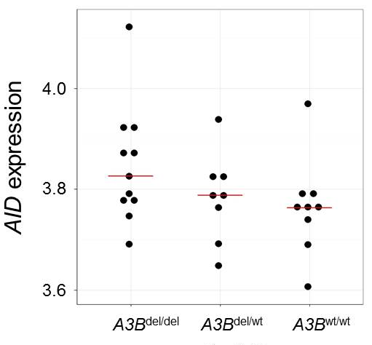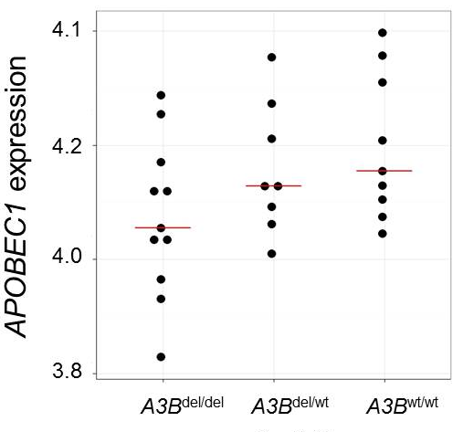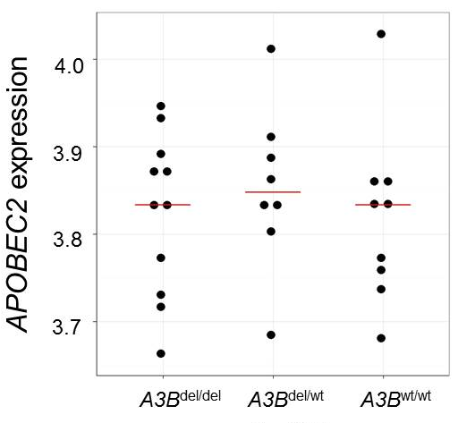
P = 0.61
P = 0.11
P = 0.19

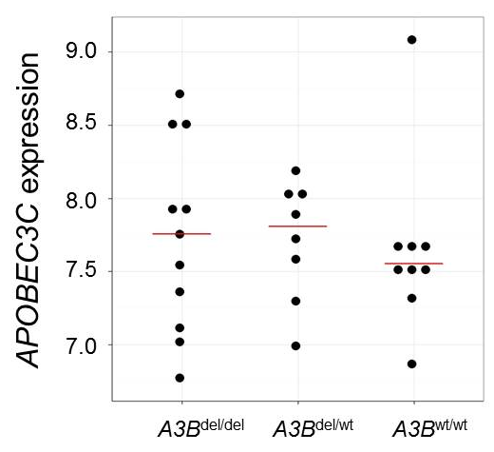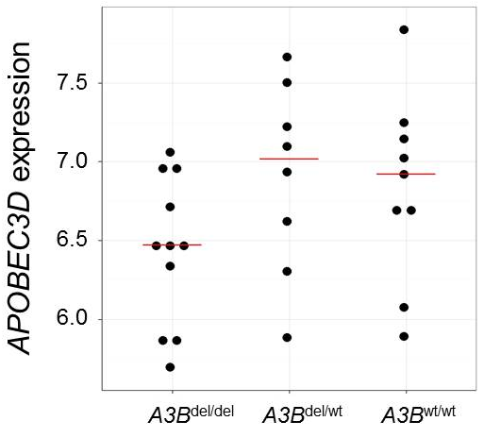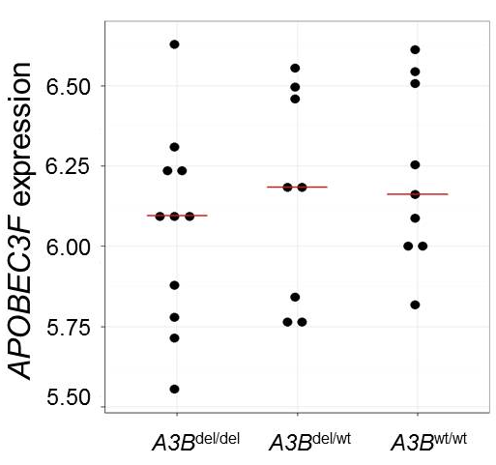
P = 0.63
P = 0.12
P = 0.38

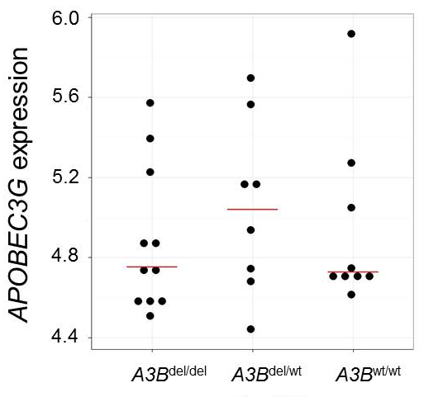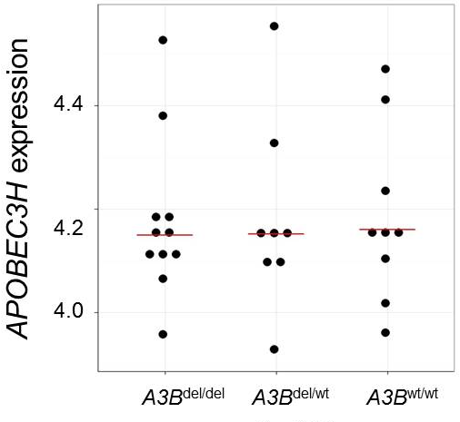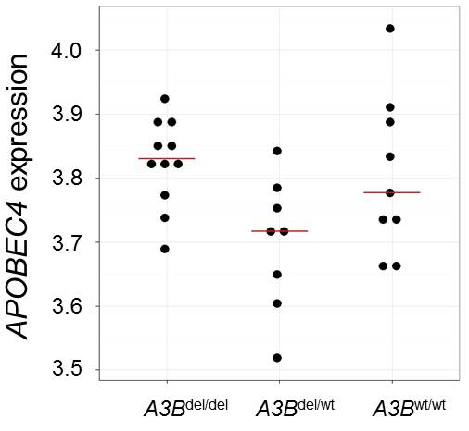
P = 0.04
P = 0.92
P = 0.68

Figure S1. The relationship between germline APOBEC3B deletion status and expression levels of 9 different APOBEC family members. Horizontal bars represent median values. P values derived from Kruskal-Wallis test. A3B^{del/del}: Two-copy deletion; A3B^{del/wt}: One-copy deletion; A3B^{wt/wt}: No deletion.

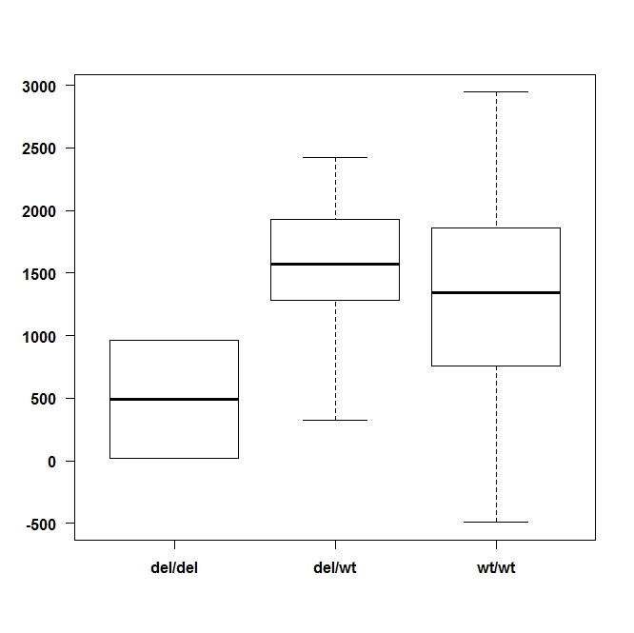
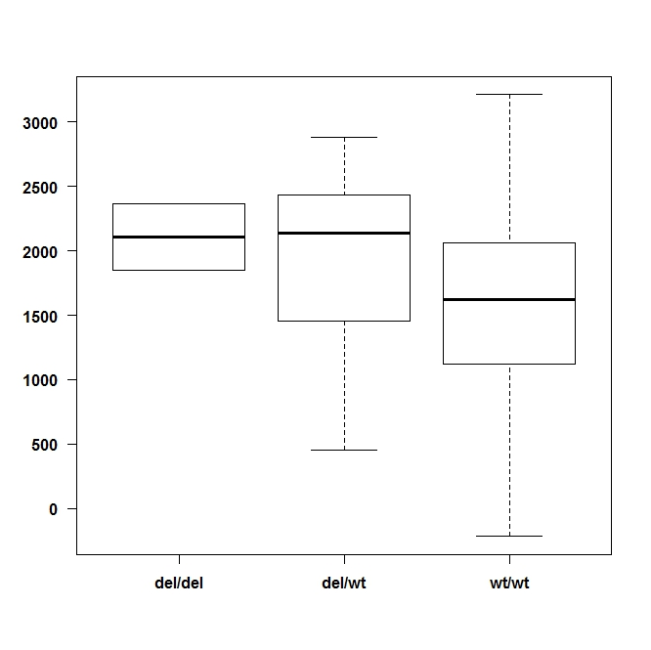
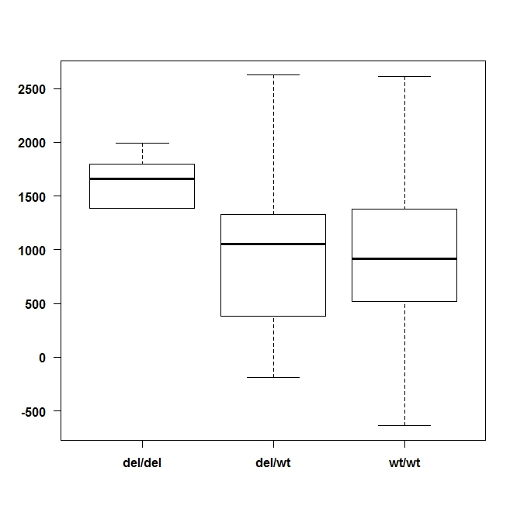
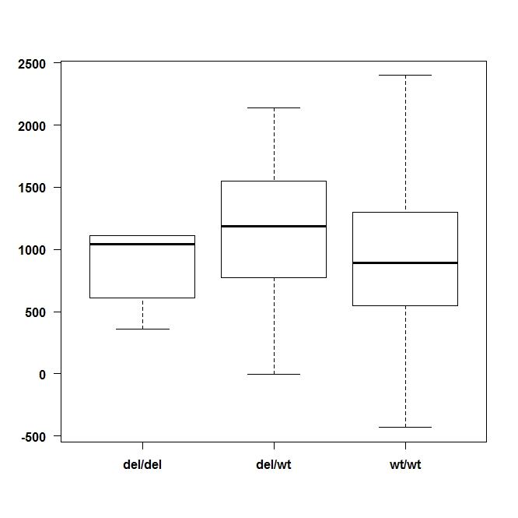
d.
c.
b.
a.
P = 0.07
A3B^{wt/wt}
(n=205)
A3B^{del/wt}
(n=31)
A3B^{del/del}
(n=2)
P = 0.01
A3B^{wt/wt}
(n=290)
A3B^{del/wt}
(n=35)
A3B^{del/del}
(n=2)
P = 0.14
A3B^{wt/wt}
(n=440)
A3B^{del/wt}
(n=44)
A3B^{del/del}
(n=5)
P = 0.02
A3B^{wt/wt}
(n=649)
A3B^{del/wt}
(n=64)
A3B^{del/del}
(n=5)
P = 0.61
P = 0.003
P = 0.005
P = 0.46
HER2-enriched
Luminal B
Basal-like
Luminal A

Figure S2. The relationship between germline APOBEC3B deletion status and immune scores in breast cancers from METABRIC after stratifying by PAM50 subtype. Y-axis represents the immune score. P values for 3-group comparison derived from Kruskal-Wallis test. P values from 2-group comparison derived from Mann-Whitney U test. A3B^{del/del}: Two-copy deletion; A3B^{del/wt}: One-copy deletion; A3B^{wt/wt}: No deletion.

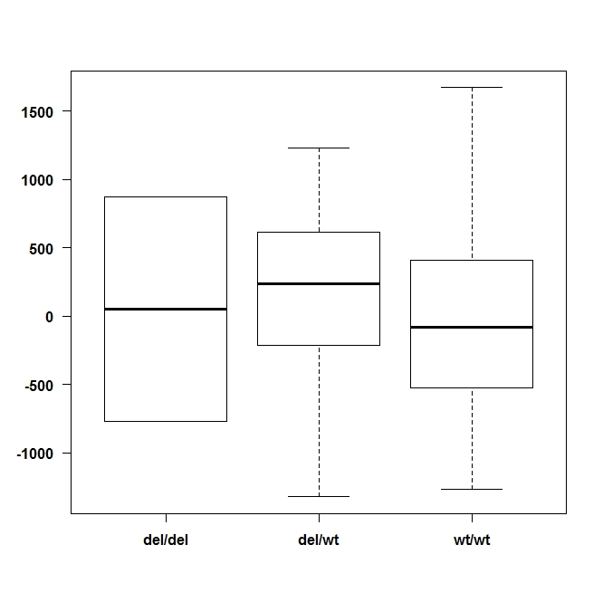
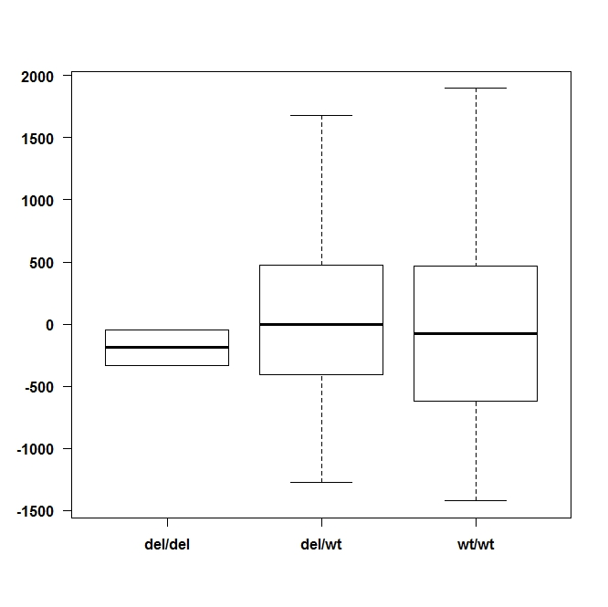
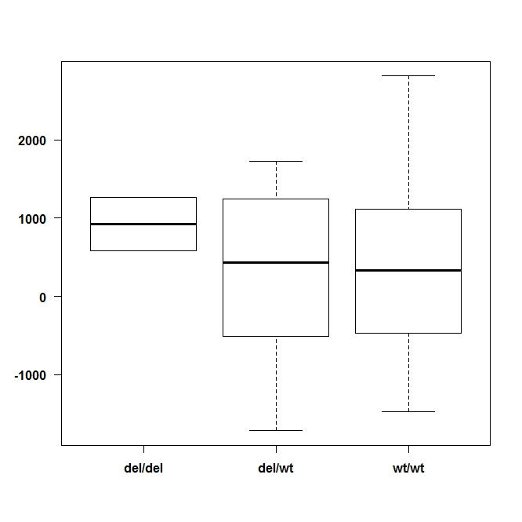
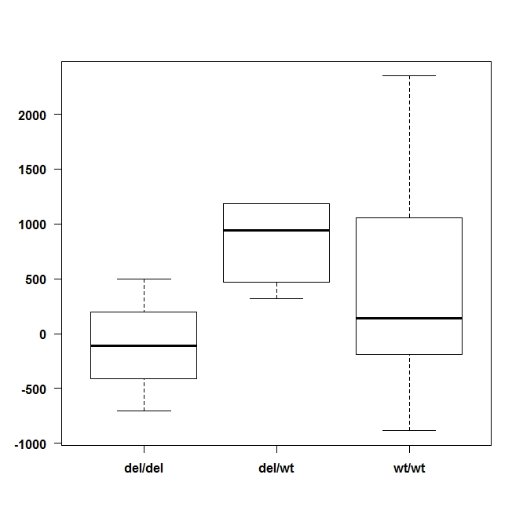
P = 0.61
P = 0.43
Luminal B
HER2-enriched
Basal-like
Luminal A
a.
b.
c.
d.
P = 0.74
P = 0.13
A3B^{del/del}
(n=2)
A3B^{del/wt}
(n=29)
A3B^{wt/wt}
(n=170)
P = 0.28
A3B^{del/del}
(n=2)
A3B^{del/wt}
(n=14)
A3B^{wt/wt}
(n=99)
P = 0.82
A3B^{del/del}
(n=2)
A3B^{del/wt}
(n=12)
A3B^{wt/wt}
(n=71)
P = 0.73
A3B^{del/del}
(n=3)
A3B^{del/wt}
(n=5)
A3B^{wt/wt}
(n=44)
P = 0.13

Luminal A

Basal-like

Figure S3. The relationship between germline APOBEC3B deletion status and immune scores in breast cancers from TCGA after stratifying by PAM50 subtype. Y-axis represents the immune score. P values for 3-group comparison derived from Kruskal-Wallis test. P values from 2-group comparison derived from Mann-Whitney U test. A3B^{del/del}: Two-copy deletion; A3B^{del/wt}: One-copy deletion; A3B^{wt/wt}: No deletion.

