Supplemental Data
MicroRNA-200c and 141 are regulated by a FOXP3-KAT2B axis and associated with tumor metastasis in breast cancer
Guangxin Zhang, Wei Zhang, Bingjin Li, Erica Stringer-Reasor, Chengjing Chu, Liyan Sun, Sejong Bae, Dongquan Chen, Shi Wei, Kenneth Jiao, Wei-Hsiung Yang, Ranji Cui, Runhua Liu and Lizhong Wang
Table S1. Primer and siRNA sequence used in this study
Primer Name | Sequence
Human KAT2B-realtime-F | CCGACCTGCAGCAAATAATT
Human KAT2B-realtime-R | TTCCCAGGAGTCTGTTCATTT
Human PITX2-realtime-F | CACTTTCCAGAGGAACCGCTA
Human PITX2-realtime-R | AGTGTTCACATCGGACACCA
Human KLF5-realtime-F | CACAAAACATCCAACCTGTCA
Human KLF5-realtime-R | TGAGTCCTCAGGTGAGCTTTT
Human MUC1-realtime-F | TTCACCACCACCATGACACC
Human MUC1-realtime-R | TTCAGAGACAGCCAGGAGAAA
Human TP53-realtime-F | TGCCTGATACAGATGCTACTTGA
Human TP53-realtime-R | TTGAGTTCCAAGGCCTCATT
Human GAPDH-realtime-F | CCCCTTCATTGACCTCAACTACAT
Human GAPDH-realtime-R | CGCTCCTGGAAGATGGTGA
has and mmu-miR-200c | CCCTAATACTGCCGGGTAATGATGGA
has and mmu-miR-141 | CCCTAACACTGTCTGGTAAAGATGG
has and mmu-miR-200b | CCCTAATACTGCCTGGTAATGATGA
has and mmu-miR-200a | CCCTAACACTGTCTGGTAACGATGT
has-miR-429 | CCCTAATACTGTCTGGTAAAACCGT
mmu-miR-429 | CCCTAATACTGTCTGGTAATGCCGT
has-miR-200c/141-ChIPseq-F (-20kb) | CAATCCACTAATTCCTTGCG
has-miR-200c/141-ChIPseq-R (-20kb) | TTGCAGCATCTTACCCATGT
has-miR-200c/141-ChIPseq-F (-4.5kb) | CAGAGAATAGGGGAATGGGAA
has-miR-200c/141-ChIPseq-R (-4.5kb) | TAGATTCAGCCGACTTGCC
has-miR-200c/141-ChIPseq-F (-4.2kb) | TCTCCCTGAGGTCTGTTTGC
has-miR-200c/141-ChIPseq-R (-4.2kb) | AAGGATAGCCCTGAGACAGCA
has-miR-200c/141-ChIPseq-F (-2.4kb) | AATTTAAATGGCTGCATCCCC
has-miR-200c/141-ChIPseq-R (-2.4kb) | GCAAGCAAAGGGCTCAGA
has-miR-200c/141-ChIPseq-F (-1.3kb) | TGGAACTTAGGAGGCTGGTC
has-miR-200c/141-ChIPseq-R (-1.3kb) | TATTGGGTTGCTCAATCCCT
has-miR-200c/141-ChIPseq-F (+0.23kb) | AGCTGAGAGCGTTGCACAA
has-miR-200c/141-ChIPseq-R (+0.23kb) | ATCCACCAGGTGACAAATCG
has-miR-200c/141-ChIPseq-F (+0.7kb) | AATCACTAGGCAAAGGGGAA
has-miR-200c/141-ChIPseq-R (+0.7kb) | TTATTTCATGCTCCCAAGGC
has-miR-200c/141-ChIPseq-F (+1.2kb) | AAGGCCTGTCTTGGGAAGATA
has-miR-200c/141-ChIPseq-R (+1.2kb) | ATTTCTCAGTCACCAGGCGT
Human KAT2B siRNA-1 | GCATGTCCATTAGCTATTTCA
Human KAT2B siRNA-2 | GTCTTGGGATTCCAGTTTAGT
Human PITX2 siRNA-1 | GAAGGTCGTGGGCACTAAAGA
Human PITX2 siRNA-2 | GAAACCACTGAATCAAAGAGA

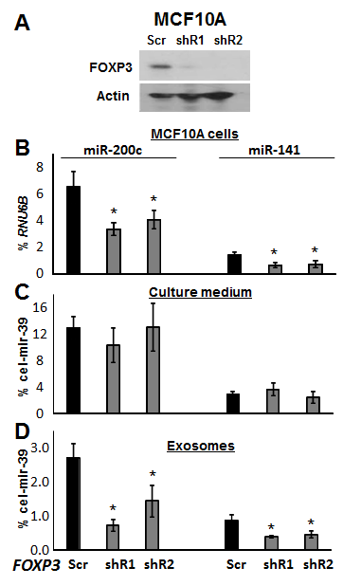
Figure S1. Levels of miR-200c and 141 in normal immortalized human epithelial cell line MCF10A. A, Western blot analyses showing protein expressions of FOXP3 in Scr or shRNA-transfected cells. B, quantification (by TaqMan miR assay) of miR-200c and 141 as percentages of RNU6B expression in MCF10A cells with and without FOXP3. C, quantification of levels of miR-200c and 141 (by nest-quantitative PCR) as percentages of cel-mir-39 expression in cell- and exosome-free culture medium with and without FOXP3. D, quantification (by nest-quantitative PCR) of levels of exosomal miR-200c and 141 as percentages of cel-mir-39 expression in exosomes with and without FOXP3. Data are presented as means ± SD. * p < 0.05 vs. Scr group (two-tailed t test). Scr, scramble; shRNA, short hairpin RNA. All experiments were repeated three times.

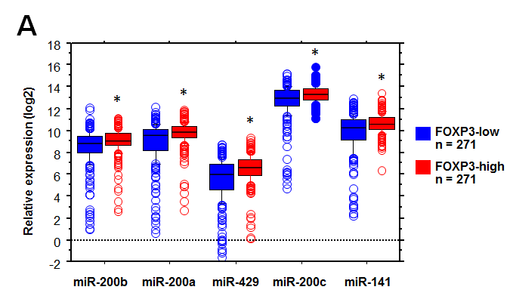
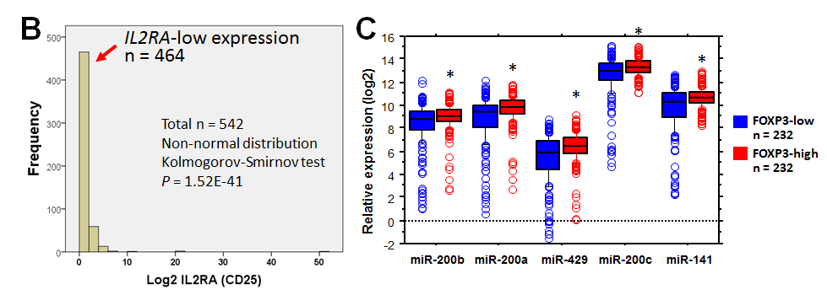
Figure S2. Associations between expression of FOXP3 and miR-200s in TCGA breast cancer samples. A, expression of miR-200 family members (miR-200 cluster 1: miR-200b/a/429; miR-200 cluster 2: miR-200c/141) in human breast cancer samples from 542 patients listed in the NCI TCGA. Values for FOXP3^{low} and FOXP3^{high} were divided by a median of FOXP3 expression. All data were expressed on a log2 basis with a normal distribution for each group. * p < 0.001 in FOXP3^{high} vs. FOXP3^{low}, two-tailed t test. B, non-normal distribution of IL2RA (CD25) expression in 542 TCGA breast cancer samples. Since FOXP3⁺ tumor-infiltrating regulatory T cells may contribute to the expression of FOXP3 in tumors, we conducted a stratification of patients by IL2RA expression, which is specifically expressed in regulatory T cells. A non-normal distribution of IL2RA expression was evident for all tumors, including 464 with low-expression (0.08-1.98 with normal distribution) and 78 with over-expression (2.02-51.61 with non-normal distribution). C, expression of miR-200 family members in IL2RA-low breast cancers from 464 patients in the NCI TCGA. To avoid the effect of FOXP3⁺ regulatory T cells, we selected the 464 IL2RA-low tumors to address the association between expression of FOXP3 and miR-200s in human breast cancers. The FOXP3^{low} and FOXP3^{high} subgroups were divided by a median of FOXP3 expression. All data were expressed on a log2 basis, with a normal distribution for each group. * p < 0.001 in FOXP3^{high} vs. FOXP3^{low}, two-tailed t test.

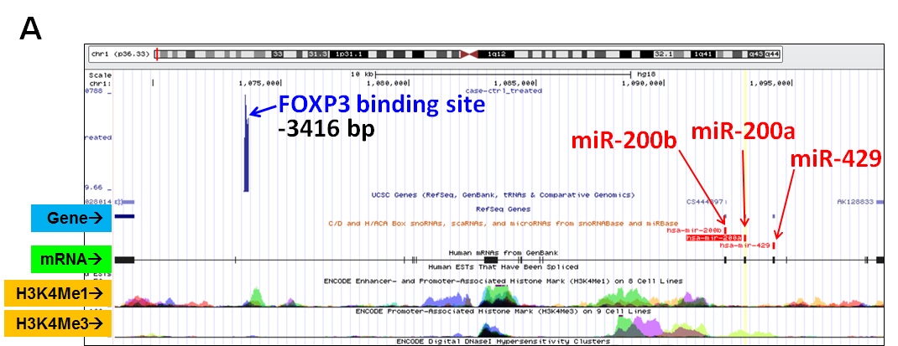
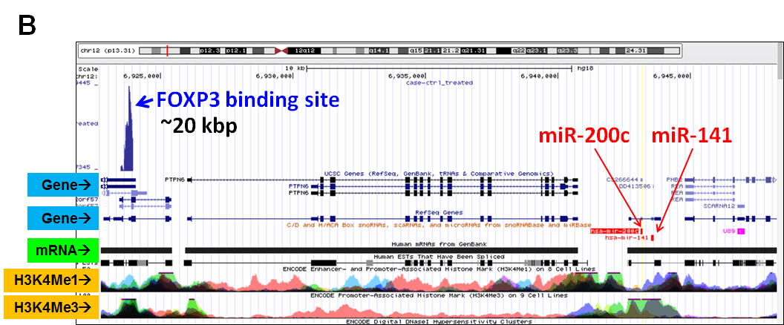
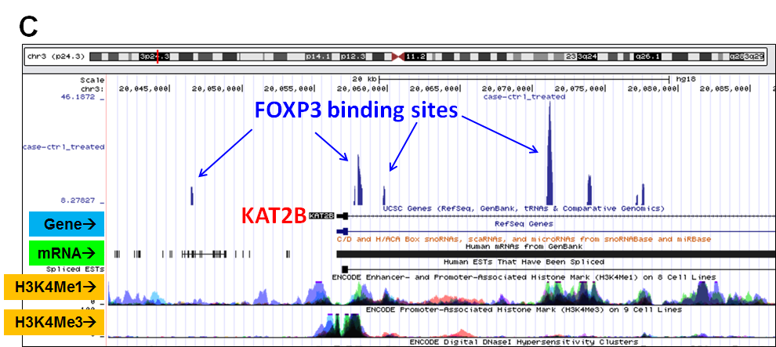
Figure S3. Potential binding signals of FOXP3 in the promoter regions of the miR-200 family and KAT2B gene. ChIP-seq data as custom tracks within the UCSC genome browser were used to identify the FOXP3 binding sites by ChIP-seq peak detection in promoter regions of miR-200 cluster 1 from human chromosome 1 (A), cluster 2 from human chromosome 12 (B), and the KAT2B gene from human chromosome 3 (C). At the top of each panel, the red vertical line within the chromosome indicates the localization of miR-200s or the KAT2B gene. The blue arrows indicate the FOXP3 binding site, and the red arrows indicate the miR-200 family members. Chr, chromosome; bp, base pair.
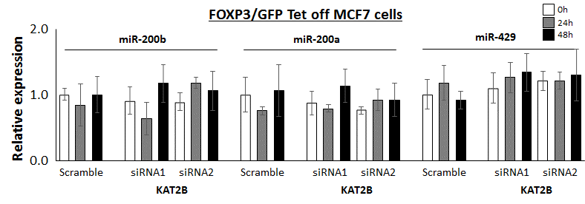
Figure S4. The transcriptional activity of miR-200b/a/429 on miR-200 cluster 1 after FOXP3 induction and KAT2B silencing in breast cancer cells. The relative quantification of miR-200b/a/429 (by qPCR) as percentages of RNU6B in FOXP3/GFP-Tet-off MCF7 cells with scramble or siRNAs of KAT2B at 0, 24, and 48 hours. All data for each group were normalized to the scramble control at 0 hour. Data are presented as the means ± SD of triplicates. All p > 0.05 vs. 0-hour group (one-way ANOVA followed by protected least-significant difference test). All experiments were repeated three times.
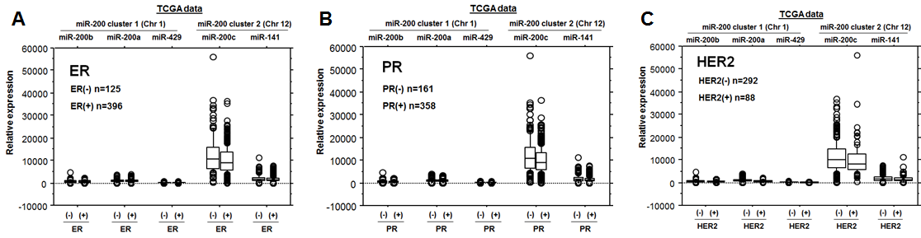
Figure S5. Association of expression levels of miR-200s with ER/PR/HER2 status in breast cancer cells. The expressions of miR-200s in breast cancer cells were analyzed for patients with breast cancers from the NCI TCGA. The subgroups were divided by (A) ER status, (B) ER status, and (C) HER2 status. The box-and-whisker plots of expression levels of miR-200s are presented as relative values for breast cancer patients with ER, PR, and HER2 status. In samples with normal distributions, the means of the variables were compared by use of a two-tailed t test between two groups. In samples with non-normal distributions, the medians of the variables between two groups were compared with a Mann-Whitney test. Between subgroups, no significant difference in expression levels of miR-200s was found for breast cancer cells. ER, estrogen receptor; PR, progesterone receptor; HER2, human epidermal growth factor receptor 2.

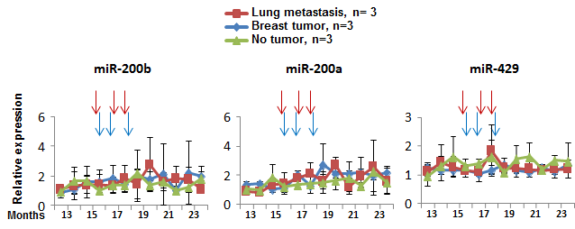
Figure S6. Levels of plasma miR-200b, 200a, and 429 in Foxp3^{sf/+} female mice during tumor progression. The relative expression was determined by nest-qPCR using the 2^{-∆Ct} against the Ct value at 1 year of age (* p < 0.05 vs. no tumor group; two-way ANOVA). The time points of tumor development (determined by visual observation) are indicated by vertical arrows. All experiments were repeated three times.
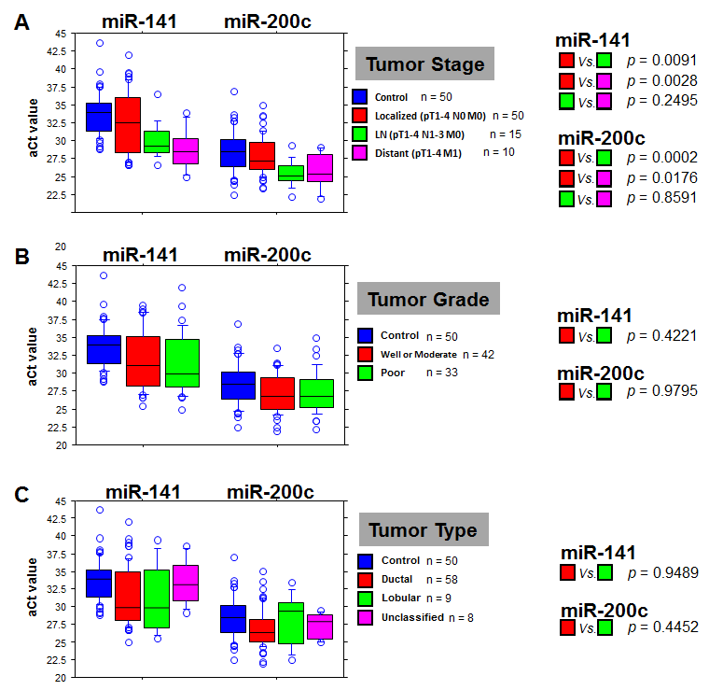
Figure S7. Plasma levels of miR-141 and 200c in breast cancer patients with clinical parameters. Box-and-whisker plots of plasma miR-200c and 141 levels are presented as adjusted PCR cycle threshold (aCt) values for patients with tumor stages (A), tumor grades (B), and tumor types (C). The aCt value of each miR was adjusted by the spiked-in control, cel-miR-39. In samples with normal distributions, the means of the variables were compared by use of a two-tailed t test between two groups. In samples with non-normal distributions, the medians of the variable between two groups were compared with a Mann-Whitney test. Local, localized breast cancer; LN, lymph node metastasis; Meta, distant metastasis, Well, well-differentiated tumor; Moderate, moderately differentiated tumor; Poor, poorly differentiated tumor; Ductal, invasive lobular carcinoma; Lobular, invasive ductal carcinoma; Unclassified, unclassified tumor type. All experiments were repeated three times.
Figure S8. Levels of miR-200b, 200a, and 429 in FOXP3-Tet-off MCF7 cells, culture medium, and exosomes. Measurements of miR-200b, 200a, and 429 were determined by qPCR; values were percentages of RNU6B or cel-mir-39 expression. Cells (A), culture medium (B), and exosomes (C) in the FOXP3-Tet-off MCF7 cells without Dox at 0, 1, 2, 3, and 5 days. Data are presented as means ± SD. * p < 0.05 (one-way ANOVA followed by protected least significant difference test for differences between groups). All experiments were repeated three times.
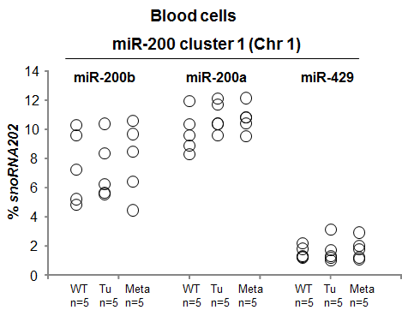
Figure S9. Expression of miR-200b, 200a, and 429 in blood cells of Foxp3^{sf/+} female mice. Measurements of miR-200b, 200a, and 429 were by qPCR; values were expressed as percentages of snoRNA202 expression. WT, wild-type; Tu, tumor; Meta, metastasis; Chr, chromosome. No significant difference was found among the WT, Tu, and Meta groups (one-way ANOVA followed by protected least significant difference test for differences between groups). All experiments were repeated three times.

