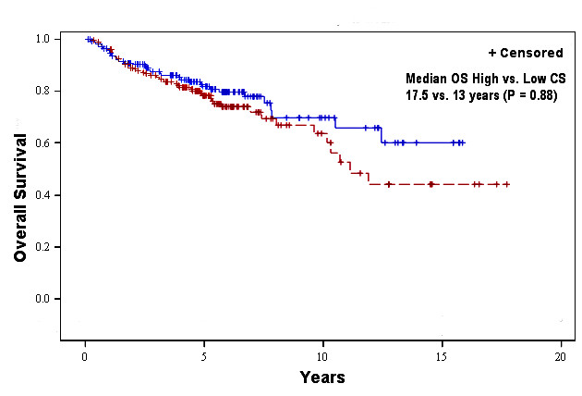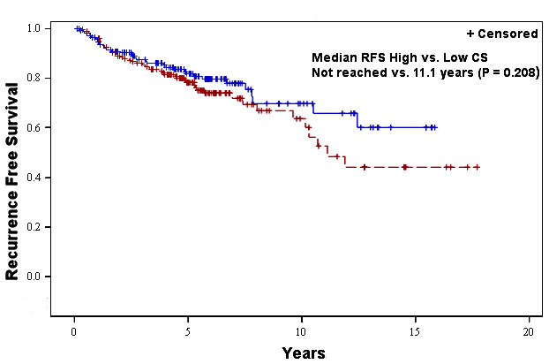
(a)
(b)

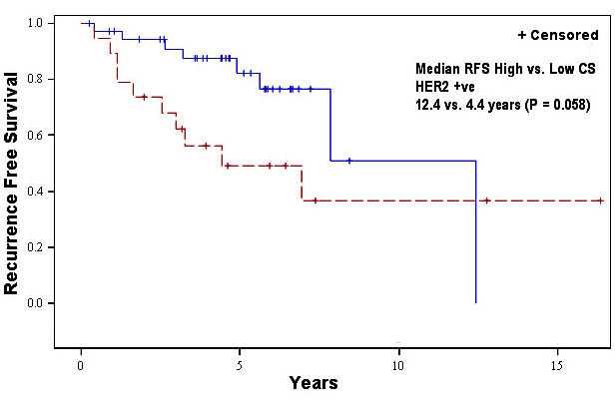
(c)

Table 2: Univariate and significant multivariate analysis of Overall Survival
Variable | Reference | Level | Univariate analysis |  | Multivariate analysis
Variable | Reference | Level | HR (95% CI) | P value | HR (95% CI) | P value
12 Chemokine |  |  | 0.96 (0.75,1.22) | 0.734
12 Chemokine (Median Split) | Low 12 Chemokine | High 12 Chemokine | 1.03 (0.7,1.52) | 0.88
12 Chemokine (10th and 90th percentile split) | Low 12 Chemokine | High 12 Chemokine | 0.7 (0.29,1.69) | 0.42
Age at DX |  |  | 1.03 (1.02,1.05) | <.0001 | 1.04 (1.02, 1.06) | 0.001
Race | White | Not White | 1.63 (0.87,3.07) | 0.126 | 3.43 (1.55, 7.57) | 0.002
Histology | Ductal | Lobular | 0.87 (0.5,1.52) | 0.622
 | Ductal | Others | 0.55 (0.22,1.36) | 0.194
Tumor Grade | Poorly/Undifferentiated | Well differentiated | 0.68 (0.32,1.42) | 0.3
 | Poorly/Undifferentiated | Moderately differentiated | 0.6 (0.38,0.94) | 0.024 | 0.44 (0.24, 0.81) | 0.009
Cancer Status | Free (NED) | Not free of tumor | 12.53 (7.86,19.98) | <.0001 | 15.95 (8.98, 28.35) | <.0001
TNM Stage | 1 | 2 | 2.89 (1.42,5.87) | <.0001
 | 1 | 3 | 5.18 (2.45,10.95)
Any adjuvant treatment | No | Yes | 0.49 (0.3,0.8) | 0.004 | 0.43 (0.21, 0.88) | 0.02
Receptor status | (ER+ or PR+)/(HER2- or HER2 Missing) | ER-/PR-/(HER2- or Missing) | 1.29 (0.76,2.21) | 0.349
 | (ER+ or PR+)/(HER2- or HER2 Missing) | HER2+ | 1.72 (1.02,2.88) | 0.041

Table 3: Univariate and significant multivariate analysis of Recurrence Free Survival between high and low chemokine groups
Variable | Reference | Level | Univariate analysis |  | Multivariate analysis
Variable | Reference | Level | HR (95% CI) | P Value | HR (95% CI) | P Value
12 Chemokine |  |  | 0.89 (0.68,1.16) | 0.374
Age at DX |  |  | 1.01 (0.99,1.03) | 0.199
12 Chemokine (Median Split) | Low 12 Chemokine | High 12 Chemokine | 0.76 (0.49,1.17) | 0.209
12 Chemokine (10th and 90th percentile Split) | Low 12 Chemokine | High 12 Chemokine | 0.72 (0.25,2.02) | 0.527
Race | White | Not White | 1.57 (0.81,3.05) | 0.179 | 3.68 (1.67, 8.14) | 0.001
Histology | Ductal | Lobular | 0.87 (0.47,1.61) | 0.656
 | Ductal | Others | 0.26 (0.06,1.07) | 0.062
Grade Differentiation | Poorly/Undifferentiated | Well differentiated | 0.49 (0.21,1.14) | 0.098
 | Poorly/Undifferentiated | Moderately differentiated | 0.51 (0.31,0.83) | 0.007
Cancer Status | Free (NED) | Not free of tumor | 15.92 (9.62,26.37) | <.0001 | 25.08 (13.2, 47.64) | <.0001
TNM Stage | 1 | 2 | 2.11 (1.09,4.12) | 0.028
 | 1 | 3 | 3.1 (1.48,6.48) | 0.003
Any adjuvant treatment | No | Yes | 0.5 (0.28,0.89) | 0.019 | 0.31 (0.14, 0.65) | 0.002
Receptor status | (ER+ or PR+)/(HER2- or HER2 Missing) | ER-/PR-/(HER2- or Missing) | 1.7 (0.98,2.94) | 0.061 | 2.99 (1.5, 5.95) | 0.002
 | (ER+ or PR+)/(HER2- or HER2 Missing) | HER2+ | 2.11 (1.2,3.7) | 0.009 | 1.64 (0.83, 3.23) | 0.148

