Additional file 3
Pedigrees of investigated families with (likely) pathogenic variants

The index patient is marked by an arrow. Index patient ID and gene variants identified in the index patient are specified below the pedigree. BC, breast cancer (dark-filled symbol); OvCa, ovarian cancer (dark-filled circle within the symbol); LFS/LFL-associated tumors (dark-filled lower right corner within the symbol); bilat., bilateral.

- Patient #7, PALB2:p.(Arg170Ilefs*14)
- Patient #43, RUNX1:c.97+1G>A
- Patient #45, ATM exon 62-63 del
- Patient #55, ATM:p.(Cys2931*), CHEK2 exon 9-10 del
- Patient #77, CDKN2A:p.(Arg98*), RECQL4:c.1390+1G>C
- Patient #78, WRN exon 15-16 del
- Patient #79, ATM:p.(Glu1978*)
- Patient #84, PMS2 exon 3-8 del, FANCI:p.(Arg1285*)
- Patient #96, PALB2:p.(Gln60Argfs*7)
- Patient #99, RECQL4:p.(Ala919Thr)
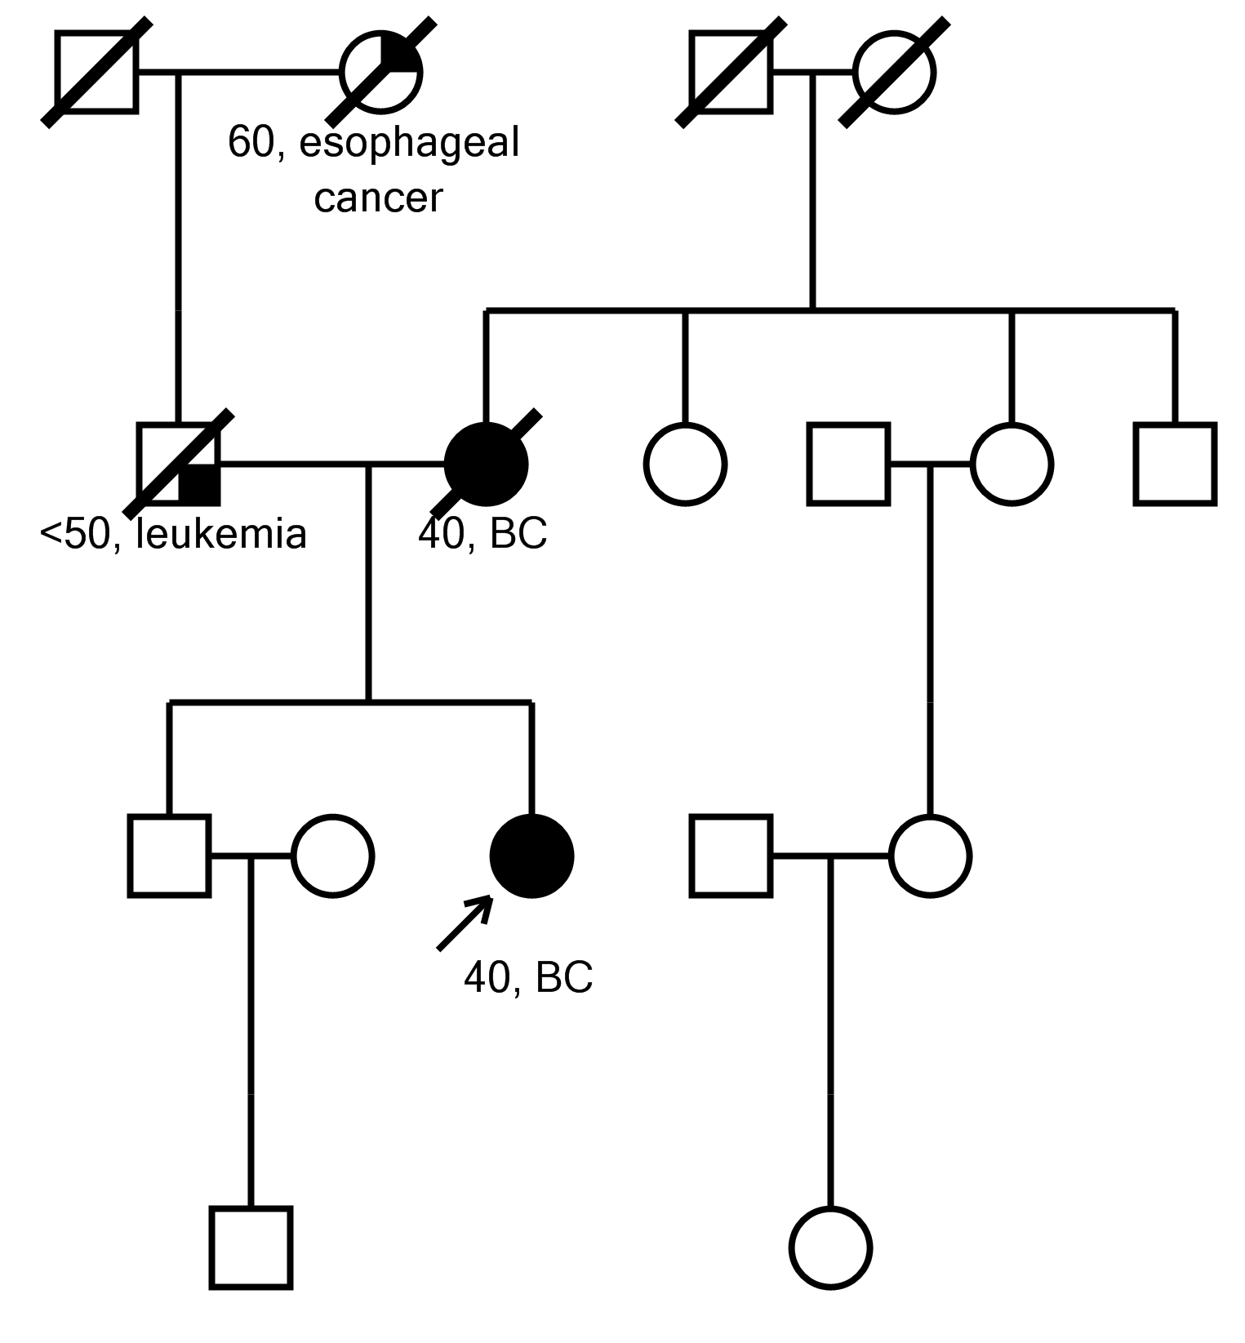

- Patient #7, PALB2:p.(Arg170Ilefs*14)
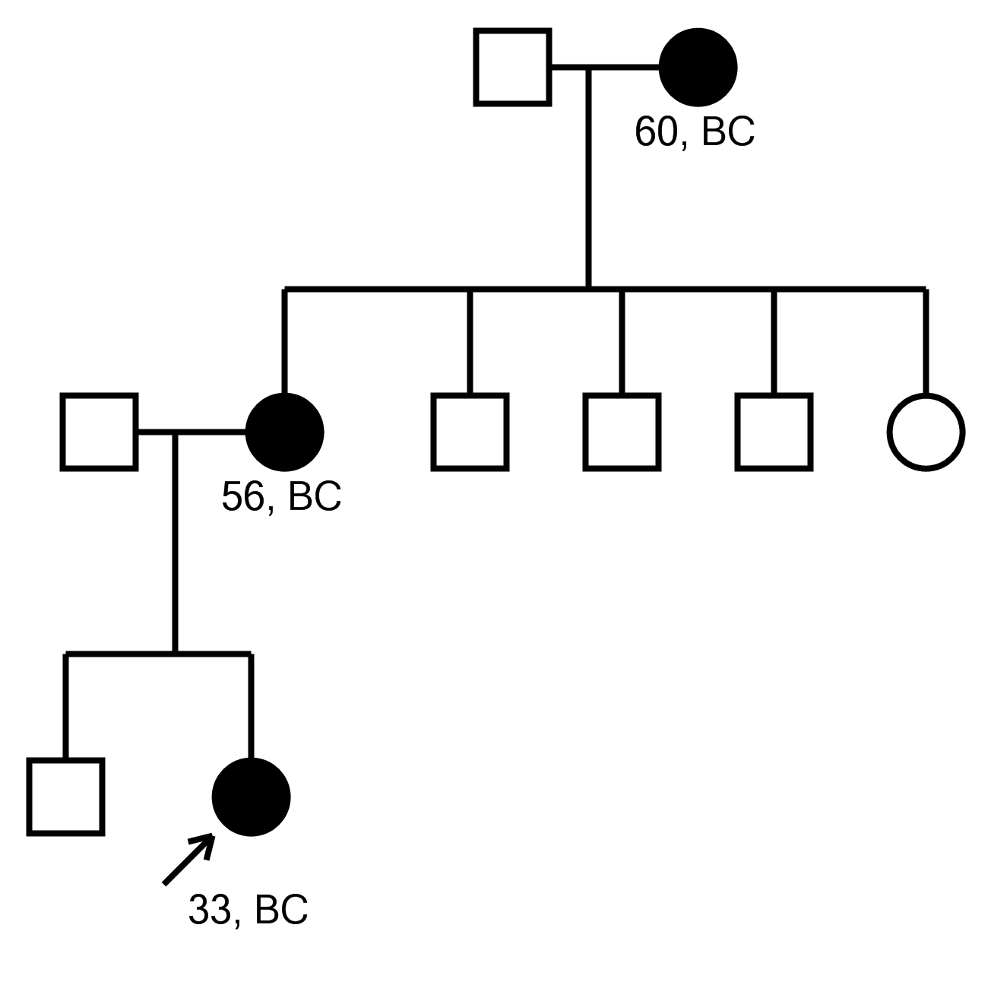

- Patient #43, RUNX1:c.97+1G>A

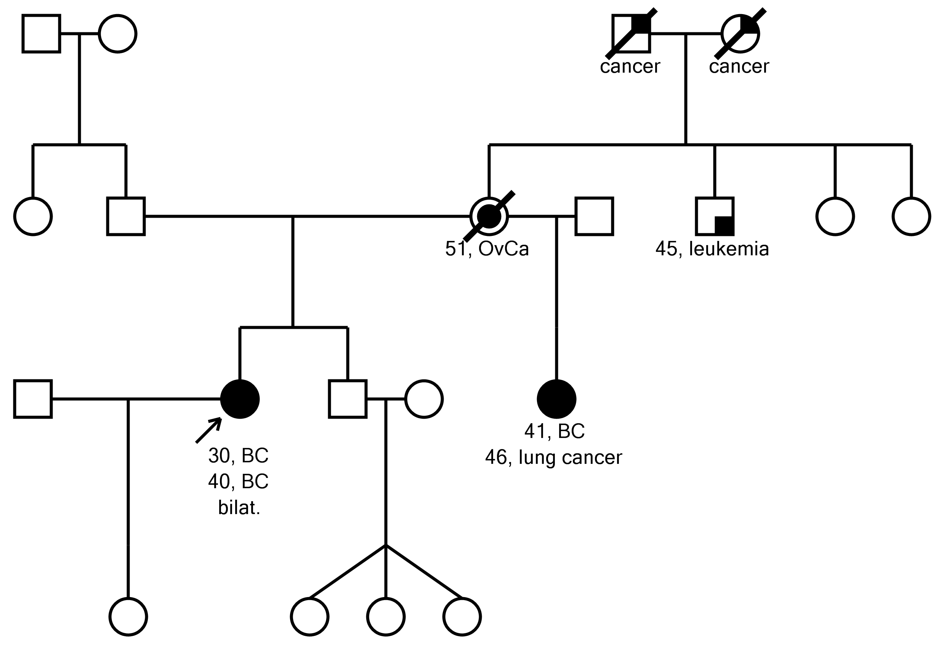
- Patient #45, ATM exon 62-63 del

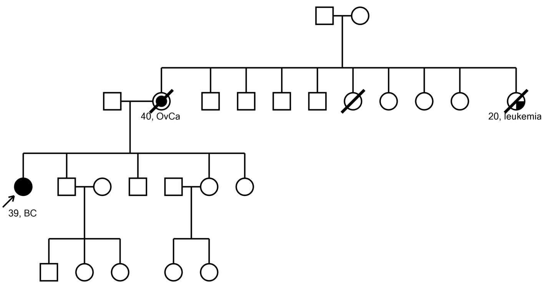

- Patient #55, ATM:p.(Cys2931*), CHEK2 exon 9-10 del

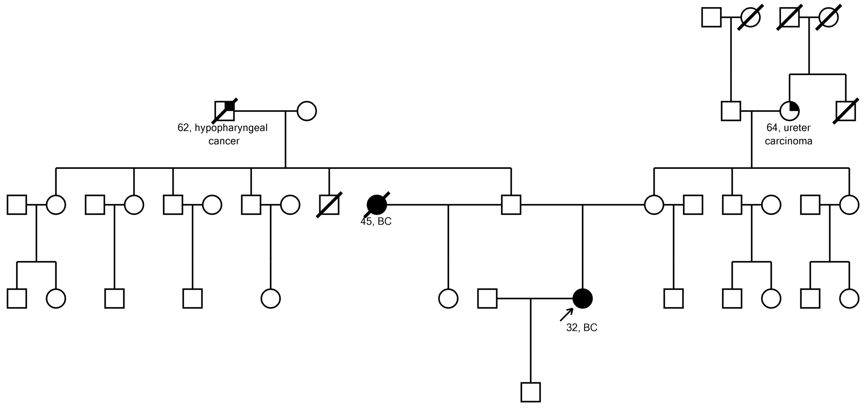

- Patient #77, CDKN2A:p.(Arg98*), RECQL4:c.1390+1G>C

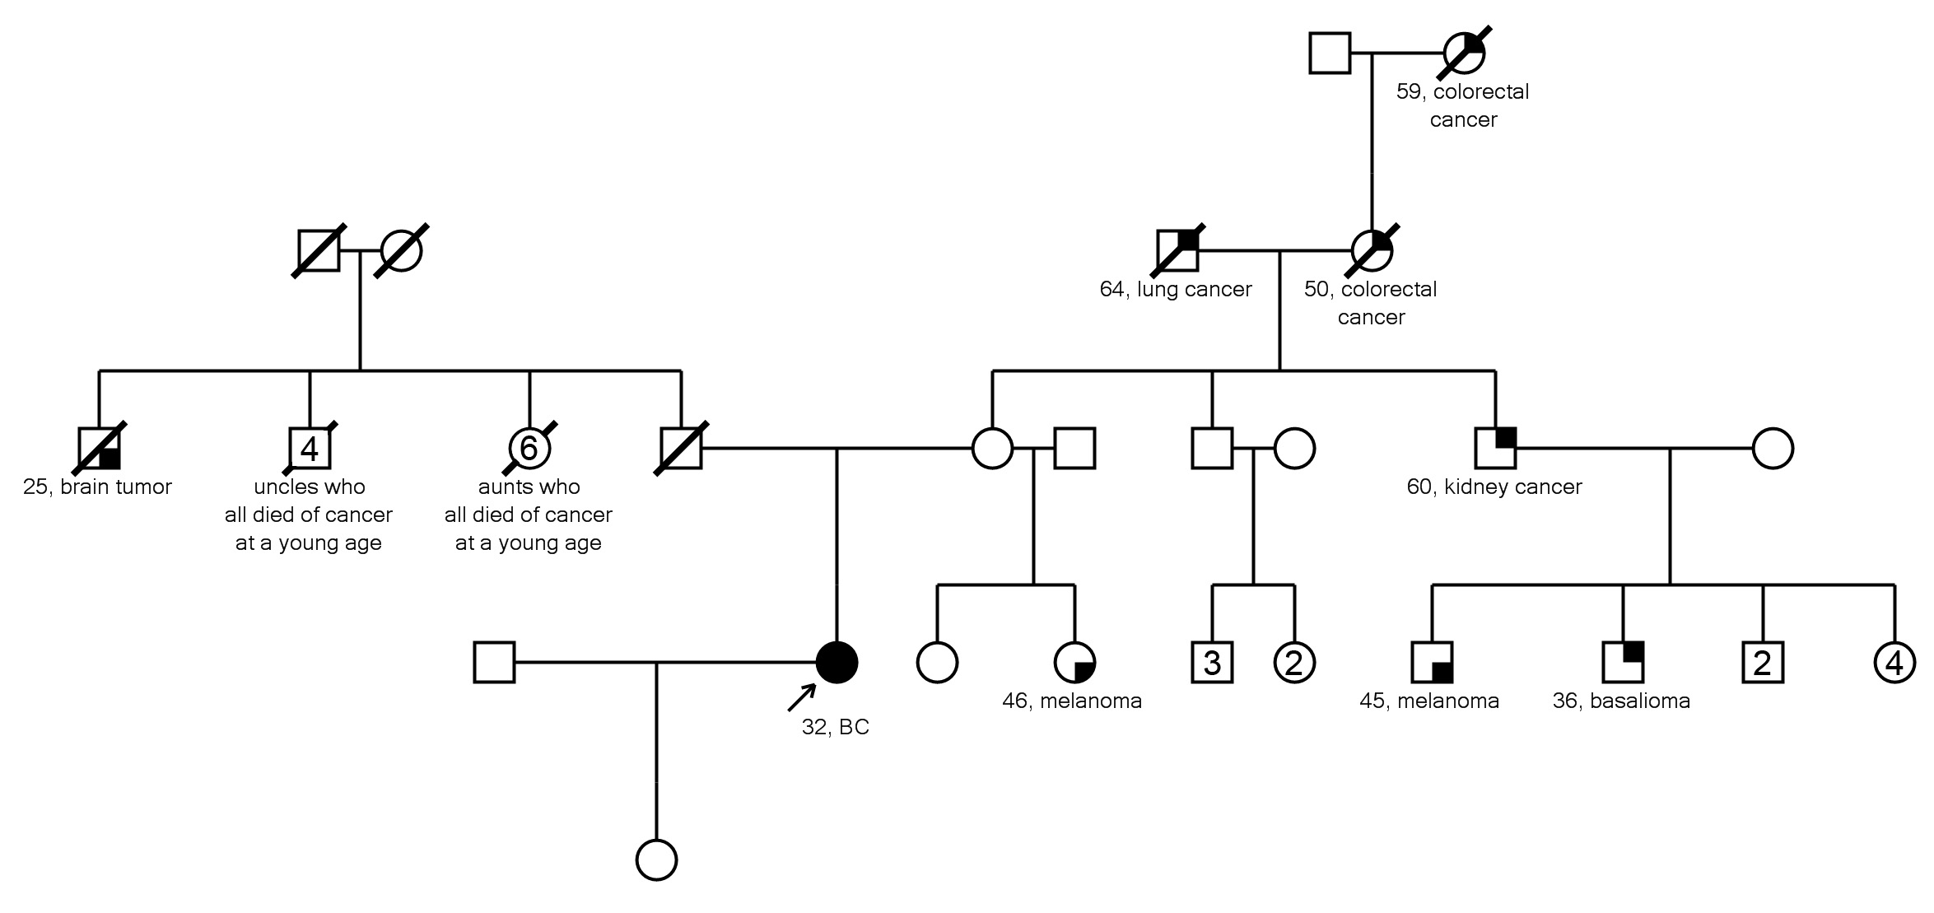

- Patient #78, WRN exon 15-16 del

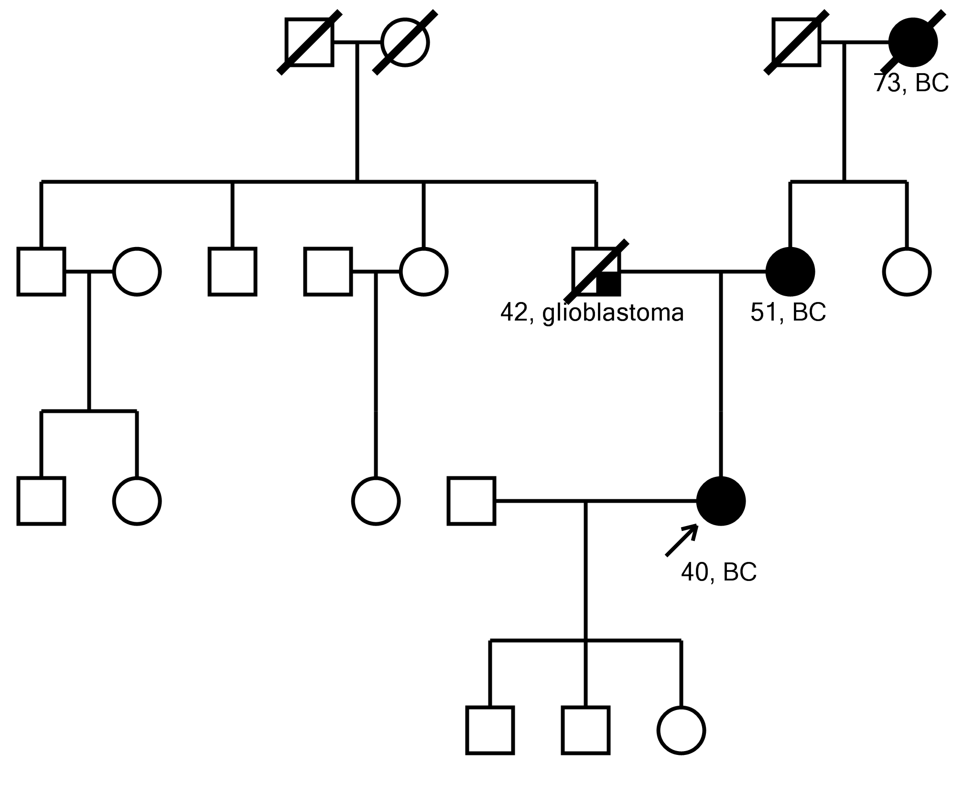

- Patient #79, ATM:p.(Glu1978*)

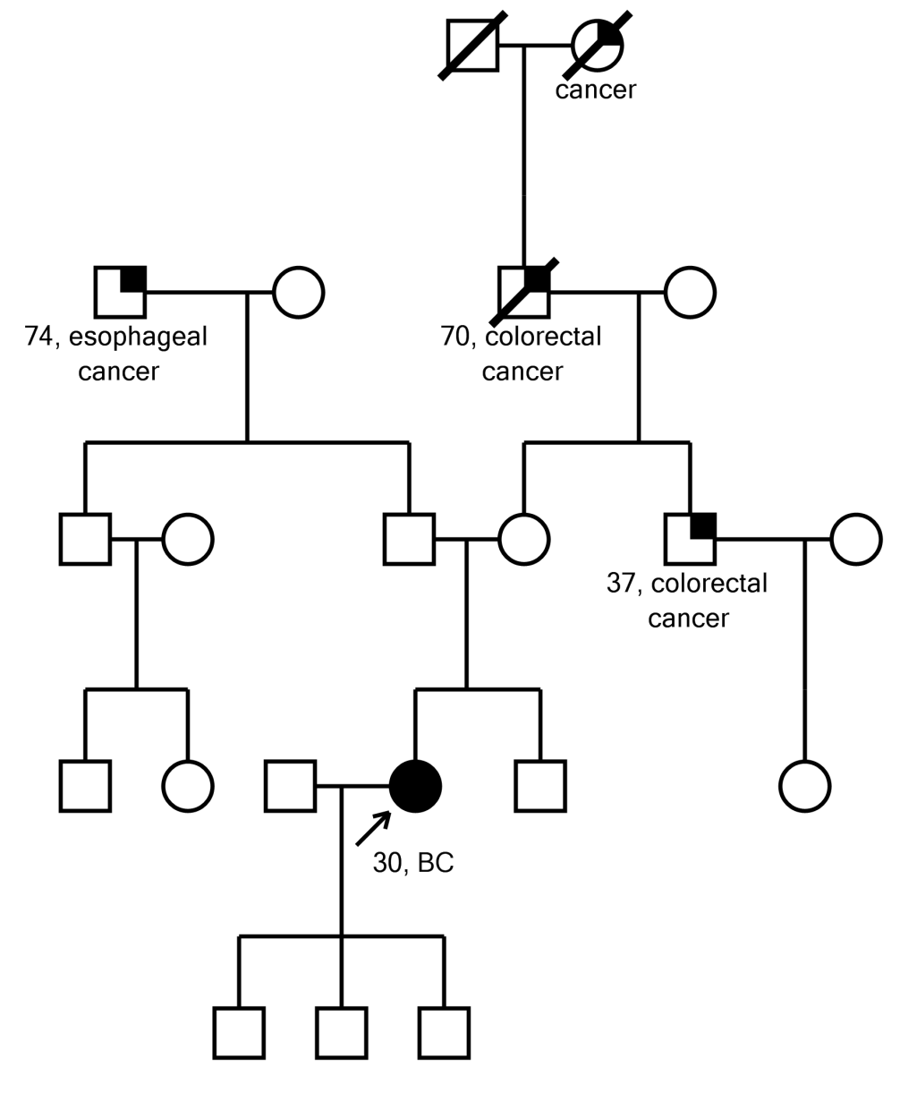

- Patient #84, PMS2 exon 3-8 del, FANCI:p.(Arg1285*)
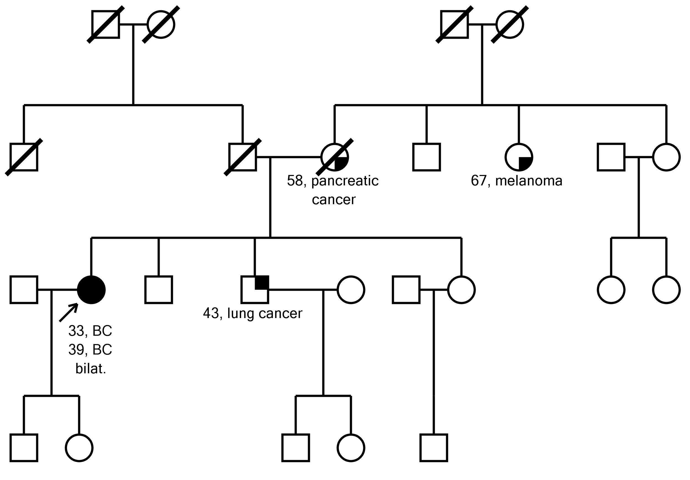

- Patient #96, PALB2:p.(Gln60Argfs*7)

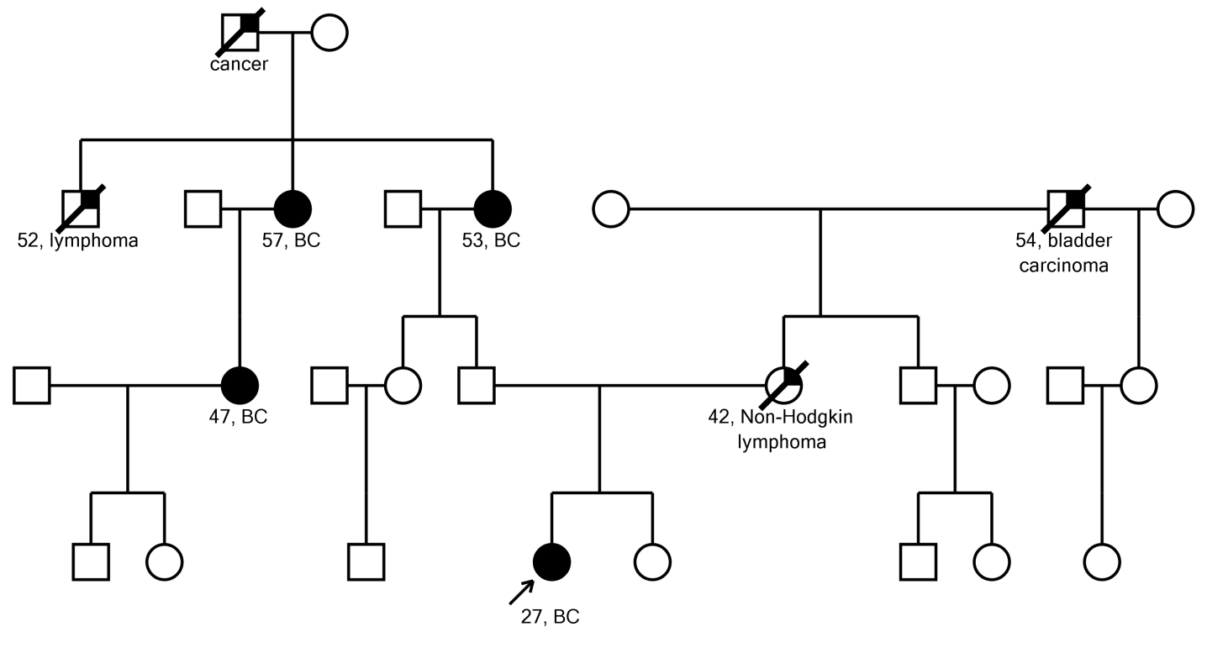

- Patient #99, RECQL4:p.(Ala919Thr)

