Supplementary Information
Efficient and tumor-specific knockdown of MTDH gene attenuates paclitaxel resistance of breast cancer cells both in vivo and in vitro
Li Yang^{1#}, Yanhua Tian^{2#}, Wei Sun Leong^{3#}, Heng Song⁴, Wei Yang¹, Meiqi Wang¹, Xinle Wang¹, Jing Kong³, Baoen Shan¹, Zhengchuan Song¹*

Table S1. Baseline Characteristics of the Patients.
Characteristic | MTDH low  (n=15) | MTDH high  (n=29) | P value
 | No. (%) | No. (%)
Age |  |  | 0.759
<50 | 9 (60.0) | 16 (55.2)
≥50 | 6 (40.0) | 13 (44.8)
Tumor size (cm) |  |  | 0.455
≤5 | 11 (73.3) | 18 (62.1)
>5 | 4 (26.7) | 11 (37.9)
Stage |  |  | 0.759
ⅡB-ⅢA | 6 (40.0) | 13 (44,8)
ⅢB-ⅢC | 9 (60.0) | 16 (55.2)
pCR | 5(33.3) | 5(17.2)
ER status |  |  | 0.919
positive | 8 (53.3) | 15 (51.7)
negative | 7 (46.7) | 14 (48.3)
PR status
positive | 6 (40.0) | 16 (55.2) | 0.759
negative | 9 (60.0) | 13 (44.8)
HER2 status
positive | 2 (13.3) | 5 (17.2) | 0.937
negative | 10 (66.7) | 18 (62.1)
unknown | 3 (20.0) | 6 (20.7)
Ki-67
≤20% | 4(26.7%) | 4(13.8%) | 0.576
＞20% ≤50% | 7(46.7%) | 16(55.2%)
＞50% | 4(26.7%) | 9(31.0%)
pCR = pathologic complete response (Can`t find malignant tumor tissues in the breast primary lesions, or only carcinoma in situ in the remaining ingredients). ER=estrogen receptor. PR=progesterone receptor. HER2=human epidermal growth factor receptor 2.
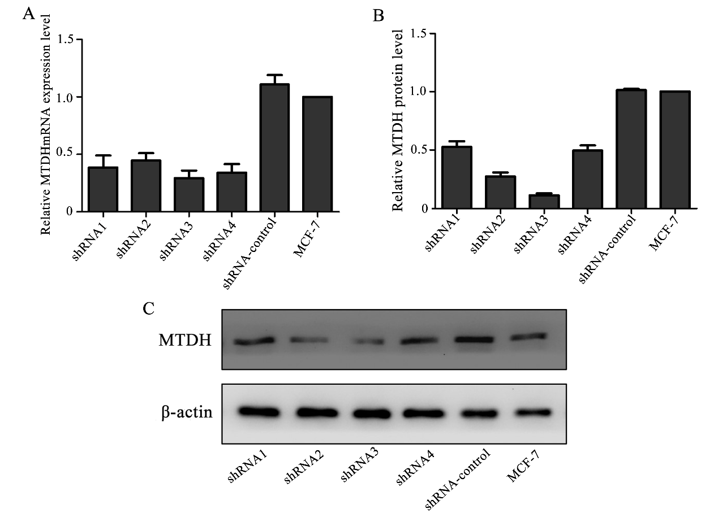
Figure S1. The MTDH mRNA and protein expressions level in different groups after transfecting. We selected the optimal silent shRNA (MTDH-shRNA3: 5'-GCAATTGGGTAGACGAAGAAA-3') via real-time PCR and western blot. A The MTDH mRNA expressions level of MTDH-shRNA1，MTDH-shRNA2，MTDH-shRNA3，MTDH-shRNA4 and shRNA-control. B and C The protein expressions level of MTDH-shRNA1, MTDH-shRNA2, MTDH-shRNA3, MTDH-shRNA4 and shRNA-control.

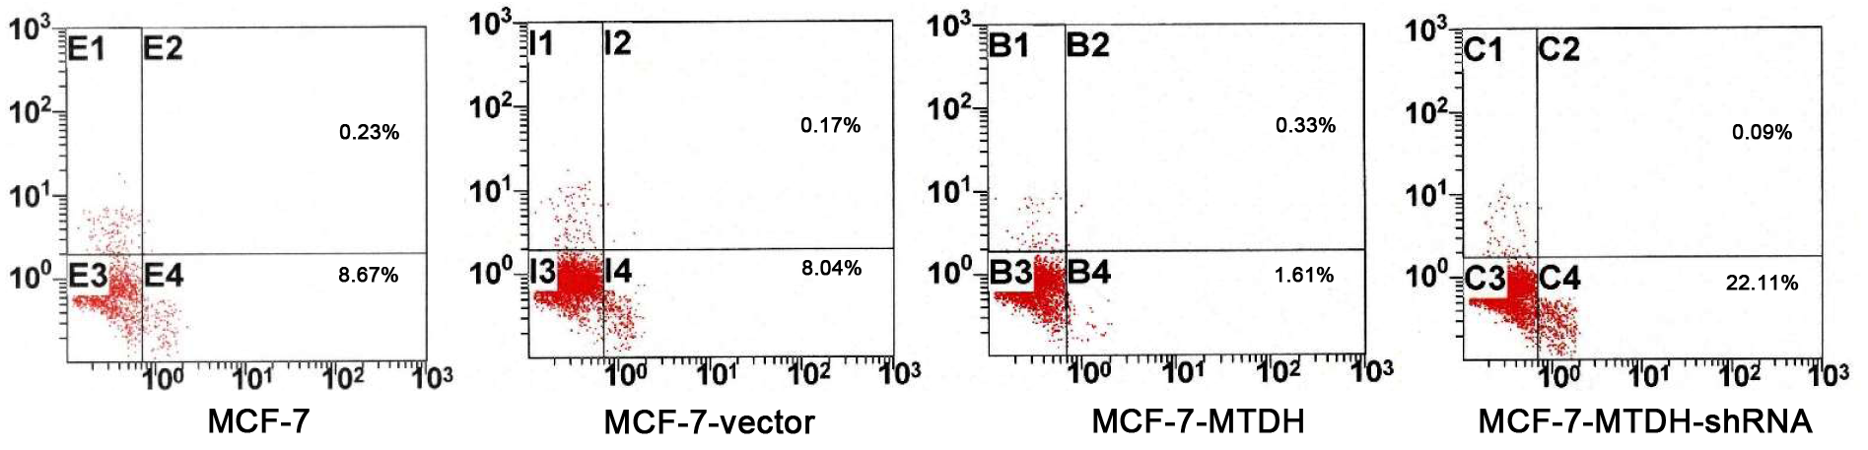
Figure S2. Annexin V-PE/7-AAD assay for determination of apoptosis of cells overexpressing or knocking-downing MTDH with a flow cytometer. MCF-7 and MCF-7-vector were used as control. Annexin-positive cells were presented in Gate 4.

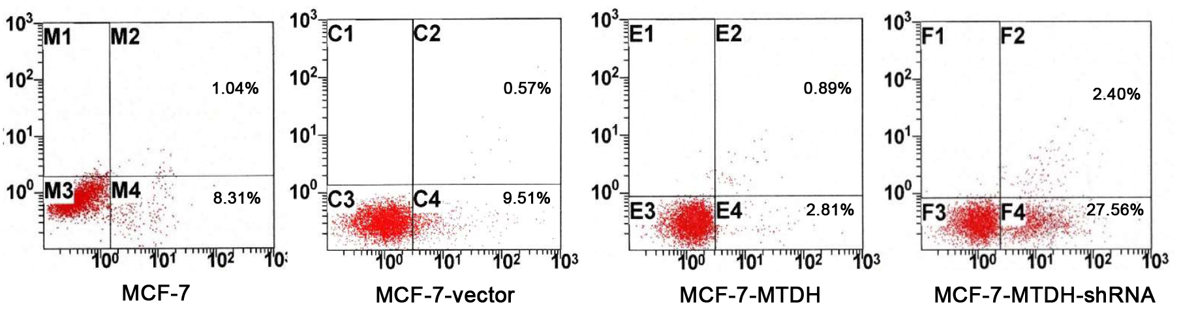

Figure S3. Annexin V-PE/7-AAD assay for determination of apoptosis of different cells after TAX treatment. The apoptosis rate of MCF-7-MTDH-shRNA cells was significantly enhanced as shown by the presence of Annexin-positive cells in Gate 4.

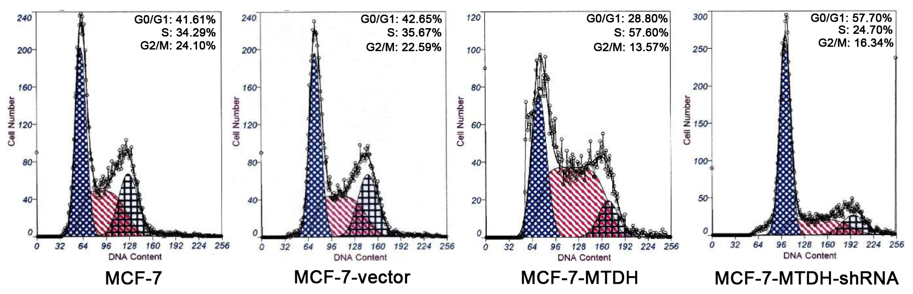
Figure S4. Flow cytometry was adopted to analyze cell cycle after cells overexpressing or knocking-downing MTDH. Overexpression of MTDH arrested cells in S phase, while MTDH silencing increased the proportion of G0/G1 phase.

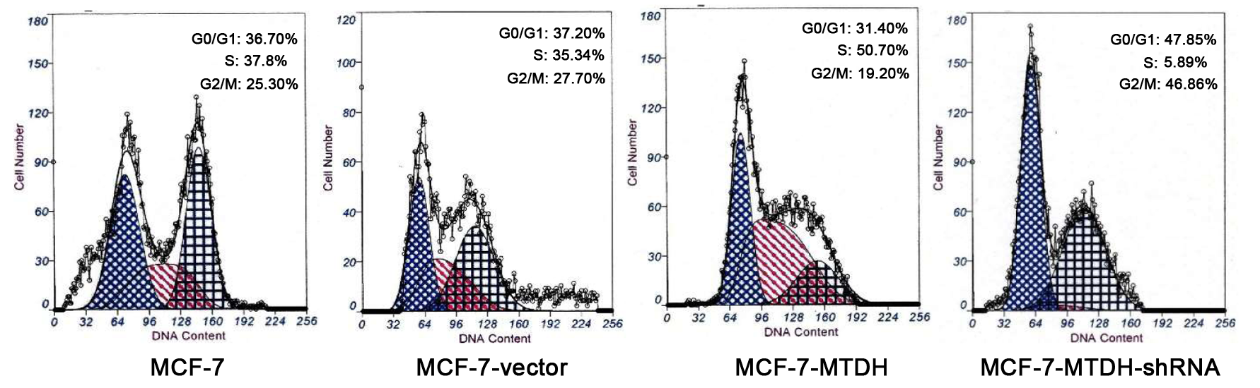
Figure S5. Cell-cycle assay for different cells after TAX treatment. The G2/M phase rate of MCF-7-MTDH-shRNA cells was significantly enhanced as shown by the presence of G2/M cells in Gate 4.

Figure S6. TAX release from the polymer NPs. Th-NPs were resuspended in PBS at either pH 7.4 or 4.4, and transferred to dialysis bags placed in 30 ml of PBS with stirring at 110 rpm/37 °C. At the indicated time points, the environmental buffer solution was removed, and detected for TAX amount by UV-absorbance assay. The NPs showed a faster release rate for TAX over time in PBS at pH 4.4 than at pH 7.4. Each bar represents the mean ± SD of three replicates.

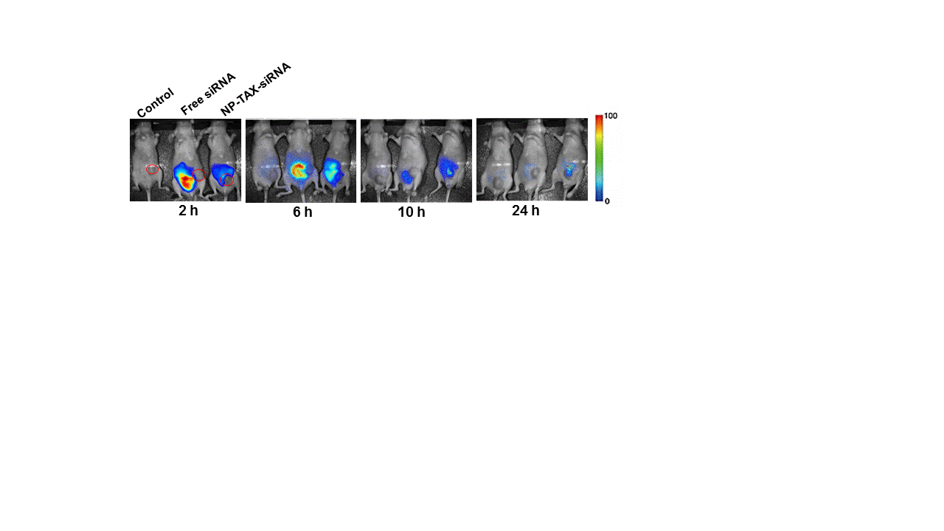
Figure S7. In vivo tumor targeting of the NPs. Nude mice bearing MCF-7 tumors (~100 mm³) were given a single intravenous injection of Cy5.5-labeled free siRNA or NP-TAX-siRNA by tail vein. In vivo fluorescence signals were recorded using a Maestro 2.10.0 imaging system for up to 24 hours post-injection. The red circles indicate the tumor.

