Additional file 1

1. Rapid onset of breast erythema, edema and/or peau d’orange, and/or warm breast, with or without an underlying palpable mass.
2. Duration of history of no more than 6 months.
3. Erythema occupying at least one-third of the breast.
4. Pathologic confirmation of invasive breast carcinoma.
Table S1 Minimum criteria required for the diagnosis of IBC

 |  | PD-L1-  sTIL | PD-L1+  sTIL | P- value  (χ² test) | P- value  (GLM)
cN-stage | 0 | 5 | 1 | 0.6
 | 1 | 37 | 16 | 0.6
 | 2 | 36 | 16 | 0.6
 | 3 | 17 | 12 | 0.6
cM-stage | 0 | 70 | 33 | 1
 | 1 | 28 | 12 | 1
Pathological type | Ductal | 90 | 44 | 0.4
 | Lobular | 5 | 0 | 0.4
 | Mixed | 2 | 1 | 0.4
Differentiation | Grade 1 | 3 | 0 | 0.01
 | Grade 2 | 30 | 5 | 0.01 | 0.75
 | Grade 3 | 57 | 38 | 0.01 | 0.44
ER | Negative | 41 | 26 | 0.1
 | Positive | 55 | 19 | 0.1
PgR | Negative | 51 | 26 | 0.6
 | Positive | 43 | 19 | 0.6
HER2+ | Negative | 38 | 25 | 0.8
 | Positive | 58 | 20 | 0.8
Molecular subtype | HR+ | 56 | 20 | 0.2
 | HR-HER2+ | 19 | 11 | 0.2
 | HR-HER2- | 18 | 14 | 0.2
sTIL | < 10% | 31 | 7 | <0.001
 | >=10 – < 40% | 27 | 28 | <0.001 | 0.02
 | >= 40 % | 3 | 10 | <0.001 | 0.001

Table S2 Correlation between PD-L1 and clinicopathological tumour characteristics. P- Values for the PD-L1+ sTIL group compared to the PD-L1- sTIL group. (Pearson Chi² test). In a multivariate model, only the strong correlation between PD-L1 positivity and sTIL scores remained significant.

A. Logistic multivariate model for pCR after NACT
Parameter | Odds ratio | Lower 95% CI | Higher 95% CI | P-value
sTIL score | 1.00 | 0.99 | 1.01 | 0.74
PD-L1 (IC) | 1.22 | 1.07 | 1.40 | 0.005
(Intercept) | 1.10 | 0.942 | 1.27 | 0.24
B. Logistic multivariate model with additional significant prognostic parameters
Parameter | Odds ratio | Lower 95% CI | Higher 95% CI | P-value
(Intercept) | 1.00 | 0.67 | 1.52 | 0.98
cN stage | 0.92 | 0.80 | 1.06 | 0.24
HR status | 1.02 | 0.82 | 1.26 | 0.86
sTIL score | 1.00 | 0.99 | 1.01 | 0.70
Taxane therapy | 1.27 | 0.89 | 1.79 | 0.18
PD-L1 (IC) | 1.22 | 1.06 | 1.40 | 0.007
Table S3 A. In a logistic multivariate model, PD-L1 expression on IC remained significant for predicting pCR. B. In a logistic multivariate model with the addition of cN stage, HR status and sTIL score (the 3 prognostic parameters for patients with initially localized disease): PD-L1 expression remained the only significant predictor for pCR after NACT.

 |  |  | P- Value (vs IBC)
Mean age | 58.4 y (30.0 y –94.6 y) |  | = .30
Mean sTIL score | 22.3%, 95% CI: 18.6 %– 25.94% |  | = .07
Menopausal status | Premenopausal | 23.9 %) | = .44
 | Postmenopausal | 76.1 %) | = .44
cN-stage | 0 | 61.4% | < .001
 | 1 | 23.9% | < .001
 | 2 | 11.4% | < .001
 | 3 | 3.4% | < .001
cM-stage | 0 | 100% | < .001
 | 1 | 0.0% | < .001
APO | Ductal | 94.3% | = .49
 | Lobular | 5.7% | = .49
 | Mixed | 0.0% | = .49
Differentiation | Grade 1 | 8.0% | =.13
 | Grade 2 | 23.9% | =.13
 | Grade 3 | 68.2% | =.13
HR | Negative | 40.4% | =.53
 | Positive | 59.6% | =.53
HER2+ | Negative | 61.7% | =.38
 | Positive | 38.2% | =.38
Molecular subtype | Luminal | 57.0% | =.91
 | HER2+ | 18.3% | =.91
 | TN | 24.6% | =.91
sTIL | < 10% | 31.0% | =.23
 | >=10 – < 40% | 48.6% | =.23
 | >= 40 % | 20.4% | =.23
PD-L1 immune cells | < 1% | 76.3% | =.006
 | >= 1 % - <5% | 18.7% | =.006
 | >= 5% - < 10% | 3.6% | =.006
 | >= 10% | 1.4% | =.006
Table S4 Patient and tumor characteristics of the nIBC control group. P- Values for the nIBC patients compared to the IBC cohort (Pearson Chi² test, ANOVA for mean age and sTIL score)

 | Lung |  | Liver |  | Bone |  | Brain
 | M- (63/92)  68.5 % | M+  (29/92)  31.5% | M-  (25/92)  27.1% | M+  (57/92)  61.9% | M-  (50/92)  54.3% | M+  (42/92)  45.7% | M-  (59/92)  64.1% | M+  (33/92)  35.9%
cM0 (52/92)  56.5 % | 37 | 15 | 26 | 26 | 30 | 22 | 31 | 21
cM1 (40/92)  43.5 % | 26 | 14 | 9 | 31 | 20 | 20 | 28 | 12
Table S5 Frequencies of organ-specific metastases of all patients that developed distant disease: 56,5% of the patients developed metastases during therapy or follow-up (M0) while 43.5% of the patients already had distant metastasis at the moment of diagnosis (M1). M-: No metastasis, M+: Metastasis.

 |  |  | P- Value (vs IBC GZA)
APO (n= 64) | Ductal (n= 54) | 84.4% | 0.1
 | Lobular (n= 7) | 11.0 % | 0.1
 | Mixed (n= 3) | 4.7 % | 0.1
Differentiation (n= 61) | Grade 1 (n= 5) | 8.2 % | 0.07
 | Grade 2 (n= 15) | 24.6 % | 0.07
 | Grade 3 (n= 41) | 67.2 % | 0.07
ER (n= 64) | Negative (n= 26) | 40.6% | 0.4
 | Positive (n= 38) | 59.4 % | 0.4
PgR (n= 64) | Negative (n= 31) | 48.4 % | 0.08
 | Positive (n= 33) | 51.6 % | 0.08
HR (n= 64) | Negative (n= 25) | 39.1 % | 0.5
 | Positive (n= 39) | 60.9 % | 0.5
HER2+ (n= 52) | Negative (n= 34) | 65.4 % | 0.2
 | Positive (n= 18) | 34.6 % | 0.2
Molecular subtype (n= 52) | Luminal (n= 31) | 59.6 % | 0.2
 | HER2+ (n= 9) | 17.3 % | 0.2
 | TN (n= 12) | 23.1 % | 0.2
sTIL (n= 64) | < 10% (n= 21) | 32.8 % | 0.9
 | >=10 – < 40% (n= 34) | 53.1 % | 0.9
 | >= 40 % (n= 9) | 14.0 % | 0.9
PD-L1 immune cells (n= 62) | < 1% (n= 38) | 61.3 % | 0.8
 | >= 1 % - <5% (n= 16) | 25.8 % | 0.8
 | >= 5% - < 10% (n= 7) | 11.2 % | 0.8
 | >= 10% (n= 1) | 1.6 % | 0.8
Mean sTIL score | 18.5 %, 95% CI: 14.7 %– 22.2 % |  | 0.8
Table S6 Patient and tumor characteristics of the IBC Validation Cohort from Marseille. (n) = number of patients. P- Values for the IBC patients from Antwerp compared to the IBC cohort from Marseille (Pearson Chi² test, ANOVA for mean sTIL score) show no significant differences between both IBC populations.

A.

B.
Figure S1 Neo-adjuvant chemotherapy A. 91 out of 103 patients without metastatic disease on diagnosis (88.3%) completed neo-adjuvant chemotherapy. 83 patients underwent a subsequent mastectomy (91.2%). B. An anthracycline based regime (Epirubicin or Doxorubicin, n=78/91, 85.7%) combined with a taxane (Docetaxel or Paclitaxel, n=74/91, 81.3%) was the most common type of NACT.

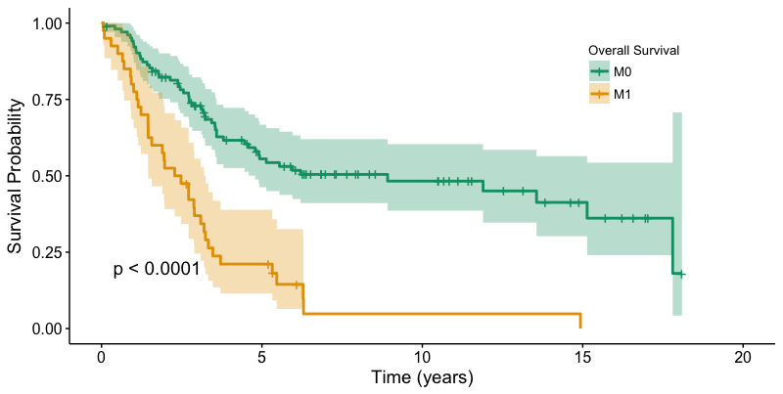
Figure S2 A. RFS: After 5 years, more than half of the patients (53.3%) had relapsed. B. Overall survival in the total IBC population (143 patients): Patients with initially localized disease live significantly longer than patients with primary metastatic disease (Median OS: 8.92 years vs. 2.38 years, p < 0.0001)

A. 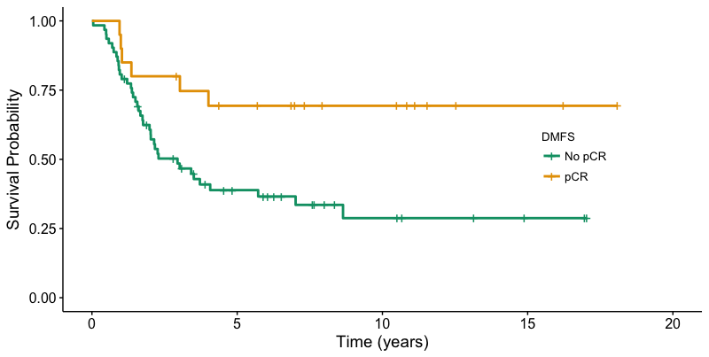
χ² = 6.1, P= 0.01
5y DMFS: 38.4 % vs. 69.3%
B. 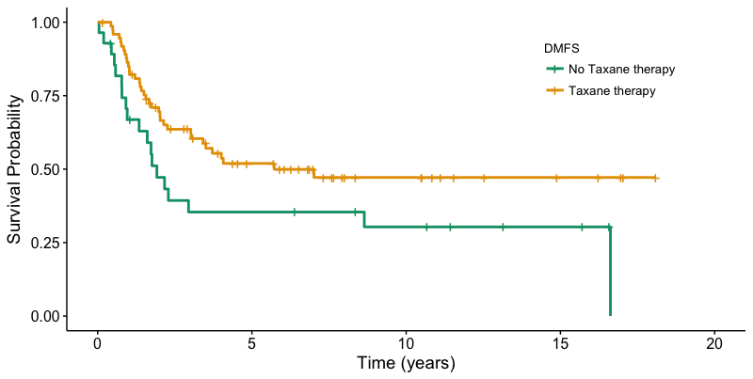
χ² = 4.4-, P= 0.03
5y DMFS: 35.4% vs. 51.9%
C. 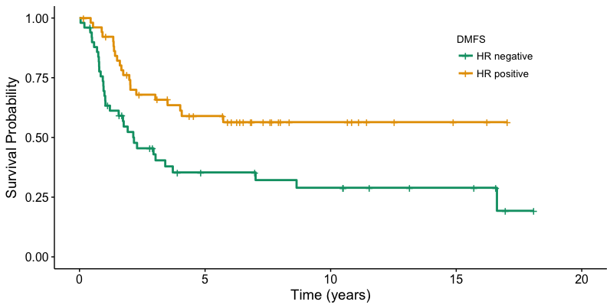
χ² = 8.3, P= 0.004
5y DMFS: 35.4% vs. 59.0%
D. 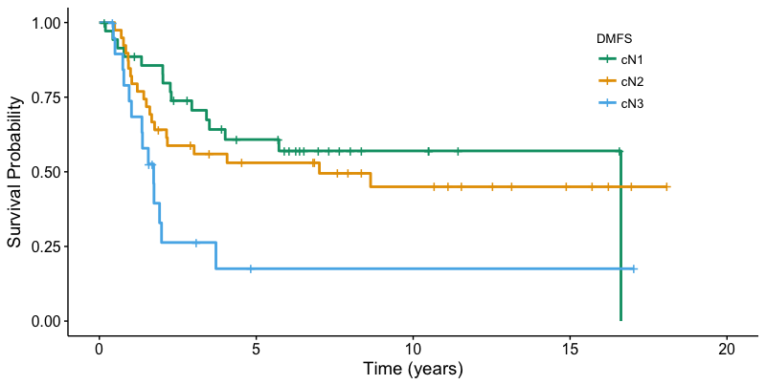
χ² = 9.8, P= 0.007
5y DMFS: 17.5% vs. 53.0% vs. 60.8%
χ² = 5, P= 0.02
5y DMFS: 27.8% vs. 51.2%
Figure S3 Kaplan Meier curves of significant prognostic variables for RFS: A. pCR after NACT B. Taxane containing chemotherapy, C. Hormone receptor status and D. Nodal status

A.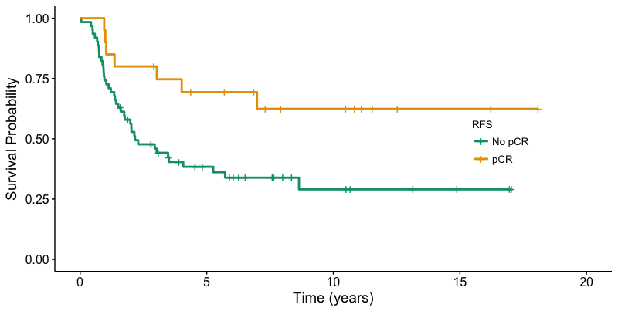
χ² = 6.1, P= 0.01
5y RFS: 38.4% vs. 69.3%
B.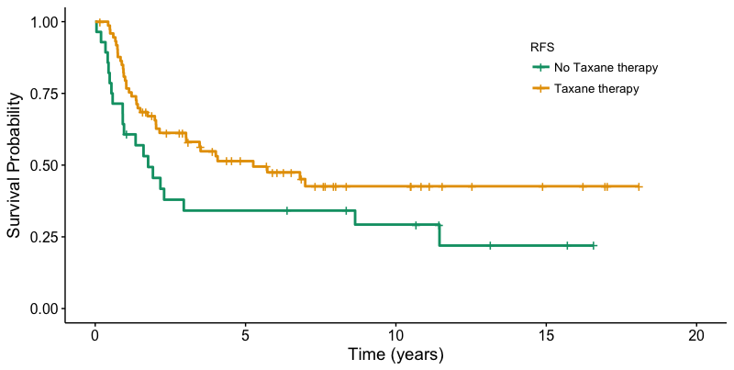
χ² = 3.8, P= 0.05
5y RFS: 34.2% vs. 51.4%
C.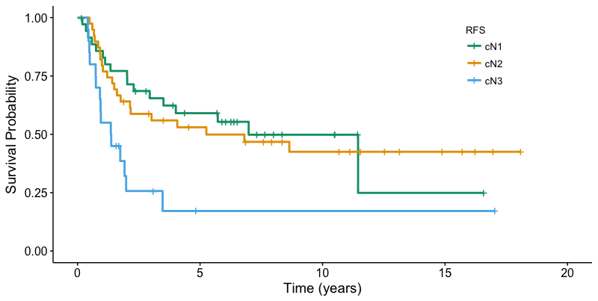
χ² = 10.4, P= 0.005
5y RFS: 17.1% vs. 53.0% vs. 59.1%
D. 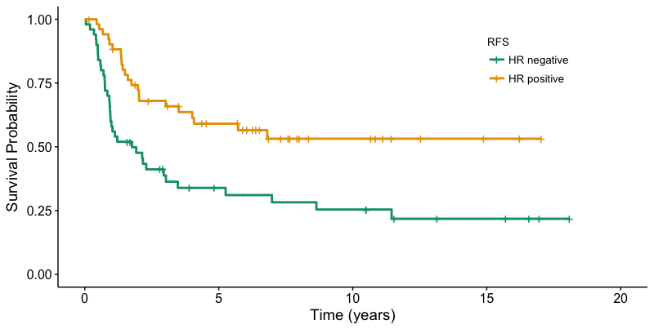Figure S4 Kaplan Meier curves of significant prognostic variables for DMFS: A. pCR after NACT, B. Taxane containing chemotherapy, C. Nodal status and D. HR status
χ² = 10.5, P= 0.001
5y RFS: 33.9% vs. 59.1%

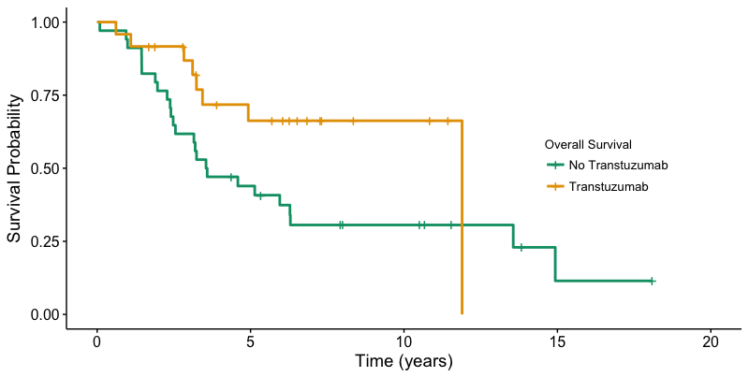

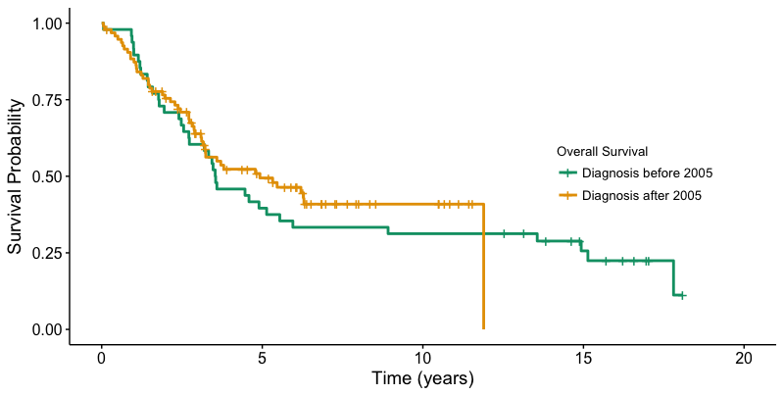
Figure S5 A. Kaplan Meier curve showing significant survival benefit for HER2 positive IBC patients that received trastuzumab. 5y OS: 66.2% vs 43.9%, χ² = 4.11, P= 0.042 B. Kaplan Meier curves showing no significant survival difference between patients diagnosed before or after 31/12/2005, when trastuzumab was added to the treatment of HER2 positive IBC. P= 0.50.

Figure S6 Clinicopathological characteristics of the validation cohort: A. Distribution of the molecular subtypes (n= 52). Luminal (HR+): 59.6% (n= 31), HER2+: 17.3% (n= 9), TN: 23.4 % (n= 12). B. Distribution of the stromal TIL scores (n= 64); respectively 32.8 %(n= 21), 53.1 % (n= 34), 14.0 % (n= 9). There is a strong correlation with PD-L1 immunoreactivity on immune cells (χ2 = 43.9, P< 0.001)

Figure S7 Patients that had a complete pathological response (17/57) showed more PD-L1 immunoreactivity (52.9% PD-L1+ IC) than patients without a complete response (40/57, 32.5% PD-L1+ IC), although this did not reach statistical significance in the validation cohort. χ² = 3.4, P= 0.18.

Figure S8 An overview of all clinicopathological values and the χ² value in the tables shows that in the validation cohort no variable had prognostic significance for OS or DFS.

Figure S9 PD-L1 antigenicity decreases over time. There was a correlation between year of diagnosis and PD-L1 positivity on immune cells (P= 0.03). However, in a multivariate model, with sTIL score and differentiation, this effect was not significant anymore (P= 0.08).

