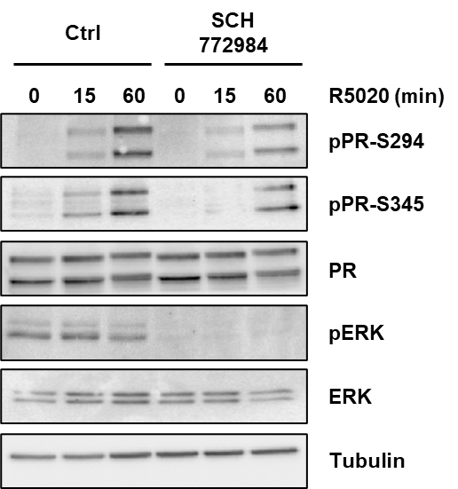

Additional File 4: Effect of ERK inhibitor on PR phosphorylation

