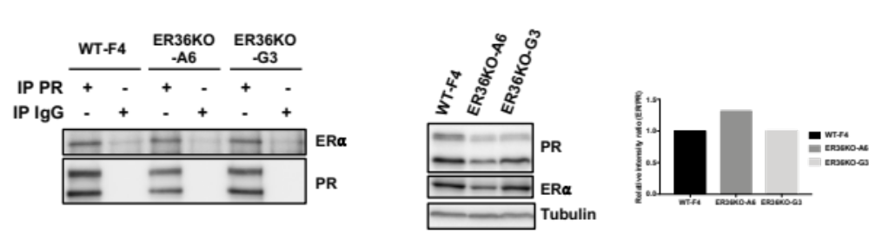

Additional File 7: Study of PR/ERα interaction
Cell extracts from T47D WTF4 and ERα-36KOA6 and G3 were immunoprecipitated with PR or irrelevant antibodies. Western blotting was then used to evaluate ERα interaction (left-hand panel). ERα, PR and GAPDH expression was studied in the inputs (middle panel). Quantification of IP results was performed (right-hand panel).

