Supplementary Table S1 Association of PD-L1 staining with clinicopathologic factors in estrogen receptor/progesterone receptor positive patients without neoadjuvant chemotherapy

 | TC |  |  | TCIC |  |  | IC |  |  | sTIL level
Factor | Negative  N(%) | Positive  N(%) | Fisher  P value | Negative  N(%) | Positive  N(%) | Fisher  P value | Negative  N(%) | Positive  N(%) | Fisher  P value | Low  N(%) | High  N(%) | Fisher  P value
Age | [N=247] |  |  | [N=247] |  |  | [N=247] |  |  | [N=250]
<50 years | 57(90) | 6(10) | 1 | 50(79) | 13(21) | 0.3214 | 52(83) | 11(17) | 0.1888 | 49(74) | 17(26) | 0.0179
≥50 years | 167(91) | 17(9) |  | 157(85) | 27(15) |  | 164(89) | 20(11) |  | 161(88) | 23(13)
Race/ethnicity | [N=247] |  |  | [N=247] |  |  | [N=247] |  |  | [N=250]
Black | 16(80) | 4(20) | 0.0658 | 11(55) | 9(45) | 0.0013 | 12(60) | 8(40) | 0.0004 | 12(63) | 7(37) | 0.0372
White+Latino | 194(92) | 16(8) |  | 183(87) | 27(13) |  | 191(91) | 19(9) |  | 184(86) | 30(14)
Others | 14(82) | 3(18) |  | 13(76) | 4(24) |  | 13(76) | 4(24) |  | 14(82) | 3(18)
Histologic subtype | [N=247] |  |  | [N=247] |  |  | [N=247] |  |  | [N=250]
IDC | 180(91) | 18(9) | 0.906 | 164(83) | 34(17) | 0.6903 | 169(85) | 29(15) | 0.1083 | 161(81) | 38(19) | 0.0237
ILC | 33(89) | 4(11) |  | 33(89) | 4(11) |  | 36(97) | 1(3) |  | 35(95) | 2(5)
Metaplastic | 0(0) | 0(0) |  | 0(0) | 0(0) |  | 0(0) | 0(0) |  | 0(0) | 0(0)
Mixed IDC/ILC | 11(92) | 1(8) |  | 10(83) | 2(17) |  | 11(92) | 1(8) |  | 14(100) | 0(0)
Histologic grade | [N=247] |  |  | [N=247] |  |  | [N=247] |  |  | [N=250]
1+2 | 189(95) | 9(5) | <0.0001 | 178(90) | 20(10) | <0.0001 | 184(93) | 14(7) | <0.0001 | 184(91) | 18(9) | <0.0001
3 | 35(71) | 14(29) |  | 29(59) | 20(41) |  | 32(65) | 17(35) |  | 26(54) | 22(46)
sTIL level | [N=244] |  |  | [N=244] |  |  | [N=244] |  |  | NA
<10% | 195(95) | 10(5) | <0.0001 | 188(92) | 17(8) | <0.0001 | 195(95) | 10(5) | <0.0001
≥10% | 26(67) | 13(33) |  | 17(44) | 22(56) |  | 18(46) | 21(54)
Tumor size | [N=247] |  |  | [N=247] |  |  | [N=247] |  |  | [N=250]
≤2cm | 128(91) | 13(9) | 0.798 | 117(83) | 24(17) | 0.3084 | 121(86) | 20(14) | 0.4964 | 125(86) | 20(14) | 0.0912
>2 to 5cm | 75(89) | 9(11) |  | 69(82) | 15(18) |  | 74(88) | 10(12) |  | 65(77) | 19(23)
>5cm | 21(95) | 1(5) |  | 21(95) | 1(5) |  | 21(95) | 1(5) |  | 20(95) | 1(5)
pN | [N=245] |  |  | [N=245] |  |  | [N=245] |  |  | [N=248]
(y)pN0 | 148(92) | 13(8) | 0.1514 | 136(84) | 25(16) | 0.6107 | 140(87) | 21(13) | 0.3148 | 137(85) | 25(15) | 0.9537
(y)pN1 | 65(92) | 6(8) |  | 60(85) | 11(15) |  | 63(89) | 8(11) |  | 59(82) | 13(18)
(y)pN2 | 6(86) | 1(14) |  | 6(86) | 1(14) |  | 7(100) | 0(0) |  | 7(88) | 1(13)
(y)pN3 | 4(67) | 2(33) |  | 4(67) | 2(33) |  | 4(67) | 2(33) |  | 5(83) | 1(17)
pM | [N=245] |  |  | [N=245] |  |  | [N=245] |  |  | [N=248]
0 | 221(91) | 21(9) | 0.2468 | 204(84) | 38(16) | 0.407 | 211(87) | 31(13) | 1 | 205(84) | 40(16) | 1
1 | 2(67) | 1(33) |  | 2(67) | 1(33) |  | 3(100) | 0(0) |  | 3(100) | 0(0)
pStage | [N=245] |  |  | [N=245] |  |  | [N=245] |  |  | [N=248]
I | 121(92) | 10(8) | 0.134 | 113(86) | 18(14) | 0.4224 | 117(89) | 14(11) | 0.6701 | 117(87) | 17(13) | 0.2297
II | 81(91) | 8(9) |  | 72(81) | 17(19) |  | 75(84) | 14(16) |  | 68(77) | 20(23)
III | 18(82) | 4(18) |  | 18(82) | 4(18) |  | 19(86) | 3(14) |  | 20(87) | 3(13)
IV | 2(67) | 1(33) |  | 2(67) | 1(33) |  | 3(100) | 0(0) |  | 3(100) | 0(0)
IDC: invasive ductal carcinoma; ILC: invasive lobular carcinoma; sTIL: stromal tumor infiltrating lymphocytes.

Supplementary Table S2 Association of PD-L1 staining with clinicopathologic factors in estrogen receptor/progesterone receptor positive patients with neoadjuvant chemotherapy
 | TC |  |  | TCIC |  |  |  | IC |  |  |  | sTIL level
Factor | Negative  N(%) | Positive  N(%) | Fisher  P value | Negative  N(%) | Positive  N(%) |  | Fisher  P value |  | Negative  N(%) | Positive  N(%) | Fisher  P value | Low  N(%) | High  N(%) | Fisher  P value
Age | [N=93] |  |  | [N=87] |  |  |  | [N=87] |  |  |  | [N=95]
<50 years | 31(94) | 2(6) | 0.2862 | 28(90) | 3(10) |  | 1 |  | 29(94) | 2(6) | 1 | 26(76) | 8(24) | 0.254
≥50 years | 59(98) | 1(2) |  | 51(91) | 5(9) |  |  |  | 51(91) | 5(9) |  | 53(87) | 8(13)
Race/ethnicity | [N=93] |  |  | [N=87] |  |  |  | [N=87] |  |  |  | [N=95]
Black | 15(88) | 2(12) | 0.0225 | 14(82) | 3(18) |  | 0.2751 |  | 15(88) | 2(12) | 0.5442 | 13(76) | 4(24) | 0.6672
White+Latino | 66(100) | 0(0) |  | 57(93) | 4(7) |  |  |  | 57(93) | 4(7) |  | 57(84) | 11(16)
Others | 9(90) | 1(10) |  | 8(89) | 1(11) |  |  |  | 8(89) | 1(11) |  | 9(90) | 1(10)
Histologic subtype | [N=93] |  |  | [N=87] |  |  |  | [N=87] |  |  |  | [N=95]
IDC | 70(96) | 3(4) | 1 | 60(88) | 8(12) |  | 0.5545 |  | 61(90) | 7(10) | 0.5317 | 60(80) | 15(20) | 0.5014
ILC | 16(100) | 0(0) |  | 15(100) | 0(0) |  |  |  | 15(100) | 0(0) |  | 15(94) | 1(6)
Metaplastic | 1(100) | 0(0) |  | 1(100) | 0(0) |  |  |  | 1(100) | 0(0) |  | 1(100) | 0(0)
Mixed IDC/ILC | 3(100) | 0(0) |  | 3(100) | 0(0) |  |  |  | 3(100) | 0(0) |  | 3(100) | 0(0)
Histologic gradeª | [N=93] |  |  | [N=87] |  |  |  | [N=87] |  |  |  | [N=95]
1+2 | 63(100) | 0(0) | 0.0313 | 57(95) | 3(5) |  | 0.101 |  | 57(95) | 3(5) | 0.1965 | 57(88) | 8(12) | 0.1375
3 | 27(90) | 3(10) |  | 22(81) | 5(19) |  |  |  | 23(85) | 4(15) |  | 22(73) | 8(27)
sTIL level | [N=93] |  |  | [N=87] |  |  |  | [N=87] |  |  |  | NA
<10% | 77(100) | 0(0) | 0.0043 | 70(97) | 2(3) |  | 0.0002 |  | 70(97) | 2(3) | 0.0014
≥10% | 13(81) | 3(19) |  | 9(60) | 6(40) |  |  |  | 10(67) | 5(33)
Tumor size | [N=93] |  |  | [N=87] |  |  |  | [N=87] |  |  |  | [N=95]
≤2cm | 14(93) | 1(7) | 0.3825 | 11(79) | 3(21) |  | 0.1213 |  | 11(79) | 3(21) | 0.1327 | 11(69) | 5(31) | 0.2305
>2 to 5cm | 40(95) | 2(5) |  | 38(90) | 4(10) |  |  |  | 39(93) | 3(7) |  | 36(84) | 7(16)
>5cm | 36(100) | 0(0) |  | 30(97) | 1(3) |  |  |  | 30(97) | 1(3) |  | 32(89) | 4(11)
ypN | [N=93] |  |  | [N=87] |  |  |  | [N=87] |  |  |  | [N=95]
(y)pN0 | 20(91) | 2(9) | 0.4098 | 18(82) | 4(18) |  | 0.1694 |  | 19(86) | 3(14) | 0.3442 | 17(77) | 5(23) | 0.8713
(y)pN1 | 37(97) | 1(3) |  | 31(89) | 4(11) |  |  |  | 31(89) | 4(11) |  | 34(85) | 6(15)
(y)pN2 | 17(100) | 0(0) |  | 16(100) | 0(0) |  |  |  | 16(100) | 0(0) |  | 14(82) | 3(18)
(y)pN3 | 16(100) | 0(0) |  | 14(100) | 0(0) |  |  |  | 14(100) | 0(0) |  | 14(88) | 2(13)
pM | [N=93] |  |  | [N=87] |  |  |  | [N=87] |  |  |  | [N=95]
0 | 84(97) | 3(3) | 1 | 75(90) | 8(10) |  | 1 |  | 76(92) | 7(8) | 1 | 73(82) | 16(18) | 0.5851
1 | 6(100) | 0(0) |  | 4(100) | 0(0) |  |  |  | 4(100) | 0(0) |  | 6(100) | 0(0)
RCB category | [N=92] |  |  | [N=86] |  |  |  | [N=86] |  |  |  | [N=94]
I | 2(100) | 0(0) | 0.6374 | 2(100) | 0(0) |  | 1 |  | 2(100) | 0(0) | 1 | 2(100) | 0(0) | 1
II | 42(95) | 2(5) |  | 37(90) | 4(10) |  |  |  | 38(93) | 3(7) |  | 38(83) | 8(17)
III | 45(98) | 1(2) |  | 39(91) | 4(9) |  |  |  | 39(91) | 4(9) |  | 38(83) | 8(17)
ªHistologic grade for post-treatment tumors was based on pre-treatment grade.
IDC: invasive ductal carcinoma; ILC: invasive lobular carcinoma; sTIL: stromal tumor infiltrating lymphocytes; RCB: residual cancer burden.

Supplementary Table S3 Association of PD-L1 staining with clinicopathologic factors in HER2 positive patients without neoadjuvant chemotherapy
 | TC [N=31] |  |  | TCIC [N=31] |  |  | IC [N=31] |  |  | sTIL level [N=33]
Factor | Negative  N(%) | Positive  N(%) | Fisher  P value | Negative  N(%) | Positive  N(%) | Fisher  P value | Negative  N(%) | Positive  N(%) | Fisher  P value | Low  N(%) | High  N(%) | Fisher  P value
Age
<50 years | 10(77) | 3(23) | 0.6254 | 6(46) | 7(54) | 0.2623 | 7(54) | 6(46) | 0.1143 | 4(29) | 10(71) | 0.0366
≥50 years | 16(89) | 2(11) |  | 13(72) | 5(28) |  | 15(83) | 3(17) |  | 13(68) | 6(32)
Race/ethnicity
Black | 4(100) | 0(0) | 1 | 2(50) | 2(50) | 1 | 2(50) | 2(50) | 0.69 | 1(20) | 4(80) | 0.1003
White+Latino | 21(81) | 5(19) |  | 16(62) | 10(38) |  | 19(73) | 7(27) |  | 16(59) | 11(41)
Others | 1(100) | 0(0) |  | 1(100) | 0(0) |  | 1(100) | 0(0) |  | 0(0) | 1(100)
Histologic type
IDC | 25(83) | 5(17) | 1 | 18(60) | 12(40) | 1 | 21(70) | 9(30) | 1 | 16(50) | 16(50) | 1
ILC | 1(100) | 0(0) |  | 1(100) | 0(0) |  | 1(100) | 0(0) |  | 1(100) | 0(0)
Histologic grade
1+2 | 13(93) | 1(7) | 0.3445 | 11(79) | 3(21) | 0.1378 | 13(93) | 1(7) | 0.0207 | 9(60) | 6(40) | 0.4905
3 | 13(76) | 4(24) |  | 8(47) | 9(53) |  | 9(53) | 8(47) |  | 8(44) | 10(56)
sTIL level |  |  |  |  |  |  |  |  |  | NA
<10% | 14(88) | 2(13) | 0.6539 | 14(88) | 2(13) | 0.0032 | 16(100) | 0(0) | 0.0002
≥10% | 12(80) | 3(20) |  | 5(33) | 10(67) |  | 6(40) | 9(60)
ER |  |  |  |  |  |  |  |  |  | [N=33]
Negative | 4(50) | 4(50) | 0.0098 | 4(44) | 5(56) | 0.2534 | 6(67) | 3(33) | 1 | 5(56) | 4(44) | 1
Positive | 22(96) | 1(4) |  | 15(68) | 7(32) |  | 16(73) | 6(27) |  | 12(50) | 12(50)
PR |  |  |  |  |  |  |  |  |  | [N=33]
Negative | 8(62) | 5(38) | 0.0076 | 4(29) | 10(71) | 0.0011 | 7(50) | 7(50) | 0.0439 | 6(40) | 9(60) | 0.3028
Positive | 18(100) | 0(0) |  | 15(88) | 2(12) |  | 15(88) | 2(12) |  | 11(61) | 7(39)
Tumor size
≤2cm | 15(88) | 2(12) | 0.6878 | 13(72) | 5(28) | 0.1865 | 14(78) | 4(22) | 0.587 | 10(56) | 8(44) | 0.857
>2 to 5cm | 10(77) | 3(23) |  | 6(50) | 6(50) |  | 7(58) | 5(42) |  | 7(50) | 7(50)
>5cm | 1(100) | 0(0) |  | 0(0) | 1(100) |  | 1(100) | 0(0) |  | 0(0) | 1(100)
pN
(y)pN0 | 19(79) | 5(21) | 0.6873 | 16(64) | 9(36) | 0.3757 | 18(72) | 7(28) | 0.541 | 14(56) | 11(44) | 0.7326
(y)pN1 | 5(100) | 0(0) |  | 3(75) | 1(25) |  | 3(75) | 1(25) |  | 3(50) | 3(50)
(y)pN2 | 1(100) | 0(0) |  | 0(0) | 1(100) |  | 0(0) | 1(100) |  | 0(0) | 1(100)
(y)pN3 | 1(100) | 0(0) |  | 0(0) | 1(100) |  | 1(100) | 0(0) |  | 0(0) | 1(100)
pM
0 | 26(84) | 5(14) | NA | 19(61) | 12(39) | NA | 22(71) | 9(29) | NA | 17(52) | 16(48) | NA
1 | 0(0) | 0(0) |  | 0(0) | 0(0) |  | 0(0) | 0(0) |  | 0(0) | 0(0)
pStage
I | 14(82) | 3(18) | 1 | 13(72) | 5(28) | 0.1285 | 15(83) | 3(17) | 0.2091 | 11(61) | 7(39) | 0.2594
II | 10(83) | 2(17) |  | 6(55) | 5(45) |  | 6(55) | 5(45) |  | 6(46) | 7(54)
III | 2(100) | 0(0) |  | 0(0) | 2(100) |  | 1(50) | 1(50) |  | 0(0) | 2(100)
IV | 0(0) | 0(0) |  | 0(0) | 0(0) |  | 0(0) | 0(0) |  | 0(0) | 0(0)
IDC: invasive ductal carcinoma; ILC: invasive lobular carcinoma; sTIL: stromal tumor infiltrating lymphocytes; ER: estrogen receptor; PR: progesterone receptor.
Supplementary Table S4 Association of PD-L1 staining with clinicopathologic factors in HER2 positive patients with neoadjuvant chemotherapy
 | TC [N=11] |  |  | TCIC [N=10] |  |  | IC [N=10] |  |  | sTIL level [N=13]
Factor | Negative  N(%) | Positive  N(%) | Fisher  P value | Negative  N(%) | Positive  N(%) | Fisher  P value | Negative  N(%) | Positive  N(%) | Fisher  P value | Low  N(%) | High  N(% | Fisher  P value
Age
<50 years | 5(100) | 0(0) | NA | 5(100) | 0(0) | 1 | 5(100) | 0(0) | 1 | 5(83) | 1(17) | 1
≥50 years | 6(100) | 0(0) |  | 4(80) | 1(20) |  | 4(80) | 1(20) |  | 6(86) | 1(14)
Race/ethnicity
Black | 2(100) | 0(0) | NA | 2(100) | 0(0) | 0.1 | 2(100) | 0(0) | 0.1 | 2(100) | 0(0) | 0.5385
White+Latino | 8(100) | 0(0) |  | 7(100) | 0(0) |  | 7(100) | 0(0) |  | 8(89) | 1(11)
Others | 1(100) | 0(0) |  | 0(0) | 1(100) |  | 0(0) | 1(100) |  | 1(50) | 1(50)
Histologic type
IDC | 10(100) | 0(0) | NA | 8(89) | 1(11) | 1 | 8(89) | 1(11) | 1 | 10(83) | 2(17) | 1
ILC | 1(100) | 0(0) |  | 1(100) | 0(0) |  | 1(100) | 0(0) |  | 1(100) | 0(0)
Histologic gradeª
1+2 | 4(100) | 0(0) | NA | 4(100) | 0(0) | 1 | 4(100) | 0(0) | 1 | 6(100) | 0(0) | 0.4615
3 | 7(100) | 0(0) |  | 5(83) | 1(17) |  | 5(83) | 1(17) |  | 5(71) | 2(29)
sTILlevel |  |  |  |  |  |  |  |  |  | NA
<10% | 9(100) | 0(0) | NA | 8(100) | 0(0) | 0.2 | 8(100) | 0(0) | 0.2
≥10% | 2(100) | 0(0) |  | 1(50) | 1(50) |  | 1(50) | 1(50)
ER
Negative | 2(100) | 0(0) | NA | 1(100) | 0(0) | 1 | 1(100) | 0(0) | 1 | 2(100) | 0(0) | 1
Positive | 9(100) | 0(0) |  | 8(89) | 1(11) |  | 8(89) | 1(11) |  | 9(82) | 2(18)
PR
Negative | 4(100) | 0(0) | NA | 3(100) | 0(0) | 1 | 3(100) | 0(0) | 1 | 4(100) | 0(0) | 1
Positive | 7(100) | 0(0) |  | 6(86) | 1(14) |  | 6(86) | 1(14) |  | 7(78) | 2(22)
Tumor size
≤2cm | 3(100) | 0(0) | NA | 2(100) | 0(0) | 1 | 2(100) | 0(0) | 1 | 4(100) | 0(0) | 0.4615
>2 to 5cm | 6(100) | 0(0) |  | 5(83) | 1(17) |  | 5(83) | 1(17) |  | 4(67) | 2(33)
>5cm | 2(100) | 0(0) |  | 2(100) | 0(0) |  | 2(100) | 0(0) |  | 3(100) | 0(0)
ypN
(y)pN0 | 5(100) | 0(0) | NA | 4(100) | 0(0) | 0.3 | 4(100) | 0(0) | 0.3 | 7(100) | 0(0) | 0.0385
(y)pN1 | 2(100) | 0(0) |  | 1(50) | 1(50) |  | 1(50) | 1(50) |  | 1(50) | 1(50)
(y)pN2 | 1(100) | 0(0) |  | 1(100) | 0(0) |  | 1(100) | 0(0) |  | 0(0) | 1(100)
(y)pN3 | 3(100) | 0(0) |  | 3(100) | 0(0) |  | 3(100) | 0(0) |  | 3(100) | 0(0)
pM
0 | 10(100) | 0(0) | NA | 8(89) | 1(11) | 1 | 8(89) | 1(11) | 1 | 10(83) | 2(17) | 1
1 | 1(100) | 0(0) |  | 1(100) | 0(0) |  | 1(100) | 0(0) |  | 1(100) | 0(0)
RCB category
I | 1(100) | 0(0) | NA | 1(100) | 0(0) | 1 | 1(100) | 0(0) | 1 | 2(100) | 0(0) | 0.2692
II | 5(100) | 0(0) |  | 4(100) | 0(0) |  | 4(100) | 0(0) |  | 6(100) | 0(0)
III | 5(100) | 0(0) |  | 4(80) | 1(20) |  | 4(80) | 1(20) |  | 3(60) | 2(40)
ªHistologic grade for post-treatment tumors was based on pre-treatment grade.
IDC: invasive ductal carcinoma; ILC: invasive lobular carcinoma; sTIL: stromal tumor infiltrating lymphocytes; ER: estrogen receptor; PR: progesterone receptor; RCB: residual cancer burden.

Supplementary Table S5 Summary of multivariate analysis in estrogen receptor/progesterone receptor positive patients without neoadjuvant chemotherapy showing the odds ratio (95% confidence interval) of variables significantly associated with PD-L1 scoring methods and sTIL level

Factor |  | TC | TCIC | IC | sTIL level
Age
≥50 vs. <50 years |  |  |  |  | 0.40 (0.18, 0.87)ª
Race/ethnicity
 | White+Latino vs. Black |  |  | 0.16 (0.04, 0.60)^{b}
 | Others vs. Black |  |  | NS
Histologic grade
3 vs. 1+2 |  | 4.60 (1.66,12.73)^{b} | 2.631 (1.10, 6.31)ª |  | 8.760 (4.09, 18.78)^{c}
sTIL level
≥10% vs. <10% |  | 5.25 (1.89, 14.58)^{b} | 9.977 (4.21, 23.65)^{c} | 22.63 (8.76, 58.45)^{c}
ª P value <0.05-0.01.
^{b} P value <0.01-0.001.
^{c} P value <0.001.
NS: Not significant.

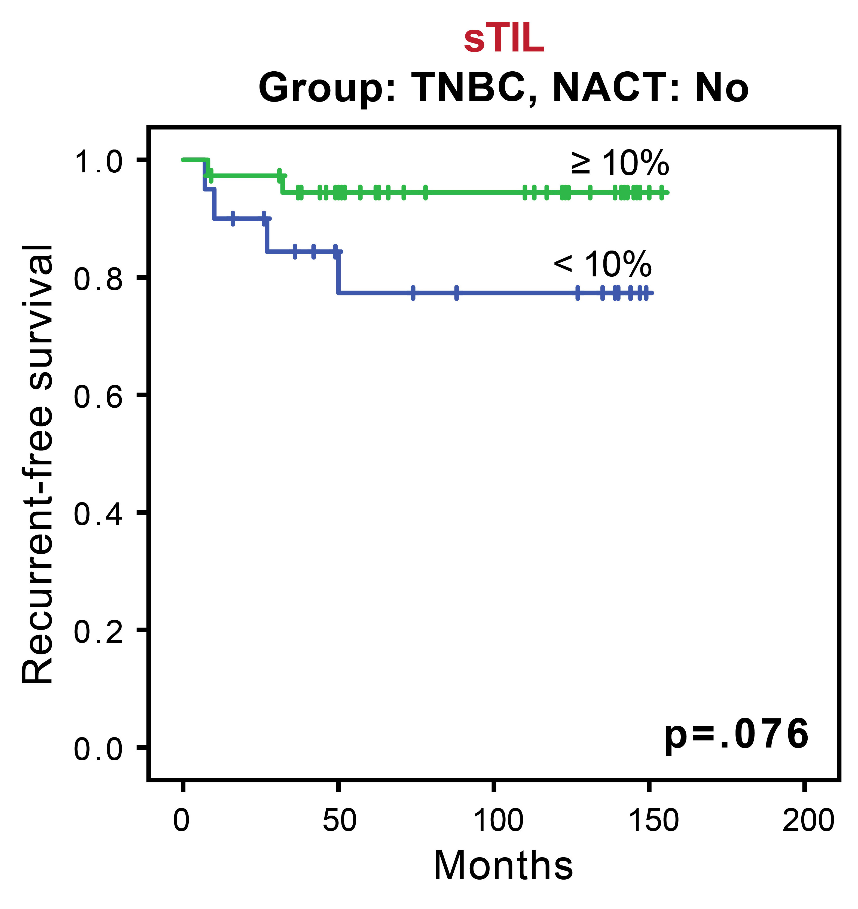
Supplementary Figure S1. Kaplan-Meier plots of recurrence-free survival between tumors with higher stromal tumor-infiltrating lymphocyte level (≥10%) and lower stromal tumor-infiltrating lymphocyte in the triple negative group without neoadjuvant chemotherapy.

