Supplementary Table S1: Linear ACCEPT gates used for the automated enumeration of CTCs and tdEVs.

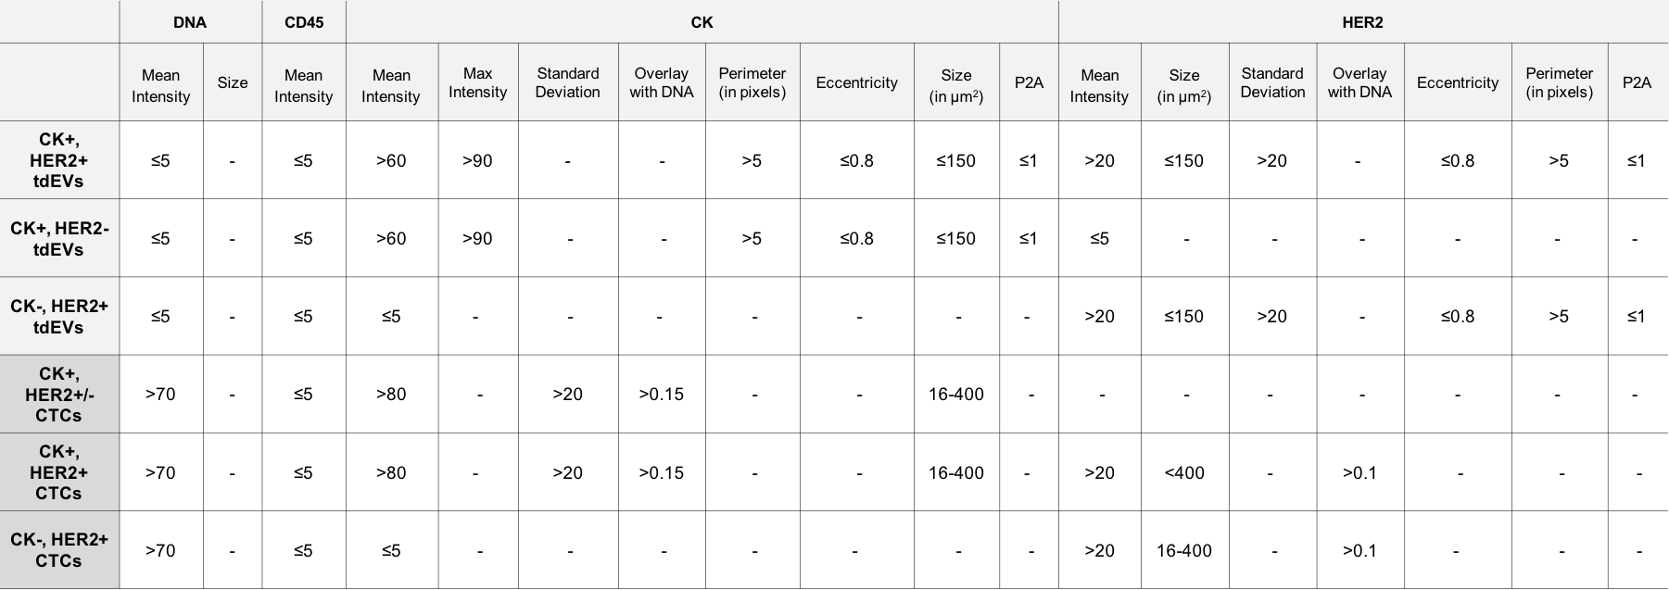

Supplementary Table S2: Univariable Cox regression analyses of CK+ and CK- CTCs and tdEVs after log transformation.

 | Overall survival
 | HR (95% CI) | p-value
log (0.1 + CK⁻ CTCs) | 1.70 (0.94 – 3.08) | 0.081
log (0.1 + CK⁺ CTCs) | 1.41 (0.89 – 2.24) | 0.140
log (0.1 + CK⁻ tdEVs) | 1.32 (0.75 – 2.32) | 0.345
log (0.1 + CK⁺ tdEVs) | 1.69 (1.03 – 2.79) | 0.039

Supplementary Table S3: Sensitivity, specificity and accuracy of ≥ 23% CTCs and ≥ 7% tdEVs, double positive for CK and HER2, as tests to predict the HER2 status of the tissue. The accuracy increases with the total CTCs and tdEVs detected (≥ 1, 5, 10, 20, 50, 100) at the cost of number of eligible patients to be assessed.

HER2+CK+ CTCs / total CTCs | Total CTCs | Patients  N (%) | sensitivity | specificity | accuracy
≥ 23% | ≥1 | 93 (95%) | 65% | 66% | 66%
≥ 23% | ≥5 | 75 (77%) | 59% | 71% | 65%
≥ 23% | ≥10 | 53 (54%) | 47% | 78% | 63%
≥ 23% | ≥20 | 38 (39%) | 46% | 86% | 66%
≥ 23% | ≥50 | 27 (28%) | 60% | 100% | 80%
≥ 23% | ≥100 | 17 (17%) | 67% | 100% | 84%
HER2+CK+ tdEVs / total tdEVs | Total tdEVs | Patients  N (%) | sensitivity | specificity | accuracy
≥ 7% | ≥1 | 98 (100%) | 74% | 74% | 74%
≥ 7% | ≥5 | 92 (94%) | 77% | 74% | 76%
≥ 7% | ≥10 | 85 (87%) | 81% | 75% | 78%
≥ 7% | ≥20 | 69 (70%) | 79% | 77% | 78%
≥ 7% | ≥50 | 48 (49%) | 80% | 89% | 85%
≥ 7% | ≥100 | 36 (37%) | 82% | 100% | 91%

