Figure S12. Kaplan-Meier curves by IHC subtype and grade with and without age-standardisation.

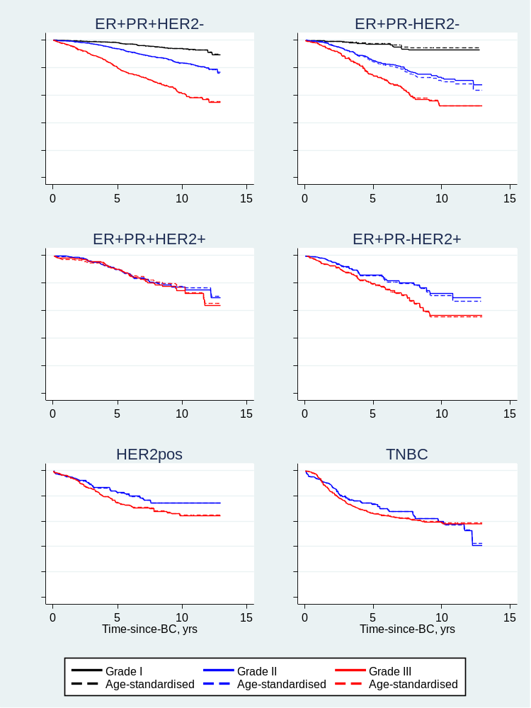

Age-standardised according to overall age-distribution in the sample using age groups (0-44: 14%, 45-54: 29%, 55-64: 33%, 65-74: 24%).

