Figure S13. Kaplan-Meier curves by IHC subtype and pTN status with and without age-standardisation. Restricted to M0.

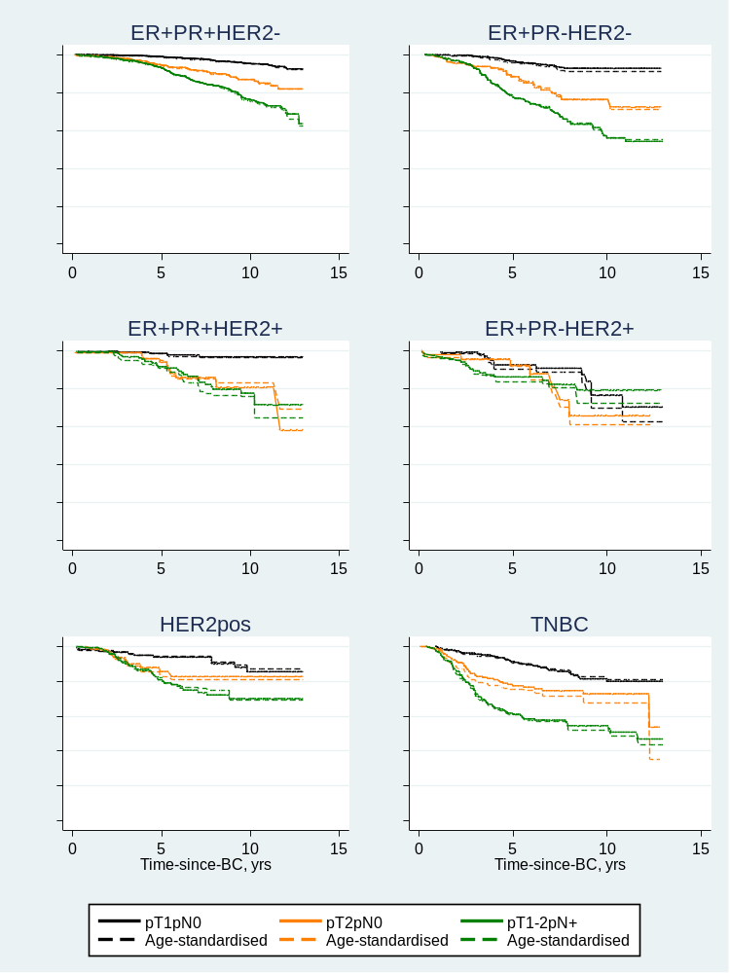
Age-standardised according to overall age-distribution in the sample using age groups (0-44: 14%, 45-54: 29%, 55-64: 33%, 65-74: 24%).

