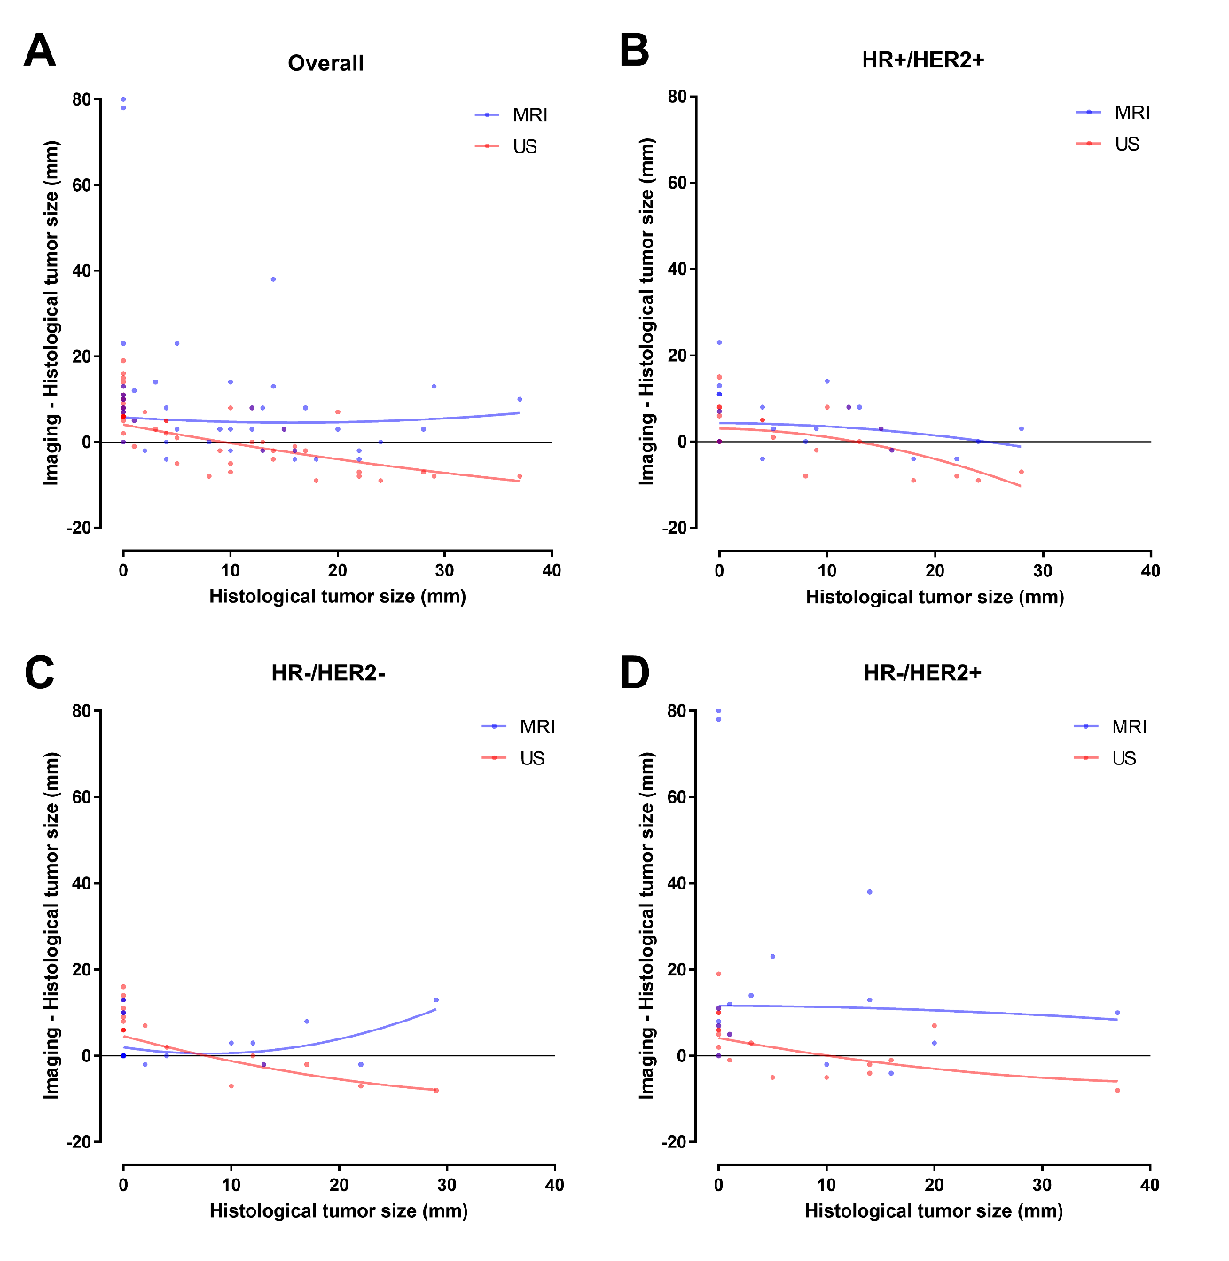

Supplementary Figure 3. Difference between tumor size according to imaging and residual tumor size versus residual tumor size. Data are shown for all patients with both MRI and US (A) and for HR+/HER2+ (B), HR-/HER2- (C) and HR-/HER2+ tumors (D). Quadratic curve was fitted using the least squares method.

