Supplementary Tables
Table 1: The semi-quantitative RT-PCR primers

Gene name  (mRNA ID) | Primer name | Primers sequences (5’-3’) | PCR  product  size (bp)
β-actin  NM_001101.3 | Forw | AAGAGCTACGAGCTGCCTGACG | 420
β-actin  NM_001101.3 | Rev | CGCCTAGAAGCATTTGCGGTGG | 420
Notch1  NM_017617.5 | Forw | TGCACACTATTCTGCCCCAG | 309
Notch1  NM_017617.5 | Rev | ACTTGAAGGCCTCCGGAATG | 309
Twist1  NM_000474.4 | Forw | AGCAACAGCGAGGAAGAGCCAGA | 425
Twist1  NM_000474.4 | Rev | AGGAAGTCGATGTACCTGGCCG | 425

Table 2. The real-time quantitative PCR (QT-PCR) primers

Gene name  (mRNA ID) | Primer name | Primers sequences (5’-3’) | PCR product  size (bp)
β-actin  NM_001101.3 | Forw | CACCATTGGCAATGAGCGGTTCC | 90
β-actin  NM_001101.3 | Rev | GTAGTTTCGTGGATGCCACAGG | 90
Notch1  NM_017617.5 | Forw | GAGGCGTGGCAGACTATGC | 140
Notch1  NM_017617.5 | Rev | CTTGTACTCCGTCAGCGTGA | 140
Twist1  NM_000474.4 | Forw | GTCCGCAGTCTTACGAGGAG | 156
Twist1  NM_000474.4 | Rev | GCTTGAGGGTCTGAATCTTGCT | 156
Snail1  NP_005976.2 |  | ACTGCAACAAGGAATACCTCAG  GCACTGGTACTTCTTGACATCTG | 242
  Forw
  Rev

Supplementary Figures

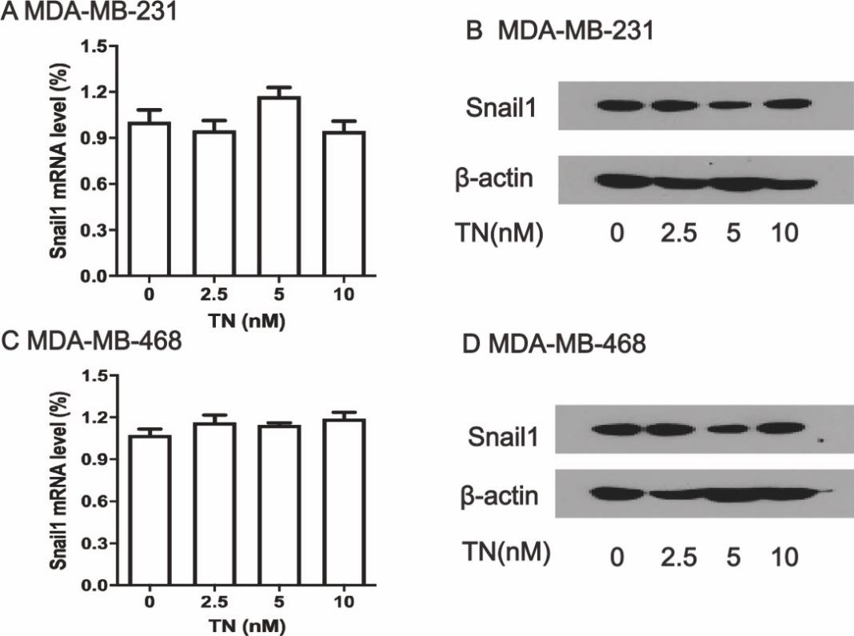
Supplementary Figure S1. Triptonide did not significantly change the levels of Snail1 mRNA and protein in the TNBC MDA-MB-231 and MDA-MB-468 cells.
After MDA-MB-231 and MDA-MB-468 cells were treated with triptonide (TN) at the concentrations of 0-10 nM for 72 h, the levels of Snail1 mRNA were measured by QT-PCR (A, C) and Snail1protein were detected by Western blotting (B, D), respectively. Triptonide do not significantly affect Snail1 expression in TNBC cells. The results represent three independent experiments.

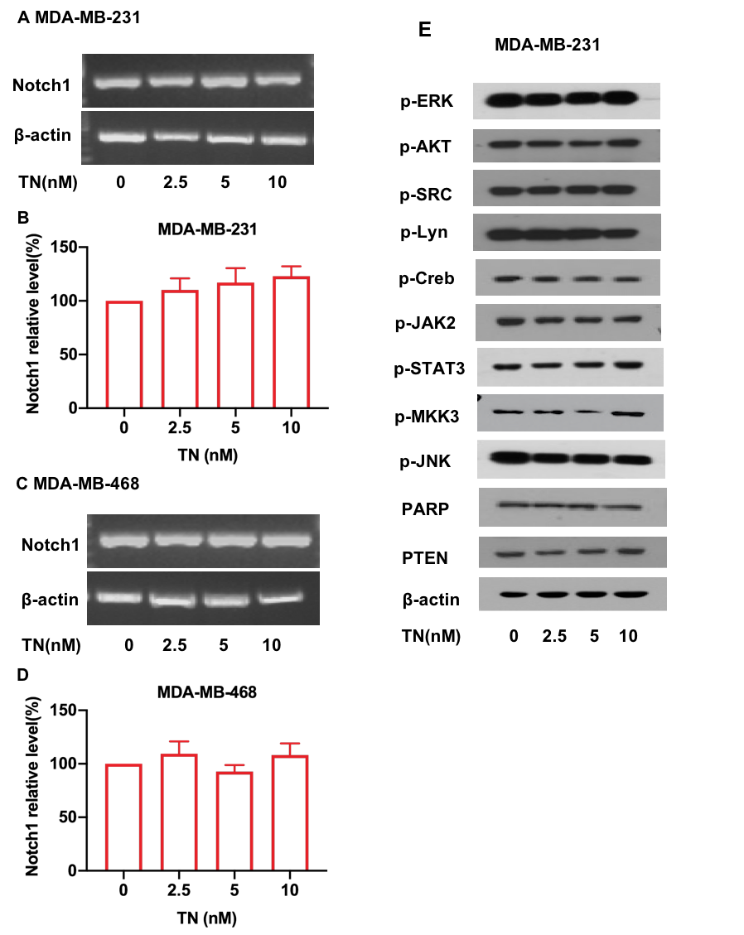
Supplementary Figure S2. Triptonide did not significantly affect the levels of Notch1 mRNA and several signaling proteins in TNBC cells.
Notch1 mRNA levels in MDA-MB-231 and MDA-MB-468 cells were quantitated by RT-PCR (A, C) and QT-PCR (B, D) after treatment by triptonide (TN) at the concentrations of 0-10 nM. The levels of several signaling proteins p-ERK, p-AKT, p-SRC, p-LYN, p-CREB, p-JAK2, p-STAT3, p-MKK3, p-JNK, PARP, and PTEN, were detected by Western blotting (E). The results represent three independent experiments.

