Supplementary information
Table S1. Kinetic model goodness-of-fit statistics with best values highlighted in bold.
Model | Number of fits that  pass the runs test | Median wRSS* error  from LOOCV
Spline-residue | 30/30 | 1.59×10⁵
2C3K | 29/30 | 2.07×10⁵
2C4K | 30/30 | 2.17×10⁵
3C5K | 30/30 | 4.32×10⁶
*Weighted residual sum-of-squares.

Fig. S1. Correlations amongst image measures in the 30-patient dataset. Correlations are shown for all the parameters of the kinetic models fitted to the data, and for SUV and TBR static measures.
Pearson coefficient r
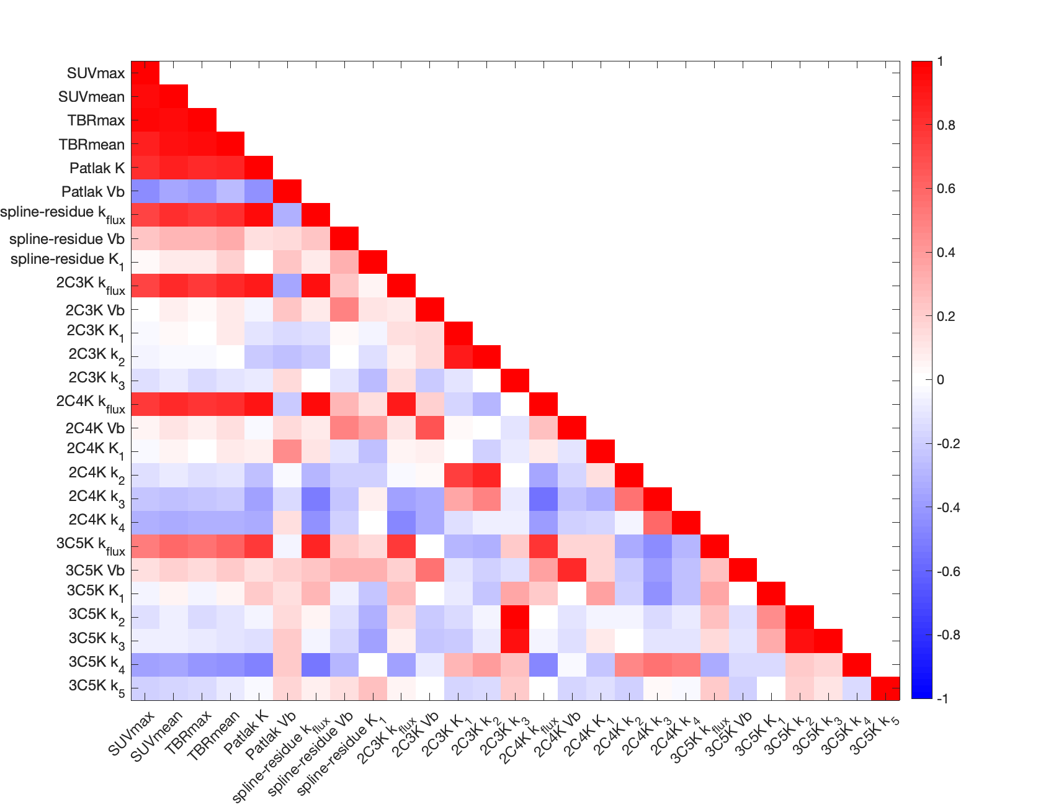
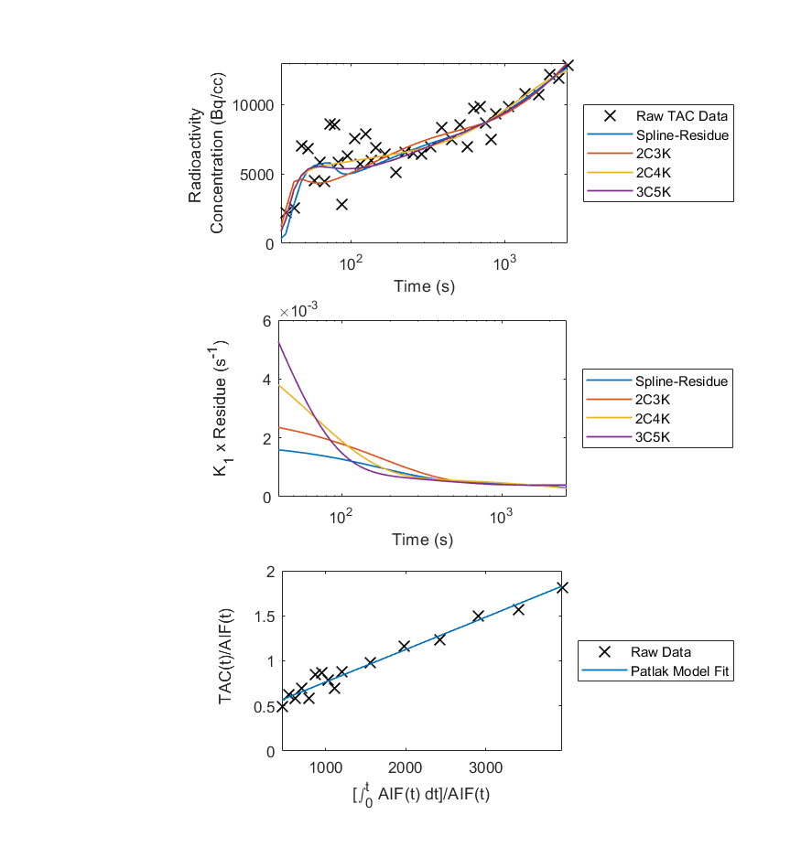
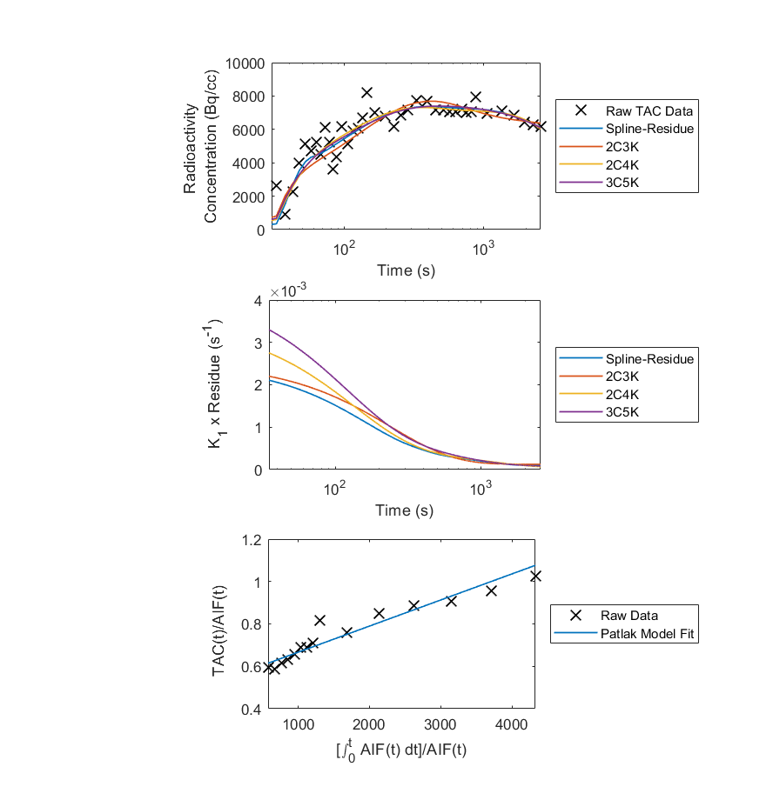
Fig. S2. Examples of kinetic model fits. (a,b) Kinetic model fits to tumour TACs of two patients. (c,d) Impulse response functions (IRFs) associated with the model fits. The IRFs describe the change with time of tumour tracer concentration after injection of a unit impulse of tracer. They are given by the product of K₁ and the residue function, and equal K₁ at the start of imaging and approximate k_{flux} at the end. (e,f) Fits of the Patlak model.
(a)
(b)
(c)
(d)
(e)
(f)

