Additional File 1. Mean predictions of breast tissue chromophores measured from optical spectroscopy (OS) by age at OS measurement quintiles in adolescent daughters and mothers in the Columbia-BCERP Study
- Water content in daughters by age at OS measurement and age at menarche
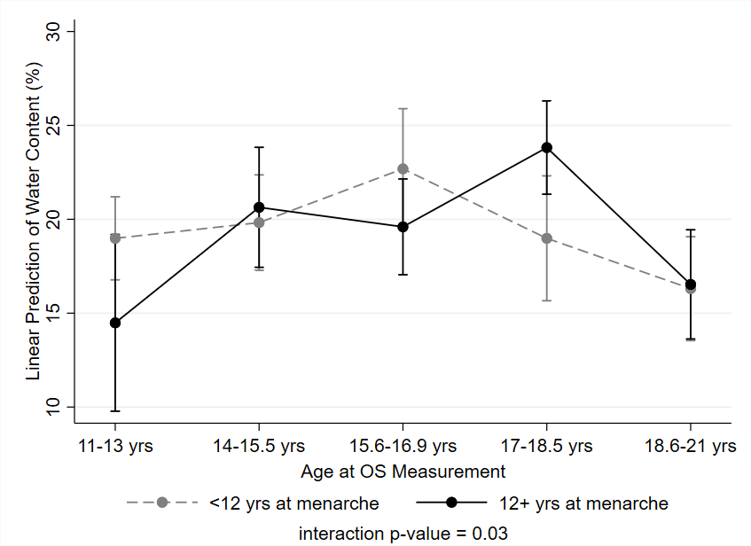
- Lipid content in daughters by age at OS measurement and age at menarche
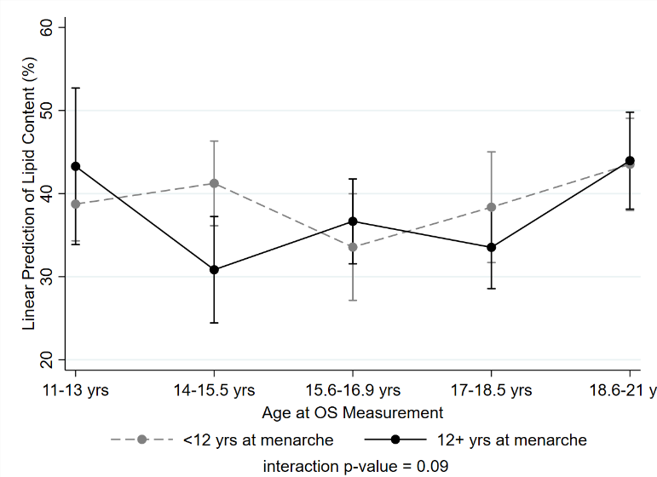
- Collagen content in daughters by age at OS measurement and age at menarche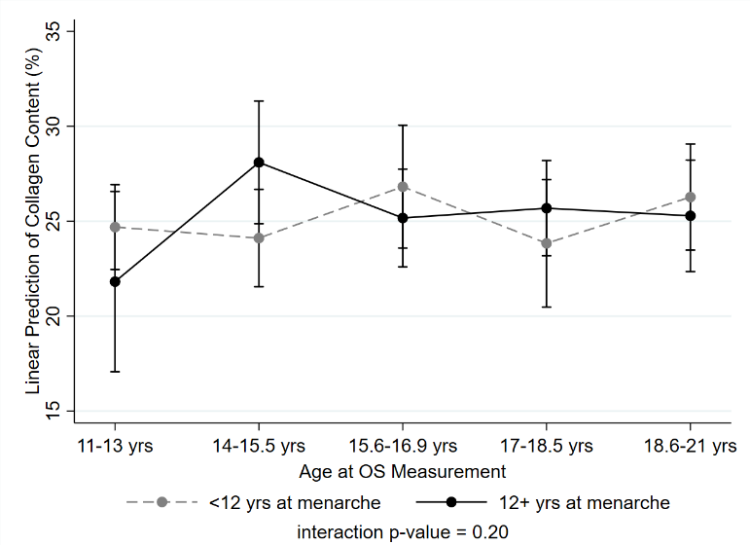
- Water content in mothers by age at OS measurement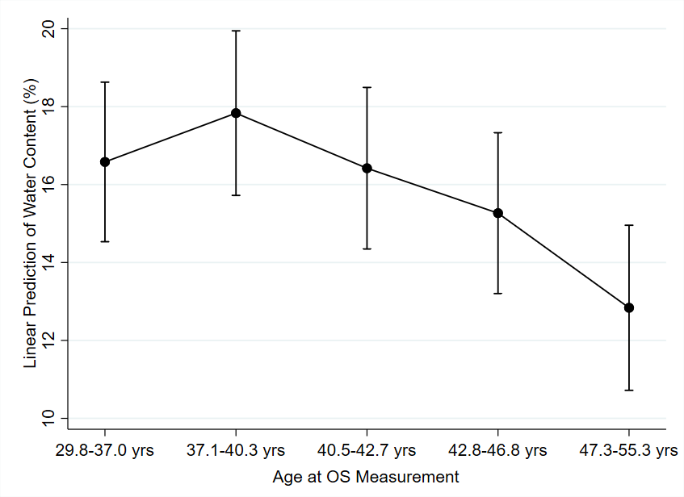
- Lipid content in mothers by age at OS measurement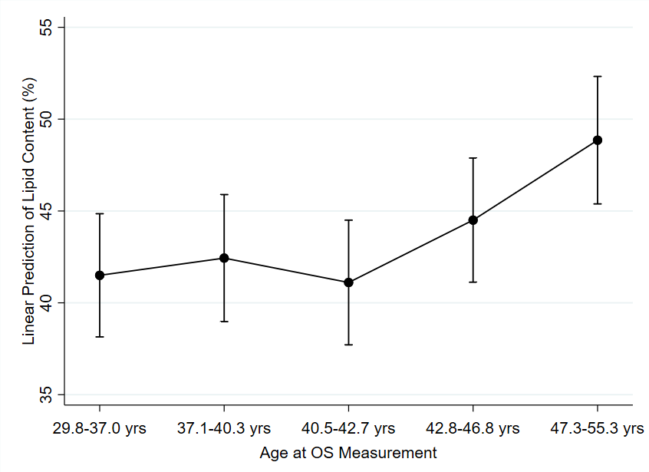

- Collagen content in mothers by age at OS measurement and age at menarche
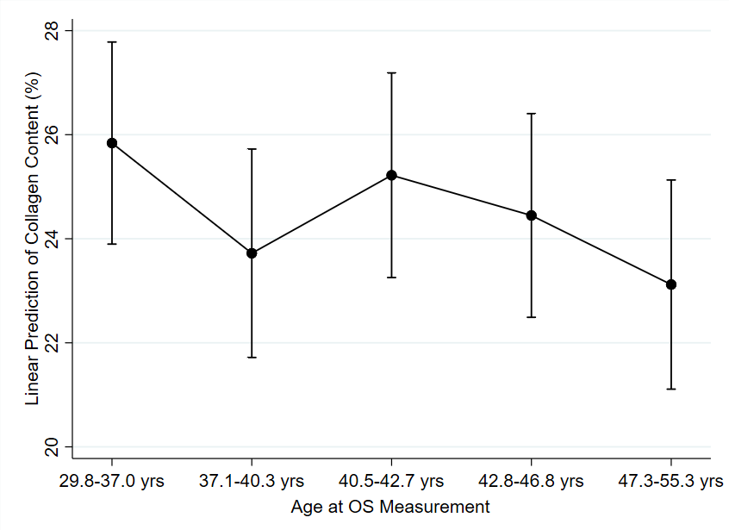

Footnote: Predicted means are adjusted for ethnicity and percent body fat at optical spectroscopy (OS) measurement. Interaction p-values in figures of daughters correspond to the Wald test statistic for the cross-product term between age at OS and menarche predicting BTC.

