Supplemental Figure 1: DFI Benefit From 10 vs 5 y Tamoxifen is Associated with Increasing BCI (H/I) Levels
Continuous risk curves based on DFI after 5- and 10-years of tamoxifen as a function of estrogen receptor (ER), progesterone receptor (PR), androgen receptor (AR), and Ki67 immunohistochemistry (IHC) expression, AR/ER IHC ratio and BCI (H/I) values.
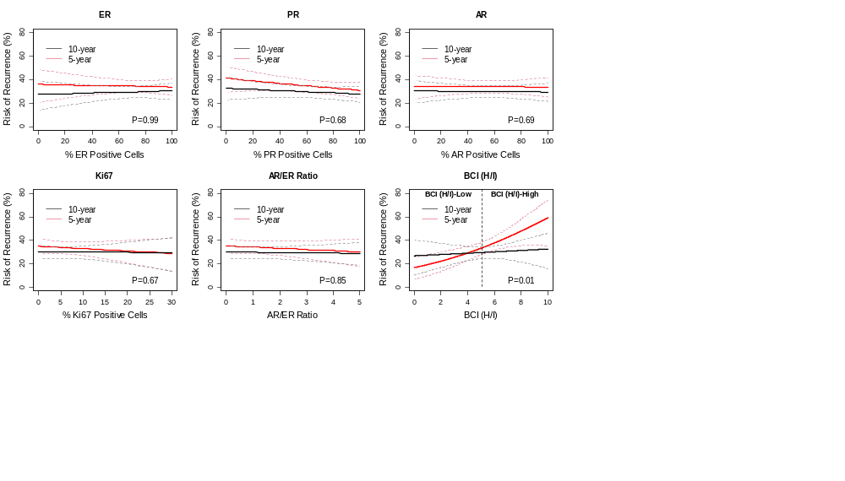

Supplemental Figure 2: DFS Benefit From 10 vs 5 y Tamoxifen is Associated with Increasing BCI (H/I) Levels
Continuous risk curves based on DFS after 5- and 10-years of tamoxifen as a function of estrogen receptor (ER), progesterone receptor (PR), androgen receptor (AR), and Ki67 immunohistochemistry (IHC) expression, AR/ER IHC ratio and BCI (H/I) values.
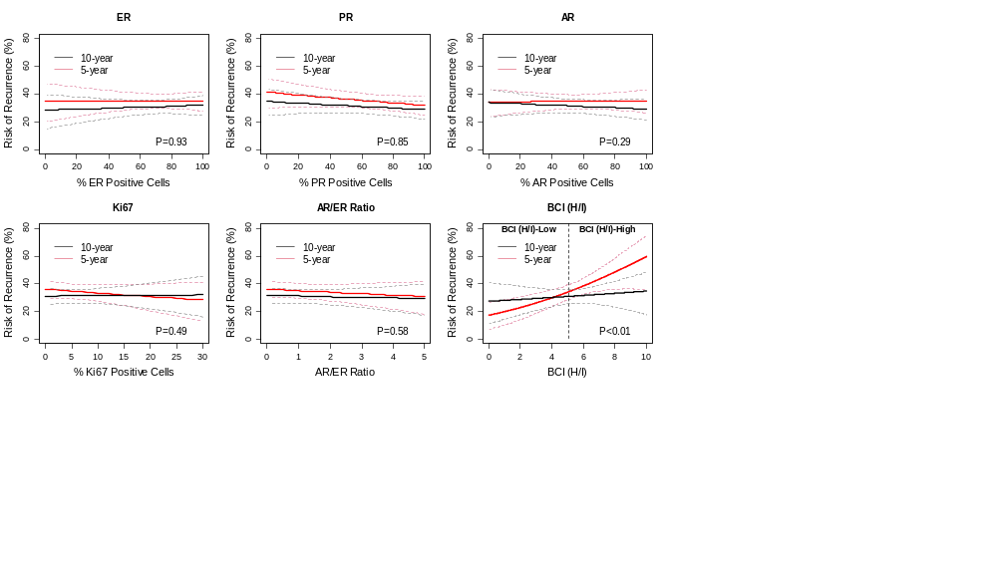

Supplemental Figure 3: Extended Endocrine Benefit From 10 vs 5 y Tamoxifen is Not Associated with Allred scores of ER, PR, or AR , or expression of ER or PR mRNA
Continuous risk curves 5- and 10-years of tamoxifen as a function of the combined proportion and intensity of estrogen receptor (ER), progesterone receptor (PR), androgen receptor (AR), expression, and of ER and PR mRNA.
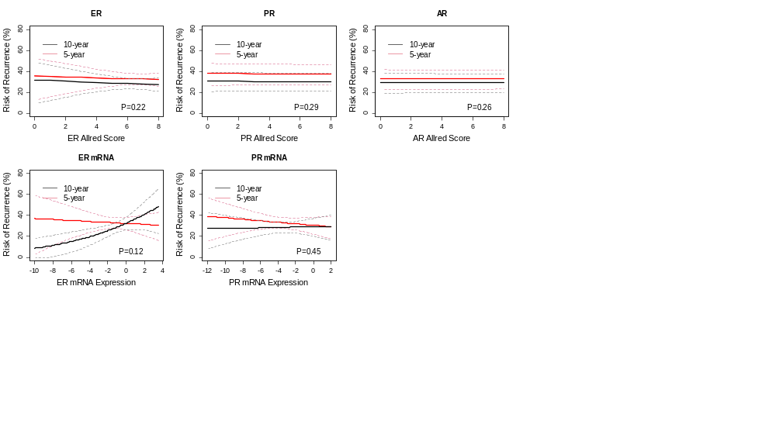

Supplemental Figure 4. Extended Endocrine Benefit From 10 vs 5 y Tamoxifen in the overall HR+ cohort (n=2,445)
Continuous risk curves based on RFI after 5- and 10-years of tamoxifen as a function of estrogen receptor (ER), progesterone receptor (PR), androgen receptor (AR) and Ki67 immunohistochemistry (IHC) expression, AR/ER ratio and BCI (H/I) values
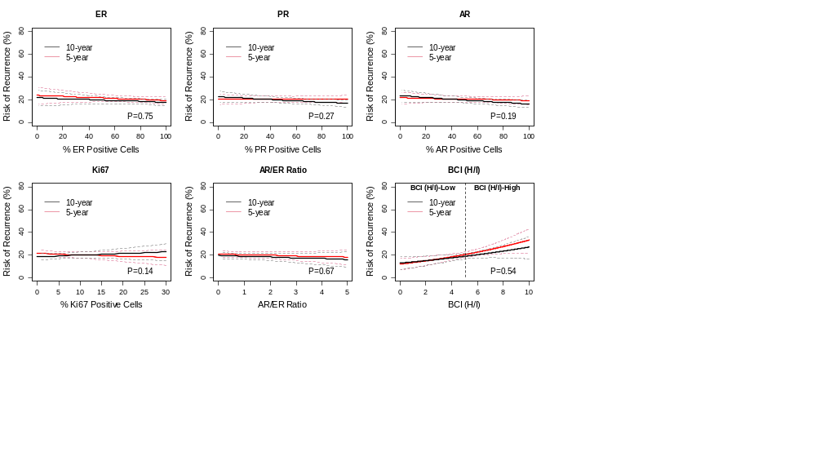

Supplemental Table 1: BCI is Prognostic for Late Distant Recurrence
Prognostic performance of BCI; ER, PR, AR, and Ki67 protein levels; the AR/ER ratio; and ER and PR mRNA.

Biomarker | Inter-quartile HR | P value
BCI | 1.37 | <0.001
ER IHC | 0.92 | 0.165
PR IHC | 0.89 | 0.281
AR IHC | 0.87 | 0.120
Ki67 IHC | 0.96 | 0.489
AR/ER Ratio | 0.99 | 0.484
ER PCR | 1.05 | 0.441
PR PCR | 1.02 | 0.811

