Supplementary materials

Supplementary tables
Table S1. Characteristics at BC diagnosis, treatments in the first 24 months after diagnosis and sick leave in function of the care pathway pattern
Table S2. Characteristics and treatments of women with a sick leave identified in the SNDS
Table S3: BC treatments associated with the likelihood of return to work, univariate analyses and after adjustment for other BC treatments only (model 1), for BC treatments and drug deliveries (model 2), for BC treatments, socioeconomic characteristics, and age (model 3) (n=303)
Table S4: BC care pathway patterns associated with the likelihood of return to work, univariate analyses, and after adjustment for drug deliveries only (model 1), for socioeconomic characteristics and age (model 2) (n=303)
Table S5: BC treatments associated with time to return to work, univariate analyses, and after adjustment for other BC treatments only (model 1), for BC treatments and drug deliveries (model 2), for BC treatments, socioeconomic characteristics, and age (model 3) (n=258)
Table S6: BC care pathways patterns associated with time to return to work, univariate analyses, and after adjustment for drug deliveries only (model 1), and for socioeconomic characteristics and age (model 2) (n=258)

Supplementary Figures
Fig S1: Dendrogram showing the hierarchical clustering of different BC treatment sequences using the optimal matching distances, Ward method.
Fig S2. Cumulative incidence of return to work according to the occupational category.

Table S1. Characteristics at BC diagnosis, treatments in the first 24 months after diagnosis and sick leave in function of the care pathway pattern
 | All women  N=626 |  | Pattern S  N=201 |  | Pattern SR  N=145 |  | Pattern SC  N=102 |  | Pattern SCR  N=107 |  | Pattern SLC  N=71 |  |  |  |  |  |  |  |  | pª
 | N | % | N | % | N | % | N | % | N | % | N |  | %
SL >21 days |  |  |  |  |  |  |  |  |  |  |  |  |  |  |  |  |  |  |  | 0.025
No | 323 | 51.6 | 115 | 57.2 | 84 | 57.9 | 47 | 46.1 | 47 | 43.9 | 30 |  | 42.3
Yes | 303 | 48.4 | 86 | 42.8 | 61 | 42.1 | 55 | 53.9 | 60 | 56.1 | 41 |  | 57.7
SL duration (months) for women with SL >21 days (n=303)
Median, IQR | 9.8 | 4.0-16.7 | 6.1 | 2.2-10.7 | 4.6 | 1.6-9.8 | 12.1 | 8.8-18.2 | 13.2 | 9.7-19.7 | 16.8 |  | 10.4-22.6 |  |  |  |  |  |  | <0.001^{b}
Mean, SD | 11.6 | 9.5 | 7.6 | 8.2 | 7.6 | 8.2 | 14.6 | 9.8 | 15.4 | 8.7 | 16.3 |  | 8.8
Age
Median, IQR | 49.1 | 44.0-54.3 | 49.9 | 45.9-54.8 | 50.6 | 46.8-55.6 | 47.2 | 41.8-52.5 | 47.2 | 42.2-52.0 | 44.4 |  | 40.2-50.5 |  |  |  |  |  |  | <0.001^{b}
Mean, SD | 48.8 | 7.4 | 50.2 | 6.7 | 50.9 | 6.1 | 47.4 | 7.8 | 47.2 | 8.2 | 44.9 |  | 7.5
Household composition |  |  |  |  |  |  |  |  |  |  |  |  |  |  |  |  |  |  |  | 0.002
In couple without <18-year-old children | 241 | 38.5 | 81 | 40.3 | 65 | 44.8 | 39 | 38.2 | 35 | 32.7 | 21 |  |  | 29.6
In couple with <18-year-old children | 170 | 27.2 | 51 | 25.4 | 25 | 17.2 | 29 | 28.4 | 35 | 32.7 | 30 |  |  | 42.3
Single without <18-year-old children | 161 | 25.7 | 56 | 27.9 | 43 | 29.7 | 27 | 26.5 | 27 | 25.2 | 8 |  | 11.3
Single with <18-year-old children | 54 | 8.6 | 13 | 6.5 | 12 | 8.3 | 7 | 6.9 | 10 | 9.3 | 12 |  | 16.9
Household income^{c} |  |  |  |  |  |  |  |  |  |  |  |  |  |  |  |  |  |  |  | 0.369
Low income | 133 | 21.2 | 38 | 18.9 | 25 | 17.2 | 25 | 24.5 | 26 | 24.3 | 19 |  | 26.8
Middle income | 253 | 40.4 | 75 | 37.3 | 61 | 42.1 | 40 | 39.2 | 47 | 43.9 | 30 |  | 42.3
High income | 240 | 38.3 | 88 | 43.8 | 59 | 40.7 | 37 | 36.3 | 34 | 31.8 | 22 |  | 31.0
Education level
Primary and secondary education | 248 | 39.6 | 80 | 39.8 | 59 | 40.7 | 49 | 48.0 | 41 | 38.3 | 19 |  | 26.8
Higher education | 378 | 60.4 | 121 | 60.2 | 86 | 59.3 | 53 | 52.0 | 66 | 61.7 | 52 |  | 73.2
Occupational category
Intellectual professionals/managers | 144 | 23.0 | 46 | 22.9 | 34 | 23.5 | 22 | 21.6 | 27 | 25.2 | 14 |  | 19.7
Employees/clerks | 252 | 40.3 | 80 | 39.8 | 56 | 38.6 | 48 | 47.1 | 39 | 36.4 | 29 |  | 40.8
Intermediate profession/technicians | 207 | 33.1 | 69 | 34.3 | 50 | 34.5 | 27 | 26.5 | 37 | 34.6 | 24 |  | 33.8
Skilled/unskilled manual workers | 23 | 3.7 | 6 | 3.0 | 5 | 3.4 | 4 | 3.9 | 4 | 3.7 | 4 |  | 5.6
Total mastectomy |  |  |  |  |  |  |  |  |  |  |  |  |  |  |  |  |  |  |  | <0.001
No | 467 | 74.6 | 145 | 72.1 | 136 | 93.8 | 66 | 64.7 | 76 | 71.0 | 44 |  | 62.0
Yes | 159 | 25.4 | 56 | 27.9 | 9 | 6.2 | 36 | 35.3 | 31 | 29.0 | 27 |  | 38.0
Breast-conservative surgery |  |  |  |  |  |  |  |  |  |  |  |  |  |  |  |  |  |  |  | <0.001
No | 124 | 19.8 | 32 | 15.9 | 15 | 10.3 | 26 | 25.5 | 31 | 29.0 | 20 |  | 28.2
Yes | 502 | 80.2 | 169 | 84.1 | 130 | 89.7 | 76 | 74.5 | 76 | 71.0 | 51 |  | 71.8
Axillary lymph node dissection |  |  |  |  |  |  |  |  |  |  |  |  |  |  |  |  |  |  |  | <0.001
No | 264 | 42.2 | 85 | 42.3 | 105 | 72.4 | 12 | 11.8 | 50 | 46.7 | 12 |  | 16.9
Yes | 362 | 57.8 | 116 | 57.7 | 40 | 27.6 | 90 | 88.2 | 57 | 53.3 | 59 |  | 83.1
Breast reconstruction |  |  |  |  |  |  |  |  |  |  |  |  |  |  |  |  |  |  |  | <0.001
No | 530 | 84.7 | 149 | 74.1 | 141 | 97.2 | 86 | 84.3 | 98 | 91.6 | 56 |  | 78.9
Yes | 96 | 15.3 | 52 | 25.9 | 4 | 2.8 | 16 | 15.7 | 9 | 8.4 | 15 |  | 21.1
Chemotherapy |  |  |  |  |  |  |  |  |  |  |  |  |  |  |  |  |  |  |  | <0.001
No | 342 | 54.6 | 199 | 99.0 | 143 | 98.6 | 0 | 0.0 | 0 | 0.0 | 0 |  | 0.0
Yes | 284 | 45.4 | 2 | 1.0 | 2 | 1.4 | 102 | 100.0 | 107 | 100.0 | 71 |  | 100.0
Radiotherapy |  |  |  |  |  |  |  |  |  |  |  |  |  |  |  |  |  |  |  | <0.001
No | 346 | 55.3 | 201 | 100.0 | 0 | 0.0 | 102 | 100.0 | 2 | 1.9 | 41 |  | 57.7
Yes | 280 | 44.7 | 0 | 0.0 | 145 | 100.0 | 0 | 0.0 | 105 | 98.1 | 30 |  | 42.3
Hormone therapy |  |  |  |  |  |  |  |  |  |  |  |  |  |  |  |  |  |  |  | <0.001
No | 198 | 31.6 | 88 | 43.8 | 38 | 26.2 | 29 | 28.4 | 18 | 16.8 | 25 |  | 35.2
Yes | 428 | 68.4 | 113 | 56.2 | 107 | 73.8 | 73 | 71.6 | 89 | 83.2 | 46 |  | 64.8
Antidepressant/anxiolytic drug delivery |  |  |  |  |  |  |  |  |  |  |  |  |  |  |  |  |  |  |  | <0.001
No | 243 | 38.8 | 98 | 48.8 | 63 | 43.4 | 31 | 30.4 | 30 | 28.0 | 21 |  | 29.6
Yes | 383 | 61.2 | 103 | 51.2 | 82 | 56.6 | 71 | 69.6 | 77 | 72.0 | 50 |  | 70.4
Antalgic drug delivery |  |  |  |  |  |  |  |  |  |  |  |  |  |  |  |  |  |  |  | <0.001
No | 229 | 36.6 | 103 | 51.2 | 52 | 35.9 | 41 | 40.2 | 15 | 14.0 | 18 |  | 25.4
Yes | 397 | 63.4 | 98 | 48.8 | 93 | 64.1 | 61 | 59.8 | 92 | 86.0 | 53 |  | 74.6
ªChi-square and Fisher’s exact tests. ^{b}Wilcoxon rank test. ^{c}Low income: Income <1,500€ for one or <2,800€ for two or more income contributors; Middle income: Income between 1,500€ and 2,000€ for one or between 2,800€ and 4,100€ for two or more income contributors; High income: Income >2,000€ for one or >4,100€ for two or more income contributors
S: “Surgery”; SR: ”Surgery and radiotherapy”; SC: “Surgery and chemotherapy”; SCR: ”Surgery, chemotherapy and radiotherapy”; SLC: “Surgery and long chemotherapy”.
SL: Sick leave identified in the SNDS

Table S2. Characteristics and treatments of women with a sick leave identified in the SNDS
 | Women with SL  N = 349 |  |  |  | SL duration ≤21 days  N=46 |  |  |  | SL duration >21 days  N=303
 | N |  | % |  | N |  | % |  | N |  |  | % |  |  | pª
Age (years)
Median, IQR | 49.1 |  | 44.4-53.5 |  | 50.6 |  | 44.8-54.4 |  | 48.7 |  |  | 44.4-53.4 |  |  | 0.190^{b}
Mean, SD | 48.5 |  | 7.2 |  | 49.6 |  | 8,4 |  | 48.4 |  |  | 7,0
Household composition |  |  |  |  |  |  |  |  |  |  |  |  |  |  | 0.981
Single without <18-year-old children | 88 |  | 25.2 |  | 11 |  | 23.9 |  | 77 |  |  | 25.4
Single with <18-year-old children | 33 |  | 9.5 |  | 4 |  | 8.7 |  | 29 |  |  | 6.6
In couple without <18-year-old children | 140 |  | 40.1 |  | 18 |  | 39.1 |  | 122 |  |  | 40.3
In couple with <18-year-old children | 88 |  | 25.2 |  | 13 |  | 28.3 |  | 75 |  |  | 24.8
Household income^{c} |  |  |  |  |  |  |  |  |  |  |  |  |  |  | 0.055
Low income | 98 |  | 28.1 |  | 7 |  | 15.2 |  | 91 |  |  | 30.0
Middle income | 143 |  | 41.0 |  | 19 |  | 41.3 |  | 124 |  |  | 40.9
High income | 108 |  | 30.9 |  | 20 |  | 43.5 |  | 88 |  |  | 29.0
Education level |  |  |  |  |  |  |  |  |  |  |  |  |  |  | 0.103
Primary and secondary education | 168 |  | 48.1 |  | 17 |  | 37.0 |  | 151 |  |  | 49.8
Highr education | 181 |  | 51.9 |  | 29 |  | 63.0 |  | 152 |  |  | 50.2
Occupational category at diagnosis |  |  |  |  |  |  |  |  |  |  |  |  |  |  | 0.534
Intellectual professionals/managers | 70 |  | 20.1 |  | 13 |  | 28.3 |  | 57 |  |  | 18.8
Employees/clerks | 183 |  | 52.4 |  | 22 |  | 47.8 |  | 161 |  |  | 53.1
Intermediate profession/technicians | 77 |  | 22.1 |  | 9 |  | 19.6 |  | 68 |  |  | 22.4
Skilled/unskilled manual workers | 19 |  | 5.4 |  | 2 |  | 4.3 |  | 17 |  |  | 5.6
Total mastectomy |  |  |  |  |  |  |  |  |  |  |  |  |  |  | 0.221
No | 263 |  | 75.4 |  | 38 |  | 82.6 |  | 225 |  |  | 74.3
Yes | 86 |  | 24.6 |  | 8 |  | 17.4 |  | 78 |  |  | 25.7
Breast-conservative surgery |  |  |  |  |  |  |  |  |  |  |  |  |  |  | 0.160
No | 64 |  | 18.3 |  | 5 |  | 10.9 |  | 59 |  |  | 19.5
Yes | 285 |  | 18.7 |  | 41 |  | 89.1 |  | 244 |  |  | 80.5
Axillary lymph node dissection |  |  |  |  |  |  |  |  |  |  |  |  |  |  | 0.025
No | 130 |  | 37.2 |  | 24 |  | 52.2 |  | 106 |  |  | 35.0
Yes | 219 |  | 62.8 |  | 22 |  | 47.8 |  | 197 |  |  | 65.0
Breast reconstruction |  |  |  |  |  |  |  |  |  |  |  |  |  |  | 0.826
No | 292 |  | 83.7 |  | 39 |  | 84.8 |  | 253 |  |  | 83.5
Yes | 57 |  | 16.3 |  | 7 |  | 15.2 |  | 50 |  |  | 16.5
Chemotherapy |  |  |  |  |  |  |  |  |  |  |  |  |  |  | 0.003
No | 180 |  | 51.6 |  | 33 |  | 71.7 |  | 147 |  |  | 48.5
Yes | 169 |  | 48.4 |  | 13 |  | 28.3 |  | 156 |  |  | 51.5
Radiotherapy |  |  |  |  |  |  |  |  |  |  |  |  |  |  | 0.619
No | 193 |  | 55.3 |  | 27 |  | 58.7 |  | 166 |  |  | 54.8
Yes | 156 |  | 44.7 |  | 19 |  | 41.3 |  | 137 |  |  | 45.2
Hormone therapy |  |  |  |  |  |  |  |  |  |  |  |  |  |  | 0.024
No | 109 |  | 31.2 |  | 21 |  | 45.7 |  | 88 |  |  | 29.0
Yes | 240 |  | 68.8 |  | 25 |  | 54.3 |  | 215 |  |  | 71.0
Antidepressant/anxiolytic drug delivery |  |  |  |  |  |  |  |  |  |  |  |  |  |  | 0.001
No | 131 |  | 37.5 |  | 27 |  | 58.7 |  | 104 |  |  | 34.3
Yes | 218 |  | 62.5 |  | 19 |  | 41.3 |  | 199 |  |  | 65.7
Antalgic drug delivery |  |  |  |  |  |  |  |  |  |  |  |  |  |  | 0.440
No | 119 |  | 34.1 |  | 18 |  | 39.1 |  | 101 |  |  | 33.3
Yes | 230 |  | 65.9 |  | 28 |  | 60.9 |  | 202 |  |  | 66.7
Care pathway^{d} |  |  |  |  |  |  |  |  |  |  |  |  |  |  | 0.052
Pattern S | 105 |  | 30.1 |  | 19 |  | 41.3 |  | 86 |  |  | 28.4
Pattern SR | 75 |  | 21.5 |  | 14 |  | 30.4 |  | 61 |  |  | 20.1
Pattern SC | 61 |  | 17.5 |  | 6 |  | 13.0 |  | 55 |  |  | 18.2
Pattern SCR | 63 |  | 18.1 |  | 3 |  | 6.5 |  | 60 |  |  | 19.8
Pattern SLC | 45 |  | 12.9 |  | 4 |  | 8.7 |  | 41 |  |  | 13.5
ªChi-square and Fisher’s exact tests; ^{b}Wilcoxon rank test.
^{c}Low income: Income <1,500€ for one or <2,800€ for two or more income contributors; Middle income: Income between 1,500€ and 2,000€ for one or between 2,800€ and 4,100€ for two or more income contributors; High income: Income >2,000€ for one or >4,100€ for two or more income contributors
^{d}S: “Surgery”; SR: ”Surgery and radiotherapy”; SC: “Surgery and chemotherapy”; SCR: ”Surgery, chemotherapy and radiotherapy”; SLC: “Surgery and long chemotherapy”.
SL: Sick leave

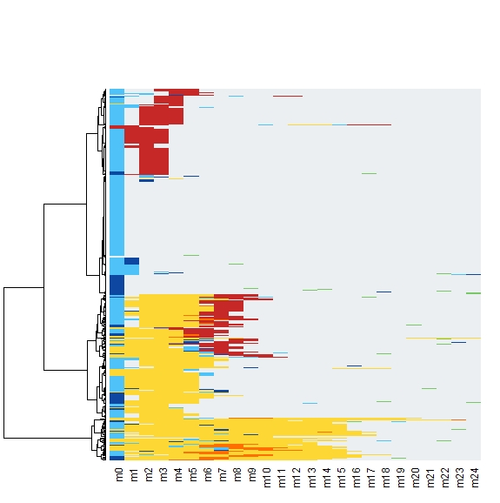
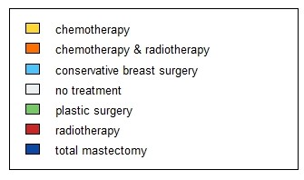
Fig S1: Dendrogram showing the hierarchical clustering of different BC treatment sequences using the optimal matching distances, Ward method.

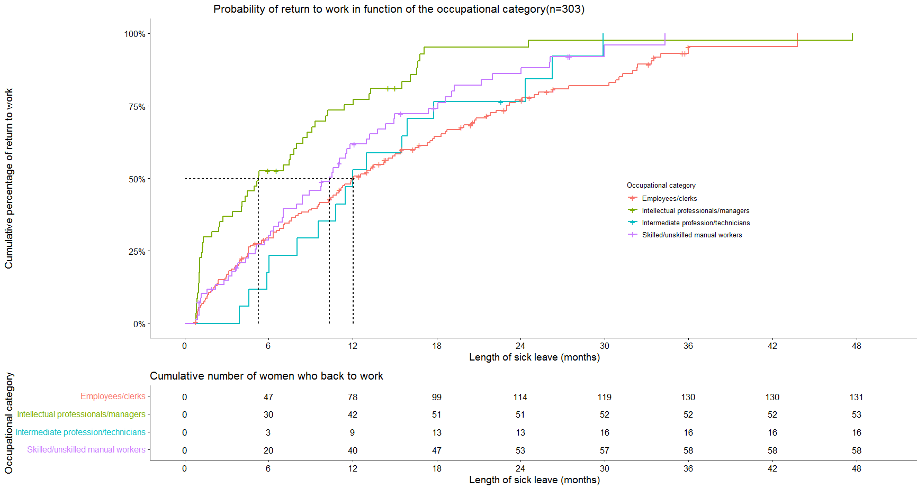

Median follow-up time in months (IQR):33.5 (21.6;36.0) ; Median survival time in months (IQR):9.8 (4.0;16.73)

Fig S2. Cumulative incidence of return to work according to the occupational category.

Table S3: BC treatments associated with the likelihood of return to work, univariate analyses and after adjustment for other BC treatments only (model 1), for BC treatments and drug deliveries (model 2), for BC treatments, socioeconomic characteristics, and age (model 3) (n=303)
 | Univariate analysis |  | Model 1 |  | Model 2 |  | Model 3
 |  | pª | HR (95% CI) | pª | HR (95% CI) | pª | HR (95% CI) | pª
Breast surgery^{b}
No | Reference | - | Reference | - | Reference | - | Reference | -
Yes | 0.09 (0.02-0.38) | 0.001 | 0.09 (0.02-0.44) | 0.003 | 0.10 (0.02-0.44) | 0.003 | 0.08 (0.02-0.38) | 0.002
Chemotherapy
No | Reference | - | Reference | - | Reference | - | Reference | -
Yes | 0.16 (0.07-0.36) | <0.001 | 0.13 (0.05-0.33) | <0.001 | 0.13 (0.05-0.32) | <0.001 | 0.08 (0.03-0.21) | <0.001
Radiotherapy
No | Reference | - | Reference | - | Reference | - | Reference | -
Yes | 0.52 (0.28-0.99) | 0.045 | 0.41 (0.22-0.76) | 0.005 | 0.41 (0.22-0.76) | 0.005 | 0.36 (0.19-0.67) | 0.001
Axillary lymph node dissection
No | Reference | - | Reference | - | Reference | - | Reference | -
Yes | 0.06 (0.01-0.48) | 0.009 | 0,09 (0.01-1,21) | 0.069 | 0.09 (0.01-1.16) | 0.065 | 0.17 (0.01-2.14) | 0.171
Hormone therapy
No | Reference | - | Reference | - | Reference | - | Reference | -
Yes | 1.12 (0.75-1.66) | 0.584 | 0.83 (0.56-1.24) | 0.357 | 0.82 (0.56-1.19) | 0.300 | 0.88 (0.62-1.27) | 0.505
Antidepressant/anxiolytic drugs
No | Reference | - | - | - | Reference | - | - | -
Yes | 0.80 (0.58-1.13) | 0.205 | - | - | 0.79 (0.56-1.13) | 0.199 | - | -
Antalgic drugs
No | Reference | - | - | - | Reference | - | - | -
Yes | 0.74 (0.56-0.97) | 0.028 | - | - | 0.80 (0.63-1.03) | 0.085 | - | -
Age (years)
20-44 | Reference | - | - | - | - | - | Reference | -
45-49 | 0.89 (0.56-1.42) | 0.626 | - | - | - | - | 0.82 (0.50-1.37) | 0.455
50-55 | 0.92 (0.54-1.56) | 0.752 | - | - | - | - | 1.12 (0.66-1.92) | 0.673
>55 | 0.65 (0.42-1.01) | 0.053 | - | - | - | - | 0.49 (0.26-0.93) | 0.030
Household income^{c}
Low income | Reference | - | - | - | - | - | Reference | -
Middle income | 1.34 (0.89-2.01) | 0.157 | - | - | - | - | 1.14 (0.74-1.75) | 0.546
High income | 3.04 (1.71-5.41) | <0.001 | - | - | - | - | 2.86 (1.35-6.07) | 0.006
Household composition
In couple without <18-year-old children | Reference | - | - | - | - | - | Reference | -
In couple with <18-year-old children | 1.48 (0.97-2.26) | 0.067 | - | - | - | - | 0.94 (0.53-1.65) | 0.821
Single without <18-year-old children | 0.63 (0.28-1.45) | 0,281 | - | - | - | - | 0.66 (0.31-1.42) | 0.284
Single with <18-year-old children | 0.98 (0.61-1.58) | 0,938 | - | - | - | - | 0.64 (0.37-1.12) | 0.121
Education level
Primary and secondary education | Reference | - | - | - | - | - | Reference | -
Higher education | 1.21 (0.82-1.80) | 0,331 | - | - | - | - | 0.98 (0.59-1.64) | 0.945
ªLog-rank test.
^{b}The two breast surgery types (total mastectomy and breast-conserving surgery) were combined into a single “breast surgery” variable due to the limited number of women in the two initial categories.
^{c}Low income: <1,500€ if one contributor or <2,800€ if two or more contributors in the household; Middle income: between 1,500€ and 2,000€ if one contributor or between 2,800€ and 4,100€ if two or more contributors in the household; High income: ≥2,000€ if one or ≥ 4,100€ if two or more contributors in the household.

