SUPPLEMENTARY FIGURES

Figure S1. BluePrint dual subtypes in the total study population and according to clinical subgroups
a. Total group, b. Hormone receptor negative disease, c. Hormone receptor positive disease, d. Node-negative disease, e. Node-positive disease, f. HER2 immunohistochemistry 1-2+ tumors, g. HER2 immunohistochemistry 3+ tumors
Abbreviations: HR = hormone receptor; cN0 = clinically node-negative; cN+ = clinically node-positive; HER2 IHC = HER2 immunohistochemistry score

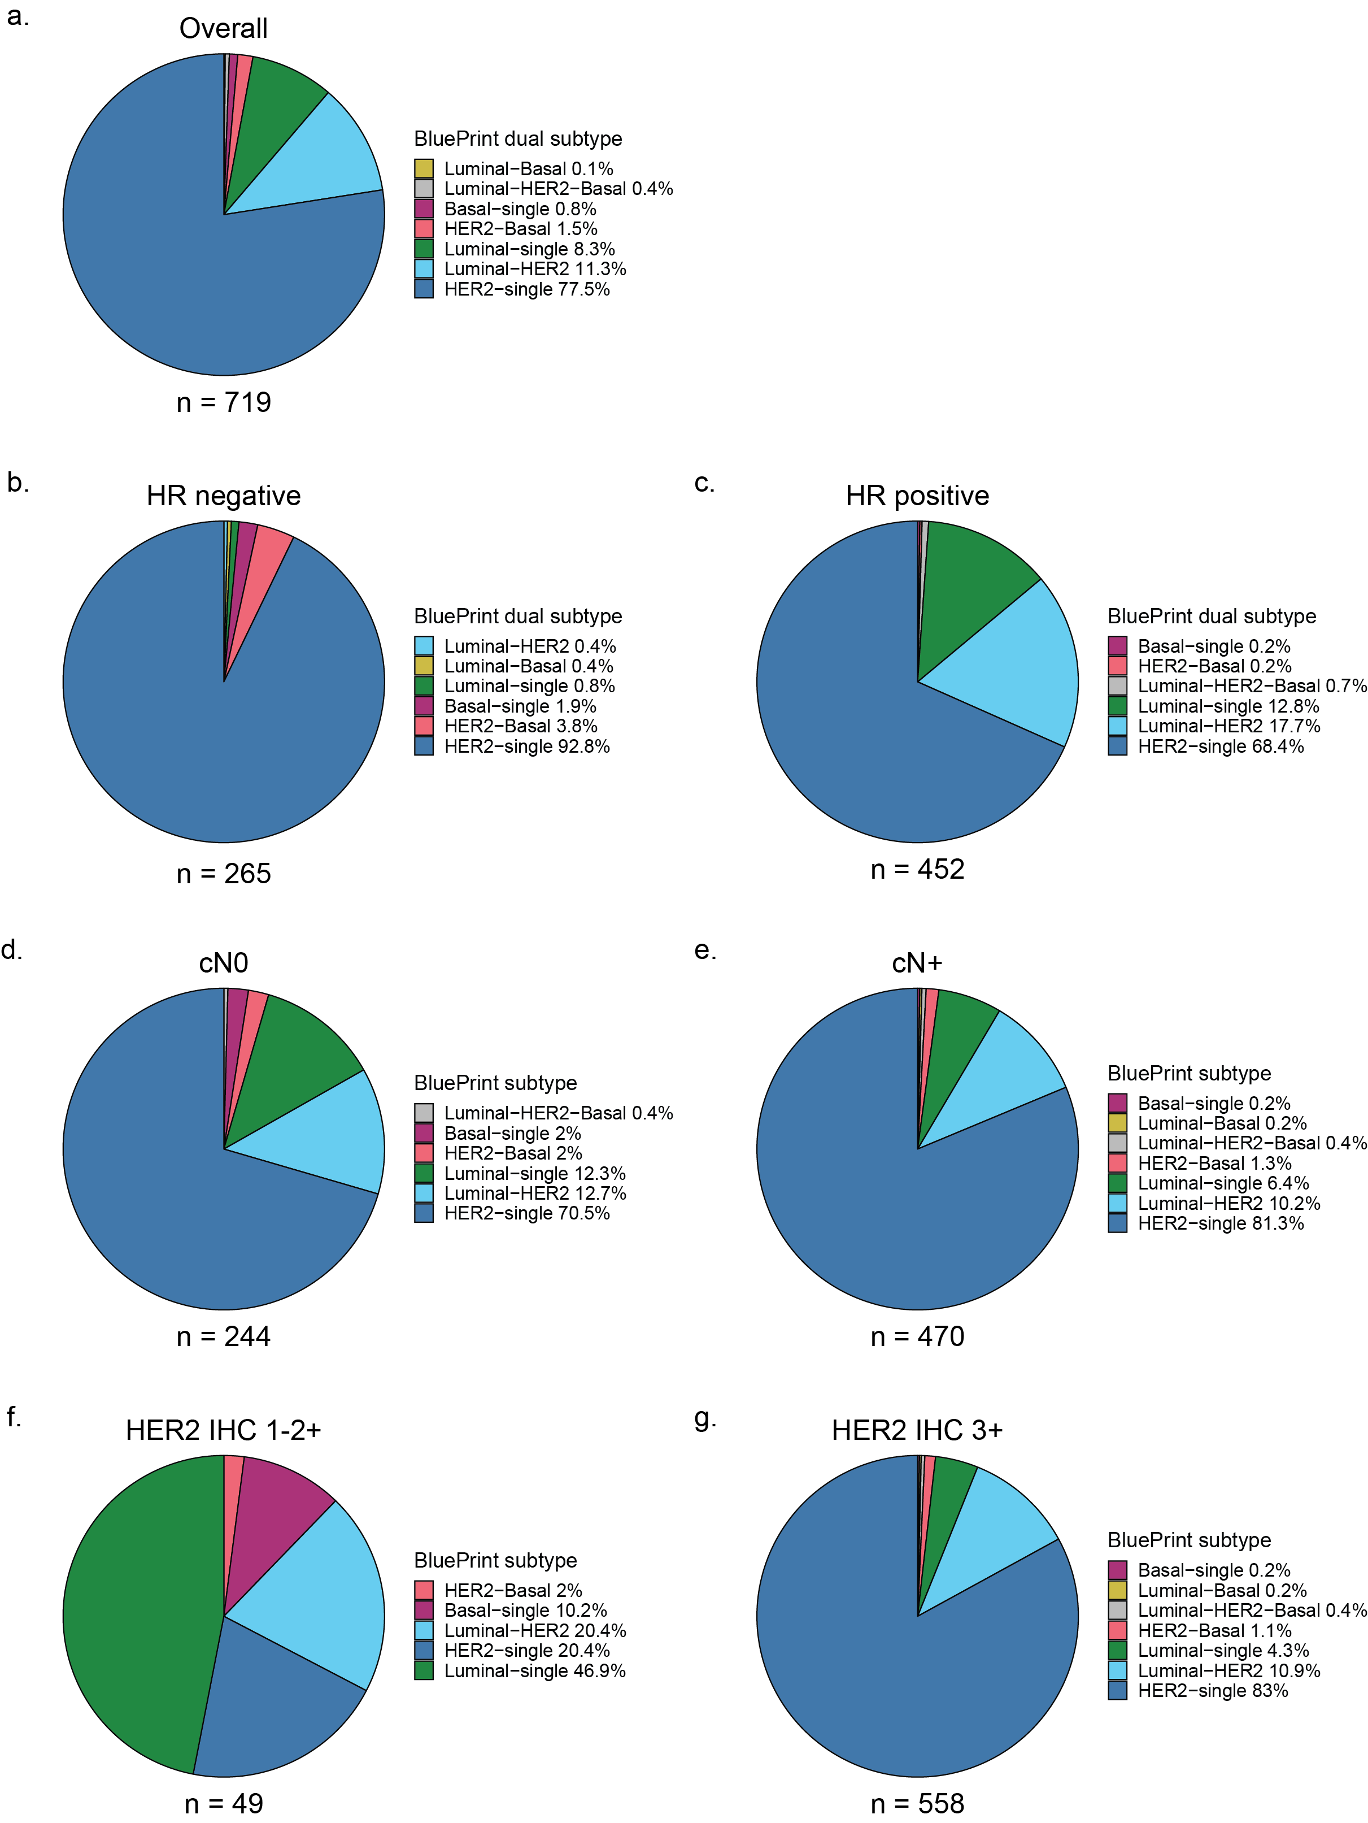
Figure S2. Kaplan-Meier curves of breast cancer specific survival according to subtype and treatment
a. Breast cancer specific survival for the three subtypes according to the standard readout, b. Breast cancer specific survival according to pertuzumab treatment in the HER2-type determined by standard readout, c. Breast cancer specific survival according to pertuzumab treatment in other subtypes determined by standard readout, d. Breast cancer specific survival for the subtypes according to the dual subtype readout. Subtypes with n < 10 are omitted. e. Breast cancer specific survival according to pertuzumab treatment in the single HER2-type determined by dual subtype readout, f. Breast cancer specific survival according to pertuzumab treatment in the other subtypes determined by dual subtype readout

a.
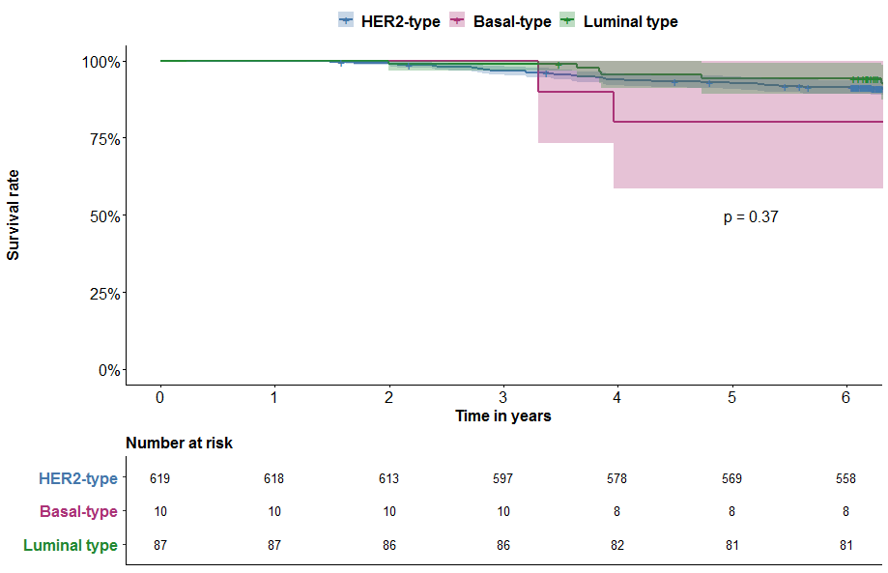
b.
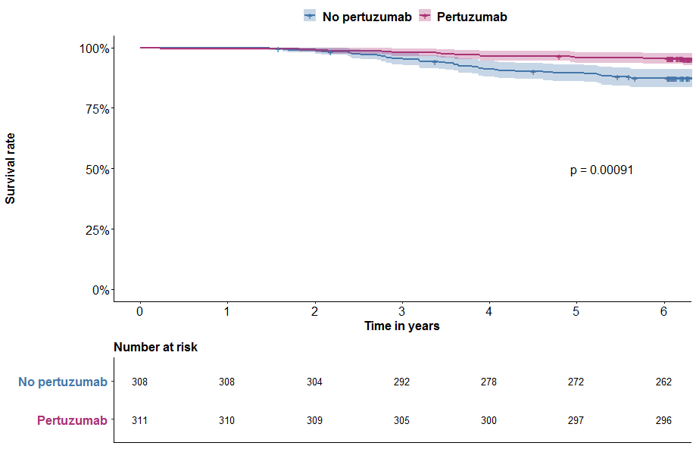

c.
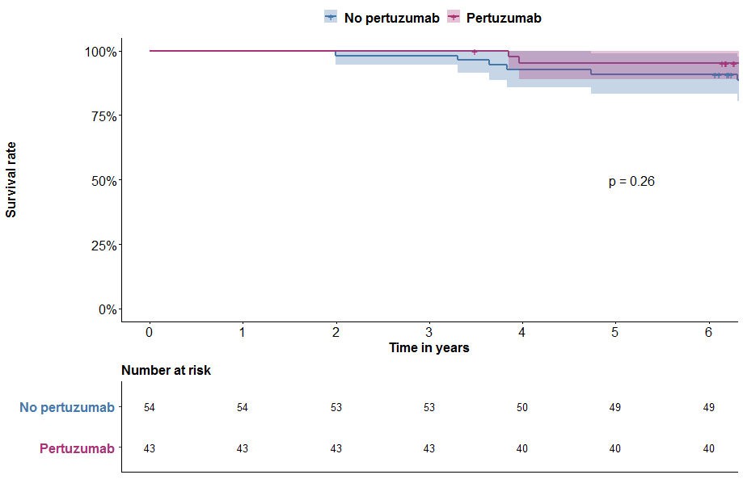

d.
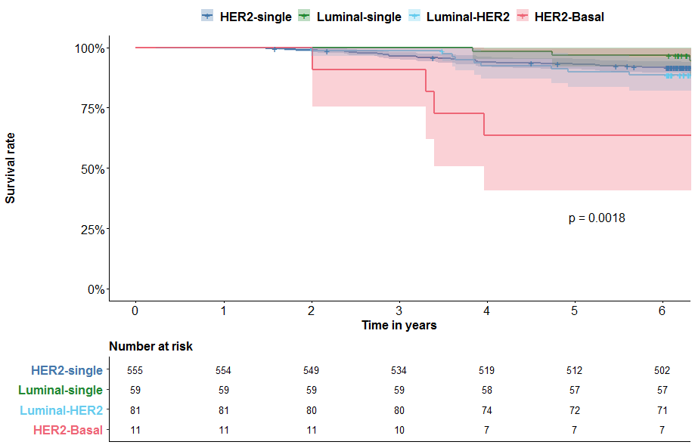

e.
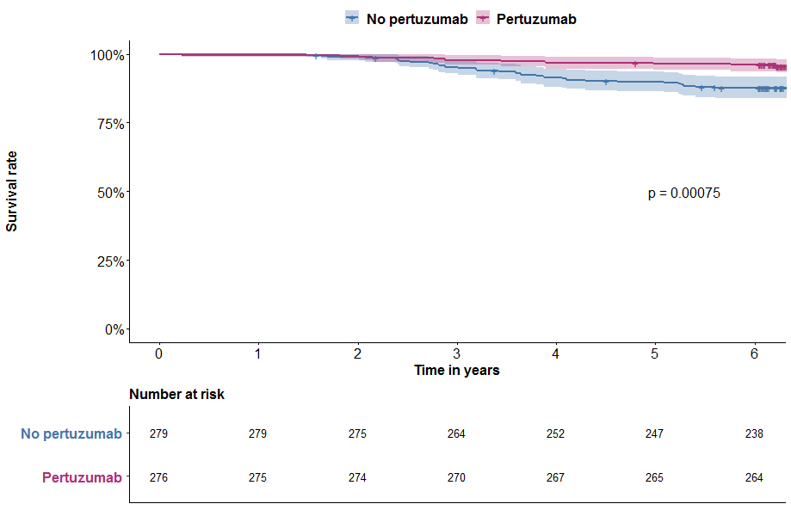

f.
