Supplementary figures and figure legends
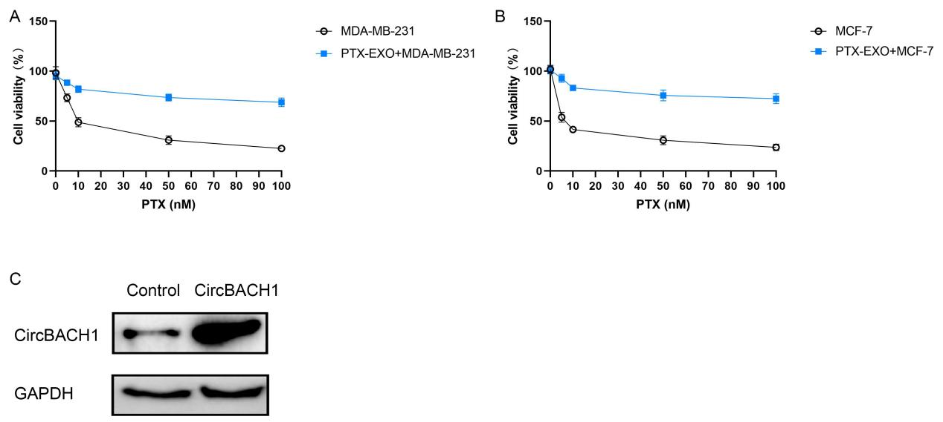

Supplementary Figure 1. PTX induced cytotoxicity in MDA-MB-231 and MCF-7 cells, but not in PTX-EXO treated in MDA-MB-231 and MCF-7 cells. Cytotoxicity of MDA-MB-231 (A) and MCF-7 (B) cells induced by different concentration of PTX. (C) Northern blotting of circBACH1 expression by transfection with circBACH1 vectors.

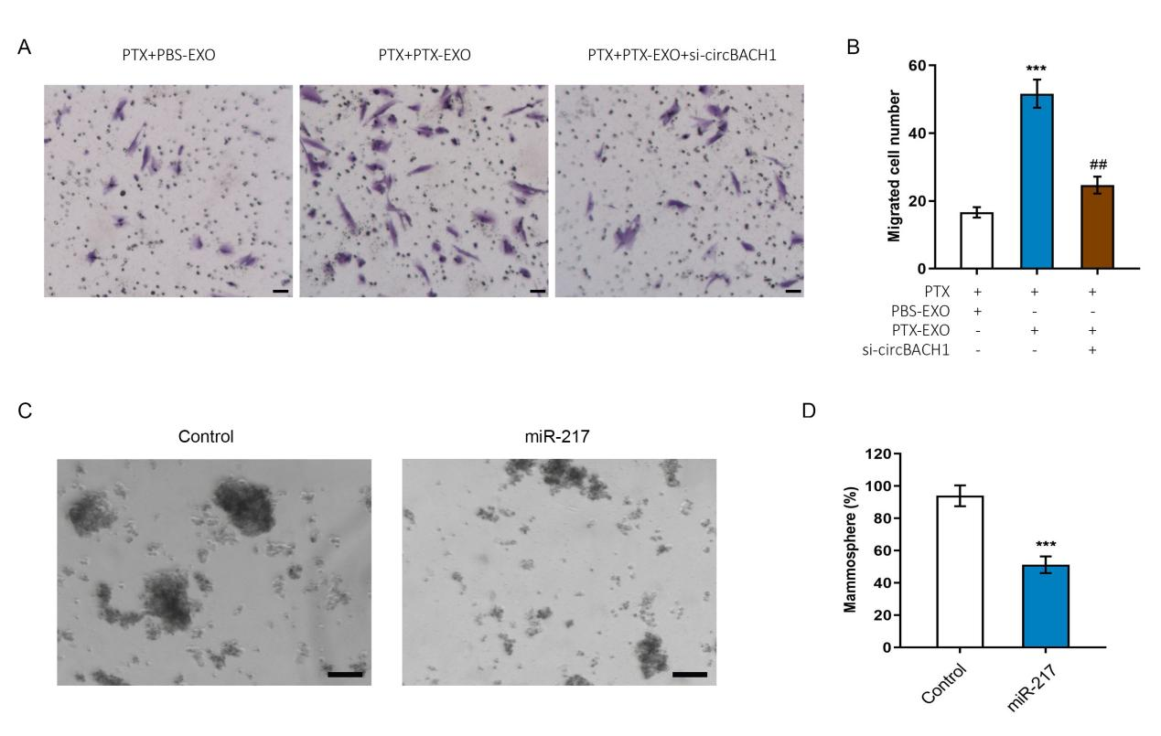
Supplementary Figure 2. Downregulation of circBACH1 reversed PTX-EXO-induced cell migration. (A, C) The cell migration was determined in MDA-MB-468 cells after treated with PTX and PBS-EXO or PTX-EXO and si-circBACH1, scale bar: 25 µm. (B) The migrated cell number of was calculated in MDA-MB-468 cells after treated with PTX and PBS-EXO or PTX-EXO, or si-circBACH1. *** P < 0.001, compared with the PTX + PBS-EXO group. ## P < 0.01, compared with the PTX + PTX-EXO group. (C, D) Mammosphere formation (%) was determined in MCF-7 cells treated with miR-217 mimics, scale bar: 50 µm. *** P < 0.001.

