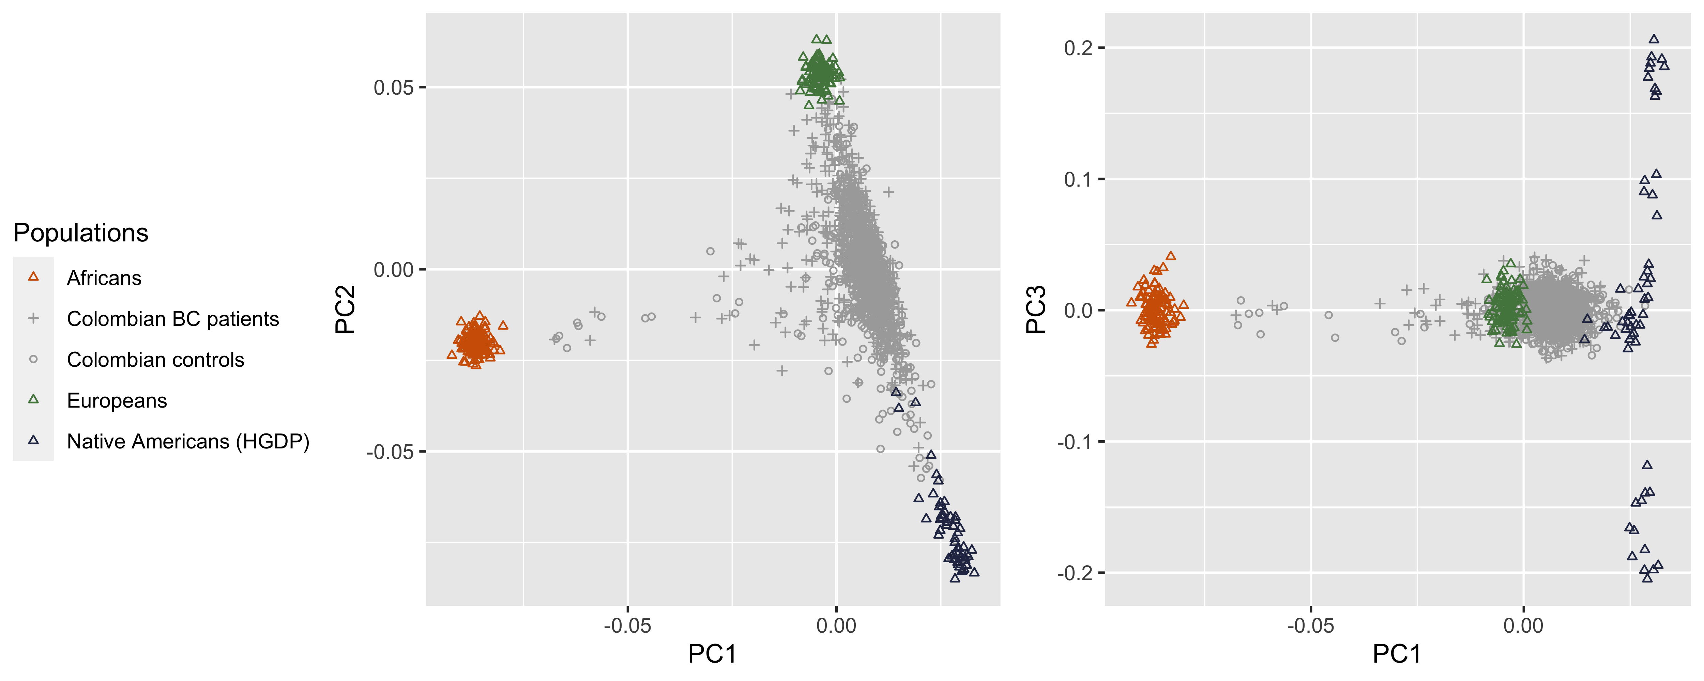
N5
N4
N3
N1
N4
N3
N2
N1
A
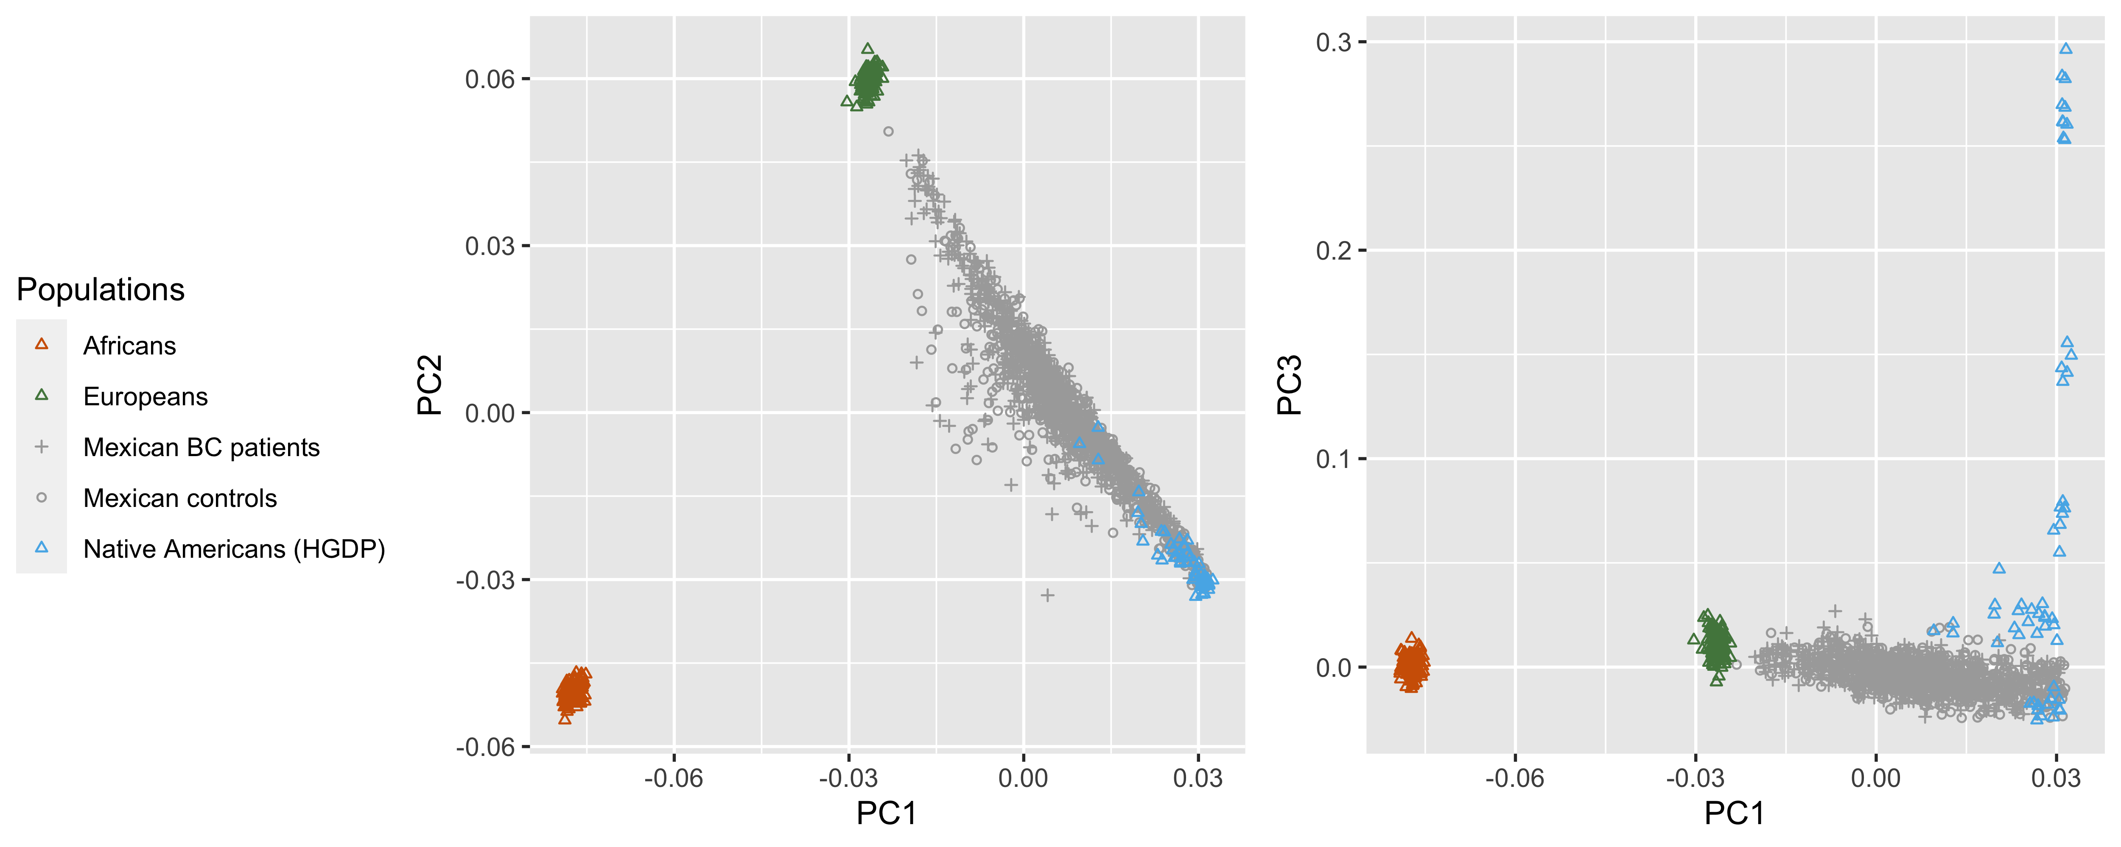
N2
N5
B
Supplementary Figure 1: Scatter plots of first versus second, and first versus third genetic principal components (PC) of study participants (crosses: BC patients, circles: population-based controls) and reference panels of African, European and Native American ancestry (reference individuals represented by triangles; Native Americans from the Human Genome Diversity Project, N1: Karitiana, N2: Surui, N3: Piapoco, N4: Maya, N5: Pima); panel A: Colombian study, panel B: Mexican study

