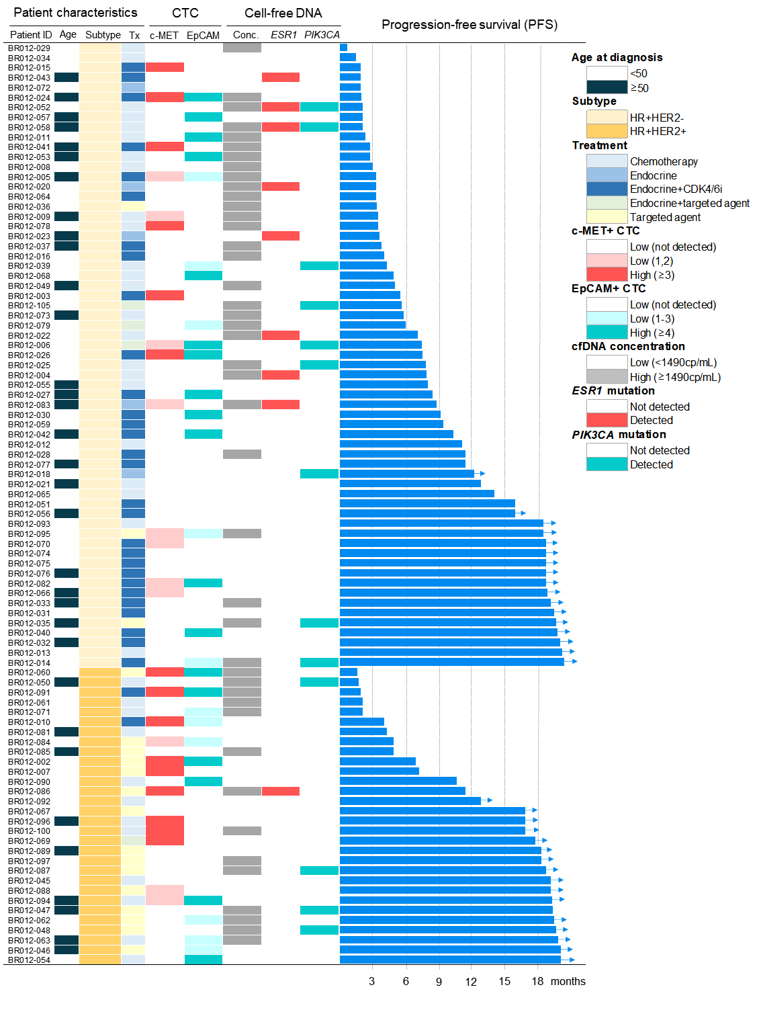
Supplementary Fig. S9 Baseline characteristics, CTC, cfDNA, and PFS data of each patient
Tx, Treatment; CTC, circulating tumor cell; Conc., concentration; PFS, progression-free survival

