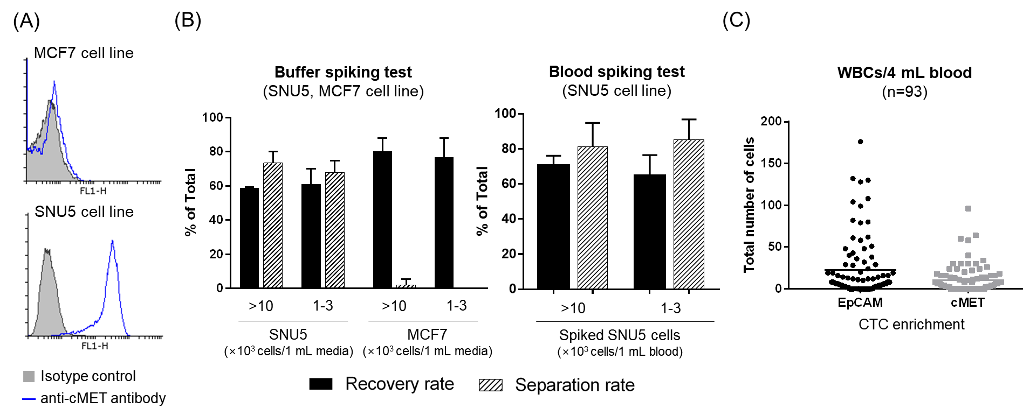
Supplementary Fig. S2 Analytical performance of the c-MET+ CTC assay used in the study. (A) Flow cytometry analysis of SNU5 and MCF7 cells labeled with 2 μg/mL of anti c-MET antibodies. (B) Recovery rates and separation rates of SNU5 and MCF7 cells spiked into buffer (left) and normal human blood (right). Data showed average +/- standard deviation from three experiments. (C) Total number of white blood cells (WBCs) contaminated during CTC enrichment per 4 mL of patient blood. CTC, circulating tumor cells

