Material and methods
Apoptosis assay
Apoptosis was quantified by surface Annexin V-FITC staining. Cells were treated with inhibitor in 48 hr and then transferred from a culture well (1.2 × 10⁶/well) to a tube and
washed with PBS containing 1% (v/v) bovine calf serum (Hyclone, Logan, UT, USA). According to the manufacturer’s instructions, the cells were incubated with a 1:40 solution of FITC-conjugated Annexin V (Roche Diagnostics, Germany) in the dark for 10 min at room temperature and the Annexin V-FITC positive cells were analyzed by flow cytometry on a BD FACSCalibur (BD Biosciences, Becton Drive, Franklin Lakes, NJ, USA). Cell Questc software (BD Biosciences) was used to determine the percentage of apoptosis in the samples.

Fig. S1. MCF-7, MCF-7/TAM-R, T47D and T47D/TAM-R were treated with a gradient concentration of MKT-077, VER-155008 and S1g-2 alone or in combination with tamoxifen at constant ratios spanning the IC₅₀ dose of each agent for 48 hr followed by CCK8 assay. The data show mean ± SD (n=3 biologically independent experiments).
Fig. S2. Western blot analysis of the levels of Hsp70 in MCF-7, MCF-7/TAM-R, T47D and T47D/TAM-R cells. The graphs show (mean ± SD, n=3 biologically independent experiments) protein level in MCF-7/TAM-R, T47D and T47D/TAM-R cells normalized to that in MCF-7.
Fig. S3. Bio-informatic analysis of Hsp70 expression and its association with survival. (A) Hsp70 mRNA expression between healthy tissue (breast) and cancer tissue (invasive breast cancer). Data was obtained from GEPIA2 database. (B) DRUGSURV Database shows that high levels of HSPA1A mRNA predicts a poor survival compared to low levels in patients suffering from breast cancer.
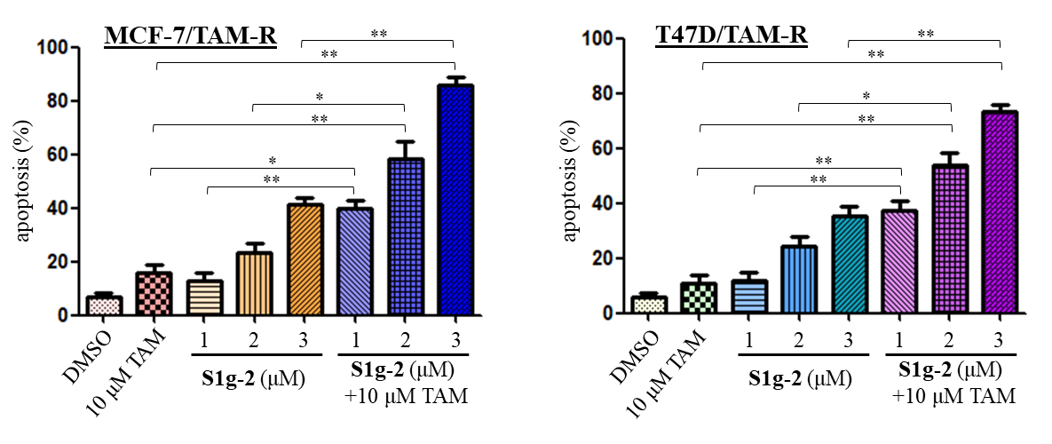
Fig. S4. S1g-2 enhanced tamoxifen-induced apoptosis in resistant cell lines. MCF-7/TAM-R or T47D/TAM-R were treated with 10 μM tamoxifen, 1, 2 or 3 μM S1g-2 alone or in combination for 48 hr, followed by apoptosis assay by Annexin V staining. *P<0.05, **P<0.01 (one-way ANOVA test).
Fig. S5. S1g-2 induced disruption of Hsp70-Bim PPI at 12 hr and apoptosis at 24 hr. (A) co-IP analysis of the levels of Hsp70-Bim PPI in MCF-7/TAM-R cells upon treatment with10 μM S1g-2 treatment for 0, 6, 12 or 24 hr. (B) western blot analysis of the levels of PARP cleavage in MCF-7/TAM-R upon 10 μM S1g-2 treatment for 0, 6, 12 or 24 hr, using β-actin as a loading control.

Table S1. The IC₅₀ value of MKT-077, S1g-2, VER-155008 and tamoxifen for cell killing activity in the tamoxifen-sensitive and -resistant breast cancer cell lines
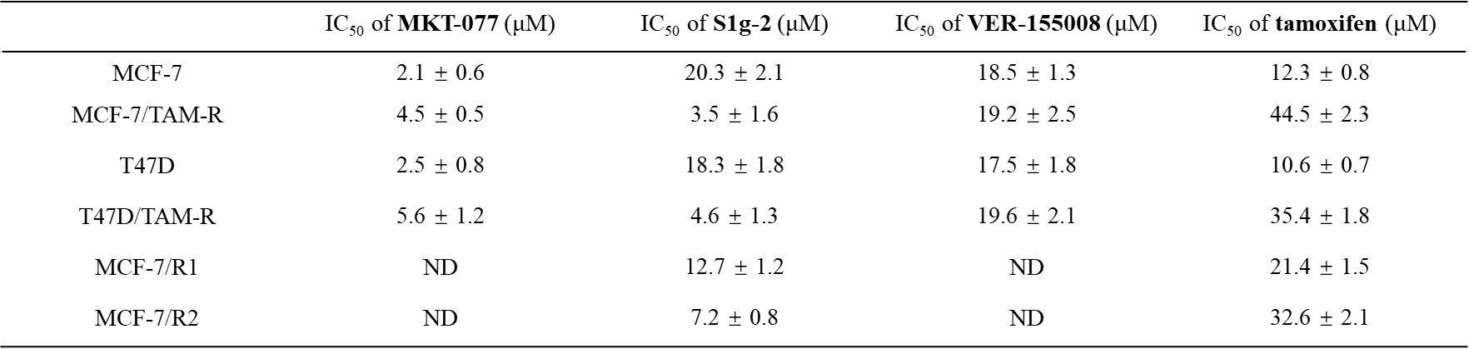
ND indicates not determined.

Table S2. The potency of MKT-077, S1g-2 and VER-155008 respectively in combinations with tamoxifen
Note: To measure CI index values, cells were simultaneously treated with MKT-077 and tamoxifen at 1:5 for MCF-7, 1:10 for MCF-7/TAM-R, 1:5 for T47D, 1:6 for T47D/TAM-R; S1g-2 and tamoxifen at 2:1 for MCF-7, 1:10 for MCF-7/TAM-R, 2:1 for T47D, 1:8 for T47D/TAM-R; VER-155008 and tamoxifen at 2:1 for MCF-7, 1:2 for MCF-7/TAM-R, 2:1 for T47D, 1:2 for T47D/TAM-R. CI < 1, CI = 1 and CI > 1 indicate synergism, addictive effect, and antagonism, respectively (column 2, 4 and 6). When 50% growth inhibition level was induced by two drugs combination at constant ratios, the respective doses of the two drugs are presented as mean ± SD, n = 3 (column 1, 3 and 5).

