Reproductive factors and mammographic density within the International Consortium of Mammographic Density: A cross-sectional study – Additional File 1

Fig S1(a-d): Funnel plots for the population-specific meta-analyses for each of the reproductive factors and the √MD measures.
Fig S2(a-b): Population-specific meta-analysis and categorical pooled analysis for parity and √NDA.
Fig S3-4(a-b): Stratified analyses (population-specific meta-analyses and pooled categorical analyses) by menopausal status for parity and √PMD.
Fig S5(a-c): Sensitivity analyses (population-specific meta-analyses) with parous women only for parity and √MD measures.
Fig S6(a-b): Population-specific meta-analysis and categorical pooled analysis for age at first birth and √NDA.
Fig S7-8(a-b): Stratified analyses (population-specific meta-analyses and pooled categorical analyses) by menopausal status for age at first birth and √PMD.
Fig S9: Population-specific meta-analysis for ever/never breastfed and √NDA.
Fig S10(a-b): Stratified meta-analyses by menopausal status for ever/never breastfed and √PMD.
Fig S11(a-b): Population-specific meta-analyses and categorical pooled analysis for lifetime breastfeeding duration and √NDA.
Fig S12-13(a-b): Stratified analyses (population-specific meta-analyses and pooled categorical analyses) by menopausal status for lifetime breastfeeding duration and √PMD.
Fig S14(a-c): Sensitivity analyses (population-specific meta-analyses) excluding shorter (<1 month) and longer (> 200 months) durations for lifetime breastfeeding duration and √MD measures.
Fig S15-16(a-c): Sensitivity analyses (population-specific meta-analyses and pooled categorical analyses) for breastfeeding duration per birth and the √MD measures.

Fig S1(a-d): Funnel plots for each of the reproductive factors and the √MD measures
Supplemental figure 1(a-d): Funnel plots of the effect size and standard error for the population-specific meta-analyses examining the associations between each of the reproductive factors and the √MD measures

(a): Funnel plots for parity and each of the √MD measures

#

(b): Funnel plots for age at first birth and each of the √MD measures

(c): Funnel plots for ever/never breastfed and each of the √MD measures

(d): Funnel plots for lifetime breastfeeding duration and each of the √MD measures

Fig S2(a-b): Population-specific meta-analysis and categorical pooled analysis for parity and √NDA

Supplemental Figure 2(a): Forest plot showing the associations between parity and √NDA for all women (parous and nulliparous) across the 40 country-ethnicity specific population groups in the ICMD sample and (b): Pooled analysis plot showing the association between parity (categorical) and √NDA for all women (parous and nulliparous) in the pooled ICMD sample. Analyses were adjusted for age at mammogram, BMI, menopausal status, use of hormone replacement therapy, age at menarche, age at first birth, and image parameters.

- Association between parity and √NDA
- Association between parity categories and √NDA

Fig S3-4(a-b): Stratified analyses (population-specific meta-analyses and pooled categorical analyses) by menopausal status for parity and √PMD
Supplemental figure 3: Forest plots showing the associations between parity and √PMD among (a) pre- and (b) post-menopausal women (parous and nulliparous) across 36 and 38 respective country-ethnicity specific population groups in the ICMD sample. Analyses were adjusted for age at mammogram, BMI, menopausal status, use of hormone replacement therapy, age at menarche, age at first birth, and image parameters.
- Association between parity and √PMD: Pre-menopausal

- Association between parity and √PMD: Post-menopausal

Supplemental figure 4: Pooled analysis plots showing the associations between parity (categorical) and √PMD among (a) pre- and (b) post-menopausal women (parous and nulliparous) in the pooled ICMD sample. Analyses were adjusted for age at mammogram, BMI, menopausal status, use of hormone replacement therapy, age at menarche, age at first birth, and image parameters.

- Association between parity categories and √PMD: Pre-menopausal

- Association between parity categories and √PMD: Post-menopausal

Fig S5(a-c): Sensitivity analyses (population-specific meta-analyses) among parous women only for parity and √MD measures
Supplemental figure 5(a-c): Forest plots showing the associations between parity and √MD measures for parous women across 40 country-ethnicity specific population groups in the ICMD sample. Analyses were adjusted for age at mammogram, BMI, menopausal status, use of hormone replacement therapy, age at menarche, age at first birth, and image parameters.

- Association between parity and √PMD

- Association between parity and √DA

- Association between parity and √NDA

Fig S6(a-b): Population-specific meta-analysis and categorical pooled analysis for age at first birth and √NDA
Supplemental figure 6(a): Forest plot showing the associations between a five-year increase in age at first birth and √NDA for parous women across the 40 country-ethnicity specific population groups in the ICMD sample and (b): Pooled analysis plot showing the association between age at first birth (categorical) and √NDA for parous women in the pooled ICMD sample. Analyses were adjusted for age at mammogram, BMI, menopausal status, use of hormone replacement therapy, age at menarche, parity, and image parameters.

- Association between a five year increase in age at first birth and √NDA
(b) Association between age at first birth categories and √NDA

Fig S7-8(a-b): Stratified analyses (population-specific meta-analyses and pooled categorical analyses) by menopausal status for age at first birth and √PMD
Supplemental figure 7: Forest plots showing the associations between a five-year increase in age at first birth and √PMD among parous (a) pre- and (b) post-menopausal women across 34 and 38 respective country-ethnicity specific population groups in the ICMD sample. Analyses were adjusted for age at mammogram, BMI, menopausal status, use of hormone replacement therapy, age at menarche, parity, and image parameters.

- Association between a five year increase in age at first birth and √PMD: Pre-menopausal
- Association between a five year increase in age at first birth and √PMD: Post-menopausal
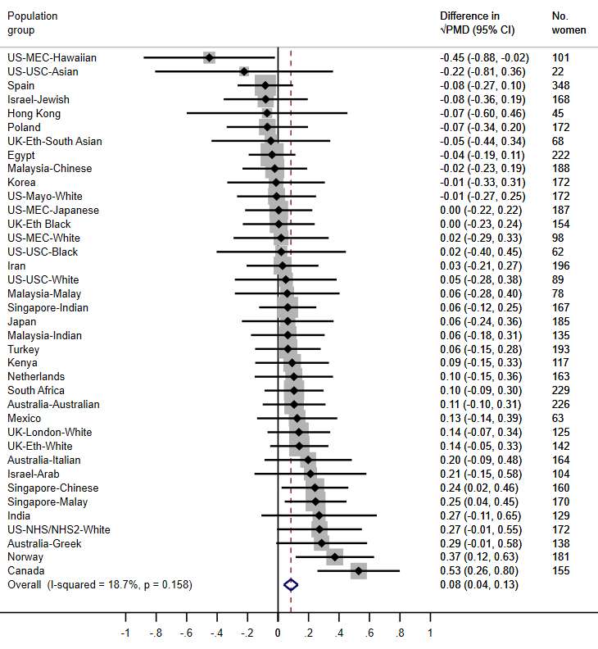

Supplemental figure 8: Pooled analysis plots showing the associations between age at first birth (categorical) and √PMD among parous (a) pre- and (b) post-menopausal women in the pooled ICMD sample. Analyses were adjusted for age at mammogram, BMI, menopausal status, use of hormone replacement therapy, age at menarche, parity, and image parameters.

- Association between age at first birth categories and √PMD: Pre-menopausal

- Association between age at first birth categories and √PMD: Post-menopausal

Fig S9: Population-specific meta-analysis for ever/never breastfed and √NDA
Supplemental figure 9: Forest plot showing the associations between ever/never breastfed and √NDA for parous women across 30 country-ethnicity specific population groups in the ICMD sample. Analyses were adjusted for age at mammogram, BMI, menopausal status, use of hormone replacement therapy, age at menarche, parity, age at first birth, and image parameters.
Association between ever/never breastfed and √NDA

Fig S10(a-b): Stratified meta-analyses by menopausal status for ever/never breastfed and √PMD
Supplemental figure 10: Forest plots showing the associations between ever/never breastfed and √PMD among parous (a) pre- and (b) post-menopausal women across 26 and 29 respective country-ethnicity specific population groups in the ICMD sample. Analyses were adjusted for age at mammogram, BMI, menopausal status, use of hormone replacement therapy, age at menarche, parity, age at first birth, and image parameters.

- Association between ever/never breastfed and √PMD: Pre-menopausal

- Association between ever/never breastfed and √PMD: Post-menopausal

Fig S11(a-b): Population-specific meta-analyses for lifetime breastfeeding duration and √NDA

Figure 11(a): Forest plot showing the associations between a six month increase in lifetime breastfeeding duration and √NDA for parous women that breastfed across 28 country-ethnicity specific population groups in the ICMD sample and (b): Pooled analysis plots showing the associations between lifetime breastfeeding duration (categorical) and √NDA for parous women that breastfed in the pooled ICMD sample. Analyses were adjusted for age at mammogram, BMI, menopausal status, use of hormone replacement therapy, age at menarche, parity, age at first birth, and image parameters.

- Association between lifetime breastfeeding duration and √NDA
(b) Association between lifetime breastfeeding duration categories and √NDA

Fig S12-13(a-b): Stratified analyses (population-specific meta-analyses and pooled categorical analyses) by menopausal status for lifetime breastfeeding duration and √PMD
Supplemental figure 12: Forest plots showing the associations between a six-month increase in lifetime breastfeeding duration and √PMD for parous (a) pre- and (b) post-menopausal women that breastfed across 22 and 27 respective country-ethnicity specific population groups in the ICMD sample. Analyses were adjusted for age at mammogram, BMI, menopausal status, use of hormone replacement therapy, age at menarche, parity, age at first birth, and image parameters.

- Association between a six month increase in lifetime breastfeeding duration and √PMD: Pre-menopausal

- Association between a six month increase in lifetime breastfeeding duration and √PMD: Post-menopausal

Supplemental figure 13: Pooled analysis plots showing the associations between lifetime breastfeeding duration (categorical) and √PMD for parous (a) pre- and (b) post-menopausal women that breastfed in the pooled ICMD sample. Analyses were adjusted for age at mammogram, BMI, menopausal status, use of hormone replacement therapy, age at menarche, parity, age at first birth, and image parameters.

- Association between lifetime breastfeeding duration categories and √PMD: Pre-menopausal

- Association between lifetime breastfeeding duration categories and √PMD: Post-menopausal

Fig S14(a-c): Sensitivity analyses (population-specific meta-analyses) excluding shorter (durations < 1 month) and longer (durations > 200 months) durations for lifetime breastfeeding duration and √MD measures
Supplemental figure 14(a-c): Forest plots showing the associations between a six-month increase in lifetime breastfeeding duration and MD measures for parous women that breastfed across the 28 country-ethnicity specific population groups in the ICMD sample. Analyses were adjusted for age at mammogram, BMI, menopausal status, use of hormone replacement therapy, age at menarche, parity, age at first birth, and image parameters.

- Association between a six month increase in lifetime breastfeeding duration and √PMD

- Association between a six month increase in lifetime breastfeeding duration and √DA

- Association between a six month increase in lifetime breastfeeding duration and √NDA

Fig S15-16(a-c): Sensitivity analyses (population-specific meta-analyses and pooled categorical analyses) for breastfeeding duration per birth and the √MD measures
Supplemental figure 15(a-c): Forest plots showing the associations between a six-month increase in breastfeeding duration per birth and √MD measures for parous women that breastfed across the 28 country-ethnicity specific population groups in the ICMD sample. Analyses were adjusted for age at mammogram, BMI, menopausal status, use of hormone replacement therapy, age at menarche, age at first birth, and image parameters.

- Association between a six month increase in breastfeeding duration per birth and √PMD

- Association between a six month increase in breastfeeding duration per birth and √DA

- Association between a six month increase in breastfeeding duration per birth and √NDA

Supplemental figure 16(a-c): Pooled analysis plots showing the associations between breastfeeding duration per birth (categorical) and √MD measures for parous women that breastfed in the pooled ICMD sample. Analyses were adjusted for age at mammogram, BMI, menopausal status, use of hormone replacement therapy, age at menarche, age at first birth, and image parameters.

- Association between breastfeeding duration per birth categories and √PMD

- Association between breastfeeding duration per birth categories and √DA

- Association between breastfeeding duration per birth categories and √NDA

