Table of Contents

Table A1 Baseline Characteristics of NACT Patients in ChiMEC 2
Table A2 Measures of Calibration of the Logistic Regression Models and Machine Learning Models with and without Quantitative Features in the Validation Set 3
Table A3 AUCs of the Quantitative Machine Learning Prediction Model across Different Racial/ethnic Groups and Subtypes 3
Table A4 AUCs of the Quantitative Machine Learning Prediction Model Fitted in the Full Dataset Compared with Models Fitted within Each Subtype Individually 4
Table A5 AUCs of the Quantitative Machine Learning Prediction Model Fitted within Each Subtype Individually in Complete Case Analysis 4
Table A6 AUCs of the Quantitative Machine Learning Prediction Model among Patients Treated for 16-28 Weeks 5
Table A7 AUCs of the Quantitative Machine Learning Prediction Model with Racial/Ethnic Groups, Insurance Type, Facility Type and Facility Location Included as Predictors 5
Table A8 Treatment Selection Potential for Different Prediction Thresholds among Different Subtypes in the Validation Set 6
Table A9 Baseline Characteristics of a Subset of 1266 HR+/HER2- Patients with Oncotype Dx Score in NCDB 6
Table A10 AUCs of Different Models in a Subset of 1266 HR+/HER2- Patients with Oncotype Dx Score in NCDB 7
Table A11 Performance Metrics of the Quantitative Machine Learning Prediction Model among Different Subtypes in ChiMEC 8
Table A12 Clinicopathological Characteristics of HR+/HER2- Patients in ChiMEC with Predicted pCR Probability < 7% 8
Table A13 Details of the Basic and Quantitative Logistic Regression Models 10
Fig. A1 Flowchart of Sample Selection Process in NCDB for Model Development and Validation 12
Fig. A2 Survival Outcomes of HR+/HER2- Patients with Low Predicted pCR Probability (<7%) Comparing Chemotherapy Recipients and Non-Recipients in ChiMEC 13

Table A1 Baseline Characteristics of NACT Patients in ChiMEC

Features, n (%) |  | Neoadjuvant Chemotherapy  (n = 584)
pCR | No | 389 (66.6)
pCR | Yes | 195 (33.4)
Age at Diagnosis,  mean (SD) |  | 50.4 (12.7)
Race / Ethnicity | Non-Hispanic White | 304 (52.1)
Race / Ethnicity | Non-Hispanic Black | 223 (38.2)
Race / Ethnicity | Hispanic | 27 (4.6)
Race / Ethnicity | Asian | 29 (5.0)
Race / Ethnicity | Other | 1 (0.2)
Subtype | HR+/HER2- | 191 (32.7)
Subtype | HR+/HER2+ | 132 (22.6)
Subtype | HR-/HER2+ | 62 (10.6)
Subtype | TNBC | 199 (34.1)
Clinical T-Stage | 1 | 112 (19.2)
Clinical T-Stage | 2 | 334 (57.2)
Clinical T-Stage | 3 | 109 (18.7)
Clinical T-Stage | 4 | 29 (5.0)
Clinical N-Stage | 0 | 278 (47.6)
Clinical N-Stage | ≥ 1 | 306 (52.4)
Tumor Grade | 1 | 11 (1.9)
Tumor Grade | 2 | 131 (22.4)
Tumor Grade | 3 | 442 (75.7)
Histological Type | Ductal | 518 (88.7)
Histological Type | Lobular | 22 (3.8)
Histological Type | Ductal and Lobular | 27 (4.6)
Histological Type | Mucinous | 0 (0.0)
Histological Type | Papillary | 1 (0.2)
Histological Type | Inflammatory | 5 (0.9)
Histological Type | Metaplasia | 5 (0.9)
Histological Type | Others | 6 (1.0)
Charlson/Deyo Score | 0 | 501 (85.8)
Charlson/Deyo Score | 1 | 39 (6.7)
Charlson/Deyo Score | ≥ 2 | 44 (7.5)
ER Status | Negative | 265 (45.4)
 | Positive | 319 (54.6)
ER (% Positivity),  median (IQR) |  | 10.1 (0, 90)
PR Status | Negative | 360 (61.6)
 | Positive | 224 (38.4)
PR (% Positivity),  median (IQR) |  | 0.5 (0, 40)
HER2 Status | Negative | 390 (66.8)
 | Positive | 194 (33.2)
HER2 IHC Categories | 0 | 71 (12.2)
HER2 IHC Categories | 1+ | 66 (11.3)
HER2 IHC Categories | 2+ | 47 (8.0)
HER2 IHC Categories | 3+ | 72 (12.3)
HER/CEP17 Ratio, median (IQR) |  | 1.4 (1.1, 4.5)
Ki-67 Score,  median (IQR) |  | 40 (23, 70)

Table A2 Measures of Calibration of the Logistic Regression Models and Machine Learning Models with and without Quantitative Features in the Validation Set

 | Logistic Regression |  | Machine Learning
 | Basic Model | Quantitative Model | Basic Model | Quantitative Model
Brier Score | 0.19 | 0.18 | 0.19 | 0.17
Calibration Intercept | -0.011 | -0.011 | 0.00069 | -0.014
Calibration Slope | 1.02 | 1.03 | 1.10 | 1.08
Integrated Calibration Index | 0.039 | 0.023 | 0.012 | 0.017

Table A3 AUCs of the Quantitative Machine Learning Prediction Model across Different Racial/ethnic Groups and Subtypes

 | Racial/ethnic group ª
 | White  (n = 11029) | Black  (n = 2675) | Hispanic  (n = 1720) | Asian  (n = 946) | Others  (n = 360)
HR+/HER2- | 0.825  (0.807-0.844) | 0.786  (0.741-0.830) | 0.814  (0.772-0.856) | 0.844  (0.784-0.904) | 0.744  (0.628-0.859)
HR+/HER2+ | 0.765  (0.747-0.783) | 0.699  (0.653-0.745) | 0.755  (0.708-0.802) | 0.721  (0.662-0.781) | 0.690  (0.578-0.803)
HR-/HER2+ | 0.649  (0.614-0.683) | 0.648  (0.583-0.713) | 0.598  (0.508-0.687) | 0.639  (0.525-0.754) | 0.615  (0.373-0.858)
TNBC | 0.653  (0.635-0.671) | 0.640  (0.607-0.674) | 0.657  (0.609-0.705) | 0.707  (0.638-0.775) | 0.667  (0.562-0.772)
ª The AUC of the final model was estimated among the 30% hold-out validation set within each breast cancer subtype and by each racial/ethnic group. The 95% CIs of the AUCs were calculated using the ‘pROC’ package in R.

Table A4 AUCs of the Quantitative Machine Learning Prediction Model Fitted in the Full Dataset Compared with Models Fitted within Each Subtype Individually

 | Fitted in the Full Dataset | Subtype-specific Models ª
HR+/HER2- | 0.817  (0.802-0.832) | 0.816  (0.801-0.831)
HR+/HER2+ | 0.751  (0.736-0.766) | 0.752  (0.737-0.767)
HR-/HER2+ | 0.640  (0.613-0.668) | 0.639  (0.612-0.667)
TNBC | 0.654  (0.639-0.669) | 0.652  (0.637-0.667)
ª The AUCs of the subtype-specific models were estimated by fitting a model within each subtype and evaluating its performance in the corresponding subtype-specific 30% hold-out validation set. The 95% CIs of the AUCs were calculated using the ‘pROC’ package in R.

Table A5 AUCs of the Quantitative Machine Learning Prediction Model Fitted within Each Subtype Individually in Complete Case Analysis

Subtype | Training set  (N) | Validation set  (N) | AUC (95% CI)  in validation set
HR+/HER2-
Basic Featuresª + ER% + PR% | 10002 | 4236 | 0.809  (0.793-0.826)
Basic Features + ER% + PR% + Ki-67 | 5769 | 2397 | 0.813  (0.791-0.835)
HR+/HER2+
Basic Features + ER% + PR%  + HER2 IHC categories + HER2/CEP17 ratios | 1969 | 876 | 0.783  (0.749-0.818)
Basic Features + ER% + PR%  + HER2 IHC categories + HER2/CEP17 ratios + Ki-67 | 1196 | 522 | 0.798  (0.755-0.841)
HR-/HER2+
Basic Features + HER2 IHC categories  + HER2/CEP17 ratios | 755 | 308 | 0.700  (0.642-0.758)
Basic Features + HER2 IHC categories  + HER2/CEP17 ratios + Ki-67 | 448 | 186 | 0.723  (0.650-0.797)
TNBC
Basic Features + Ki-67 | 6469 | 2712 | 0.663  (0.642-0.684)
ª All the models include the basic features (i.e. age at diagnosis, clinical T and N stages, histology types, tumor grades and comorbidity index) and the listed quantitative biomarkers after list-wise deletion

Table A6 AUCs of the Quantitative Machine Learning Prediction Model among Patients Treated for 16-28 Weeks

 | Racial/ethnic group ª
 | White  (n =8730) | Black  (n = 2025) | Hispanic  (n = 1332) | Asian  (n = 755) | Others  (n = 276)
HR+/HER2- | 0.823  (0.803-0.844) | 0.780  (0.729-0.832) | 0.817  (0.769-0.866) | 0.841  (0.771-0.910) | 0.770  (0.640-0.900)
HR+/HER2+ | 0.758  (0.738-0.777) | 0.701  (0.651-0.752) | 0.741  (0.689-0.794) | 0.714  (0.650-0.778) | 0.707  (0.583-0.832)
HR-/HER2+ | 0.633  (0.593-0.672) | 0.660  (0.587-0.733) | 0.561  (0.456-0.665) | 0.624  (0.497-0.751) | 0.606  (0.342-0.871)
TNBC | 0.645  (0.625-0.666) | 0.624  (0.584-0.664) | 0.658  (0.603-0.712) | 0.659  (0.578-0.741) | 0.670  (0.551-0.788)
ª The AUC of the final model was estimated among patients in the 30% hold-out validation set who were treated for 16-28 weeks (i.e., excluding possible non-adherence or treatment delays) within each breast cancer subtype and by each racial/ethnic group. The 95% CIs of the AUCs were calculated using the ‘pROC’ package in R.

Table A7 AUCs of the Quantitative Machine Learning Prediction Model with Racial/Ethnic Groups, Insurance Type, Facility Type and Facility Location Included as Predictors

 | Racial/ethnic group ª
 | White  (n =11029) | Black  (n = 2675) | Hispanic  (n = 1720) | Asian  (n = 946) | Others  (n = 360)
HR+/HER2- | 0.823  (0.805-0.842) | 0.786  (0.740-0.831) | 0.813  (0.770-0.856) | 0.852  (0.795-0.908) | 0.739  (0.621-0.857)
HR+/HER2+ | 0.766  (0.748-0.784) | 0.697  (0.651-0.742) | 0.752  (0.705-0.799) | 0.712  (0.651-0.772) | 0.710  (0.599-0.820)
HR-/HER2+ | 0.652  (0.618-0.686) | 0.642  (0.577-0.706) | 0.582  (0.493-0.671) | 0.651  (0.541-0.760) | 0.623  (0.377-0.869)
TNBC | 0.653  (0.635-0.671) | 0.640  (0.606-0.673) | 0.656  (0.608-0.703) | 0.700  (0.630-0.769) | 0.677  (0.574-0.780)
ª In addition to the basic and quantitative clinicopathological features included in the final model, we also trained a model including racial/ethnic group, insurance type, facility type and facility location as predictors, and estimated its performance in the 30% hold-out validation set within each breast cancer subtype and by each racial/ethnic group. The 95% CIs of the AUCs were calculated using the ‘pROC’ package in R.

Table A8 Treatment Selection Potential for Different Prediction Thresholds among Different Subtypes in the Validation Set

Threshold | Patients (%) waiving chemotherapy across subtypes  (i.e. predicted pCR probability < threshold)
Threshold | HR+/HER2- | HR+/HER2+ | HR-/HER2+ | TNBC
3% | 12.5 | 0.3 | 0 | 0
5% | 29.5 | 1.6 | 0 | 0
7% | 43.0 | 3.6 | 0 | 0.04
10% | 56.2 | 7.5 | 0 | 0.5
15% | 67.5 | 14.1 | 0 | 1.8

Table A9 Baseline Characteristics of a Subset of 1266 HR+/HER2- Patients with Oncotype Dx Score in NCDB

Features, n (%) |  | Training Set ª  (n = 903) | Validation Set  (n = 363) | P-Value^{b}
pCR | No | 818 (90.6) | 318 (87.6) | 0.11
pCR | Yes | 85 (9.4) | 45 (12.4)
Age at Diagnosis,  mean (SD) |  | 54.8 (12.5) | 53.7 (12.3) | 0.13
Race / Ethnicity | Non-Hispanic White | 658 (72.9) | 245 (67.5) | 0.063
Race / Ethnicity | Non-Hispanic Black | 102 (11.3) | 45 (12.4)
Race / Ethnicity | Hispanic | 60 (6.6) | 42 (11.6)
Race / Ethnicity | Asian | 66 (7.3) | 25 (6.9)
Race / Ethnicity | Other | 17 (1.9) | 6 (1.7)
Clinical T-Stage | I | 210 (23.3) | 79 (21.8) | 0.22
Clinical T-Stage | II | 547 (60.6) | 211 (58.1)
Clinical T-Stage | III | 100 (11.1) | 59 (16.3)
Clinical T-Stage | IV | 46 (5.1) | 14 (3.9)
Clinical N-Stage | 0 | 645 (71.4) | 258 (71.1) | 0.90
Clinical N-Stage | ≥1 | 258 (28.6) | 105 (28.9)
Tumor Grade | 1 | 74 (8.2) | 32 (8.8) | 0.58
Tumor Grade | 2 | 462 (51.2) | 189 (52.1)
Tumor Grade | 3 | 367 (40.6) | 142 (39.1)
Histological Type | Ductal | 782 (86.6) | 315 (86.8) | 0.47
Histological Type | Lobular | 63 (7.0) | 30 (8.3)
Histological Type | Ductal and Lobular | 33 (3.7) | 10 (2.8)
Histological Type | Mucinous | 8 (0.9) | 5 (1.4)
Histological Type | Inflammatory | 8 (0.9) | 0 (0.0)
Histological Type | Metaplasia | 2 (0.2) | 0 (0.0)
Histological Type | Others | 7 (0.8) | 3 (0.8)
Charlson/Deyo Score | 0 | 789 (87.4) | 310 (85.4) | 0.23
Charlson/Deyo Score | 1 | 87 (9.6) | 25 (6.9)
Charlson/Deyo Score | ≥2 | 27 (3.0) | 28 (7.7)
ER Status | Negative | 9 (1.0) | 0 (0.0) | 0.067
 | Positive | 894 (99.0) | 363 (100.0)
ER (% Positivity) | median (IQR) | 95 (80, 99) | 95 (90, 100) | 0.19
 | missing (%) | 200 (22.2) | 73 (20.1)
PR Status | Negative | 184 (20.4) | 71 (19.6) | 0.74
 | Positive | 719 (79.6) | 292 (80.4)
PR (% Positivity) | median (IQR) | 37.5 (2, 85) | 50 (5, 90) | 0.13
 | missing (%) | 13 (1.4) | 3 (0.8)
HER2 IHC Categories | 0 | 273 (30.2) | 92 (25.3) | 0.20
HER2 IHC Categories | 1+ | 333 (36.9) | 147 (40.6)
HER2 IHC Categories | 2+ | 203 (22.5) | 84 (23.1)
HER2 IHC Categories | missing | 94 (10.4) | 40 (11.0)
HER/CEP17 Ratio | median (IQR) | 1.2 (1.1, 1.4) | 1.2 (1, 1.4) | 0.64
 | missing (%) | 555 (61.5) | 212 (58.4)
Ki-67 score | median (IQR) | 30 (17, 53) | 35 (19, 55) | 0.37
 | missing (%) | 421 (46.6) | 158 (43.5)
Oncotype Dx score | median (IQR) | 29 (21, 38) | 28 (21, 37) | 0.33
Oncotype Dx score (categorical) | 0 - 25 | 316 (35.0) | 139 (38.3) | 0.27
Oncotype Dx score (categorical) | 26 - 100 | 587 (65.0) | 224 (61.7)
ª The train/validation split here is the same as the train/validation split used to develop the model in the full dataset to prevent data leakage
^{b} P-values were estimated using t-tests for age at diagnosis; Wilcoxon Rank-Sum tests for clinical T-stage, tumor grade, Charlson/Deyo score, ER%, PR%, HER2 IHC categories, HER/CEP17 ratio, Ki-67 score and Oncotype Dx score; Fisher's exact test for race/ethnicity, histological type, ER status and χ2 tests for the other categorical variables.

Table A10 AUCs of Different Models in a Subset of 1266 HR+/HER2- Patients with Oncotype Dx Score in NCDB
 | AUC (95% CI) ª
Final Model,  developed in the full dataset ^{b} | 0.735  (0.655-0.815)
Oncotype Dx score,  developed in the subset ^{c} | 0.677  (0.595-0.758)
Oncotype Dx score + all clinicopathological predictors,  developed in the subset ^{d} | 0.684  (0.605-0.763)
Oncotype Dx score + Final Model’s predicted value,  developed in the subset ^{e} | 0.736  (0.659-0.813)
ª The corresponding model’s AUC when applied in the subset’s validation set (n=363)
^{b} The Final Model refers to the machine learning model including both the basic and quantitative features developed in the full dataset
^{c} Developed a logistic regression model with Oncotype Dx score as the predictor in the subset’s training set (n=903)
^{d} Developed a machine learning model (using the same algorithm as described in Methods) in the subset’s training set (n=903). The predictors included the Oncotype Dx score and all the clinicopathological predictors used in the Final Model, i.e., age at diagnosis, clinical T and N stages, histology types, tumor grades, comorbidity index, ER%, PR% , HER2 IHC categories, HER2/CEP17 ratios and Ki-67
^{e} Developed a logistic regression model with Oncotype Dx score and the Final Model’s predicted value as two predictors in the subset’s training set (n=903)

Table A11 Performance Metrics of the Quantitative Machine Learning Prediction Model among Different Subtypes in ChiMEC

 | AUC  (95% CI) | Prediction Threshold = 0.07
 | AUC  (95% CI) | Sensitivity (%) | Specificity (%) | PPV  (%) | NPV  (%) | Patients waiving chemotherapy  (%)
Overall  (n = 584) | 0.711  (0.668-0.753) | 98.5 | 18.8 | 37.8 | 96.1 | 13.0
HR+/HER2-  (n = 191) | 0.810  (0.742-0.878) | 92.3 | 46.7 | 30.8 | 95.9 | 38.7
HR+/HER2+  (n = 132) | 0.669  (0.567-0.772) | 100 | 2.3 | 33.8 | 100 | 1.5
HR-/HER2+  (n = 62) | 0.598  (0.452-0.744) | 100 | 0 | 59.7 | - | 0
TNBC  (n = 199) | 0.618  (0.538-0.698) | 100 | 0 | 37.7 | - | 0

Table A12 Clinicopathological Characteristics of HR+/HER2- Patients in ChiMEC with Predicted pCR Probability < 7%

Features, n (%) |  | NACT  (n = 70) | Only Received  Hormone Therapy  (n = 408) | P-Value ª
pCR | No | 67 (95.7) | - | -
pCR | Yes | 3 (4.3) | -
Age at Diagnosis,  mean (SD) |  | 53.6 (11.3) | 65.8 (10.8) | <0.001
Years of follow-up, median (IQR) |  | 6.9 (4.7, 9.6) | 6.5 (4.4, 9.1) | 0.52
Race / Ethnicity | Non-Hispanic White | 43 (61.4) | 239 (58.6) | 0.81
Race / Ethnicity | Non-Hispanic Black | 21 (30.0) | 139 (34.1)
Race / Ethnicity | Hispanic | 4 (5.7) | 14 (3.4)
Race / Ethnicity | Asian | 2 (2.9) | 14 (3.4)
Race / Ethnicity | Other | 0 | 2 (0.5)
Vital Status | Alive | 58 (82.9) | 352 (86.3) | 0.45
 | Deceased | 12 (17.1) | 56 (13.7)
Recurrence | No | 57 (81.4) | 380 (93.1) | 0.001
Recurrence | Yes | 13 (18.6) | 28 (6.9)
Clinical T-Stage | 1 | 9 (12.9) | 254 (62.3) | <0.001
Clinical T-Stage | 2 | 30 (42.9) | 136 (33.3)
Clinical T-Stage | 3 | 21 (30.0) | 15 (3.7)
Clinical T-Stage | 4 | 10 (14.3) | 3 (0.7)
Clinical N-Stage | 0 | 15 (21.4) | 374 (91.7) | <0.001
Clinical N-Stage | ≥1 | 55 (78.6) | 34 (8.3)
Tumor Grade | 1 | 3 (4.3) | 78 (19.1) | <0.001
Tumor Grade | 2 | 43 (61.4) | 312 (76.5)
Tumor Grade | 3 | 24 (34.3) | 18 (4.4)
Histological Type | Ductal | 49 (70.0) | 231 (56.6) | 0.21
Histological Type | Lobular | 12 (17.1) | 99 (24.3)
Histological Type | Ductal and Lobular | 9 (12.9) | 64 (15.7)
Histological Type | Mucinous | 0 | 10 (2.5)
Histological Type | Others | 0 | 4 (1.0)
Charlson/Deyo Score | 0 | 57 (81.4) | 300 (73.5) | 0.12
Charlson/Deyo Score | 1 | 6 (8.6) | 27 (6.6)
Charlson/Deyo Score | ≥2 | 7 (10.0) | 81 (19.9)
ER Status | Negative | 0 | 0 | -
 | Positive | 70 (100.0) | 408 (100.0)
ER (% Positivity) | median (IQR) | 90 (90, 94) | 90 (90, 95) | 0.036
 | missing (%) | 4 (5.7) | 7 (1.7)
PR Status | Negative | 5 (7.1) | 12 (2.9) | 0.079
 | Positive | 65 (92.9) | 396 (97.1)
PR (% Positivity) | median (IQR) | 60 (40, 90) | 90 (60, 90) | <0.001
 | missing (%) | 4 (5.7) | 6 (1.5)
HER2 IHC Categories | 0 | 13 (18.6) | 62 (15.2) | 0.37
HER2 IHC Categories | 1+ | 12 (17.1) | 77 (18.9)
HER2 IHC Categories | 2+ | 10 (14.3) | 25 (6.1)
HER2 IHC Categories | missing | 35 (50.0) | 62 (15.2)
HER/CEP17 Ratio | median (IQR) | 1.2 (1.0, 1.4) | 1.1 (1.0, 1.2) | 0.29
 | missing (%) | 27 (38.6) | 57 (14.0)
Ki-67 Score | median (IQR) | 21.3 (15.6, 30) | 7 (5, 10) | <0.001
 | missing (%) | 30 (42.9) | 85 (20.8)

Table A13 Details of the Basic and Quantitative Logistic Regression Models

 | Odds Ratio  (95% CI) | P | Odds Ratio (95% CI) | P
Age at Diagnosis,  per 10 year increase | 0.79 (0.71-0.89) | <0.001 | 0.83 (0.74-0.94) | 0.002
Age at Diagnosis
(in Groups)
18-39 | 0.79 (0.60-1.03) | 0.084 | 0.89 (0.68-1.18) | 0.43
40-44 | 0.86 (0.71-1.05) | 0.13 | 0.96 (0.79-1.18) | 0.72
45-49 | 0.95 (0.82-1.09) | 0.44 | 1.02 (0.88-1.18) | 0.83
50-54 | 0.96 (0.86-1.06) | 0.40 | 0.98 (0.88-1.08) | 0.64
55-59 (reference) | 1 | - | 1 | -
60-64 | 1.07 (0.96-1.18) | 0.21 | 1.05 (0.95-1.17) | 0.35
65-69 | 1.12 (0.97-1.29) | 0.12 | 1.10 (0.94-1.27) | 0.23
70-74 | 1.08 (0.89-1.32) | 0.44 | 1.02 (0.83-1.25) | 0.88
75-79 | 1.01 (0.77-1.31) | 0.97 | 0.94 (0.71-1.23) | 0.64
80-90 | 0.94 (0.66-1.34) | 0.71 | 0.76 (0.53-1.10) | 0.15
Clinical T Stage
1 | 1.26 (1.20-1.33) | <0.001 | 1.29 (1.22-1.37) | <0.001
2 (reference) | 1 | - | 1 | -
3 | 0.78 (0.73-0.84) | <0.001 | 0.76 (0.70-0.82) | <0.001
4 | 0.63 (0.55-0.71) | <0.001 | 0.62 (0.54-0.71) | <0.001
Clinical N Stage
0 (reference) | 1 | - | 1 | -
≥ 1 | 0.70 (0.66-0.73) | <0.001 | 0.71 (0.67-0.74) | <0.001
Tumor Grade
1 | 0.33 (0.28-0.39) | <0.001 | 0.58 (0.49-0.69) | <0.001
2 | 0.51 (0.49-0.54) | <0.001 | 0.69 (0.65-0.74) | <0.001
3 (reference) | 1 | - | 1 | -
Histological Type
Ductal (reference) | 1 | - | 1 | -
Lobular | 0.55 (0.47-0.64) | <0.001 | 0.70 (0.60-0.83) | <0.001
Ductal and Lobular | 0.46 (0.36-0.58) | <0.001 | 0.59 (0.46-0.75) | <0.001
Mucinous | 0.27 (0.15-0.50) | <0.001 | 0.28 (0.16-0.52) | <0.001
Papillary | 1.83 (0.71-4.73) | 0.21 | 1.99 (0.74-5.33) | 0.17
Inflammatory | 1.27 (1.05-1.54) | 0.013 | 1.21 (0.99-1.48) | 0.057
Metaplasia | 0.21 (0.15-0.29) | <0.001 | 0.20 (0.15-0.28) | <0.001
Others | 1.35 (1.07-1.69) | 0.010 | 1.24 (0.98-1.56) | 0.072
Charlson/Deyo Score
0 (reference) | 1 | - | 1 | -
1 | 0.94 (0.88-1.02) | 0.13 | 0.94 (0.87-1.02) | 0.12
≥ 2 | 0.74 (0.65-0.84) | <0.001 | 0.73 (0.64-0.83) | <0.001
Subtype
HR+/HER2- | 1 | - | 1 | -
HR+/HER2+ | 3.53 (3.30-3.77) | <0.001 | 1.63 (1.45-1.85) | <0.001
HR-/HER2+ | 9.32 (8.57-10.13) | <0.001 | 1.29 (1.13-1.48) | <0.001
TNBC | 2.60 (2.44-2.77) | <0.001 | 1.01 (0.94-1.10) | 0.71
ER (% Positivity),  per 10% increase |  |  | 0.88 (0.87-0.89) | <0.001
PR (% Positivity),  per 10% increase |  |  | 0.93 (0.92-0.94) | <0.001
HER2 IHC Categories
0 (reference) |  |  | 1 | -
1+ |  |  | 0.97 (0.91-1.04) | 0.46
2+ |  |  | 0.90 (0.83-0.98) | 0.017
3+ |  |  | 2.93 (2.58-3.33) | <0.001
HER/CEP17 Ratio,  per 1 unit increase |  |  | 1.03 (1.02-1.05) | <0.001
Ki-67 Score,  per 1 unit increase |  |  | 1.01 (1.00-1.01) | <0.001
Intercept | 1.16 (0.61-2.21) | 0.66 | 1.40 (0.72-2.75) | 0.33

Fig. A1 Flowchart of Sample Selection Process in NCDB for Model Development and Validation
Patients diagnosed with breast cancer in NCDB 2018-2020
(N=760,492)

Excluded:
Non-carcinoma (e.g. sarcoma) | (n=1,664)
Stage 0 or IV | (n=191,605)
No surgery | (n=31,468)
No chemotherapy | (n=333,090)
Chemotherapy data missing | (n=3,768)
Not NACT | (n=137,070)
Neoadjuvant radiation therapy | (n=198)
Missing pCR information | (n=2,959)

Patients diagnosed with breast cancer receiving NACT in NCDB
(N=58,670)
Excluded:
Subtype missing | (n=266)
ER status missing | (n=5)
PR status missing | (n=17)
Inconsistent HER2 status | (n=20)
Clinical T stage missing | (n=16)
Histological grade missing | (n=2,137)

Breast cancer patients used for model development and validation
(N=56,209)

Excluded:
Receiving NACT >28 weeks | (n=5,430)
Receiving NACT <16 weeks | (n=6,128)
Missing treatment duration | (n=527)

Sensitivity Analysis: patients who received NACT for 16-28 weeks
(N=44,124)

Fig. A2 Survival Outcomes of HR+/HER2- Patients with Low Predicted pCR Probability (<7%) Comparing Chemotherapy Recipients and Non-Recipients in ChiMEC

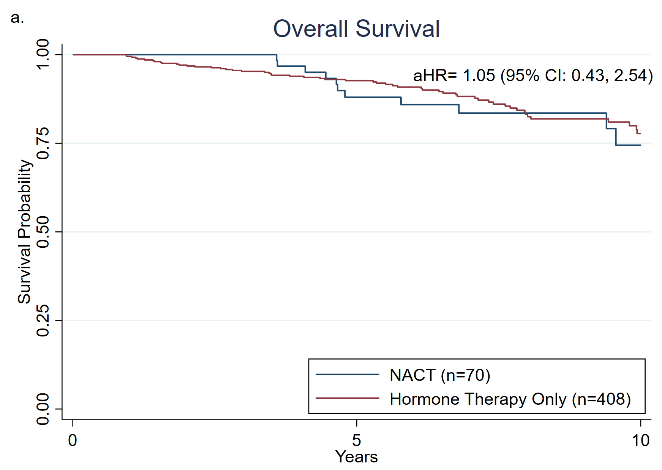
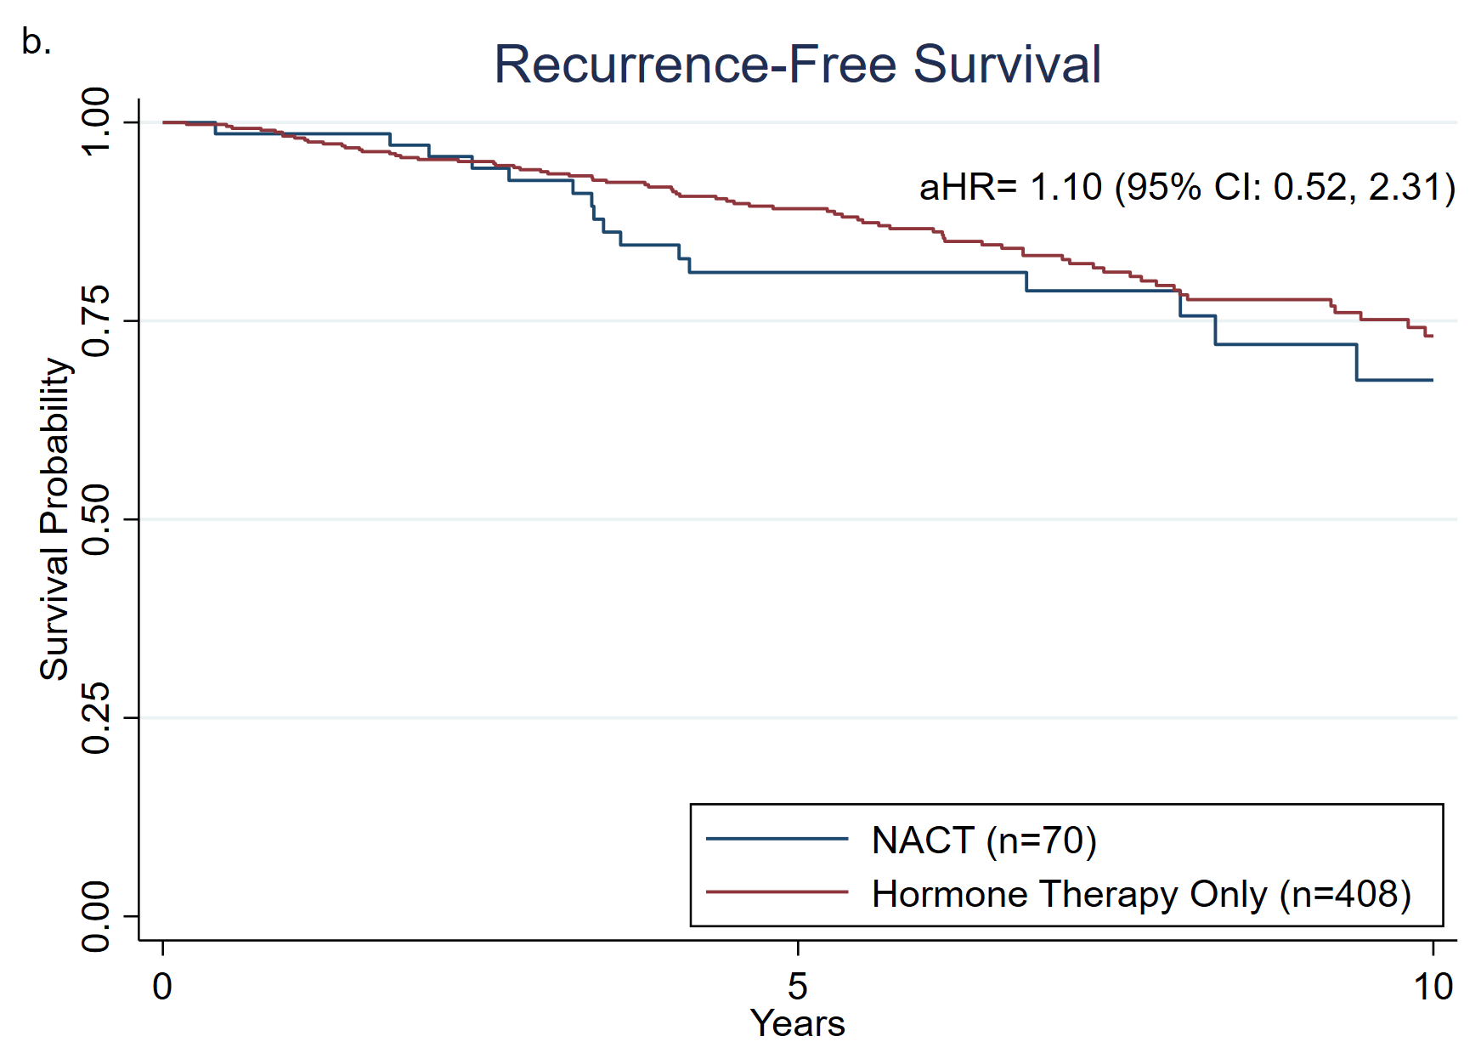
aHR: Adjusted Hazard Ratio, estimated using Cox regression adjusting for age at diagnosis, race/ethnicity, clinical T and N stage, tumor grade and comorbidities.

