SUPPLEMENTARY MATERIAL

Longitudinal history of mammographic breast density and breast cancer risk by familial risk, menopausal status, and initial mammographic density level in a high risk cohort: a nested case-control study

Parisa Tehranifar, DrPH,^{1,2} Erica J. Lee Argov, MPH¹ Shweta Athilat, MPH¹ Yuyan Liao, MS¹ Ying Wei, PhD³ Alexandra J. White, PhD⁴ Katie M. O’Brien, PhD⁴ Dale P. Sandler, PhD⁴ Mary Beth Terry, PhD^{1,2}

¹ Department of Epidemiology, Columbia University Mailman School of Public Health, New York, NY, USA.
² Herbert Irving Comprehensive Cancer Center, Columbia University Irving Medical Center, New York, NY, USA.
³ Department of Biostatistics, Columbia University Mailman School of Public Health, New York, NY, USA.
⁴ Epidemiology Branch, National Institute of Environmental Health Sciences, Research Triangle Park, North Carolina, USA.

Supplementary Table 1 – Comparison of women through mammogram collection and selection into current analysis
 | Total  N=3506 |  | ≥1 Readable Mammoª  N=1817 |  | In Analysis^{b}  N=1222
Characteristics | N (%) or  mean ± SD |  | N (%) or  mean ± SD |  | N (%) or  mean ± SD
Breast Cancer Status
Cases | 1263 (36.0) |  | 656 (36.1) |  | 323 (26.4)
Controls (at Age ≤ 60) | 2243 (64.0) |  | 1161 (63.9) |  | 899 (73.6)
Age at baseline, y | 48.7 ± 5.5 |  | 49.0 ± 5.4 |  | 47.9 ± 5.0
BMI at baseline | 27.6 ± 6.2 |  | 27.4 ± 6.2 |  | 27.3 ± 6.2
<25 | 1424 (40.6) |  | 783 (43.1) |  | 549 (44.9)
25-29.9 | 1095 (31.2) |  | 553 (30.4) |  | 354 (29.0)
≥ 30 | 984 (28.1) |  | 479 (26.4) |  | 318 (26.0)
Missing | 3 (0.1) |  | 2 (0.1) |  | 1 (0.1)
Family history of breast cancer
0 first degree relatives | 123 (3.5) |  | 55 (3.0) |  | 41 (3.4)
1 first degree relatives | 2407 (68.7) |  | 1256 (69.1) |  | 850 (69.6)
≥ 2 first degree relatives | 976 (27.8) |  | 506 (27.8) |  | 331 (27.1)
1 first or second degree relatives | 1581 (45.1) |  | 797 (43.9) |  | 541 (44.3)
2 first or second degree relatives | 1137 (32.4) |  | 620 (34.1) |  | 428 (35.0)
≥ 3 first or second degree relatives | 788 (22.5) |  | 400 (22.0) |  | 253 (20.7)
Earliest Age at diagnosis for first degree relatives | 44.4 ± 7.9 |  | 44.9 ± 7.9 |  | 44.5 ± 7.8
<40 | 892 (26.4) |  | 420 (23.8) |  | 290 (24.6)
40 - 49 | 1615 (47.7) |  | 855 (48.5) |  | 600 (50.8)
≥50 | 873 (25.8) |  | 485 (27.5) |  | 289 (24.5)
Missing | 3 (0.1) |  | 2 (0.1) |  | 2 (0.2)
Menopausal status at time of first mammogram
Pre | 2193 (62.5) |  | 1121 (61.7) |  | 830 (67.9)
Post | 1313 (37.5) |  | 696 (38.3) |  | 392 (32.1)
Hormone replacement Therapy use at baseline
Never users | 2615 (74.6) |  | 1345 (74.0) |  | 952 (77.9)
Former users | 587 (16.7) |  | 308 (17.0) |  | 168 (13.7)
Current users | 295 (8.4) |  | 161 (8.9) |  | 99 (8.1)
Missing | 9 (0.3) |  | 3 (0.2) |  | 3 (0.2)
Number of live birth | 2.2 ± 0.9 |  | 2.2 ± 0.9 |  | 2.2 ± 0.9
0 (nulliparous) | 782 (22.3) |  | 421 (23.2) |  | 280 (22.9)
1 | 558 (15.9) |  | 265 (14.6) |  | 172 (14.1)
2 | 1361 (38.8) |  | 710 (39.1) |  | 476 (39.0)
≥ 3 | 804 (22.9) |  | 421 (23.2) |  | 294 (24.1)
Missing | 1 (0.0)
Age at first birth in parous women, y | 26.0 ± 5.5 |  | 26.2 ± 5.4 |  | 26.2 ± 5.4
<25 | 1171 (43.0) |  | 573 (41.0) |  | 385 (40.9)
25 - 29 | 868 (31.9) |  | 460 (33.0) |  | 313 (33.2)
≥30 | 684 (25.1) |  | 363 (26.0) |  | 244 (25.9)
Breastfeeding duration in parous women, wk | 54.2 ± 70.1 |  | 56.9 ± 70.0 |  | 59.1 ± 73.6
Live Birth, No Breastfeeding | 591 (21.7) |  | 258 (18.5) |  | 156 (16.6)
<12 | 328 (12.0) |  | 170 (12.2) |  | 122 (13.0)
≥12 - <26 | 398 (14.6) |  | 197 (14.1) |  | 133 (14.1)
≥26 - <52 | 400 (14.7) |  | 223 (16.0) |  | 155 (16.5)
≥52 - <78 | 352 (12.9) |  | 191 (13.7) |  | 131 (13.9)
≥78 | 652 (23.9) |  | 356 (25.5) |  | 244 (25.9)
Missing | 2 (0.1) |  | 1 (0.1) |  | 1 (0.1)
Age at menarche, y | 12.7 ± 1.5 |  | 12.7 ± 1.5 |  | 12.7 ± 1.5
Alcohol consumption
Never/Former Drinker | 554 (15.8) |  | 244 (13.4) |  | 157 (12.8)
Current drinker <1 drink day | 2463 (70.3) |  | 1302 (71.7) |  | 877 (71.8)
Current drinker 1 – 1.9 drinks/day | 326 (9.3) |  | 181 (10.0) |  | 124 (10.1)
Current drinker 2+ drinks/day | 158 (4.5) |  | 87 (4.8) |  | 63 (5.2)
Missing | 5 (0.1) |  | 3 (0.2) |  | 1 (0.1)
Education
≥College graduate | 1928 (55.0) |  | 1085 (59.7) |  | 711 (58.2)
Tech/some college | 1159 (33.1) |  | 558 (30.7) |  | 385 (31.5)
≤High school | 419 (12.0) |  | 174 (9.6) |  | 126 (10.3)
Race/Ethnicity
Asian, Hawaiian/Pacific Islander, Native American | 96 (2.7) |  | 42 (2.3) |  | 30 (2.4)
Hispanic | 167 (4.8) |  | 45 (2.5) |  | 28 (2.3)
Non-Hispanic Black | 304 (8.7) |  | 126 (6.9) |  | 72 (5.9)
Non-Hispanic White | 2939 (83.8) |  | 1604 (88.3) |  | 1096 (89.4)

ª Reasons for exclusion included participant refusal, inability to reach participants, obtain mammography information from participants or obtain mammograms from facilities, deceased or incapacitated participants; defective or incompatible images
^{b} Mammograms obtained at ages >60 years or following case diagnosis, and not meeting time period criteria for inclusion.

Supplementary Table 2. Multivariable associations between the largest annual absolute change in percent density and dense area from any two mammogramsª with breast cancer risk

Overall | Cases  (N=323) | Controls  (N=899) | Adjusted b  OR (95% CI)
Overall | N (%) / Mean (SD) | N (%) / Mean (SD) | Adjusted b  OR (95% CI)
Percent Density
Decrease percent density (>5%) | 75 (23.2) | 272 (30.3) | Ref
Stable percent density (+/- ≤5%) | 195 (60.4) | 441 (49.1) | 2.61 (1.84 - 3.71)
Increase percent density (>5%) | 53 (16.4) | 186 (20.7) | 1.47 (0.95 - 2.28)
Percent density for earlier mammogram | 38.1 ± 14.9 | 33.6 ± 13.9 | 1.03 (1.01 - 1.04)^{c}
Dense Area
Decrease dense area (>5cm²) | 95 (29.4) | 393 (43.7) | Ref
Stable dense area (+/- <5cm²) | 117 (36.2) | 248 (27.6) | 2.79 (1.92 - 3.99)
Increase dense area (>5cm²) | 111 (34.4) | 258 (28.7) | 2.34 (1.65 - 3.32)
Dense area for earlier mammogram | 49.7 ± 22.1 | 48.2 ± 22.1 | 1.01 (1.00 - 1.02)^{c}
ª Changes between any two pairs of mammograms at least 9 months apart, regardless of direction of change, separately for percent density and dense area were considered; For mammograms that were obtained ≥9 month and <12 month, we extrapolated the time to 12 month.
^{b} Adjusted for age at earlier mammogram, BMI at baseline, and number of first- and second-degree relatives with breast cancer
^{c} OR for one unit change in percent density/dense area

Supplementary Table 3. Multivariable associations between largest annual absolute change in mammographic density from any two mammograms with breast cancer according to percent density levels of earlier mammogram

Overallª |  |  |  | Density tertile from the earlier mammogram^{b}
Overallª | N (Cases/Controls) |  |  | Lowest tertile  OR (95% CI) | Middle tertile  OR (95% CI) | Highest tertile  OR (95% CI) | P  intxn
Overallª | Lowest tertile | Middle tertile | Highest tertile
Percent Density
Decrease percent density (>5%) | 4 / 28 | 17 / 96 | 54 / 148 | Ref | 1.11 (0.34 - 3.64) | 2.02 (0.66 – 6.20) | 0.68
Stable percent density (+/- <5%) | 59 / 196 | 64 / 143 | 72 / 102 | 2.40 (0.80 – 7.25) | 3.08 (1.02 – 9.31) | 4.40 (1.43 – 13.5) | 0.68
Increase percent density (>5%) | 17 / 76 | 19 / 61 | 17 / 49 | 1.52 (0.46 – 5.02) | 2.09 (0.63 – 6.87) | 1.82 (0.54 – 6.16) | 0.68
Dense area
Decrease dense area (>5cm²) | 11 / 45 | 33 / 138 | 51 / 210 | Ref | 0.90 (0.41 - 1.98) | 0.91 (0.43 - 1.92) | 0.18
Stable dense area (+/- ≤5cm²) | 52 / 139 | 33 / 73 | 32 / 36 | 1.59 (0.75 - 3.39) | 1.98 (0.89 - 4.42) | 4.21 (1.81 - 9.80) | 0.18
Increase dense area (>5cm²) | 37 / 115 | 37 / 89 | 37 / 54 | 1.47 (0.67 - 3.20) | 1.65 (0.75 - 3.62) | 2.84 (1.25 - 6.45) | 0.18
ªmodels adjusted for age at first mammogram, BMI at baseline, percent density/dense area at first mammogram, first- or second-degree family history of breast cancer, and interaction between percent density/dense area at first mammogram with percent density/dense area change
^{b} tertile based on the controls

Supplementary Table 4. Largest annual relative mammographic density change according to age at diagnosis for first degree relatives with breast cancer
Overallª |  |  |  | Age at diagnosis for first degree relatives with breast cancer
Overallª | N (Cases/Controls) |  |  | <40  OR (95% CI) | 40 - 49  OR (95% CI) | ≥50  OR (95% CI) | P  intxn
Overallª | <40 | 40 - 49 | ≥50
Percent density
Decrease percent density (>10%) | 18 / 73 | 49 / 152 | 29 / 76 | Ref | 1.54 (0.82 - 2.92) | 2.19 (1.08 - 4.45) | 0.63
Stable percent density (+/- <10%) | 35 / 52 | 61 / 116 | 28 / 55 | 3.00 (1.48 - 6.08) | 2.86 (1.51 - 5.41) | 3.52 (1.69 - 7.34) | 0.63
Increase percent density (>10%) | 28 / 84 | 41 / 181 | 24 / 77 | 1.63 (0.80 - 3.32) | 1.43 (0.74 - 2.76) | 2.38 (1.14 - 4.98) | 0.63
Dense area
Decrease dense area (>10%) | 18 / 82 | 45 / 154 | 21 / 76 | Ref | 1.73 (0.92 - 3.38 | 2.09 (1.00 - 4.40) | 0.23
Stable dense area (+/- ≤10%) | 27 / 36 | 36 / 88 | 24 / 49 | 4.44 (2.09 - 9.44) | 2.76 (1.40 - 5.44) | 3.99 (1.88 - 8.47) | 0.23
Increase dense area (>10%) | 36 / 91 | 70 / 207 | 36 / 83 | 2.03 (1.03 - 3.99) | 2.23 (1.20 - 4.14) | 3.72 (1.86 - 7.45) | 0.23
ªParticipants without a first-degree relatives excluded; models adjusted for age at earlier mammogram, BMI at baseline, percent density/dense area at earlier mammogram, number of first- and second-degree relatives, age at diagnosis for first-degree relatives with breast cancer and interaction with age at diagnosis for first-degree relatives with breast cancer.

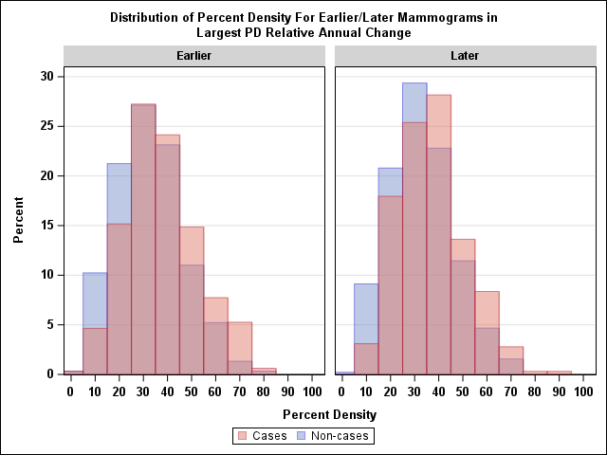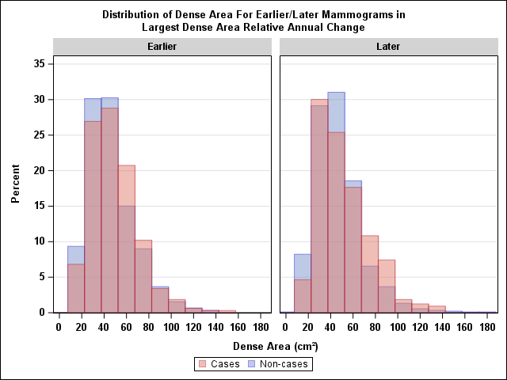
(PD)
Percent Density
Dense Area

Supplementary Figure 1. Distribution of the percent density/dense area for earlier and later mammograms used in the largest relative annual change analysis, by case and control status

Supplementary Figure 2. Associations between the Largest Relative Annual Change in Percent Density and Breast Cancer by the Number of First- and Second-degree Relatives with Breast Cancer. Models adjusted for age at earlier mammogram, BMI at baseline, percent density at earlier mammogram, first degree relatives (FDR) or second degree relatives (SDR) with breast cancer and interaction with 1st or 2nd degree relatives with breast cancer (p_{int} = 0 .002).

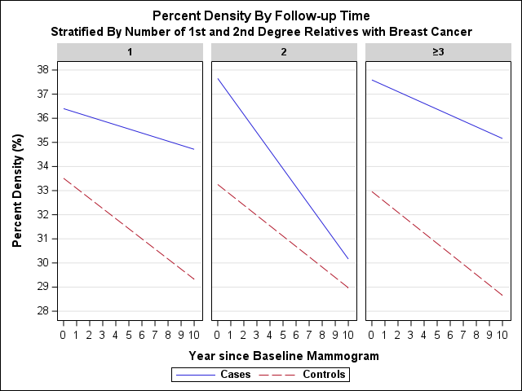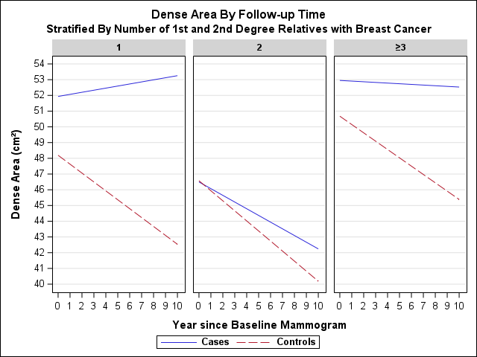

Supplementary Figure 3. Longitudinal change in mammographic density for cases and controls by number of first- and second-degree relatives with breast cancer. Adjusted for age closest to baseline and BMI at baseline, follow-up time, case-control status and product term between follow-up time and case status

