ADDITIONAL FILE 3: SUPPLEMENTARY FIGURES

Patient-derived response estimates from zero-passage organoids of luminal breast cancer

Róża K Przanowska¹*, Najwa Labban¹*, Piotr Przanowski¹, Russell B Hawes¹, Kristen A Atkins², Shayna L Showalter^{3,4#}, Kevin A Janes^{1,4,5#§}

¹ Department of Biomedical Engineering, University of Virginia, Charlottesville, VA 22908, USA
² Department of Pathology, University of Virginia, Charlottesville, VA 22908, USA
³ Department of Surgery, University of Virginia Health System, Charlottesville, VA 22908, USA
⁴ University of Virginia Comprehensive Cancer Center, University of Virginia, Charlottesville, VA 22908, USA
⁵ Department of Biochemistry and Molecular Genetics, University of Virginia School of Medicine, Charlottesville, VA 22908, USA

* co-first
# co-corresponding authors: Shayna L Showalter and Kevin A Janes
§ lead contact: Kevin A Janes (kjanes@virginia.edu)

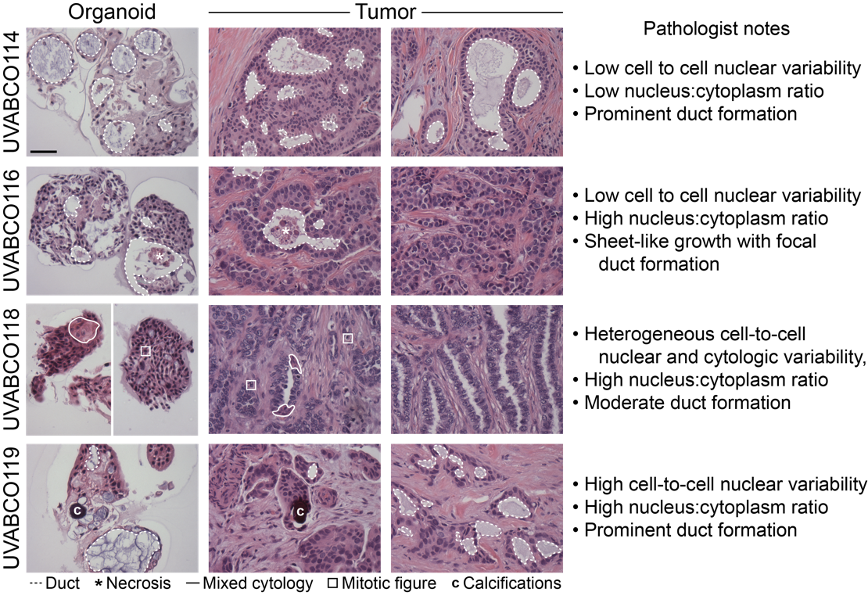

Fig. S1. Histologic comparison of zero-passage organoids with originating luminal tumors.
Annotated hematoxylin-eosin images are shown alongside histologic similarities noted by a clinical pathologist. Scale bar is 100 µm.

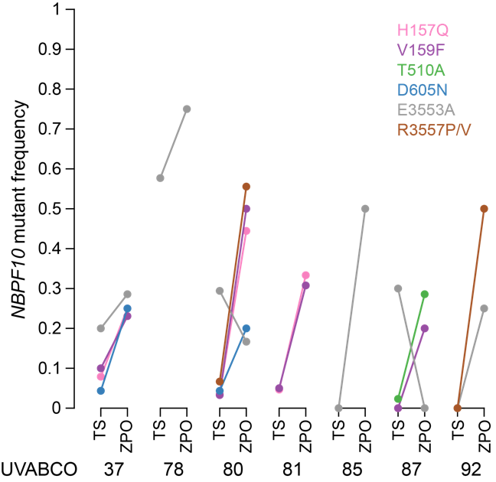

Fig. S2. Somatic mutations are retained and enriched in zero-passage organoids.
Recurrent enrichment of NBPF10 passenger mutations in zero-passage organoid (ZPO) samples (n = 7 cases) compared to the corresponding tumor scrape (TS). Estimated frequency of expression based on read counts is shown for the indicated coding mutations in NBPF10.

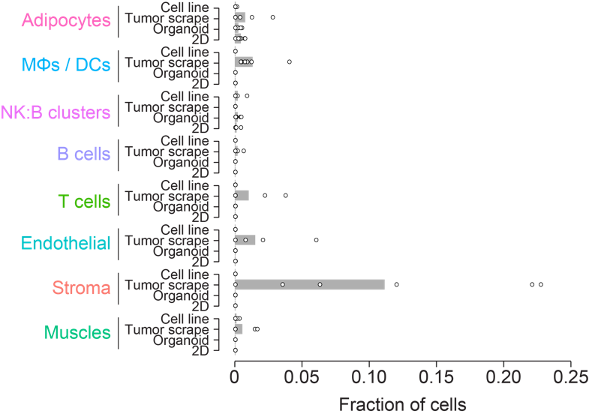

Fig. S3. Deconvolution identifies non-epithelial cell types predominantly in tumor scrapes.
CIBERSORTx-inferred cell lineage fractions (excluding Basal and Luminal shown in Fig. 2E,F) in originating tumor scrapes, zero-passage organoids, 2D cultured cells and luminal breast cancer cell lines (n = 6 samples in each group).

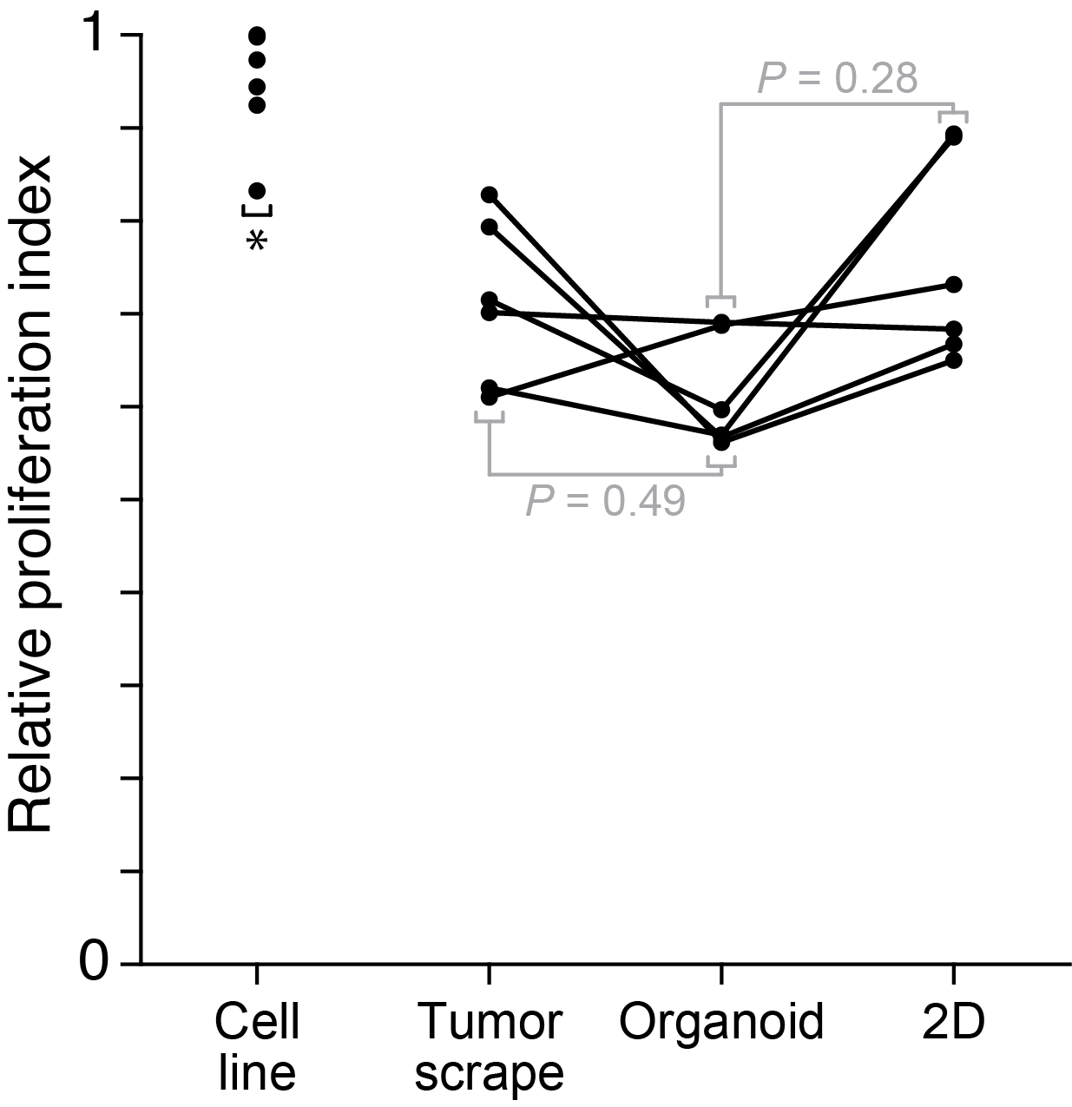

Fig. S4. Luminal cell lines are more proliferative than tumor scrapes, zero-passage organoids, and short-term 2D cultures.
The CIBERSORTx-inferred epithelial transcriptomes were projected on a gene signature for proliferation rate [23] and normalized to the maximum-observed rate of luminal breast cancer cell lines (MCF7, T47D, HCC1500, CAMA1, EFM19, and ZR-75-1). *P < 0.05 by paired two-sided t test after arcsine transformation of percentages and Šidák correction for multiple hypothesis testing.

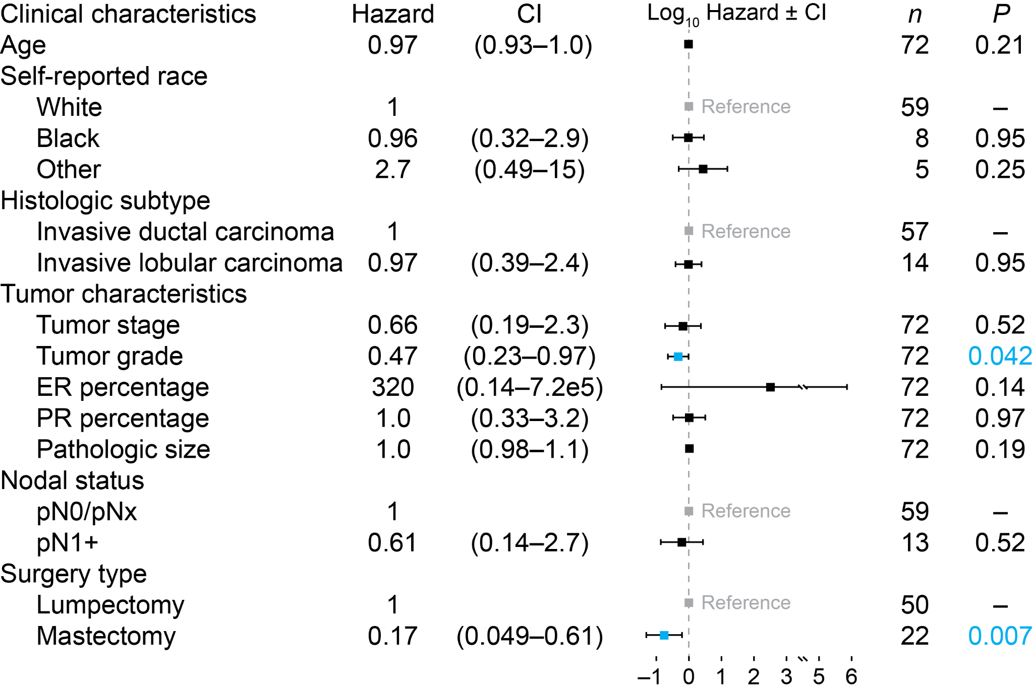

Fig. S5. Post-surgical characteristics and their association with organoid failure risk by day 14. Cox proportional hazards model for n = 72 luminal breast cancers showing hazard ratios with confidence interval (CI). Significant factors are blue. One surgical case contained both intraductal carcinoma and intralobular carcinoma, which led to the exclusion of that factor for this case. Tumor grade at resection was missing for one of the specimens (see Methods).

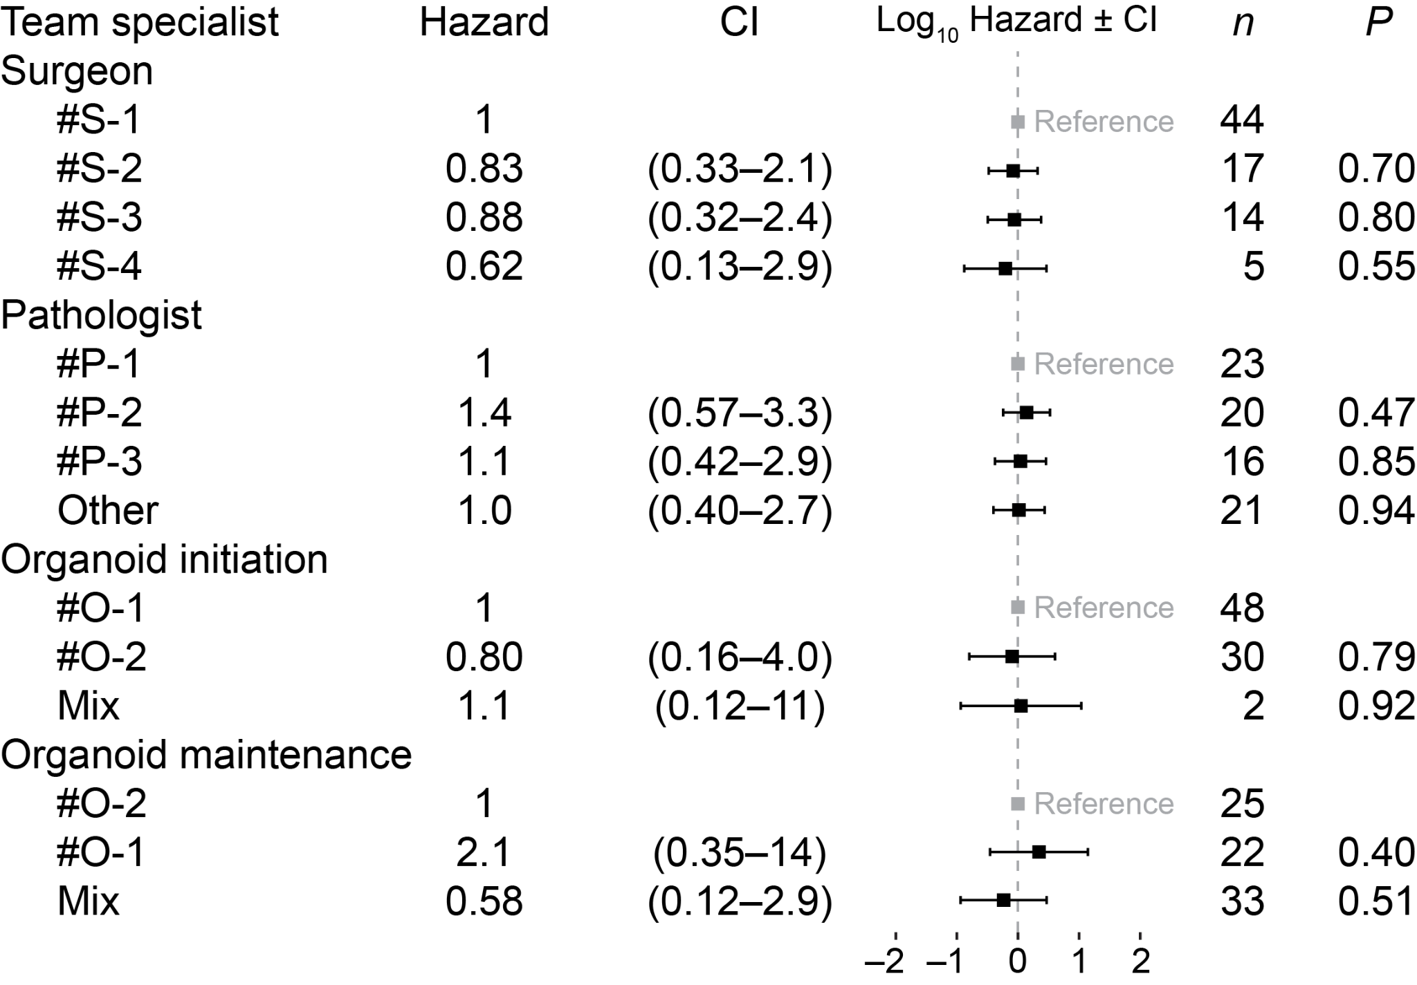

Fig. S6. Handler characteristics and their association with organoid failure risk by day 14. Cox proportional hazards model for n = 72 luminal breast cancers showing hazard ratios for surgeon (S), pathologist (P), and organoid culturist (O) with confidence interval (CI). “Other” indicates 11 different pathology assistants. “Mix” indicates O-1 and O-2 worked on organoid initiation or maintenance together.

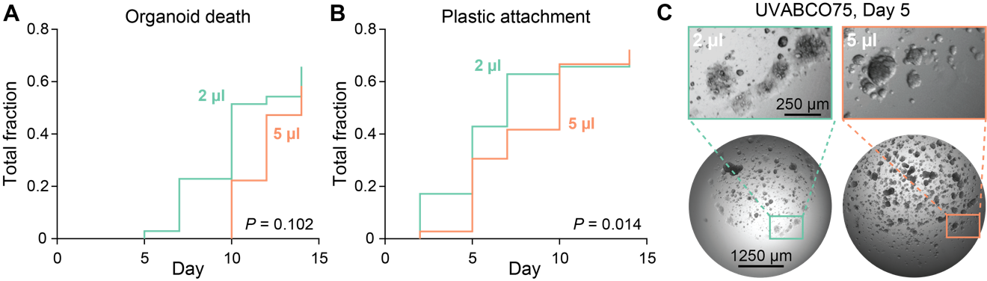

Fig. S7. 2 µl organoid cultures attach to plastic earlier and may die faster.
(A and B) Cox proportional hazard models for organoid death and plastic attachment using volume as a continuous variable for n = 35–36 cultures from 12 independent luminal breast cancers.
(C) Representative image of a paired 2 µl and 5 µl organoid culture with premature plastic attachment on day 5. Scale bars are 250 µm (top) and 1250 µm (bottom).

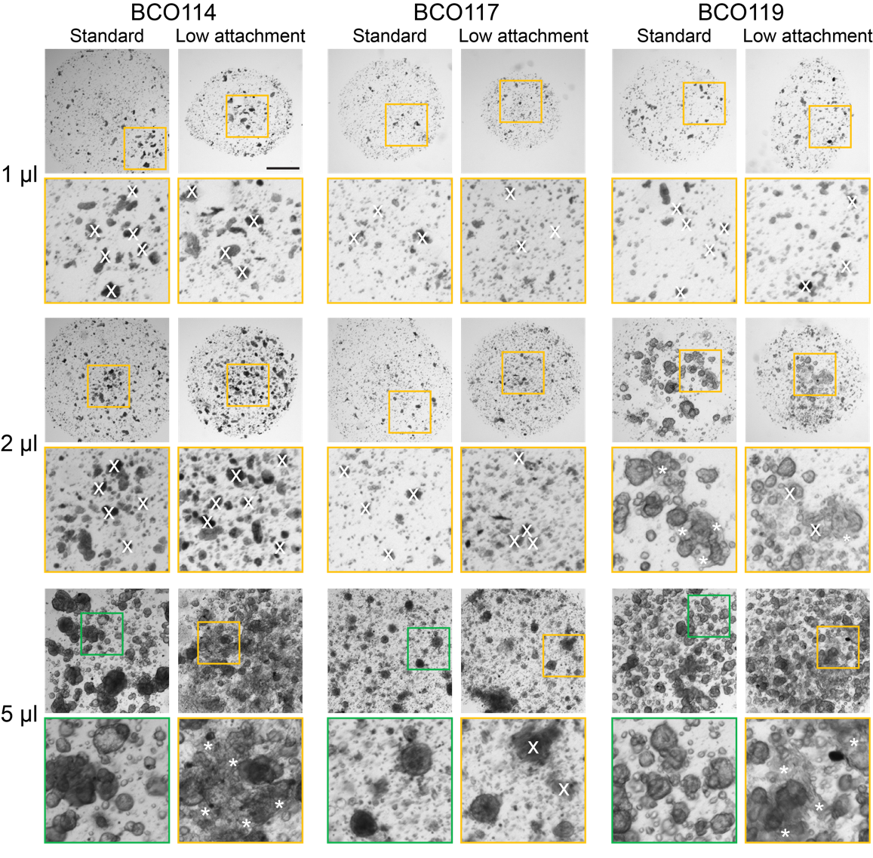

Fig. S8. Zero-passage organoids do not initiate reliably in matrigel sitting drops on low-attachment plates. Standard zero-passage organoid hanging drops at the indicated volumes were compared to sitting drops plated on low-attachment plates for n = 3 cases. Enlarged regions (yellow, green) show regions of organoid death (x) and plastic attachment (asterisk). Scale bar is 500 µm.

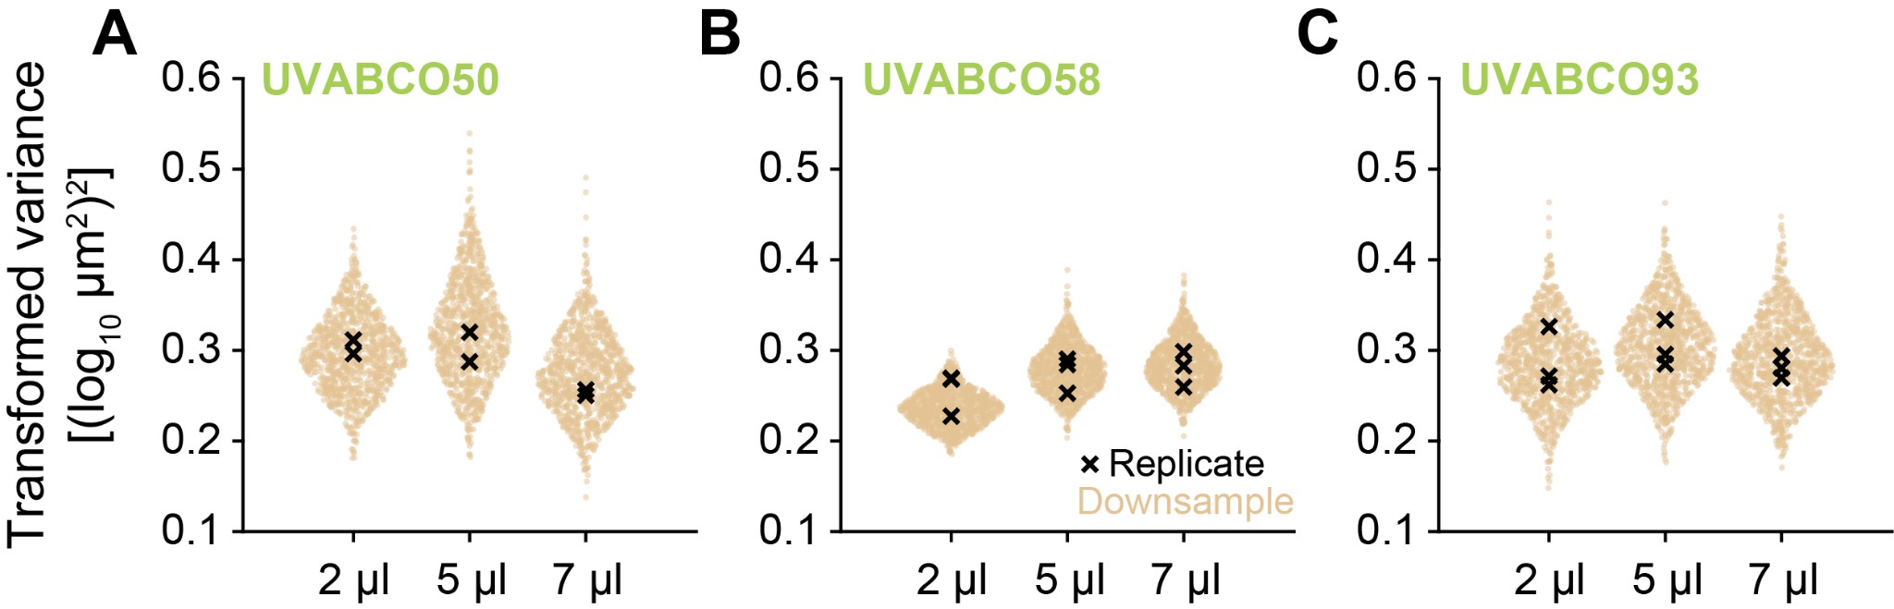

Fig. S9. Differences in organoid size variance are not consistently attributable to culture volume.
(A–C) Organoid counts in the larger volumes of three patients were repeatedly downsampled to the 2 µl median (n = 1000 iterations; tan), and variance was estimated after shifted log transformation (see Methods). Variance estimates of the entire organoid count from each volume and technical replicate are overlaid (black).

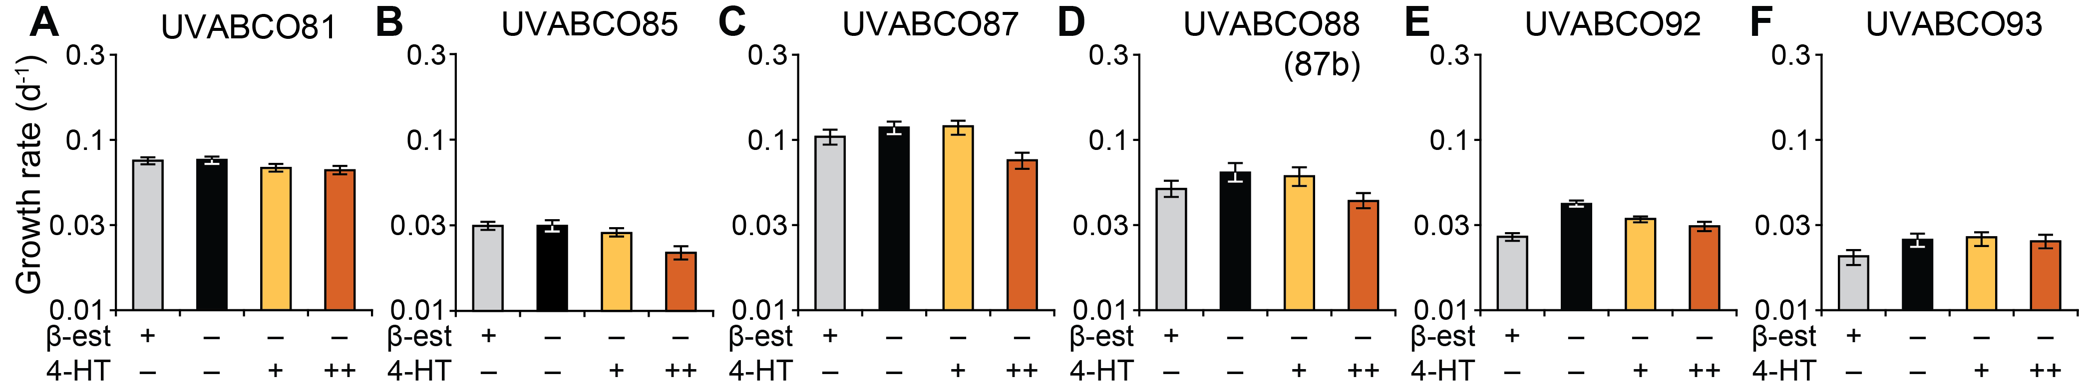

Fig. S10. Bootstrap resampling of the results shown in Fig. 5.
(A–F) Time point and condition data were resampled with replacement to the median organoid number of each patient (n = 100 bootstrapping iterations) and volumetric growth rates estimated as in Fig. 5 for control cultures (gray), cultures with β-estradiol withdrawn (β-est; black), and cultures with β-est withdrawn plus 200 nM 4-hydroxytamoxifen (4-HT; yellow) or 3 µM 4-HT (orange) on day 5. Best-fit per-day (d⁻¹) volumetric growth rates for each condition are summarized as the median ± interquartile range of the bootstrap iterations.

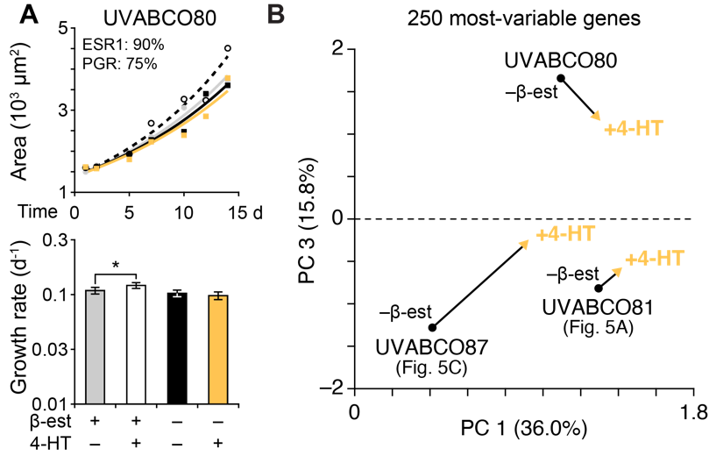

Fig. S11. Transcriptomic similarities among 4-HT-resistant zero-passage organoids.
(A) Upper panel shows mean organoid area at six time points after shifted log transformation (n = 56–109 organoids per time point and condition; see Methods) for control cultures (gray), cultures treated with 200 nM 4-hydroxytamoxifen (4-HT; white), cultures with β-estradiol withdrawn (β-est; black), and cultures with β-est withdrawn plus 200 nM 4-HT (yellow) on day 5. Overlaid are non-linear least-squares curve fits for area growth as a function of volumetric growth rate. Pathologic estimates of positivity for estrogen receptor (ESR1) and progesterone receptor (PGR) are reported as cellular percentages in the inset. Lower panels summarize the best-fit per-day (d⁻¹) volumetric growth rate for each condition with 90% confidence intervals estimated by support plane analysis. *P < 0.05 after Bonferroni correction for multiple-hypothesis testing.
(B) Principal component (PC) analysis of the 250 highest-variance genes measured by RNA-seq of the indicated cases upon β-est withdrawal (–β-est; black) ± 200 nM 4-HT (yellow). The overall variance captured by PC 1 and PC 3 is shown in parenthesis. PC 2 captured 4-HT-invariant differences between cases.

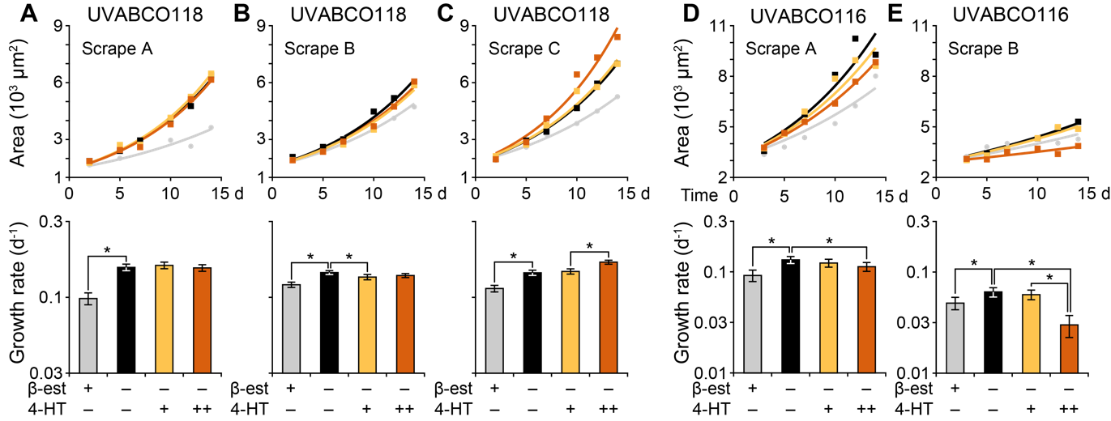

Fig. S12. Replication of tamoxifen-induced phenotypes among zero-passage organoids from independent tumor scrapes of the same luminal breast cancers.
(A–E) Upper panels show mean organoid area at six time points after shifted log transformation (n = 43–620 organoids per patient, time point, and condition; see Methods) for control cultures (gray), cultures with β-estradiol withdrawn (β-est; black), and cultures with β-est withdrawn plus 200 nM 4-hydroxytamoxifen (4-HT; yellow) or 3 µM 4-HT (orange) on day 5. Overlaid are non-linear least-squares curve fits for area growth as a function of volumetric growth rate. For (A–E), three serial scrapes were obtained from UVABCO118 (ESR1: 100%; PGR: 100%). For (E) and (F), two spatially separated scrapes were obtained from UVABCO116 (ESR1: 95%; PGR: 80%). Lower panels summarize the best-fit per-day (d⁻¹) volumetric growth rate for each condition with 90% confidence intervals estimated by support plane analysis. *P < 0.05 after Bonferroni correction for multiple-hypothesis testing.

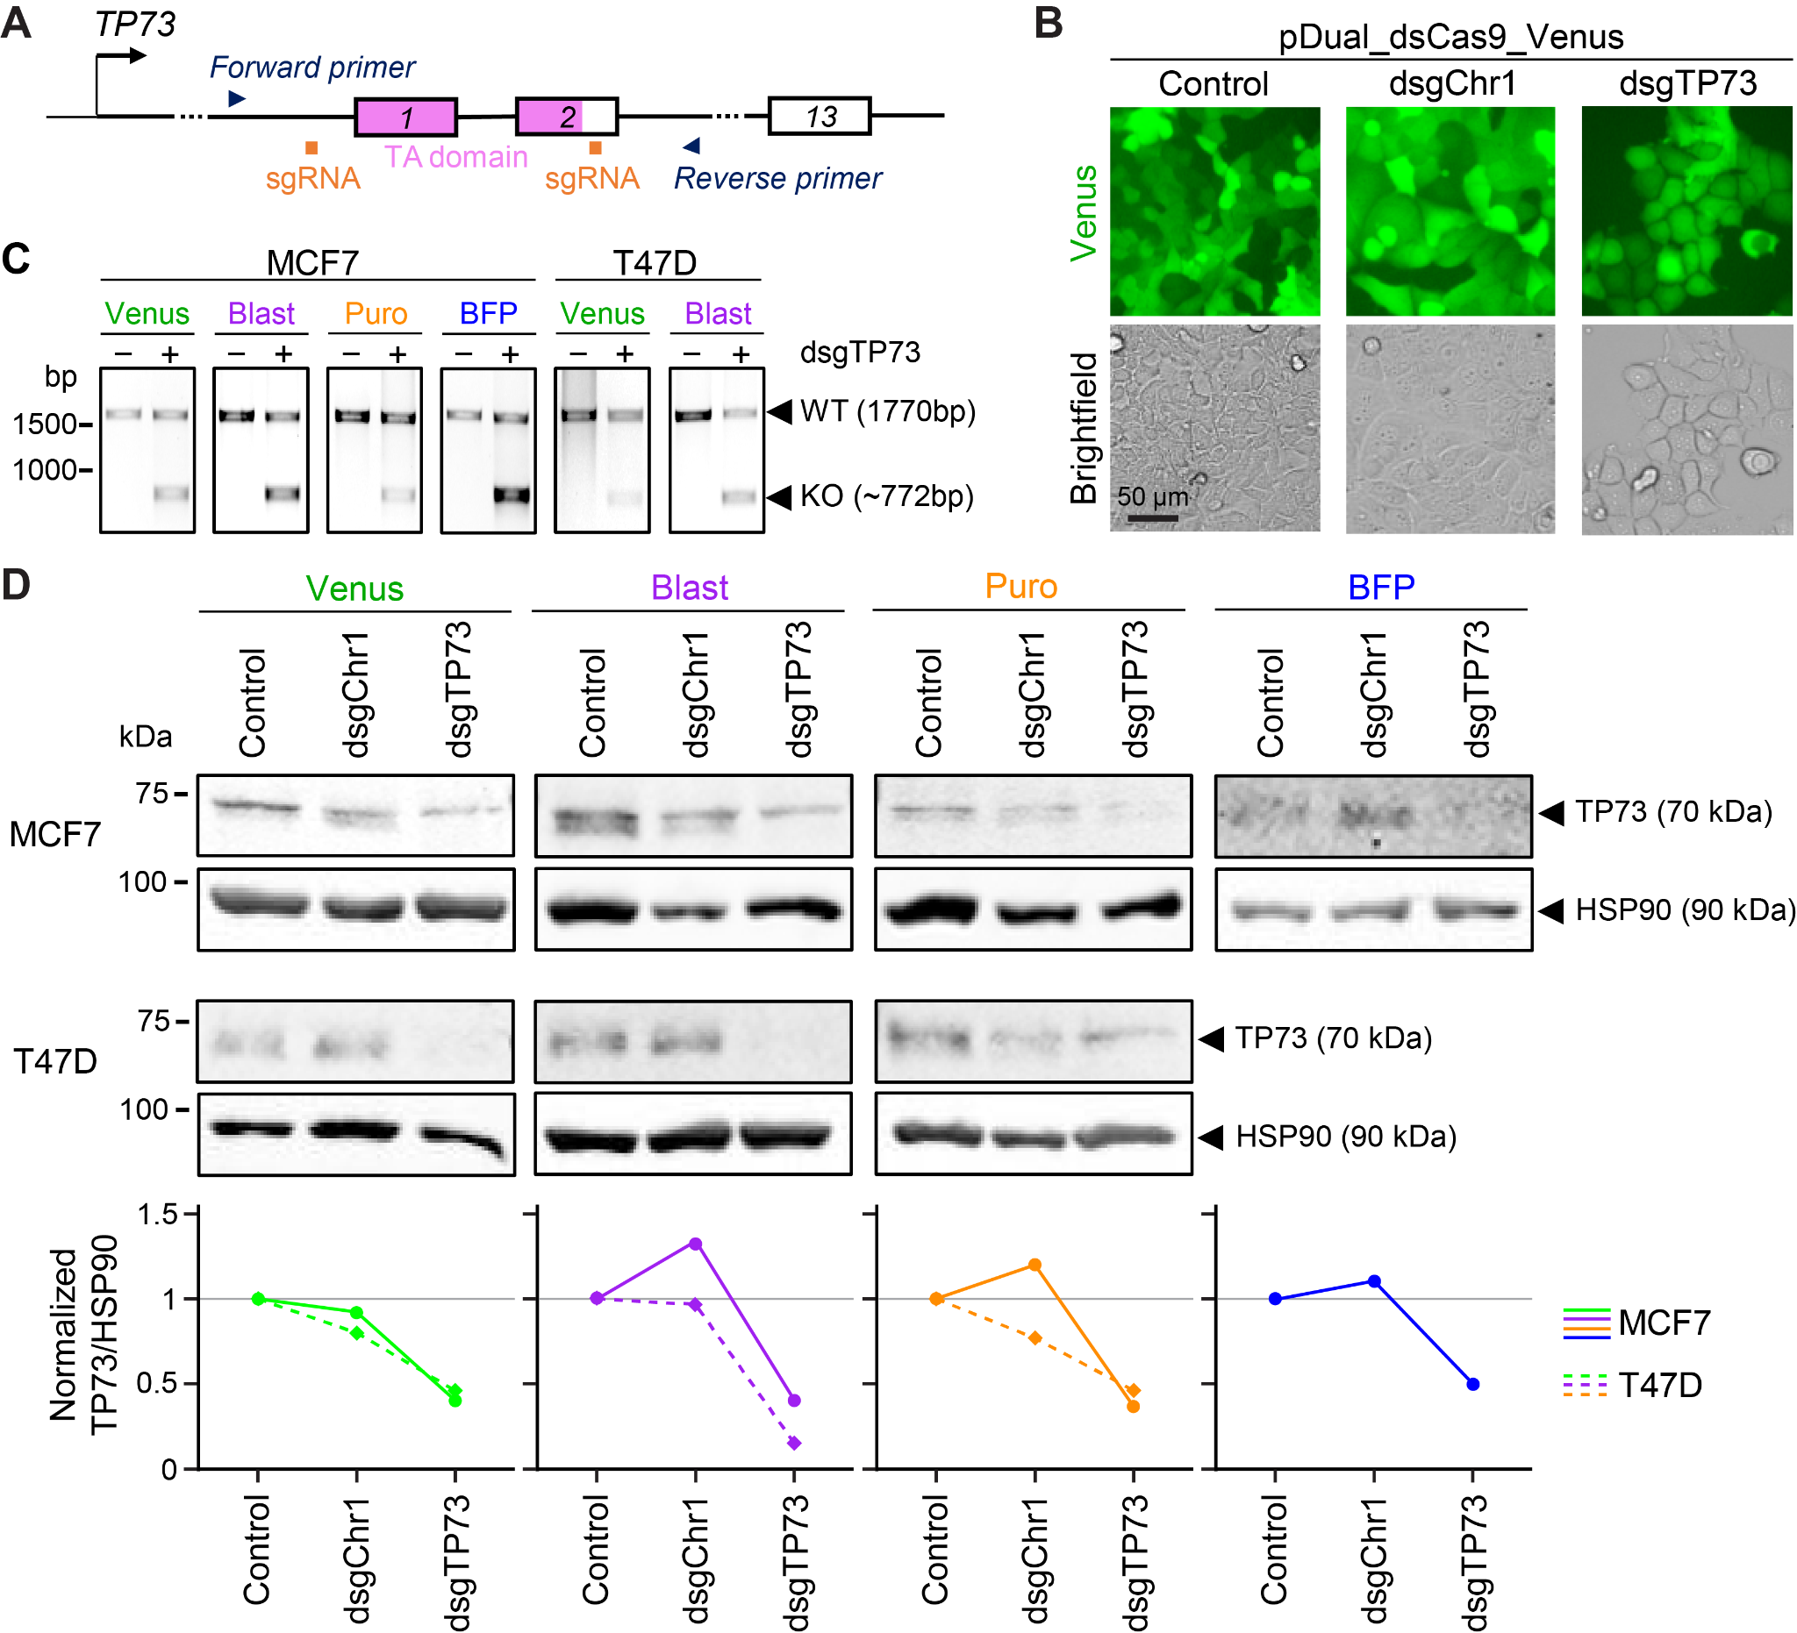

Fig. S13. Efficient transduction of pDual_dsCas9_Venus and deletion of TP73 in luminal breast cancer cell lines.
(A) Experimental design for targeting and detecting deletion of the transactivation domain of TP73 (TA, pink). Dual sgRNAs are in orange and genotyping PCR primers are in blue.
(B) Confirmation of Venus-sorted MCF7 cells transduced with different versions of pDual_dsCas9_Venus. Scale bar is 50 µm.
(C) Genotyping of selected polyclonal MCF7 or T47D cells transduced with different pDual_dsCas9 versions encoding dual-sgRNA (dsgRNA) of TP73 as in (A). The control lane is empty pDual_dsCas9_Venus (nontargeting), and the second lane is from cells transduced and selected by sorting or antibiotic. DNA markers are on the left and PCR band sizes for wild-type and knockout amplicons are on the right.
(D) Immunoblotting of TP73 and HSP90 (housekeeping control) in selected polyclonal MCF7 or T47D cells transduced with empty pDual_dsCas9 (control), pDual_dsCas9 encoding dsgRNA targeting a noncoding region of human chromosome 1 (dsgChr1), or pDual_dsCas9 encoding dsgRNA targeting TP73 as in (A) (dsgTP73) sorted (Venus and BFP) or selected (Blast and Puro). Protein markers are on the left and proteins are on the right. Blots were quantified, normalized to HSP90, and plotted relative to control (gray line).

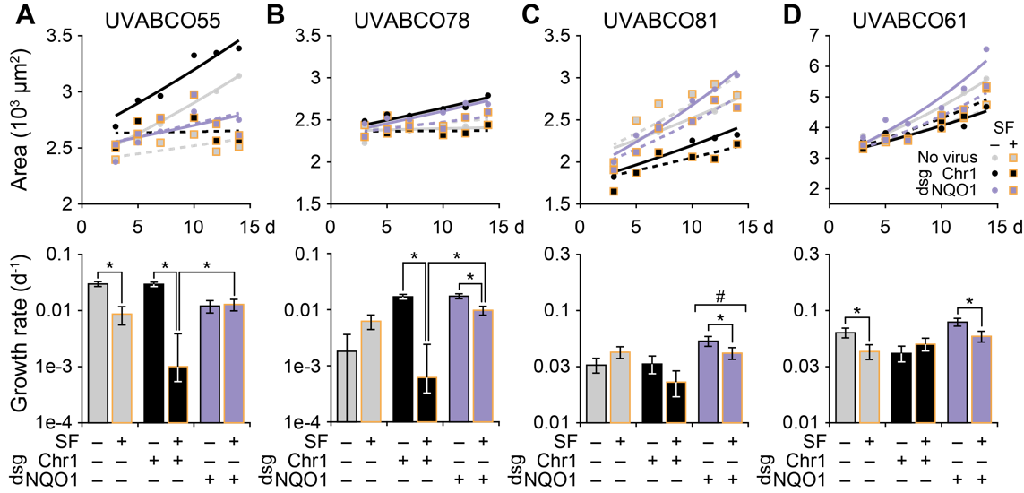

Fig. S14. Different classes of patient-specific responses to combinatorial NQO1 depletion and sulforaphane treatment in zero-passage organoids.
(A–D) Upper panels show mean organoid area at six time points after shifted log transformation (n = 113–1648 organoids per patient, time point, and condition; see Methods) for control cultures transduced with Cas9 only (gray), cultures with dual-sgRNAs (dsgRNAs) targeting a noncoding region of chromosome 1 (Chr1) targeted (black), and cultures with NQO1 targeted with dsgRNA (purple). Genotypes were treated with 10 µM sulforaphane (SF, yellow boxes) or 0.1% DMSO control. Overlaid are non-linear least-squares curve fits for area growth as a function of volumetric growth rate and genotype. Lower panels summarize the best-fit per-day (d⁻¹) volumetric growth rate for each condition with 90% confidence intervals estimated by support plane analysis. *P < 0.05 after Bonferroni correction for multiple-hypothesis testing for the indicated pairwise comparisons. #P < 0.05 indicating both dsgNQO1 conditions are less than the corresponding dsgChr1 condition.

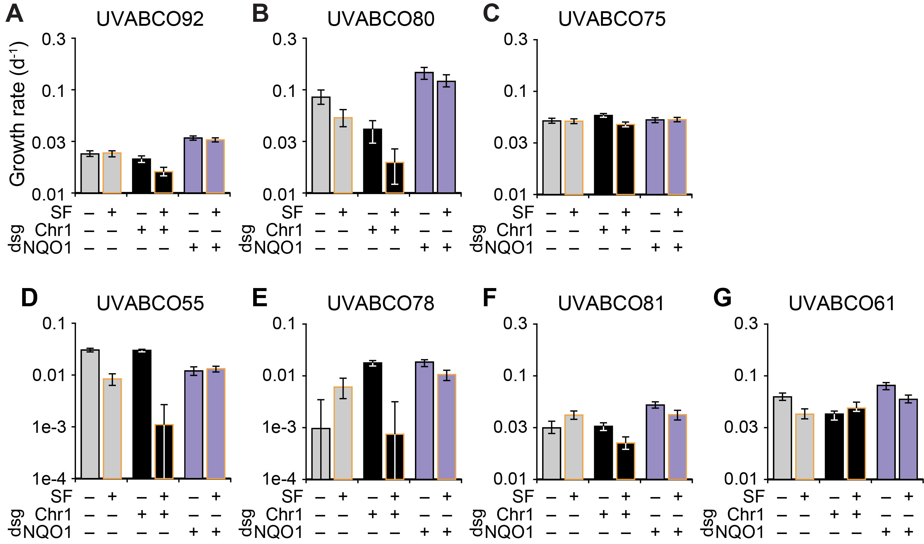

Fig. S15. Bootstrap resampling of the results shown in Fig. 7 and Additional file 3: Fig. S14.
(A–G) Time point and condition data were resampled with replacement to the median organoid number of each patient (n = 100 bootstrapping iterations) and volumetric growth rates estimated as in Fig. 7 and Additioanl file 15: Fig. S14 for control cultures transduced with Cas9 only (gray), cultures with dual-sgRNAs (dsgRNAs) targeting a noncoding region of chromosome 1 (Chr1) targeted (black), and cultures with NQO1 targeted with dsgRNA (purple), and each genotype treated with 10 µM sulforaphane (SF, yellow boxes) or 0.1% DMSO control. Best-fit per-day (d⁻¹) volumetric growth rates for each condition are summarized as the median ± interquartile range of the bootstrap iterations.

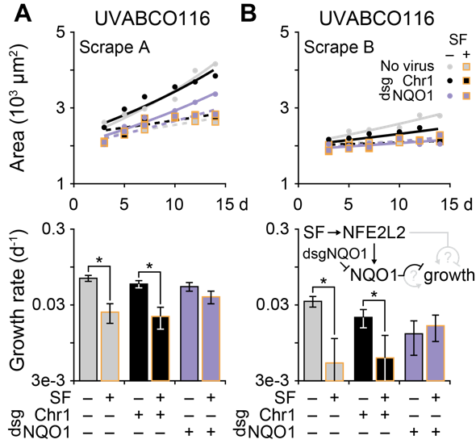

Fig. S16. Reproducible genetic and pharmacologic phenotypes in zero-passage organoids from spatially distinct tumor scrapes of the same luminal breast cancer.
(A and B) Upper panels show mean organoid area at six time points after shifted log transformation (n = 48–162 organoids per scrape, time point, and condition; see Methods) for control cultures transduced with Cas9 only (gray), cultures with dual-sgRNAs (dsgRNAs) targeting a noncoding region of chromosome 1 (Chr1) targeted (black), and cultures with NQO1 targeted with dsgRNA (purple). Genotypes were treated with 10 µM sulforaphane (SF, yellow boxes) or 0.1% DMSO control. Overlaid are non-linear least-squares curve fits for growth as a function of volumetric growth rate and genotype. Lower panels summarize the best-fit per-day (d⁻¹) volumetric growth rate for each condition with 90% confidence intervals estimated by support plane analysis. *P < 0.05 after Bonferroni correction for multiple-hypothesis testing for the indicated pairwise comparisons. The inset of the lower panel of (B) illustrates the implied relationship between sulforaphane (SF), the transcription factor NFE2L2, its target NQO1, and organoid growth for UVABCO116.

