Supplementary Fig. S1

Ai.
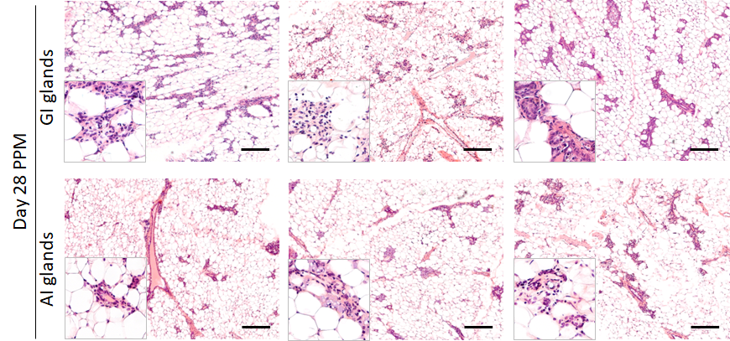
Aii.
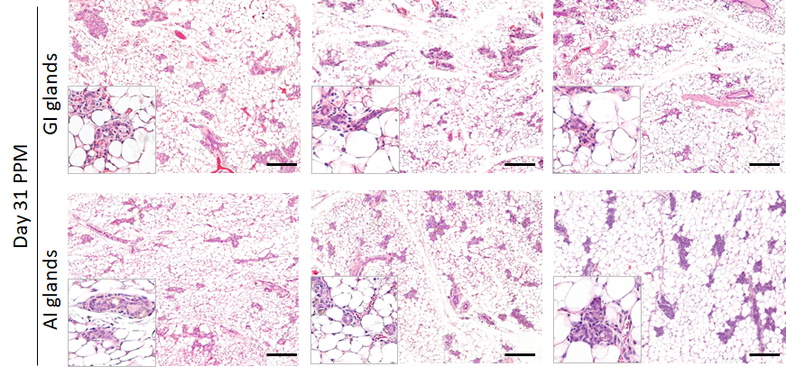

Supplementary Figure S1: A. Representative images of H&E-stained sections of mouse mammary glands subjected to AI and GI harvested on i. day28 PPM, ii. day31 PPM. (Scale bar: 50μM, higher magnification pictures are added in the inserts)
Supplementary Fig. S1

Aiii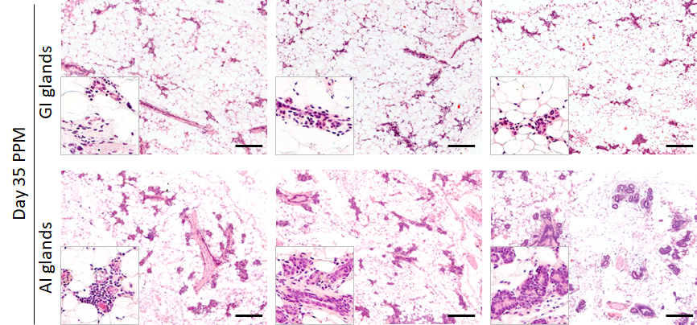
B.
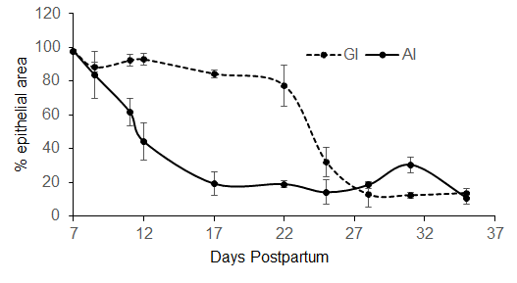
Supplementary Figure S1: Aiii. Representative images of H&E-stained sections of mouse mammary glands subjected to AI and GI harvested on day35 PPM. (Scale bar: 50μM, higher magnification pictures in the inserts). B. Kinetics comparing epithelial cell loss during AI and GI of mammary gland. H&E-stained mammary gland sections were imaged using Vectra 3.0 and quantified using InFORM software.
Supplementary Fig. S1

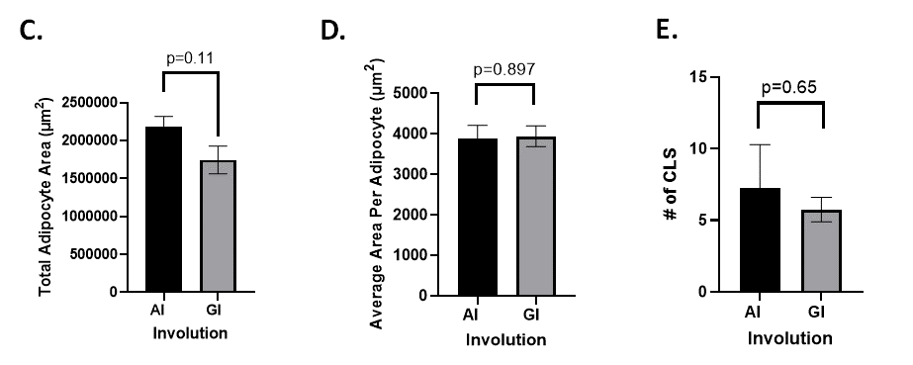

Supplementary Figure S1: C. Comparison of total area covered by epithelial cells, D. average area per adipocyte, and E. total number of crown-like structures (CLS) in AI and GI glands harvested on day 28 PPM. FFPE sections were stained by IHC using F4/80 antibody, imaged and quantified using Image J software.
Supplementary Fig. S2
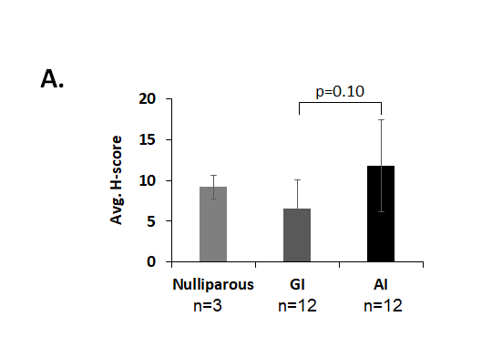
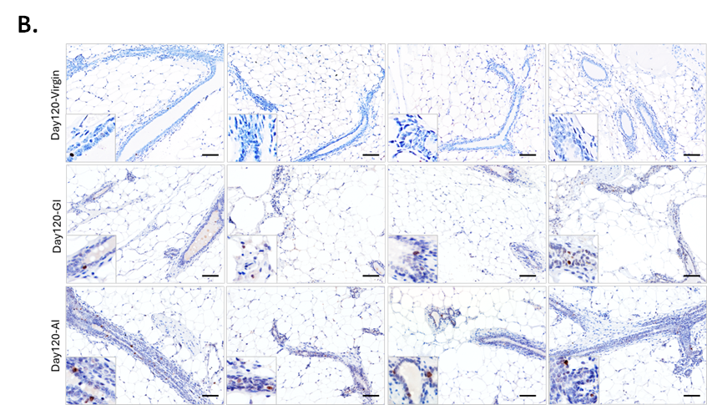
Supplementary Fig. S2: A. γH2AX-positive cells in AI and GI mammary glands from FVB/N mice harvested on day 120 postpartum, as determined by IHC and quantified using InFORM software. B. Representative images of γH2AX stained sections of mammary glands from C57BL/6 mice that are quantified in Fig. 2D (n=4). Inserts are higher magnification of areas within the same image. (Scale bar: 50μM)
Supplementary Fig. S2
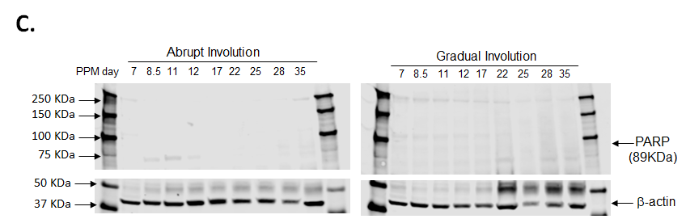

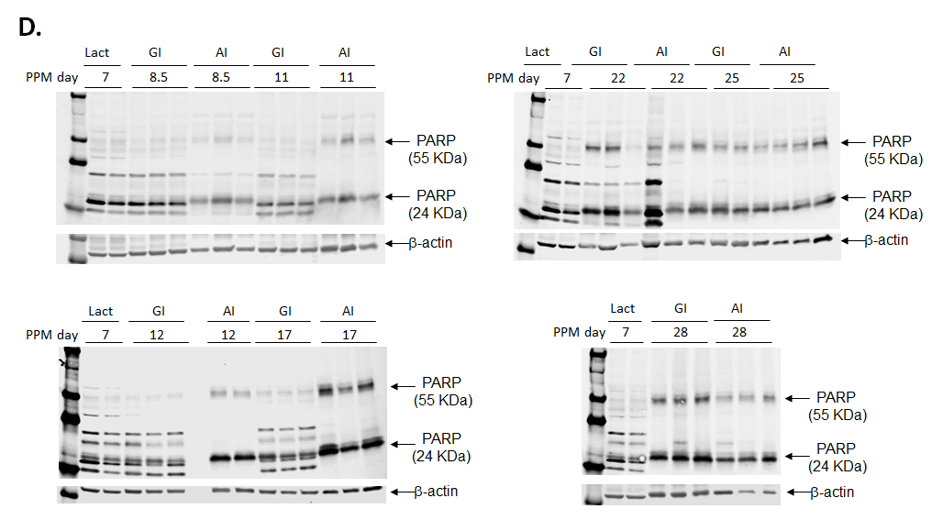

Supplementary Fig. S2: C. Western blot analysis of whole mammary gland extract resolved on 8% SDS-PAGE and probed for cleaved PARP (upper panel) and β-actin (lower panel). The same Western blot analysis has been used in Fig. 2Ei to show the kinetics of 55 and 24KDa cleaved PARP in AI ang GI glands. D. Western blot analysis of whole mammary gland extract probed for cleaved PARP at different time points (n=3 mice/time point). Lact: Lactating gland
Supplementary Fig. S3
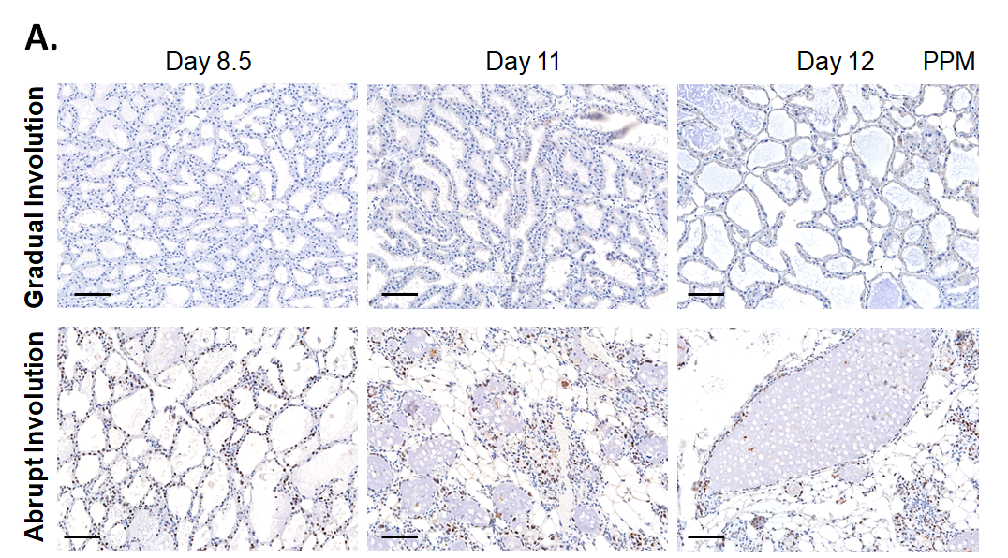

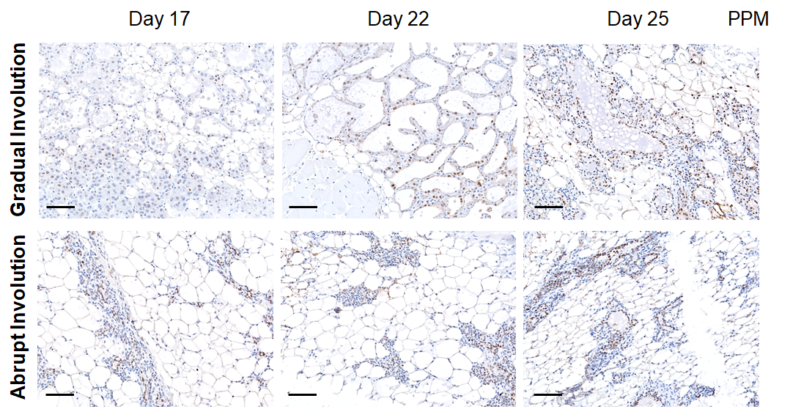

Supplementary Fig. S3: A. Representative images of pStat3^{Y705} IHC in AI and GI glands at the indicated timepoints. (Scale Bar: 50μM).

Supplementary Fig. S3

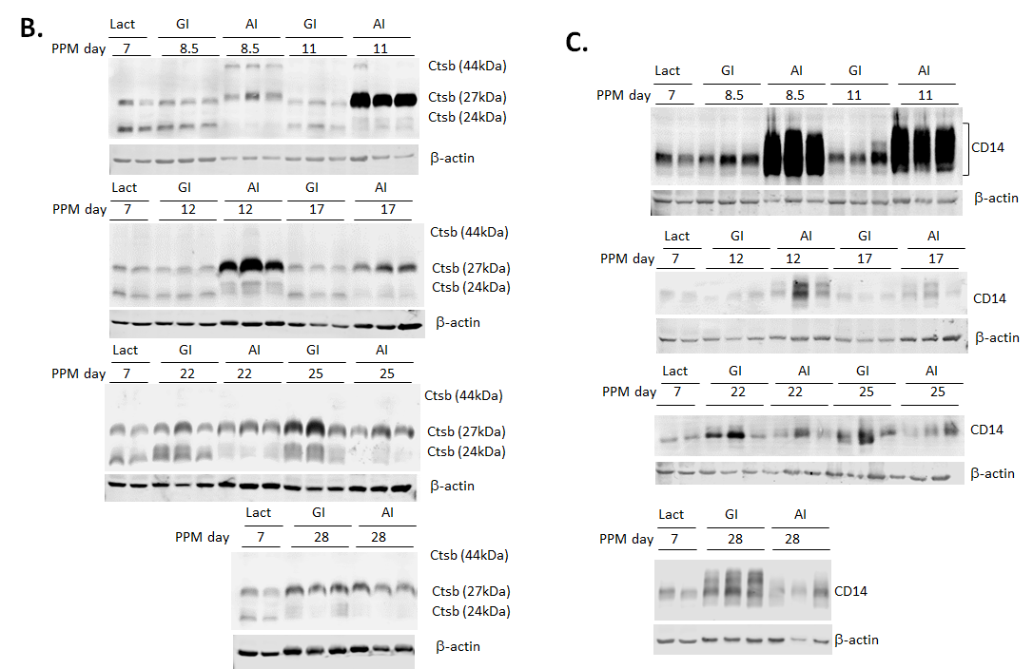

Supplementary Fig. S3: B. Western blot analysis of CtsB and C. CD14 in whole mammary gland lysates harvested at indicated time points. (n=2, day 7 PPM, n=3, all other time points). Thirty micrograms of the whole-cell lysates were resolved on 10% SDS-PAGE, probed with respective antibodies, and imaged using LI-COR imaging system.

Supplementary Fig. S4

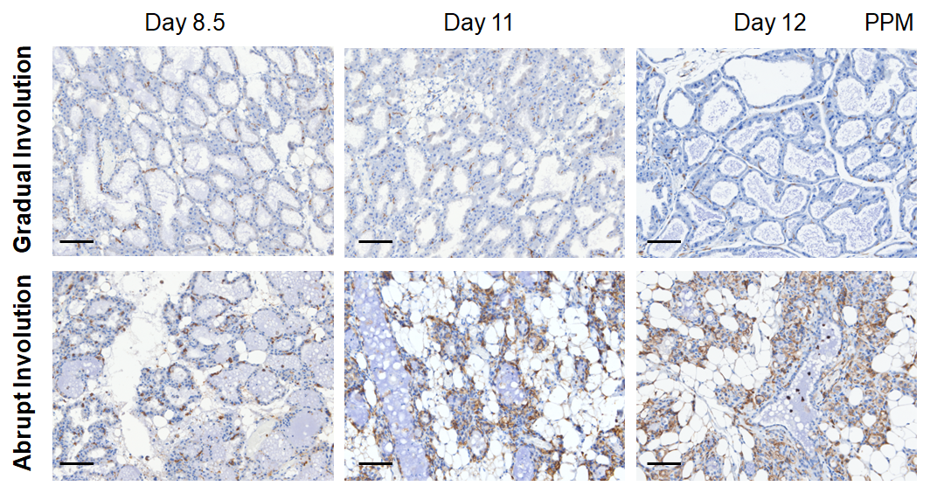
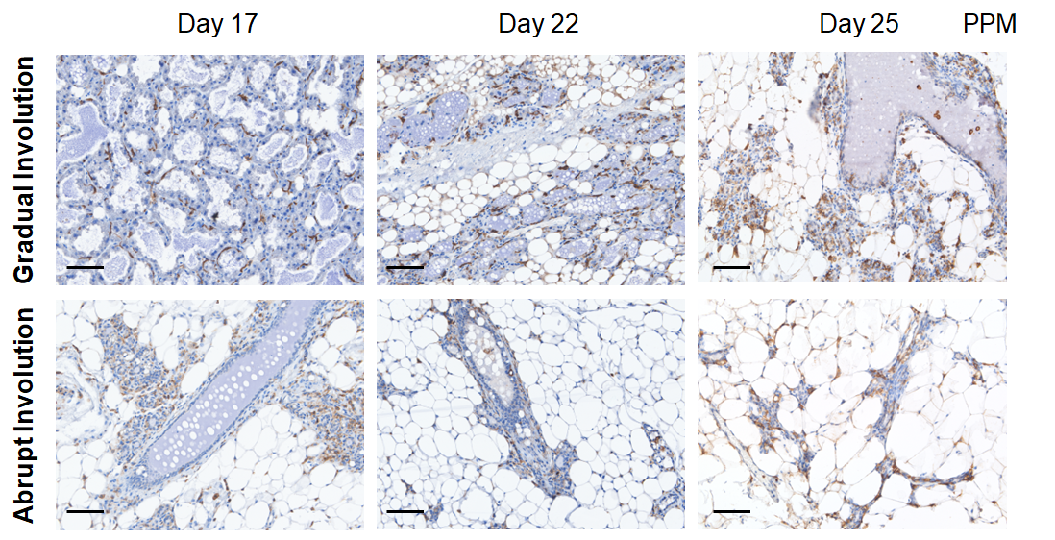

Supplementary Fig. S4: Representative images of F4/80 IHC in AI and GI glands at the indicated timepoints. (Scale Bar: 50μM). PPM: postpartum

Supplementary Fig. S5

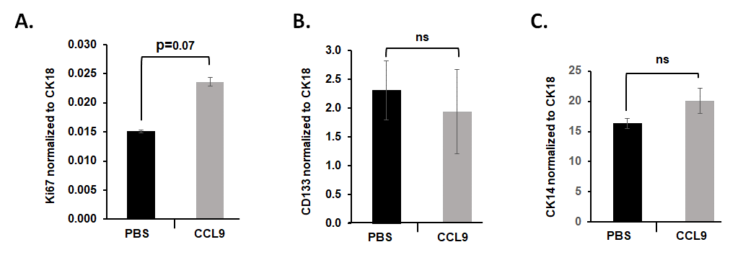

Supplementary Fig. S5: Quantitative RT-PCR analysis of A. Ki67, B. CD133, and C. CK14 in total RNA isolated from LP organoids cultured for 12 days with and without CCL9 (100ng/ml). ns: non-significant

Supplementary Fig. S6
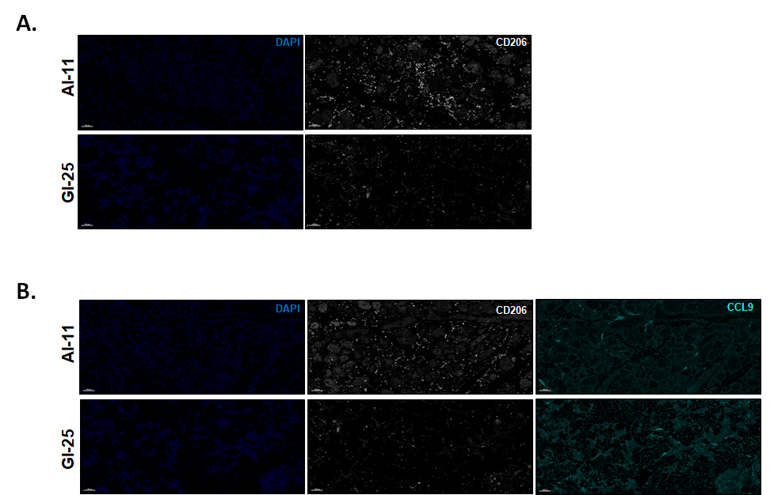

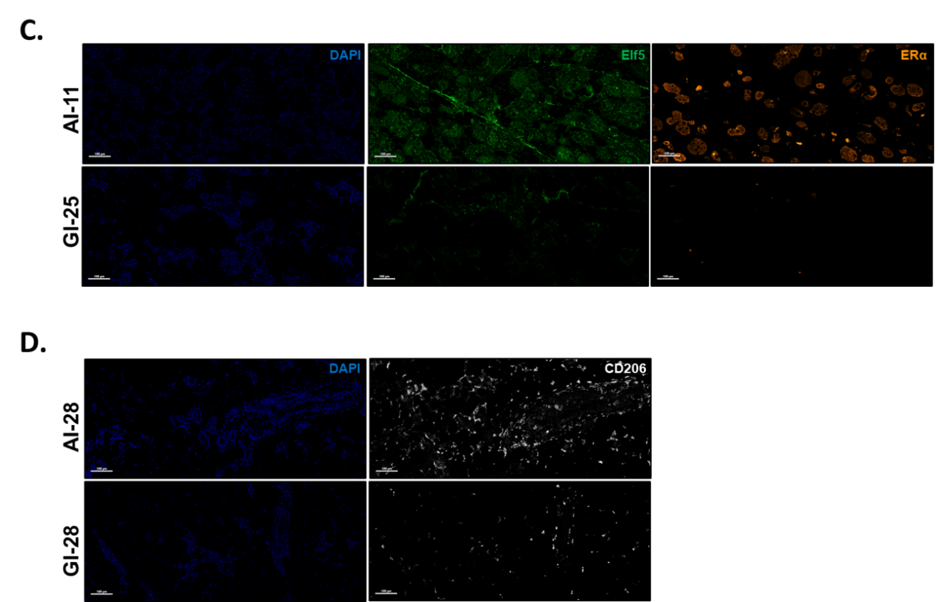
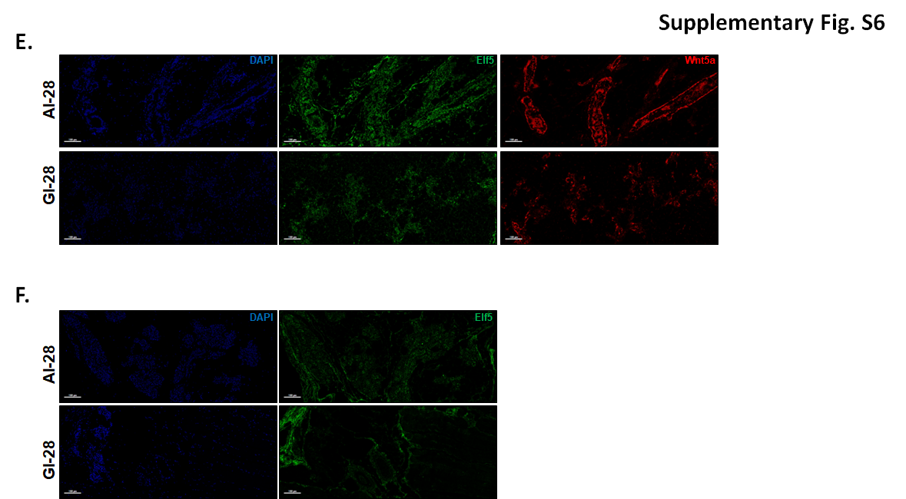

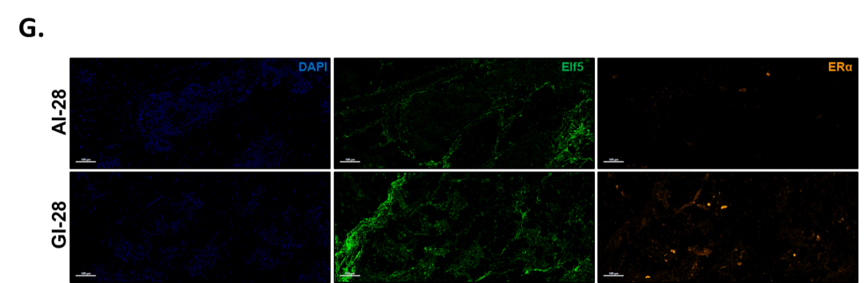

Supplementary Fig. S6: AI and GI mouse mammary glands harvested at indicated time points were subjected to multiplex IF analysis for probing 6 antigens (CD-206, CCL9, CCR1, ERα, ELF5, and WNT5a). Representative 10x single channel/color figures of A. CD206+ M2-like macrophages; B. CCL9+ CD206+ M2-like macrophages; and C. ERα expressing ELF5+ LP cells in mammary glands of AI-day11 vs. GI-day25 mice. D-G. The representative 10x single channel/color figures of D. CD206+ M2-like macrophages; E. Wnt5a+ ELF5+; F. ELF5+; and G. ERα+ ELF5+ LP cells in mammary glands of AI-day28 vs. GI-day28 mice. DAPI was used to counterstain the cell nuclei.
Supplementary Fig. S7

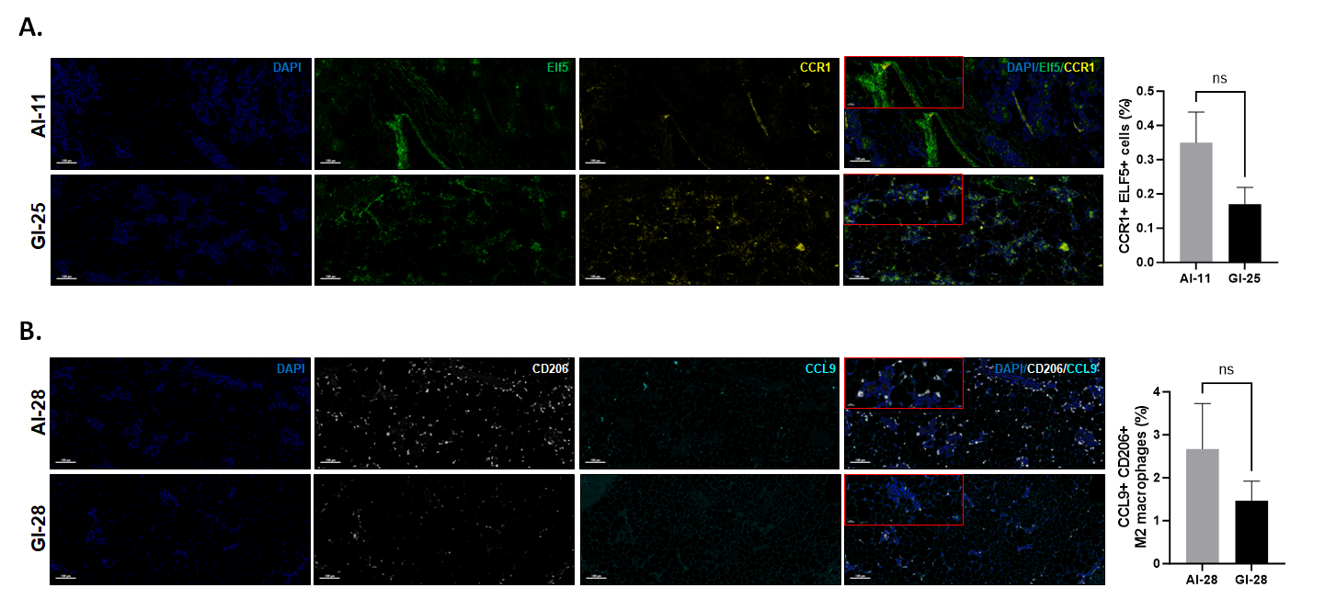
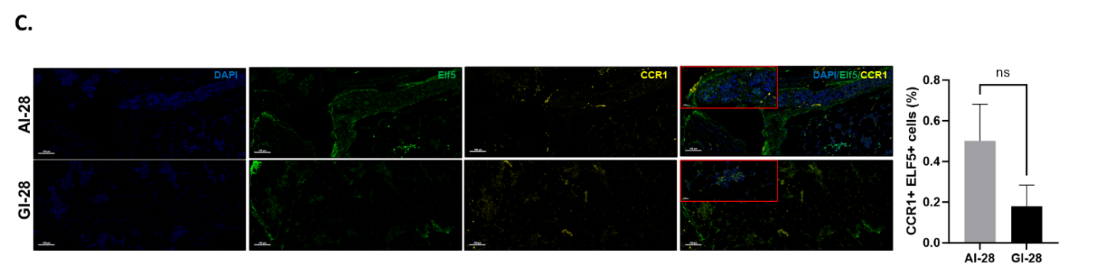
Supplementary Fig. 7: AI and GI mouse mammary glands harvested at indicated time points were subjected to multiplex IF analysis for probing 6 antigens (CD-206, CCL9, CCR1, ERα, ELF5, and WNT5a). Representative 10x single channel/color and merged figures (inset 40x merged) and bar diagrams showing the normalized A. CCR1+ ELF5+ (AI-day 11 vs. GI-day 25), B. CCL9+ CD206+ (AI-day 28 vs. GI-day 28), C. CCR1+ ELF5+ (AI-day 28 vs. GI-day 28). (AI-11: AI gland harvested on day 11 PPM, GI-25: GI gland harvested on day 25 PPM, AI-28 & GI-28: AI and GI glands harvested on day 28 PPM). DAPI was used to counterstain the cell nuclei. ns: non-significant

Supplementary Table S1: List of qRT-PCR primers
C/EBPδ | ACTCCTGCCATGTACGACGA | Forward
 | GTCGCCCCAGTCGGGTTC | Reverse
CD14 | ACAGGGGCTGCCAAATTGGTCG | Forward
 | AGCACACGCTCCATGGTCGGTA | Reverse
Chi3L | GTACAAGCTGGTCTGCTACTTC | Forward
 | ATGTGCTAAGCATGTTGTCGC | Reverse
CtsB | AGGCTGGACGCAACTTCTAC | Forward
 | CCCCAAATGCCCAACAAGAG | Reverse
CtsL | CCCTATGAAGCGAAGGACGG | Forward
 | CCATGGTCGAGGTTCTTGCT | Reverse
Lrg1 | CCATGTCAGTGTGCAGATTC | Forward
 | AAGAGTGAGAGGTGGAAGAG | Reverse
MMP2 | TGATGGCATCGCTCAGATCC | Forward
 | CCCAGTACTCATTCCCTGCG | Reverse
Orm1 | CCTCTATGCCAAAAGGCCAGA | Forward
 | TGGTCTCCTTCCCCAACTCA | Reverse
Orm2 | CCCTCAATGCAAAAAGGCCAG | Forward
 | TGGTCTCCTTCTCCAGCTCA | Reverse
RPL37 | AGAAGCAAGATGACGAAGGGAA | Forward
 | CTTGGGTTTCGGCGTTGTTC | Reverse
Slpi | GGCCTTTTACCTTTCACGGTG | Forward
 | TACGGCATTGTGGCTTCTCAA | Reverse
Stat3 | CTTGTCTACCTCTACCCCGACAT | Forward
 | GATCCATGTCAAACGTGAGCG | Reverse

