Supplementary Appendix
Supplementary Information
I. Fine-tuned hyperparameters for all machine learning models
II. VGG 19 model details
III. The model uses a variety of data augmentation methods during training
IV. The cross-validation method used to train the model
V. Machine learning models' hyperparameters optimizing

Supplementary Figures
Figure S1. Principal component analysis plot for evaluating batch effect correction in three machines.
Figure S2. ROC curves for all models in the HR+/HER2-, HER2+, and TNBC subgroups.
Figure S3. DCA curves for all models in the HR+/HER2-, HER2+, and TNBC subgroups.

Supplementary Tables
Table S1. The ultrasonographic images acquisition parameters
Table S2. Characteristics of patients in the training and test cohorts
Table S3. Radiomics features and deep learning features for Pre, Post, and Delta models
Table S4. Performance of three single-modality models constructed using five machine learning algorithms for predicting the efficacy of NAC in the training cohort and the test cohort
Table S5. Performance of the Integrated model in predicting pCR after NAC across various molecular subtypes in the training and test cohorts
Table S6. Checklist for Artificial Intelligence in Medical Imaging

Supplementary Information
I. Fine-tuned hyperparameters for all machine learning models
Pre model
Xgboost
'colsample_bylevel': 0.6455141470634179, 'colsample_bynode': 0.8654402486545548, 'colsample_bytree': 0.4721251150894793, 'gamma': 2, 'learning_rate': 0.11296706081086198, 'max_depth': 13, 'min_child_weight': 11, 'n_estimators': 174, 'reg_alpha': 1.2935846085668579, 'reg_lambda': 11.793340750979755, 'seed': 29, 'subsample': 0.4697900093525095, 'tree_method': 'hist'
RF
'random_state': 420, 'n_estimators': 1000, 'min_samples_split': 11, 'min_samples_leaf': 3, 'max_features': 'sqrt', 'max_depth': 1, 'bootstrap': True
SVM
'C': 3.5621888716216756, 'cache_size': 200, 'class_weight': 'balanced', 'coef0': 1, 'degree': 2, 'gamma': 10.0, 'kernel': 'linear', 'probability': True, 'shrinking': False, 'tol': 0.0001, 'verbose': False
DT
'class_weight': None, 'criterion': 'entropy', 'max_depth': 1, 'max_features': 'log2', 'min_samples_leaf': 11, 'min_samples_split': 3, 'random_state': 420
Logistics
'C': 0.3111215106803057, 'max_iter': 200, 'penalty': 'l2', 'random_state': 420
Post
Xgboost
'tree_method': 'exact', 'subsample': 0.8, 'seed': 20, 'reg_lambda': 20, 'reg_alpha': 1, 'n_estimators': 100, 'min_child_weight': 2, 'max_depth': 1, 'learning_rate': 0.001, 'gamma': 0, 'colsample_bytree': 1.0, 'colsample_bynode': 0.9, 'colsample_bylevel': 1.0
RF
'random_state': 420, 'n_estimators': 2000, 'min_samples_split': 30, 'min_samples_leaf': 4, 'max_features': 'log2', 'max_depth': 1, 'bootstrap': True
SVM
'C': 0.9808393264227353, 'cache_size': 200, 'class_weight': 'balanced', 'coef0': 2, 'degree': 4, 'gamma': 'auto', 'kernel': 'linear', 'probability': True, 'shrinking': False, 'tol': 0.0001, 'verbose': False
DT
'random_state': 420, 'min_samples_split': 4, 'min_samples_leaf': 2, 'max_features': 'log2', 'max_depth': 1, 'criterion': 'entropy', 'class_weight': None
Logistic
'C': 6.421783529507991, 'max_iter': 69, 'penalty': 'l2', 'random_state': 420
Delta
Xgboost
'colsample_bylevel': 0.3358697913502505, 'colsample_bynode': 0.8434537977237714, 'colsample_bytree': 0.4946504727979226, 'gamma': 6, 'learning_rate': 0.1178392622723777, 'max_depth': 16, 'min_child_weight': 2, 'n_estimators': 1621, 'reg_alpha': 2.326125825844436, 'reg_lambda': 1.872103375349774, 'seed': 54, 'subsample': 0.5731865626649907, 'tree_method': 'exact'
RF
'bootstrap': True, 'max_depth': 2, 'max_features': 'sqrt', 'max_leaf_nodes': 10, 'min_impurity_decrease': 0.041783776665203436, 'min_samples_leaf': 12, 'min_samples_split': 3, 'n_estimators': 718, 'random_state': 420
SVM
'C': 1.033137313736187, 'cache_size': 200, 'class_weight': None, 'coef0': 0, 'degree': 2, 'gamma': 0.01, 'kernel': 'rbf', 'probability': True, 'shrinking': True, 'tol': 0.0001, 'verbose': False
DT
'class_weight': 'balanced', 'criterion': 'gini', 'max_depth': 1, 'max_features': 'sqrt', 'min_samples_leaf': 15, 'min_samples_split': 3, 'random_state': 420
Logistics
'C': 5.350343974510156, 'max_iter': 89, 'penalty': 'l2', 'random_state': 420
DLR
Xgboost
'colsample_bylevel': 0.9484857597295391, 'colsample_bynode': 0.8070584643642904, 'colsample_bytree': 0.6987438442057513, 'gamma': 0, 'learning_rate': 0.09831343634983353, 'max_depth': 2, 'min_child_weight': 2, 'n_estimators': 553, 'reg_alpha': 7.207907657782535, 'reg_lambda': 5.76788446200045, 'seed': 133, 'subsample': 0.11966548844452066, 'tree_method': 'exact'
RF
'bootstrap': True, 'max_depth': 1, 'max_features': 'sqrt', 'max_leaf_nodes': 29, 'min_impurity_decrease': 0.0033928662403703404, 'min_samples_leaf': 15, 'min_samples_split': 4, 'n_estimators': 719, 'random_state': 420
SVM
'C': 1.186351914306224, 'cache_size': 200, 'class_weight': 'balanced', 'coef0': 0, 'degree': 4, 'gamma': 1.0, 'kernel': 'linear', 'probability': True, 'shrinking': False, 'tol': 0.0001, 'verbose': False
DT
'class_weight': 'balanced', 'criterion': 'gini', 'max_depth': 1, 'max_features': 'auto', 'min_samples_leaf': 13, 'min_samples_split': 3, 'random_state': 420
Logistics
'C': 9.02775399190717, 'max_iter': 20, 'penalty': 'l2', 'random_state': 420
Integrated
Xgboost
'colsample_bylevel': 0.5548556804826149, 'colsample_bynode': 0.6420814348782268, 'colsample_bytree': 0.3841579139514725, 'gamma': 18, 'learning_rate': 0.0490009006180859, 'max_depth': 1, 'min_child_weight': 2, 'n_estimators': 165, 'reg_alpha': 6.018921014909921, 'reg_lambda': 6.123952298482029, 'seed': 25, 'subsample': 0.9933731327905969, 'tree_method': 'hist'
RF
‘bootstrap': True, 'max_depth': 2, 'max_features': 'sqrt', 'max_leaf_nodes': 20, 'min_impurity_decrease': 0.0802215448501682, 'min_samples_leaf': 22, 'min_samples_split': 2, 'n_estimators': 2749, 'random_state': 420
SVM
'C': 0.2561726221242939, 'cache_size': 200, 'class_weight': None, 'coef0': 2, 'degree': 4, 'gamma': 'scale', 'kernel': 'poly', 'probability': True, 'shrinking': True, 'tol': 0.0001, 'verbose': False
DT
'class_weight': None, 'criterion': 'entropy', 'max_depth': 2, 'max_features': 'auto', 'min_samples_leaf': 21, 'min_samples_split': 4, 'random_state': 420
Logistics
'C': 1.8781346976747664, 'max_iter': 109.45923785863023, 'penalty': 'l2', 'random_state': 420
Note: XGBoost, eXtreme Gradient Boosting; RF, random forest; SVM, support vector machine; logistics, multivariate logistic regression analysis; DT, decision tree.

II. VGG19 model details
1. The number of epochs used to train the last layer
The number of epochs for the overall training is set to 26, which means that the number of rounds of the cycle training model is 26. In each round of training (for epoch in range(26) loop), parameter updates are made to the entire model, including the pre-trained VGG19 part and the last custom modified classification layer.
2. Selected batch size
The batch size is explicitly specified when the data loader is created. batch_size=32 is set to the data loader for both the training set and the test set, which means that each iteration of training (training set case) or forward propagation evaluation (test set case) is operated at the scale of 32 images per batch.
3. Customize the weight initialization method of the layer
In the custom MyVgg19Model class, for the last classification layer, PyTorch's default weight initialization method is used to initialize the weight parameters of this layer, and the weight will be initialized according to uniform by default, and the bias is initialized to 0.
4. Dropout frequency (if applicable) and regularization methods to prevent overfitting
Dropout frequency: The Dropout layer is not used in the custom MyVgg19Model class and the entire training process code, and the Dropout is not suitable for this model architecture.
Regularization method: weight_decay=0.001 is used as a regularization method in the code, in the optimizer definition section: optimizer = optim. SGD (model. parameters, (lr=0.003, momentum=0.9, weight_decay=0.001) The weight_decay parameter here is applied to the optimizer SGD (Stochastic Gradient Descent), which is essentially L2 regularization, which adds a penalty term to the loss function, which is proportional to the sum of squares of the model weights, so as to limit the size of the model weights, avoid overfitting the model too complex, and make the model better generalized to new data. At the same time, the idea of early stopping is used in the training process, and by comparing the AUC (area under the curve, an indicator used to measure the performance of the classification model) between the training set and the test set, the model weight (best_model_weights) of the smallest difference is saved, which is essentially a strategy to prevent overfitting and select a model with better generalization ability.

III. The model uses a variety of data augmentation methods during training
1. Horizontal flipping, flipping the image horizontally with a 50% probability. This data augmentation method helps the model learn the invariance of the image in the case of horizontal flipping, makes the model more robust to the horizontal direction of the image, prevents the model from relying too much on the orientation of the image, and improves the generalization ability of the model.
2. Random affine transformation, including: randomly rotating the image within the range of ±5 degrees, so that the model can learn the image features at different angles and enhance the model's adaptability to rotation. Randomly panning the image horizontally and vertically, with a panning range of 2% of the image size, helps the model learn the features of the image at different locations and prevents the model from being overly sensitive to the absolute position of objects in the image.
3. Randomly adjust the brightness and contrast of the image, the brightness is randomly adjusted within the range of ±20%, and the contrast is randomly adjusted within the range of ±20%. This operation can simulate images under different lighting conditions, improving the robustness of the model to lighting changes.
4. CLAHE (Contrast Limited Adaptive Histogram Equalization) transform, which is an adaptive histogram equalization method used to enhance the contrast of images.
5. Use the mean and standard deviation to normalize the image to normalize the image pixel value to a specific range, which helps the model to converge faster and better.

IV. The cross-validation method used to train the model
Both the VGG19 deep learning and XGBoost machine learning models use a hierarchical cross-validation approach, which ensures that the proportion of different class samples in each fold is about the same as the proportion in the original dataset, which is important for dealing with category imbalance datasets. The training dataset is divided into 10 parts (folded) and experimented with multiple attempts, each time picking a different part as the test set and the rest as the training set.

V. Machine learning models' hyperparameters optimizing
Xgboost
'learning_rate':uniform(0.001,0.1), 'max_depth':randint(1, 3), 'n_estimators':randint(100, 5000), 'gamma':randint(0,20), 'min_child_weight':randint(1,10), 'colsample_bytree':uniform(0.1,1),
'colsample_bylevel':uniform(0.1,1), 'colsample_bynode':uniform(0.1,1), 'subsample':uniform(0.1,1), 'reg_lambda':uniform(0,20), 'reg_alpha':uniform(0,20), 'seed':randint(5,200), 'tree_method': ['auto', 'exact', 'approx', 'hist']

RF
'n_estimators':randint(200,5000), 'max_depth':randint(1,3), 'min_samples_split':randint(1,5), 'min_samples_leaf':randint(10,45), 'max_features':['auto','sqrt','log2'], 'bootstrap':[True,False],
'random_state':randint(5,200), 'max_leaf_nodes':randint(5,30), 'min_impurity_decrease': uniform(0, 0.1)

SVM
'C':uniform(0.01,2), 'kernel':['linear','rbf','poly'], 'degree':randint(2,5), 'gamma':['scale','auto']+list(np.logspace(-3,3,7)), 'coef0':[0,1,2], 'shrinking':[True,False],
'probability':[True], 'tol':[1e-4], 'cache_size':[200], 'class_weight':[None,'balanced'],
'verbose': [False]

DT
'criterion': ['gini', 'entropy'], 'max_depth': [1, 2, 3], 'min_samples_split': randint(1, 5), 'min_samples_leaf': randint(10, 45), 'max_features': ['auto', 'sqrt', 'log2'], 'class_weight': [None, 'balanced'], 'random_state': [5, 10, 15, 20, 25, 30, 35, 40, 45, 50, 55, 60, 65, 70]

Logistics
'penalty':['l1','l2'], 'C':uniform(0.0001,10), 'max_iter':randint(10,100), 'random_state': list(range(1, 200))

Supplementary Figures
b
a
c
d
Supplementary Figure 1. Principal component analysis plot for evaluating batch effect correction in three machines. (a, b): before NAC; (c, d): after 2 cycles of NAC; (a, c): before batch effect correction in three kinds of machines respectively; (b, d): After batch effect correction using Combat method.

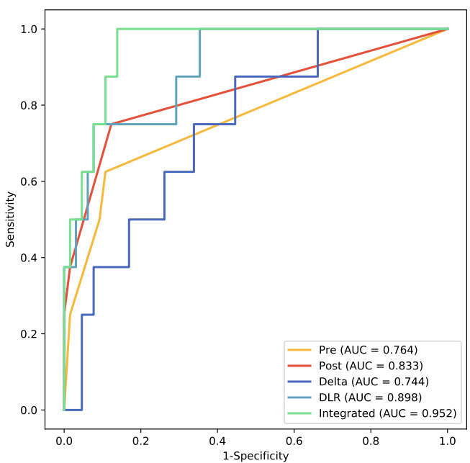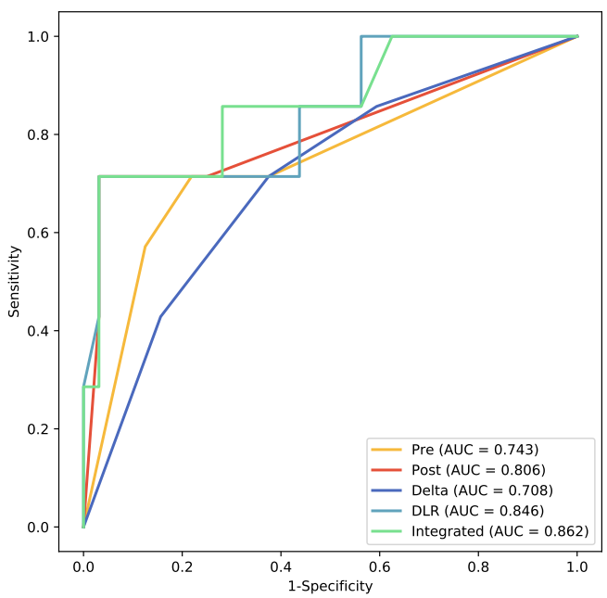
b
a
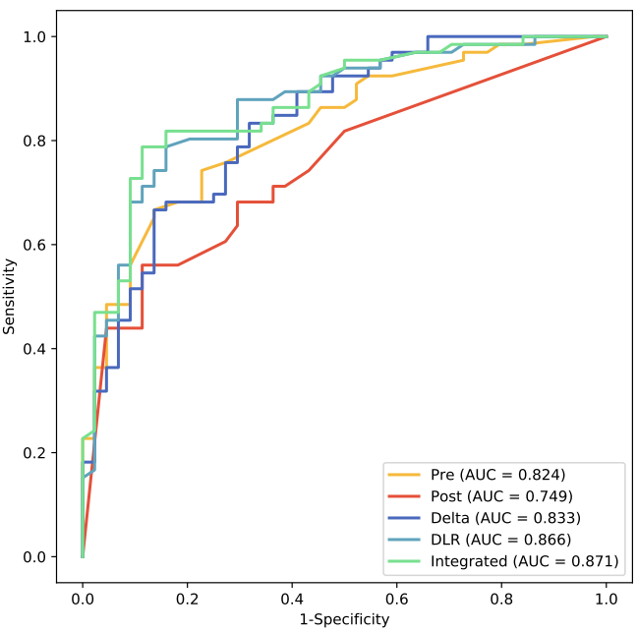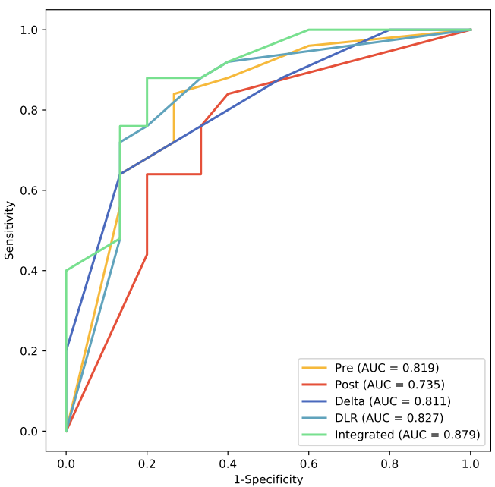
d
c
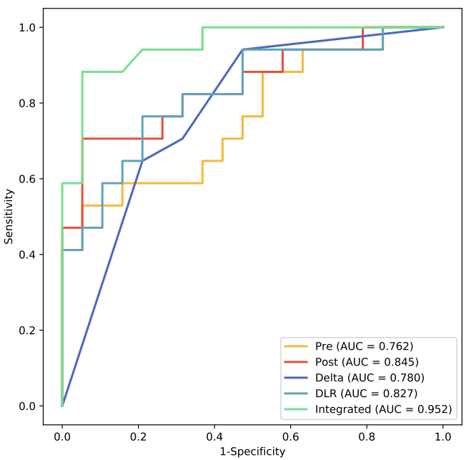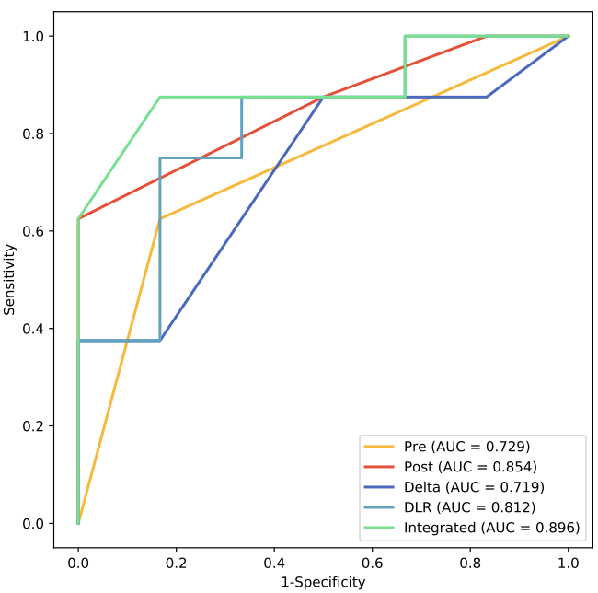
e
f
Supplementary Figure 2. ROC curves for all models in the HR+/HER2- (a: training cohort, b: test cohort), HER2+ (c: training cohort, d: test cohort), and TNBC (e: training cohort, f: test cohort) subgroups.

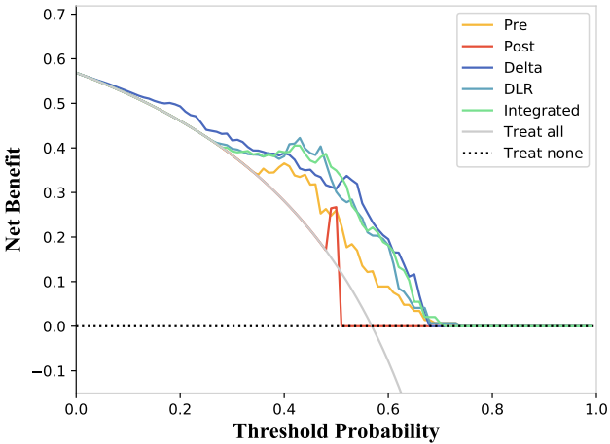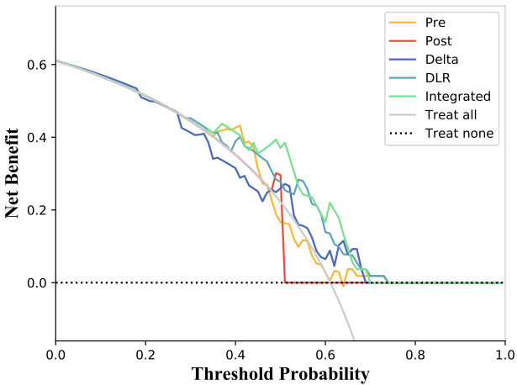
b
a
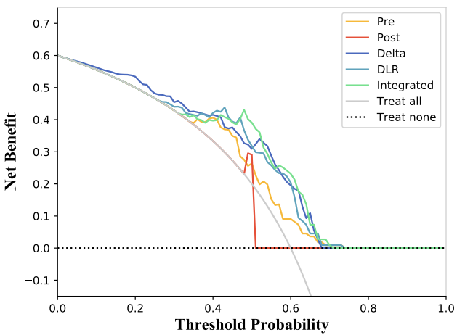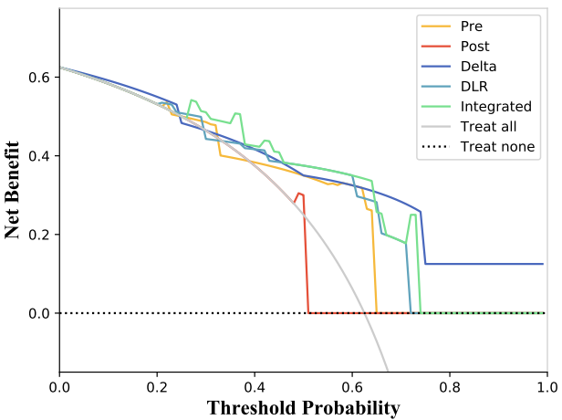
d
c
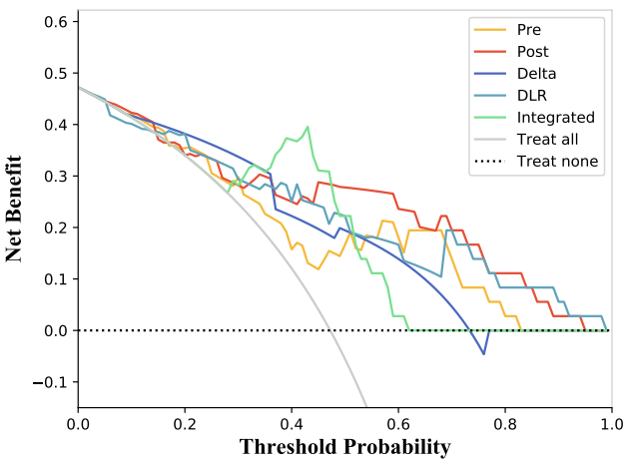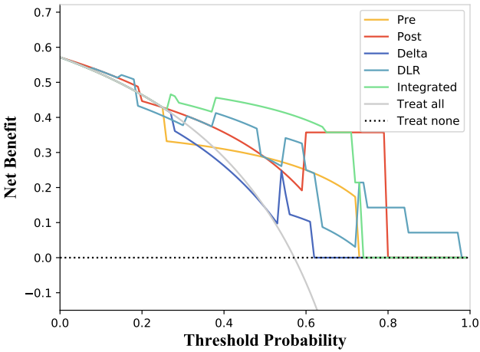
f
e
Supplementary Figure 3. DCA curves for all models in the HR+/HER2- (a: training cohort, b: test cohort), HER2+ (c: training cohort, d: test cohort), and TNBC (e: training cohort, f: test cohort) subgroups.

Supplementary Tables
Supplementary Table 1. The ultrasonographic images acquisition parameters
 | Scanner | Probe | Frequency  (MHZ) | Patients
 |  |  |  | pCR | Non-pCR | P-value
Pre-NAC | GE (LOGIQ E9) | ML6-159 | 14 | 85 | 109 | 0.641
Pre-NAC | Esaote (MyLab Twice) | LA523 | 10 | 27 | 42 | 0.641
Pre-NAC | TOSHIBA (Aplio i900) | i18LX5 | 12 | 18 | 30 | 0.641
Post-NAC | GE (LOGIQ E9) | ML6-159 | 14 | 79 | 94 | 0.327
Post-NAC | Esaote (MyLab Twice) | LA523 | 10 | 30 | 48 | 0.327
Post-NAC | TOSHIBA (Aplio i900) | i18LX5 | 12 | 22 | 39 | 0.327

Supplementary Table 2. Characteristics of patients in the training and test cohorts
Characteristics | Training cohort(N=219) | Test cohort(N=93) |  | P value
Age, mean±SD, years | 49.2±11.1  4(1.83％)  159(72.6％)  56(25.6％)  26(11.9％)  106(48.4％)  50(22.8％)  37(16.9％)  121(55.3％)  98(44.7％)  102(46.6％)  117(53.4％)  110(50.2％)  109(49.8％)  50(22.8％)  169(77.2％) | 49.7±10.3  1(1.08％)  65(69.9％)  27(29.0％)  11(11.8％)  46(49.5％)  20(21.5％)  16(17.2％)  54(58.1％)  39(41.9％)  43(46.2％)  50(53.8％)  40(43.0％)  53(57.0％)  20(21.5％)  73(78.5％) | 0.702
Grade(％)  I  II  III |  |  | 0.777
Moduler(％)  luminalA  luminalB  Her2overexpression  Triple-negative |  |  | 0.995
ER status(％)  Positive  Negative |  |  | 0.739
PR status(％)  Positive  Negative |  |  | 0.956
HER-2 status(％)  Positive  Negative |  |  | 0.297
Ki-67 status(％)  ＜20％  ≥20％ |  |  | 0.914

Supplementary Table 3. Radiomics features and deep learning features for Pre, Post, and Delta models
Pre | Post | Delta
Exponential_glrlm_RunEntropy | exponential_firstorder_Energy | wavelet-  HH_gldm_LargeDependenceHighGrayLevelEmphasis
gradient_firstorder_Energy | exponential_firstorder_TotalEnergy | wavelet-HH_gldm_ SmallDependenceEmphasis
gradient_glrlm_RunEntropy | exponential_glrlm_RunEntropy | wavelet-HH_gldm_SmallDependenceHighGrayLevelEmphasis
lbp-2D_glrlm_RunEntropy | gradient_glrlm_RunEntropy | wavelet-HH_glszm_ LargeAreaEmphasis
original_firstorder_RootMeanSquared | lbp-2D_glrlm_RunEntropy | wavelet-HH_glszm_LargeAreaHighGrayLevelEmphasis
square_glrlm_RunEntropy | original_shape2D_MinorAxisLength | wavelet-HH_glszm_LargeAreaLowGrayLevelEmphasis
squareroot_firstorder_Energy | square_glrlm_RunEntropy | wavelet-HH_glszm_ZoneVariance
wavelet-HH_glrlm_LongRunEmphasis | wavelet-HH_gldm_Small  DependenceHighGrayLevelEmphasis | wavelet-LH_glszm_  GrayLevelNonUniformity
wavelet-HH_glrlm_  LongRunLowGrayLevelEmphasis | wavelet-HH_glrlm_LongRunHigh  GrayLevelEmphasis | wavelet-LH_glszm_  SizeZoneNonUniformity
wavelet-HH_glrlm_  LongRunHighGrayLevelEmphasis | wavelet-LL_gldm_SmallDependence  HighGrayLevelEmphasis | DF_delta2320
wavelet-LH_glcm_JointAverage | DF_post2755
wavelet-LH_glcm_SumAverage | DF_post421
wavelet-LL_firstorder_  MeanAbsoluteDeviation | DF_post3362
DF_pre2865
DF_pre3716
DF_pre3401
Supplementary Table 4. Performance of three single-modality models constructed using five machine learning algorithms for predicting the efficacy of NAC in the training cohort and the test cohort
Model | Features | Training cohort |  |  |  | Test cohort
Model | Features | F1 Score | MCC | Precision | Recall | F1 Score | MCC | Precision | Recall
XGBoost | Pre | 0.670 | 0.549 | 0.631 | 0.714 | 0.652 | 0.431 | 0.651 | 0.775
 | Post | 0.664 | 0.596 | 0.784 | 0.723 | 0.708 | 0.541 | 0.717 | 0.752
 | Delta | 0.711 | 0.509 | 0.719 | 0.703 | 0.634 | 0.447 | 0.619 | 0.650
RF | Pre | 0.681 | 0.527 | 0.637 | 0.752 | 0.600 | 0.425 | 0.625 | 0.750
 | Post | 0.662 | 0.576 | 0.703 | 0.725 | 0.674 | 0.537 | 0.612 | 0.749
 | Delta | 0.705 | 0.524 | 0.759 | 0.659 | 0.627 | 0.467 | 0.621 | 0.648
SVM | Pre | 0.623 | 0.489 | 0.882 | 0.594 | 0.610 | 0.473 | 0.647 | 0.595
 | Post | 0.666 | 0.552 | 0.745 | 0.657 | 0.640 | 0.497 | 0.685 | 0.600
 | Delta | 0.682 | 0.477 | 0.719 | 0.648 | 0.612 | 0.423 | 0.656 | 0.603
logistics | Pre | 0.598 | 0.441 | 0.659 | 0.599 | 0.562 | 0.430 | 0.548 | 0.548
 | Post | 0.689 | 0.487 | 0.722 | 0.659 | 0.691 | 0.453 | 0.682 | 0.700
 | Delta | 0.628 | 0.538 | 0.685 | 0.646 | 0.589 | 0.428 | 0.714 | 0.583
DT | Pre | 0.564 | 0.521 | 0.638 | 0.591 | 0.540 | 0.501 | 0.588 | 0.535
 | Post | 0.690 | 0.572 | 0.724 | 0.642 | 0.691 | 0.458 | 0.626 | 0.647
 | Delta | 0.678 | 0.510 | 0.677 | 0.629 | 0.602 | 0.448 | 0.601 | 0.612
MCC, Matthews Correlation Coefficient; XGBoost, eXtreme Gradient Boosting; RF, random forest; SVM, support vector machine; logistics, multivariate logistic regression analysis; DT, decision tree.

Supplementary Table 5. Performance of the Integrated model in predicting pCR after NAC across various molecular subtypes in the training and test cohorts
Molecular subtype | Model | Training cohort |  |  |  | Test cohort
Molecular subtype | Model | F1 Score | MCC | Precision | Recall | F1 Score | MCC | Precision | Recall
HR+/HER2- | Pre | 0.728 | 0.525 | 0.600 | 0.625 | 0.735 | 0.488 | 0.746 | 0.714
HR+/HER2- | Post | 0.625 | 0.579 | 0.725 | 0.875 | 0.667 | 0.589 | 0.689 | 0.717
HR+/HER2- | Delta | 0.665 | 0.489 | 0.786 | 0.647 | 0.636 | 0.415 | 0.769 | 0.623
HR+/HER2- | DLR | 0.715 | 0.652 | 0.911 | 0.787 | 0.639 | 0.588 | 0.803 | 0.653
HR+/HER2- | Integrated | 0.733 | 0.707 | 0.907 | 0.821 | 0.710 | 0.652 | 0.837 | 0.727
HER2+ | Pre | 0.708 | 0.476 | 0.783 | 0.716 | 0.765 | 0.573 | 0.818 | 0.720
HER2+ | Post | 0.791 | 0.483 | 0.826 | 0.760 | 0.740 | 0.492 | 0.700 | 0.756
HER2+ | Delta | 0.741 | 0.496 | 0.793 | 0.697 | 0.744 | 0.493 | 0.889 | 0.640
HER2+ | DLR | 0.715 | 0.592 | 0.902 | 0.738 | 0.772 | 0.545 | 0.891 | 0.680
HER2+ | Integrated | 0.806 | 0.601 | 0.906 | 0.727 | 0.773 | 0.530 | 0.895 | 0.689
TNBC | Pre | 0.724 | 0.511 | 0.833 | 0.729 | 0.710 | 0.458 | 0.738 | 0.750
TNBC | Post | 0.778 | 0.629 | 0.715 | 0.875 | 0.756 | 0.625 | 0.700 | 0.647
TNBC | Delta | 0.803 | 0.678 | 0.733 | 0.782 | 0.776 | 0.487 | 0.783 | 0.775
TNBC | DLR | 0.765 | 0.698 | 0.785 | 0.864 | 0.744 | 0.563 | 0.759 | 0.848
TNBC | Integrated | 0.879 | 0.779 | 0.828 | 0.882 | 0.867 | 0.708 | 0.806 | 0.845
MCC, Matthews Correlation Coefficient; HR, hormone receptor; Her-2, human epidermal growth factor receptor-2; TNBC, triple negative breast cancer.

Supplementary Table 6. Checklist for Artificial Intelligence in Medical Imaging (CLAIM)
Section/ Topic | No. | Item | Reported on Page Number/ Line Number | Reported on Section/ Paragraph
TITLE or ABSTRACT
 | 1 | Identification as a study of AI methodology, specifying the category of technology used (eg, deep learn-ing) | P 1/ L 1-2 | Title
ABSTRACT
 | 2 | Structured summary of study design, methods, results, and conclusions | P 1-2/ L 10-43 | Abstract
INTRODUCTION
 | 3 | Scientific and clinical background, including the intended use and clinical role of the AI approach | P 3-4/ L 47-84
 | 4 | Study objectives and hypotheses | P 4/ L 84-88
METHODS
Study Design | 5 | Prospective or retrospective study | P 5/ L 91-92
 | 6 | Study goal, such as model creation, exploratory study, feasibility study, noninferiority trial | P 4/ L 84-88
Data | 7 | Data sources | P 5/ L 93-94
 | 8 | Eligibility criteria: how, where, and when potentially eligible participants or studies were identified (eg, symptoms, results from previous tests, inclusion in registry, patient-care setting, location, dates) | P 5/ L 94-101
 | 9 | Data preprocessing steps | P 7-8/ L 140-148
 | 10 | Selection of data subsets, if applicable | P 6/ L 104-107
 | 11 | Definitions of data elements, with references to common data elements | P 6/ L 121-123
 | 12 | De-identification methods | P 7/ L 131-133
 | 13 | How missing data were handled | No missing data
Ground Truth | 14 | Definition of ground truth reference standard, in sufficient detail to allow replication | P 6/ L 114-120
 | 15 | Rationale for choosing the reference standard (if alternatives exist) | P 6/ L 114-120
 | 16 | Source of ground truth annotations; qualifications and preparation of annotators | P 7/ L 135-138
 | 17 | Annotation tools | P 7/ L 135-138
 | 18 | Measurement of inter- and intrarater variability; methods to mitigate variability and/or resolve discrepancies | P 7/ L 138-140
Data Partitions | 19 | Intended sample size and how it was determined
 | 20 | How data were assigned to partitions; specify proportions | P 6/ L 104-107
 | 21 | Level at which partitions are disjoint (eg, image, study, patient, institution) | P 6/ L 104-107
Model | 22 | Detailed description of model, including inputs, outputs, all intermediate layers and connections | P 8/ L 160-165
 | 23 | Software libraries, frameworks, and packages | P 8/ L 160; P 11/ L 221
 | 24 | Initialization of model parameters (eg, randomization, transfer learning) | P 8/ L 165-167
Training | 25 | Details of training approach, including data augmentation, hyperparameters, number of models trained | P 8-9/ L 138-172;  P 9-10/ L 189-201  Supplementary Information
 | 26 | Method of selecting the final model | P 10/ L 193-197
 | 27 | Ensembling techniques, if applicable | P 10/ L 193-197
Evaluation | 28 | Metrics of model performance | P 10/ L 204-209
 | 29 | Statistical measures of significance and uncertainty (eg, confidence intervals) | P 11/ L 221-225
 | 30 | Robustness or sensitivity analysis | P 15/ L 260-266
 | 31 | Methods for explainability or interpretability (eg, saliency maps) and how they were validated | P 10-11/ L 211-219
 | 32 | Validation or testing on external data | P 9/ L 191-192;  P 10/ L 204-209
RESULTS
Data | 33 | Flow of participants or cases, using a diagram to indicate inclusion and exclusion | P 5/ L 102
 | 34 | Demographic and clinical characteristics of cases in each partition | P 14/ L 231-235;  Supplementary Table 2
Model performance | 35 | Performance metrics for optimal model(s) on all data partitions | P 16/ Table 2, 3  P 18/ Table 4  Supplementary Table 4\5
 | 36 | Estimates of diagnostic accuracy and their precision (such as 95% confidence intervals) | P 16/ Table 2, 3  P 18/ Table 4  Supplementary Table 4\5
 | 37 | Failure analysis of incorrectly classified cases | P 21/ L 321-329
DISCUSSION
 | 38 | Study limitations, including potential bias, statistical uncertainty, and generalizability | P 27/ L 448-457
 | 39 | Implications for practice, including the intended use and/or clinical role | P 28/ L 460-462
OTHER
INFORMATION
 | 40 | Registration number and name of registry
 | 41 | Where the full study protocol can be accessed
 | 42 | Sources of funding and other support; role of funders | P 28/ L 464-465

