Supplemental materials

Supplemental table 1. Complete search strategy
Ovid MEDLINE(R) ALL <1946 to November 15, 2023>

Concepts | Search Terms
circulating tumor DNA | 1 exp Circulating Tumor DNA/ 2682  2 circulating tumo?r DNA.mp. 5460  3 ctDNA.mp. 4508  4 cell free tumo?r dna.mp. 302  5 exp DNA, Neoplasm/ 47314  6 1 or 2 or 3 or 4 or 5 50759
triple negative breast cancer | 7 exp Triple Negative Breast Neoplasms/ 10488  8 (triple negative breast cancer* or TNBC).mp. [mp=title, book title, abstract, original title, name of substance word, subject heading word, floating sub-heading word, keyword heading word, organism supplementary concept word, protocol supplementary concept word, rare disease supplementary concept word, unique identifier, synonyms, population supplementary concept word, anatomy supplementary concept word] 18113  9 Triple Negative Breast Neoplasm*.mp. 10564  10 ER.mp. 115190  11 estrogen receptor*.mp. 67187  12 10 or 11 155748  13 Progesterone receptor*.mp. 24667  14 PR.mp. 68227  15 13 or 14 83749  16 epidermal growth factor receptor 2.mp. 11560  17 (HER2 or HER 2).mp. 44253  18 erbB-2.mp. 32845  19 16 or 17 or 18 56783  20 12 and 15 and 19 7471  21 negat*.mp. 1647898  22 20 and 21 4900  23 7 or 8 or 9 or 22 22595  24 6 and 23 146  25 1 or 2 or 3 or 4 6585  26 (breast* or mammar*).mp. 683171  27 25 and 26 781  28 24 or 27 848
Prognosis | 29 prognos*.mp. 1109960  30 exp Prognosis/ or prognos*.mp. 2375973  31 risk.mp. or exp Risk/ 3353942  32 exp Survival Analysis/ or survival.mp. 1580294  33 30 or 31 or 32 5943075  34 28 and 33 466

Elsevier Embase Search Strategy, searched 1946-11/16/23
Concepts | Search Terms
circulating tumor DNA
  #3 | #1 OR #2 | 18116
  #2 | 'ctdna'/exp OR ctdna | 13356
  #1 | 'circulating tumor dna'/exp OR 'circulating tumor dna' OR 'circulating tumour dna' OR 'cell free tumour dna' OR 'cell free tumor dna' | 11815
triple negative breast cancer
  #16 | #13 OR #15 | 2646
  #15 | #3 AND #14 | 2587
  #14 | breast* OR mammar* | 1047669
  #13 | #3 AND #12 | 409
  #12 | #4 OR #5 OR #11 | 49886
  #11 | #9 AND #10 | 15987
  #10 | negat* | 2299373
  #9 | #6 AND #7 AND #8 | 26371
  #8 | 'epidermal growth factor receptor'/exp OR 'epidermal growth factor receptor*' OR 'her2' OR 'her 2' OR 'erbb-2' | 231558
  #7 | 'progesterone receptor'/exp OR 'progesterone receptor*' OR pr | 251591
  #6 | 'estrogen receptor'/exp OR 'estrogen receptor*' OR er | 311716
  #5 | 'triple negative breast cancer'/exp OR 'triple negative breast cancer*' | 39927
  #4 | 'triple negative breast neoplasms'/exp OR 'triple negative breast neoplasm*' | 36589
Prognosis
  #21 | #16 AND #20 | 1030
  #20 | #17 OR #18 OR #19 | 6171778
  #19 | 'survival analysis'/exp OR 'survival analysis' | 97640
  #18 | 'risk'/exp OR risk | 5075490
  #17 | 'prognosis'/exp OR prognos* | 1503736

Ovid EBM Reviews - Cochrane Central Register of Controlled Trials <October 2023>

Concepts | Search Terms
circulating tumor DNA | 1 exp Circulating Tumor DNA/ 68  2 circulating tumo?r DNA.mp. 646  3 ctDNA.mp. 813  4 cell free tumo?r dna.mp. 18  5 exp DNA, Neoplasm/ 323  6 1 or 2 or 3 or 4 or 5 1286
triple negative breast cancer | 7 exp Triple Negative Breast Neoplasms/ 456  8 (triple negative breast cancer* or TNBC).mp. [mp=title, original title, abstract, floating sub-heading word, mesh headings, heading words, keyword] 1718  9 Triple Negative Breast Neoplasm*.mp. 461  10 ER.mp. 8851  11 estrogen receptor*.mp. 3952  12 10 or 11 11171  13 Progesterone receptor*.mp. 1442  14 PR.mp. 15629  15 13 or 14 16656  16 epidermal growth factor receptor 2.mp. 2633  17 (HER2 or HER 2).mp. 8021  18 erbB-2.mp. 1423  19 16 or 17 or 18 8514  20 12 and 15 and 19 1012  21 negat*.mp. 103668  22 20 and 21 735  23 7 or 8 or 9 or 22 2314  24 6 and 23 66  25 1 or 2 or 3 or 4 1041  26 (breast* or mammar*).mp. 62994  27 25 and 26 268  28 24 or 27 268
Prognosis | 29 prognos*.mp. 54546  30 exp Prognosis/ or prognos*.mp. 235941  31 risk.mp. or exp Risk/ 286282  32 exp Survival Analysis/ or survival.mp. 133682  33 30 or 31 or 32 529597  34 28 and 33 212

Web of Science Collections (A&HCI , BKCI-SSH , BKCI-S , CCR-EXPANDED , ESCI , IC , CPCI-SSH , CPCI-S , SCI-EXPANDED , SSCI), searched 1900-11/16/23

Concepts | Search Terms
circulating tumor DNA | 1: TS=((circulating tumor DNA) OR ctDNA OR (cell free tumor dna)) Results: 25,071
triple negative breast cancer | 2: TS=(triple negative breast cancer* OR TNBC OR triple negative breast neoplasm* OR breast* or mammar*) Results: 933,985  3: TS=((estrogen receptor* OR ER) AND (Progesterone receptor* OR PR) AND (epidermal growth factor receptor 2 OR HER2 OR HER 2 OR erbB-2) AND negat*) Results: 5,223  4: #2 OR #3 Results: 934,062  5: #1 AND #4 Results: 4725  6: TS=(tumor* OR neoplasm* OR cancer* OR adenocarcinoma) Results: 4,322,207  7: #6 AND #5 Results: 4718
Prognosis | 8: TS=(prognos* OR risk OR survival)  Results: 5,960,734  9: #8 AND #7  Results: 2,577

Table S2. Risk of bias and quality assessment
First author | publication year | Study participation | Study Attrition | Prognostic factor measurement | Outcome measurement | Study confounding | Statistical analysis and reporting | Quality assessment
Barnell | 2022 | Low | Moderate | Low | Low | High | Low | Good
Butler | 2019 | High | Low | Low | Low | High | Low | Fair
Cailleux | 2022 | Low | Low | Low | Low | Moderate | Low | Good
Cavallone | 2020 | Moderate | Low | Low | Low | High | Low | Fair
Chen | 2017 | Low | Low | Moderate | Low | Moderate | Low | Good
Chen | 2020 | High | High | Moderate | Moderate | High | Moderate | Poor
Gupta | 2023 | Moderate | Moderate | Moderate | Moderate | High | High | Fair
Lee | 2023 | Low | Low | Low | Low | High | Low | Fair
Magbanua | 2023 | Low | High | Low | Low | Moderate | Low | Good
Molinero | 2022 | High | High | Moderate | Moderate | Moderate | Moderate | Poor
Ortolan | 2021 | Low | Low | Low | Low | Moderate | Low | Good
Parsons | 2023 | Low | Low | Low | Low | Low | Low | Good
Radovich | 2020 | Low | Low | Low | Low | High | Low | Good
Roseshter | 2023 | Moderate | High | Low | Moderate | High | Moderate | Poor
Schneider | 2022 | Low | Low | Low | Low | High | Low | Good
Shaw | 2024 | Low | Low | Moderate | Low | Moderate | Low | Good
Stecklein | 2023 | Low | Low | Low | Low | Low | Low | Good
Turner | 2023 | Low | Low | Low | Low | High | Low | Good
Zaikova | 2024 | Low | Low | Moderate | Low | Moderate | Low | Good

Figure S1. Subgroup analysis separating studies where ctDNA was drawn before surgery versus after surgery
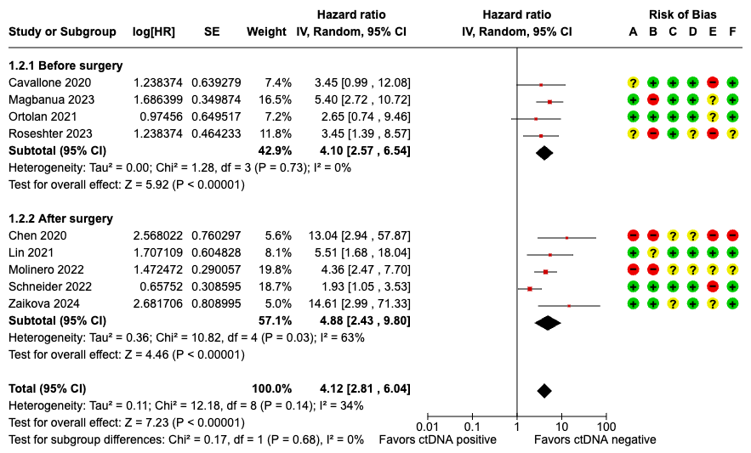
CI: Confidence interval; HR: Hazard ratio; IV: Inverse variance; SE: Standard error

Figure S2. Subgroup analysis separating studies where ctDNA assay was tumor informed versus tumor agnostic
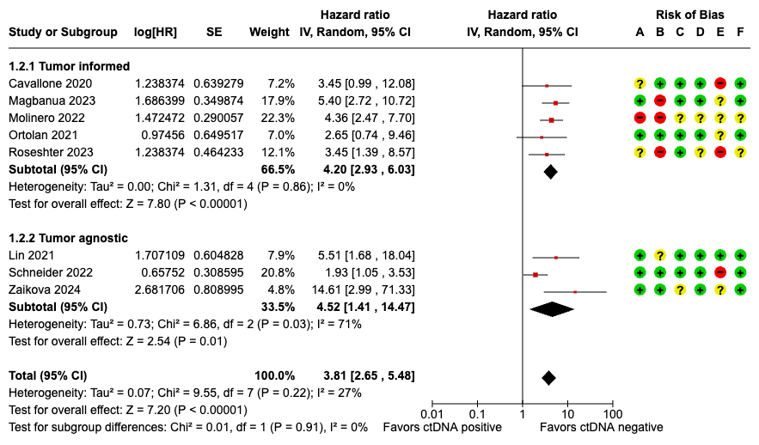
CI: Confidence interval; HR: Hazard ratio; IV: Inverse variance; SE: Standard error

Figure S3. Subgroup analysis separating studies by when patients received therapy
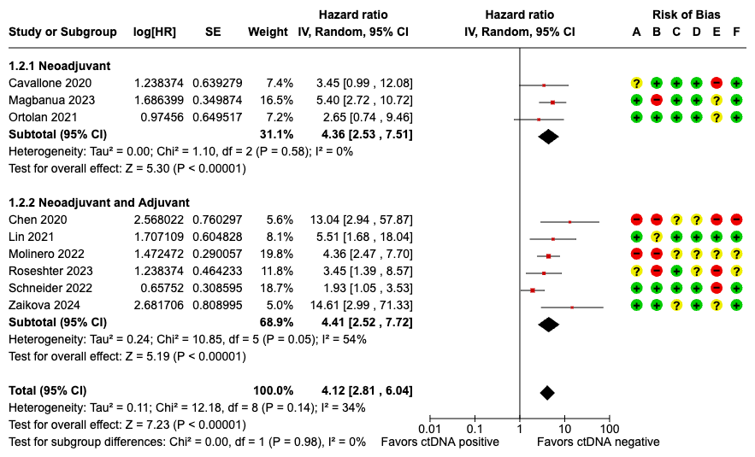
CI: Confidence interval; HR: Hazard ratio; IV: Inverse variance; SE: Standard error

Figure S4. Subgroup analysis separating studies by type of therapy patients received
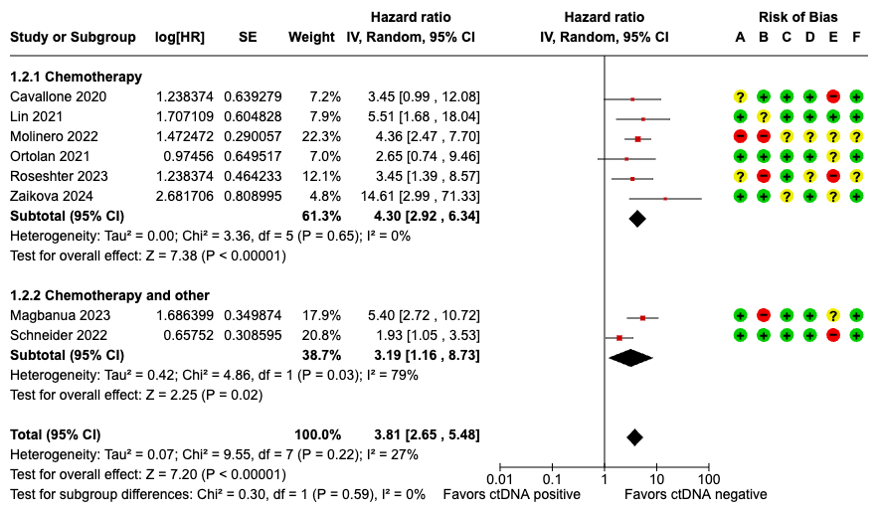
CI: Confidence interval; HR: Hazard ratio; IV: Inverse variance; SE: Standard error
Figure S5. Subgroup analysis separating studies where ctDNA was drawn before surgery verses after surgery
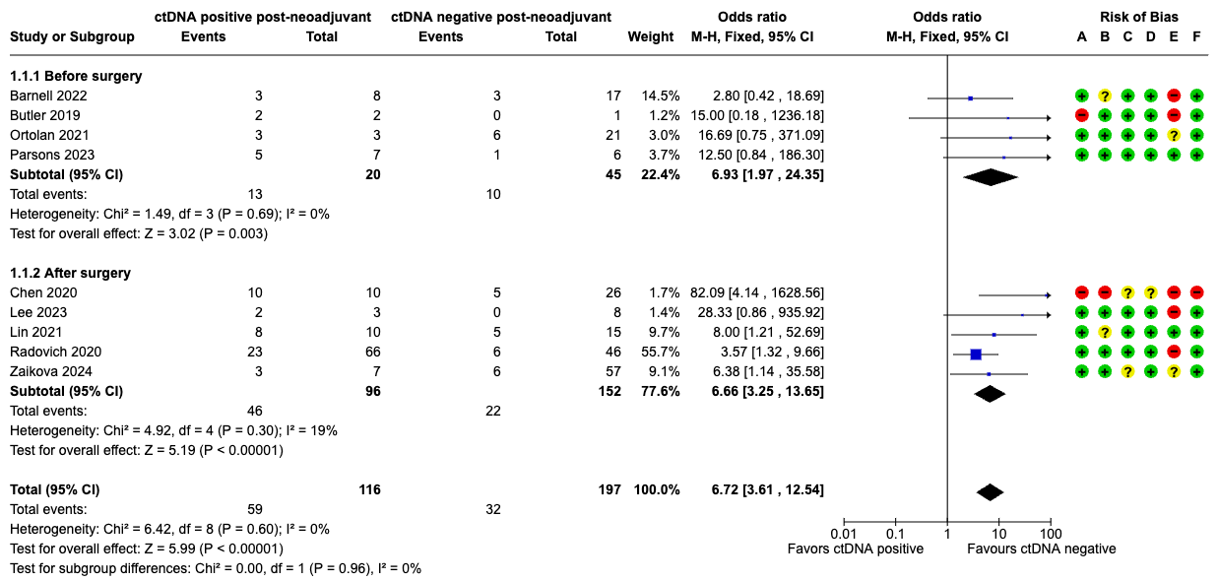
M-H: Mantel-Haenzel; CI: Confidence interval
Figure S6. Subgroup analysis separating studies where ctDNA assay was tumor informed verses tumor agnostic
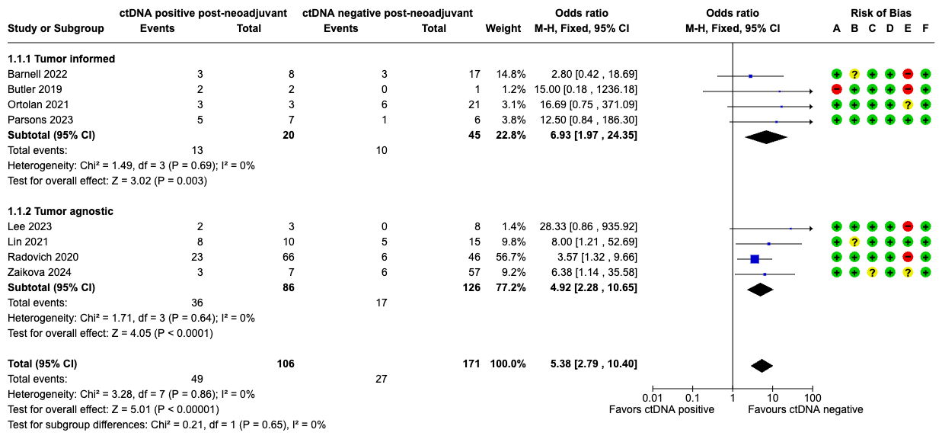
M-H: Mantel-Haenzel; CI: Confidence interval

Figure S7. Subgroup analysis separating studies by when patients received therapy
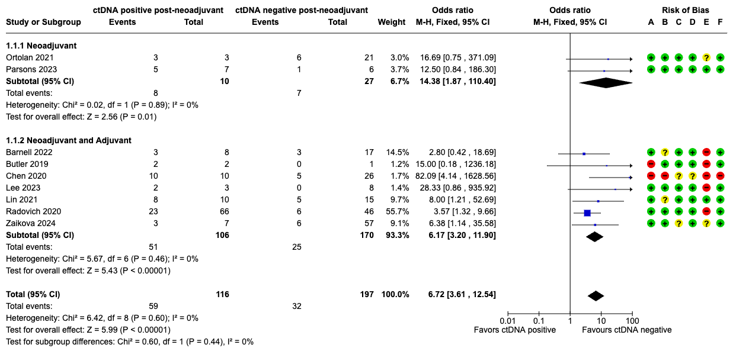
M-H: Mantel-Haenzel; CI: Confidence interval
Figure S8A-B. Sensitivity analysis for figure 3. A) Removing Butler 2019 and Lee 2023 for zero events in the ctDNA negative arm. B) removing Chen 2020 for high risk of bias.
A
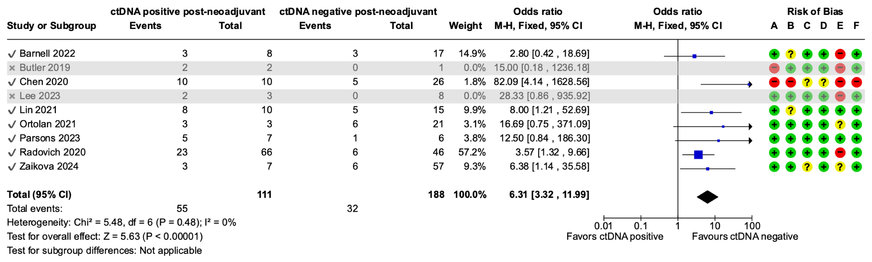
B
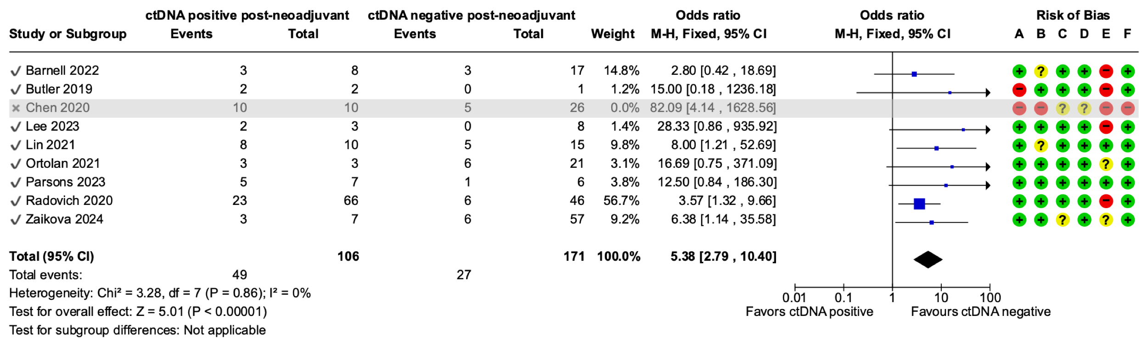
M-H: Mantel-Haenzel; CI: Confidence interval

Figure S9. correlation between ctDNA detection during or post-adjuvant therapy for studies reporting recurrence as a time-to-event outcome.
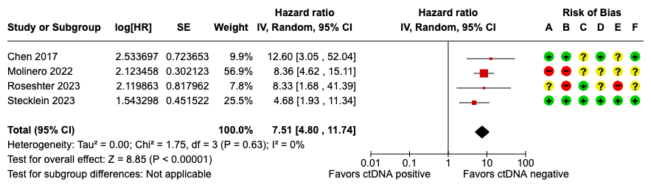
CI: Confidence interval; HR: Hazard ratio; IV: Inverse variance; SE: Standard error

Figure S10. correlation between ctDNA detection in the post-neoadjuvant setting (before or after surgery) for studies reporting death as a time-to-event outcome.
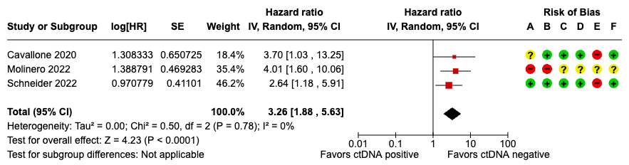
CI: Confidence interval; HR: Hazard ratio; IV: Inverse variance; SE: Standard error

Figure S11. correlation between ctDNA detection during or after adjuvant therapy for studies reporting death as a time-to-event outcome.
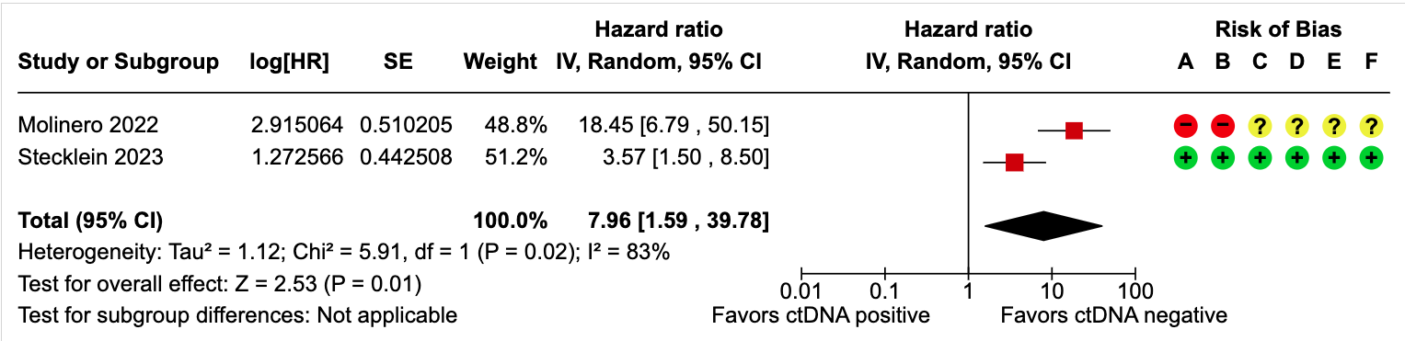
CI: Confidence interval; HR: Hazard ratio; IV: Inverse variance; SE: Standard error

Figure S12. correlation between ctDNA detection during-neoadjuvant with patient level data on achievement of pCR
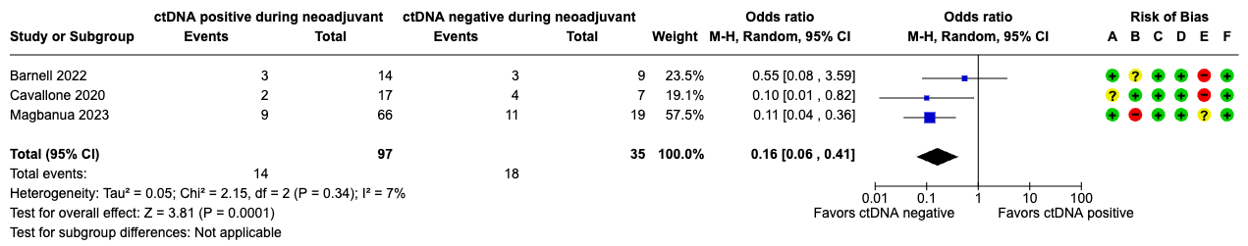
M-H: Mantel-Haenzel; CI: Confidence interval

Figure S13. Sensitivity analysis for figure 4 removing Ortolan 2021 for zero events in the ctDNA negative group.
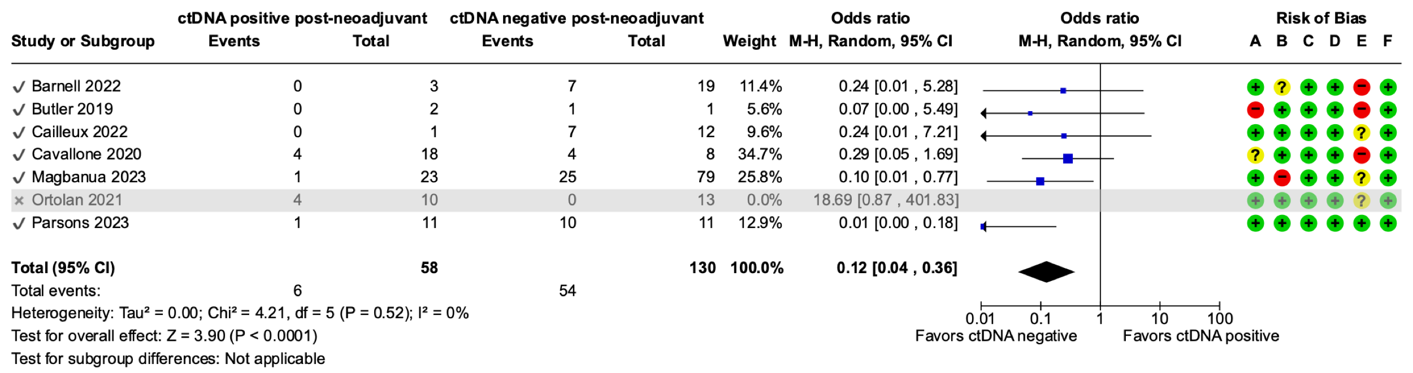
M-H: Mantel-Haenzel; CI: Confidence interval

