Supplementary Material
Supplementary Table 1 PRISMA 2020 Checklist.
Supplementary Table 2 PRISMA 2020 for Abstract Checklist.
Supplementary Table 3 Search strategies.
Supplementary Table 4 Risk of bias assessment - Newcastle-Ottawa Scale
Supplementary Figure 1 Leave-one-out sensitivity analyses. A. Pathological complete response (pCR). B. Overall survival (OS) - Univariate analysis. C. Overall survival (OS) - Multivariate analysis. D. Disease-free survival (DFS) - Univariate analysis. E. Disease-free survival (DFS) - Multivariate analysis.
Supplementary Figure 2 Forest plot - Outcomes in the general population. A. Overall survival (OS) - Univariate analysis. B. Overall survival (OS) - Multivariate analysis. C. Disease-free survival (DFS) - Univariate analysis. D. Disease-free survival (DFS) - Multivariate analysis.
Supplementary Figure 3 Forest plot - Outcomes according to breast cancer subtype. A. Overall survival (OS) - Univariate analysis. B. Overall survival (OS) - Multivariate analysis. C. Disease-free survival (DFS) - Univariate analysis. D. Disease-free survival (DFS) - Multivariate analysis.
Supplementary Figure 4 Analysis of publication bias (Funnel Plot). A. Overall survival (OS) - Univariate analysis. B. Overall survival (OS) - Multivariate analysis. C. Disease-free survival (DFS) - Univariate analysis. D. Disease-free survival (DFS) - Multivariate analysis.
Supplementary Figure 5 Drapery plot - Assessment of heterogeneity between studies. A. Overall survival (OS) - Univariate analysis. B. Overall survival (OS) - Multivariate analysis. C. Disease-free survival (DFS) - Univariate analysis. D. Disease-free survival (DFS) - Multivariate analysis.

Table S1. PRISMA 2020 Checklist.
Section and Topic | Item # | Checklist item |  | Location where item is reported
TITLE
Title | 1 | Identify the report as a systematic review. |  | Page 1
ABSTRACT
Abstract | 2 | See the PRISMA 2020 for Abstracts checklist. |  | Supplementary Materials: Table S2.
INTRODUCTION
Rationale | 3 | Describe the rationale for the review in the context of existing knowledge. |  | Page 3-4
Objectives | 4 | Provide an explicit statement of the objective(s) or question(s) the review addresses. |  | Page 3-4
METHODS
Eligibility criteria | 5 | Specify the inclusion and exclusion criteria for the review and how studies were grouped for the syntheses. |  | Pages 4-5
Information sources | 6 | Specify all databases, registers, websites, organisations, reference lists and other sources searched or consulted to identify studies. Specify the date when each source was last searched or consulted. |  | Page 5
Search strategy | 7 | Present the full search strategies for all databases, registers and websites, including any filters and limits used. |  | Supplementary Materials: Table S3
Selection process | 8 | Specify the methods used to decide whether a study met the inclusion criteria of the review, including how many reviewers screened each record and each report retrieved, whether they worked independently, and if applicable, details of automation tools used in the process. |  | Page 5
Data collection process | 9 | Specify the methods used to collect data from reports, including how many reviewers collected data from each report, whether they worked independently, any processes for obtaining or confirming data from study investigators, and if applicable, details of automation tools used in the process. |  | Page 6
Data items | 10a | List and define all outcomes for which data were sought. Specify whether all results that were compatible with each outcome domain in each study were sought (e.g. for all measures, time points, analyses), and if not, the methods used to decide which results to collect. |  | Pages 6
Data items | 10b | List and define all other variables for which data were sought (e.g. participant and intervention characteristics, funding sources). Describe any assumptions made about any missing or unclear information. |  | NO
Study risk of bias assessment | 11 | Specify the methods used to assess risk of bias in the included studies, including details of the tool(s) used, how many reviewers assessed each study and whether they worked independently, and if applicable, details of automation tools used in the process. |  | Page 6
Effect measures | 12 | Specify for each outcome the effect measure(s) (e.g. risk ratio, mean difference) used in the synthesis or presentation of results. |  | Page 6-7
Synthesis methods | 13a | Describe the processes used to decide which studies were eligible for each synthesis (e.g. tabulating the study intervention characteristics and comparing against the planned groups for each synthesis (item #5)). |  | Pages 6-7
Synthesis methods | 13b | Describe any methods required to prepare the data for presentation or synthesis, such as handling of missing summary statistics, or data conversions. |  | Pages 6-7
Synthesis methods | 13c | Describe any methods used to tabulate or visually display results of individual studies and syntheses. |  | Pages 6-7
Synthesis methods | 13d | Describe any methods used to synthesize results and provide a rationale for the choice(s). If meta-analysis was performed, describe the model(s), method(s) to identify the presence and extent of statistical heterogeneity, and software package(s) used. |  | Pages 6-7
Synthesis methods | 13e | Describe any methods used to explore possible causes of heterogeneity among study results (e.g. subgroup analysis, meta-regression). |  | Pages 6-7
Synthesis methods | 13f | Describe any sensitivity analyses conducted to assess robustness of the synthesized results. |  | Pages 6-7
Reporting bias assessment | 14 | Describe any methods used to assess risk of bias due to missing results in a synthesis (arising from reporting biases). |  | Pages 6-7
Certainty assessment | 15 | Describe any methods used to assess certainty (or confidence) in the body of evidence for an outcome. |  | Pages 6-7
RESULTS
Study selection | 16a | Describe the results of the search and selection process, from the number of records identified in the search to the number of studies included in the review, ideally using a flow diagram. |  | Pages 7-8  Figure 1
Study selection | 16b | Cite studies that might appear to meet the inclusion criteria, but which were excluded, and explain why they were excluded. | Page 8  Figure 1
Study characteristics | 17 | Cite each included study and present its characteristics. |  | Pages 8-10  Table 1
Risk of bias in studies | 18 | Present assessments of risk of bias for each included study. |  | Supplementary Materials: Table S5
Results of individual studies | 19 | For all outcomes, present, for each study: (a) summary statistics for each group (where appropriate) and (b) an effect estimate and its precision (e.g. confidence/credible interval), ideally using structured tables or plots. |  | Page 11 Figure 2  Supplementary Materials:  Figure 3
Results of syntheses | 20a | For each synthesis, briefly summarise the characteristics and risk of bias among contributing studies. |  | Pages 10-15  Figures 3 and 4.  Supplementary Materials: Figure 4 and Table 5
Results of syntheses | 20b | Present results of all statistical syntheses conducted. If meta-analysis was done, present for each the summary estimate and its precision (e.g. confidence/credible interval) and measures of statistical heterogeneity. If comparing groups, describe the direction of the effect. |  | Pages 10-15  Figure 2 and Table 2.  Supplementary Materials: Figures 2 and 3
Results of syntheses | 20c | Present results of all investigations of possible causes of heterogeneity among study results. |  | Pages 13-14  Figure 3  Supplementary Materials:  Figures 1 and 5
Results of syntheses | 20d | Present results of all sensitivity analyses conducted to assess the robustness of the synthesized results. |  | Pages 13-14  Supplementary Materials:  Figure 5
Reporting biases | 21 | Present assessments of risk of bias due to missing results (arising from reporting biases) for each synthesis assessed. |  | Pages 14-15  Figure 4  Supplementary Materials:  Figure 5
Certainty of evidence | 22 | Present assessments of certainty (or confidence) in the body of evidence for each outcome assessed. |  | Pages 13-15
DISCUSSION
Discussion | 23a | Provide a general interpretation of the results in the context of other evidence. |  | Pages 16-19
Discussion | 23b | Discuss any limitations of the evidence included in the review. |  | Pages 16-19
Discussion | 23c | Discuss any limitations of the review processes used. |  | Pages 16-19
Discussion | 23d | Discuss implications of the results for practice, policy, and future research. |  | Pages 16-19
OTHER INFORMATION
Registration and protocol | 24a | Provide registration information for the review, including register name and registration number, or state that the review was not registered. |  | Page 4
Registration and protocol | 24b | Indicate where the review protocol can be accessed, or state that a protocol was not prepared. |  | Page 4
Registration and protocol | 24c | Describe and explain any amendments to information provided at registration or in the protocol. |  | Page 4
Support | 25 | Describe sources of financial or non-financial support for the review, and the role of the funders or sponsors in the review. |  | Page 21
Competing interests | 26 | Declare any competing interests of review authors. |  | Page 20
Availability of data, code and other materials | 27 | Report which of the following are publicly available and where they can be found: template data collection forms; data extracted from included studies; data used for all analyses; analytic code; any other materials used in the review. |  | Page 21

Table S2. PRISMA 2020 for Abstract Checklist.

Section and Topic | Item # | Checklist item | Reported (Yes/No)
TITLE
Title | 1 | Identify the report as a systematic review. | Yes
BACKGROUND
Objectives | 2 | Provide an explicit statement of the main objective(s) or question(s) the review addresses. | Yes
METHODS
Eligibility criteria | 3 | Specify the inclusion and exclusion criteria for the review. | No
Information sources | 4 | Specify the information sources (e.g. databases, registers) used to identify studies and the date when each was last searched. | Yes
Risk of bias | 5 | Specify the methods used to assess risk of bias in the included studies. | No
Synthesis of results | 6 | Specify the methods used to present and synthesise results. | Yes
RESULTS
Included studies | 7 | Give the total number of included studies and participants and summarise relevant characteristics of studies. | Yes
Synthesis of results | 8 | Present results for main outcomes, preferably indicating the number of included studies and participants for each. If meta-analysis was done, report the summary estimate and confidence/credible interval. If comparing groups, indicate the direction of the effect (i.e. which group is favoured). | Yes
DISCUSSION
Limitations of evidence | 9 | Provide a brief summary of the limitations of the evidence included in the review (e.g. study risk of bias, inconsistency and imprecision). | No
Interpretation | 10 | Provide a general interpretation of the results and important implications. | Yes
OTHER
Funding | 11 | Specify the primary source of funding for the review. | No
Registration | 12 | Provide the register name and registration number. | No

Table S3. Search Strategies
Database | Search Strategy
PubMed/MEDLINE  2,796 results  (22/01/2024) | (“breast gland cancer" OR "breast gland neoplasm" OR "breast malignancies" OR "breast malignancy" OR "breast tumor malignant" OR "Ca breast" OR "cancer in the mammary gland" OR "cancer of the breast" OR "cancer of the mammary gland" OR "cancer, breast" OR "malignancies of the breast" OR "malignancy of the breast" OR "malignant breast neoplasm" OR "malignant breast tumor" OR "malignant neoplasm of the breast" OR "malignant tumor of the breast" OR "mamma cancer" OR "mammary cancer" OR "mammary gland cancer" OR "mammary gland malignancy" OR "mammary malignancies" OR "mammary malignancy" OR "breast cancer" OR "Breast Neoplasm" OR "Breast Tumor" OR “Neoplasm, Breast” OR “Breast Tumors” OR “Tumor, Breast” OR “Tumors, Breast” OR “Neoplasms, Breast” OR “Cancer, Breast” OR “Cancer, Mammary” OR “Cancers, Mammary” OR “Mammary Cancers” OR “Malignant Neoplasm of Breast” OR “Breast Malignant Neoplasm” OR “Breast Malignant Neoplasms” OR “Malignant Tumor of Breast” OR “Breast Malignant Tumor” OR “Breast Malignant Tumors” OR “Cancer of Breast” OR “Cancer of the Breast” OR “Mammary Carcinoma, Human” OR “Carcinoma, Human Mammary” OR “Carcinomas, Human Mammary” OR “Human Mammary Carcinomas” OR “Mammary Neoplasms, Human” OR “Human Mammary Neoplasm” OR “Human Mammary Neoplasms” OR “Neoplasm, Human Mammary” OR “Neoplasms, Human Mammary” OR “Mammary Neoplasm, Human” OR “Breast Carcinoma” OR “Breast Carcinomas” OR “Carcinoma, Breast” OR “Carcinomas, Breast”) AND ("Neoadjuvant Therapies" OR "Therapy, Neoadjuvant" OR "Neoadjuvant Treatment" OR "Neoadjuvant Treatments" OR "Treatment, Neoadjuvant" OR "Neoadjuvant Chemoradiotherapy" OR "Chemoradiotherapy, Neoadjuvant" OR "Neoadjuvant Chemoradiotherapies" OR "Neoadjuvant Chemoradiation Therapy" OR "Chemoradiation Therapy, Neoadjuvant" OR "Neoadjuvant Chemoradiation Therapies" OR "Therapy, Neoadjuvant Chemoradiation" OR "Neoadjuvant Chemoradiation Treatment" OR "Chemoradiation Treatment, Neoadjuvant" OR "Neoadjuvant Chemoradiation Treatments" OR "Treatment, Neoadjuvant Chemoradiation" OR "Neoadjuvant Chemoradiation" OR "Chemoradiation, Neoadjuvant" OR "Neoadjuvant Chemoradiations" OR "Neoadjuvant Radiotherapy" OR "Neoadjuvant Radiotherapies" OR "Radiotherapy, Neoadjuvant" OR "Neoadjuvant Radiation Treatment" OR "Neoadjuvant Radiation Treatments" OR "Radiation Treatment, Neoadjuvant" OR "Treatment, Neoadjuvant Radiation" OR "Neoadjuvant Radiation Therapy" OR "Neoadjuvant Radiation Therapies" OR "Radiation Therapy, Neoadjuvant" OR "Therapy, Neoadjuvant Radiation" OR "Neoadjuvant Radiation" OR "Neoadjuvant Radiations" OR "Radiation, Neoadjuvant" OR "Neoadjuvant Chemotherapy" OR "Chemotherapy, Neoadjuvant" OR "Neoadjuvant Chemotherapies" OR "Neoadjuvant Chemotherapy Treatment" OR "Chemotherapy Treatment, Neoadjuvant" OR "Neoadjuvant Chemotherapy Treatments" OR "Treatment, Neoadjuvant Chemotherapy" OR "Neoadjuvant Systemic Therapy" OR "Neoadjuvant Systemic Therapies" OR "Systemic Therapy, Neoadjuvant" OR "Therapy, Neoadjuvant Systemic" OR "Neoadjuvant Systemic Treatment" OR "Neoadjuvant Systemic Treatments" OR "Systemic Treatment, Neoadjuvant" OR "Treatment, Neoadjuvant Systemic" OR “neo-adjuvant therapy” OR “neo-adjuvant treatment”) AND ("erbB2" OR "erbB-2" OR "HER2" OR "HER-2" OR "c-erbB-2 Genes" OR "c erbB 2 Genes" OR "c-erbB-2 Gene" OR "Genes, erbb2" OR "Gene, erbb2" OR "erbb2 Gene" OR "erbb2 Genes" OR "Genes, HER-2" OR "HER-2 Gene" OR "HER-2 Genes" OR "Genes, neu" OR "neu Gene" OR "neu Genes" OR "Genes, HER2" OR "Gene, HER2" OR "HER2 Gene" OR "HER2 Genes" OR "erbB-2 Genes" OR "erbB 2 Genes" OR "erbB-2 Gene" OR "c-erbB-2 Proto-Oncogenes" OR "c erbB 2 Proto Oncogenes" OR "c-erbB-2 Proto-Oncogene") AND (“low” OR “moderate” OR “intermediate” OR “zero” OR “negative”)
Scopus  3,181 results  (22/01/2024) | (TITLE-ABS-KEY("breast gland cancer") OR TITLE-ABS-KEY("breast gland neoplasm") OR TITLE-ABS-KEY("breast malignancies") OR TITLE-ABS-KEY("breast malignancy") OR TITLE-ABS-KEY("breast tumor malignant") OR TITLE-ABS-KEY("Ca breast") OR TITLE-ABS-KEY("cancer in the mammary gland") OR TITLE-ABS-KEY("cancer of the breast") OR TITLE-ABS-KEY("cancer of the mammary gland") OR TITLE-ABS-KEY("cancer, breast") OR TITLE-ABS-KEY("malignancies of the breast") OR TITLE-ABS-KEY("malignancy of the breast") OR TITLE-ABS-KEY("malignant breast neoplasm") OR TITLE-ABS-KEY("malignant breast tumor") OR TITLE-ABS-KEY("malignant neoplasm of the breast") OR TITLE-ABS-KEY("malignant tumor of the breast") OR TITLE-ABS-KEY("mamma cancer") OR TITLE-ABS-KEY("mammary cancer") OR TITLE-ABS-KEY("mammary gland cancer") OR TITLE-ABS-KEY("mammary gland malignancy") OR TITLE-ABS-KEY("mammary malignancies") OR TITLE-ABS-KEY("mammary malignancy") OR TITLE-ABS-KEY("breast cancer") OR TITLE-ABS-KEY("Breast Neoplasm") OR TITLE-ABS-KEY("Breast Tumor") OR TITLE-ABS-KEY("Neoplasm, Breast") OR TITLE-ABS-KEY("Breast Tumors") OR TITLE-ABS-KEY("Tumor, Breast") OR TITLE-ABS-KEY("Tumors, Breast") OR TITLE-ABS-KEY("Neoplasms, Breast") OR TITLE-ABS-KEY("Cancer, Breast") OR TITLE-ABS-KEY("Cancer, Mammary") OR TITLE-ABS-KEY("Cancers, Mammary") OR TITLE-ABS-KEY("Mammary Cancers") OR TITLE-ABS-KEY("Malignant Neoplasm of Breast") OR TITLE-ABS-KEY("Breast Malignant Neoplasm") OR TITLE-ABS-KEY("Breast Malignant Neoplasms") OR TITLE-ABS-KEY("Malignant Tumor of Breast") OR TITLE-ABS-KEY("Breast Malignant Tumor") OR TITLE-ABS-KEY("Breast Malignant Tumors") OR TITLE-ABS-KEY("Cancer of Breast") OR TITLE-ABS-KEY("Cancer of the Breast") OR TITLE-ABS-KEY("Mammary Carcinoma, Human") OR TITLE-ABS-KEY("Carcinoma, Human Mammary") OR TITLE-ABS-KEY("Carcinomas, Human Mammary") OR TITLE-ABS-KEY("Human Mammary Carcinomas") OR TITLE-ABS-KEY("Mammary Neoplasms, Human") OR TITLE-ABS-KEY("Human Mammary Neoplasm") OR TITLE-ABS-KEY("Human Mammary Neoplasms") OR TITLE-ABS-KEY("Neoplasm, Human Mammary") OR TITLE-ABS-KEY("Neoplasms, Human Mammary") OR TITLE-ABS-KEY("Mammary Neoplasm, Human") OR TITLE-ABS-KEY("Breast Carcinoma") OR TITLE-ABS-KEY("Breast Carcinomas") OR TITLE-ABS-KEY("Carcinoma, Breast") OR TITLE-ABS-KEY("Carcinomas, Breast")) AND (TITLE-ABS-KEY("Neoadjuvant Therapies") OR TITLE-ABS-KEY("Therapy, Neoadjuvant") OR TITLE-ABS-KEY("Neoadjuvant Treatment") OR TITLE-ABS-KEY("Neoadjuvant Treatments") OR TITLE-ABS-KEY("Treatment, Neoadjuvant") OR TITLE-ABS-KEY("Neoadjuvant Chemoradiotherapy") OR TITLE-ABS-KEY("Chemoradiotherapy, Neoadjuvant") OR TITLE-ABS-KEY("Neoadjuvant Chemoradiotherapies") OR TITLE-ABS-KEY("Neoadjuvant Chemoradiation Therapy") OR TITLE-ABS-KEY("Chemoradiation Therapy, Neoadjuvant") OR TITLE-ABS-KEY("Neoadjuvant Chemoradiation Therapies") OR TITLE-ABS-KEY("Therapy, Neoadjuvant Chemoradiation") OR TITLE-ABS-KEY("Neoadjuvant Chemoradiation Treatment") OR TITLE-ABS-KEY("Chemoradiation Treatment, Neoadjuvant") OR TITLE-ABS-KEY("Neoadjuvant Chemoradiation Treatments") OR TITLE-ABS-KEY("Treatment, Neoadjuvant Chemoradiation") OR TITLE-ABS-KEY("Neoadjuvant Chemoradiation") OR TITLE-ABS-KEY("Chemoradiation, Neoadjuvant") OR TITLE-ABS-KEY("Neoadjuvant Chemoradiations") OR TITLE-ABS-KEY("Neoadjuvant Radiotherapy") OR TITLE-ABS-KEY("Neoadjuvant Radiotherapies") OR TITLE-ABS-KEY("Radiotherapy, Neoadjuvant") OR TITLE-ABS-KEY("Neoadjuvant Radiation Treatment") OR TITLE-ABS-KEY("Neoadjuvant Radiation Treatments") OR TITLE-ABS-KEY("Radiation Treatment, Neoadjuvant") OR TITLE-ABS-KEY("Treatment, Neoadjuvant Radiation") OR TITLE-ABS-KEY("Neoadjuvant Radiation Therapy") OR TITLE-ABS-KEY("Neoadjuvant Radiation Therapies") OR TITLE-ABS-KEY("Radiation Therapy, Neoadjuvant") OR TITLE-ABS-KEY("Therapy, Neoadjuvant Radiation") OR TITLE-ABS-KEY("Neoadjuvant Radiation") OR TITLE-ABS-KEY("Neoadjuvant Radiations") OR TITLE-ABS-KEY("Radiation, Neoadjuvant") OR TITLE-ABS-KEY("Neoadjuvant Chemotherapy") OR TITLE-ABS-KEY("Chemotherapy, Neoadjuvant") OR TITLE-ABS-KEY("Neoadjuvant Chemotherapies") OR TITLE-ABS-KEY("Neoadjuvant Chemotherapy Treatment") OR TITLE-ABS-KEY("Chemotherapy Treatment, Neoadjuvant") OR TITLE-ABS-KEY("Neoadjuvant Chemotherapy Treatments") OR TITLE-ABS-KEY("Treatment, Neoadjuvant Chemotherapy") OR TITLE-ABS-KEY("Neoadjuvant Systemic Therapy") OR TITLE-ABS-KEY("Neoadjuvant Systemic Therapies") OR TITLE-ABS-KEY("Systemic Therapy, Neoadjuvant") OR TITLE-ABS-KEY("Therapy, Neoadjuvant Systemic") OR TITLE-ABS-KEY("Neoadjuvant Systemic Treatment") OR TITLE-ABS-KEY("Neoadjuvant Systemic Treatments") OR TITLE-ABS-KEY("Systemic Treatment, Neoadjuvant") OR TITLE-ABS-KEY("Treatment, Neoadjuvant Systemic") OR TITLE-ABS-KEY("neo-adjuvant therapy") OR TITLE-ABS-KEY("neo-adjuvant treatment")) AND (TITLE-ABS-KEY("erbB2") OR TITLE-ABS-KEY("erbB-2") OR TITLE-ABS-KEY("HER2") OR TITLE-ABS-KEY("HER-2") OR TITLE-ABS-KEY("c-erbB-2 Genes") OR TITLE-ABS-KEY("c erbB 2 Genes") OR TITLE-ABS-KEY("c-erbB-2 Gene") OR TITLE-ABS-KEY("Genes, erbb2") OR TITLE-ABS-KEY("Gene, erbb2") OR TITLE-ABS-KEY("erbb2 Gene") OR TITLE-ABS-KEY("erbb2 Genes") OR TITLE-ABS-KEY("Genes, HER-2") OR TITLE-ABS-KEY("HER-2 Gene") OR TITLE-ABS-KEY("HER-2 Genes") OR TITLE-ABS-KEY("Genes, neu") OR TITLE-ABS-KEY("neu Gene") OR TITLE-ABS-KEY("neu Genes") OR TITLE-ABS-KEY("Genes, HER2") OR TITLE-ABS-KEY("Gene, HER2") OR TITLE-ABS-KEY("HER2 Gene") OR TITLE-ABS-KEY("HER2 Genes") OR TITLE-ABS-KEY("erbB-2 Genes") OR TITLE-ABS-KEY("erbB 2 Genes") OR TITLE-ABS-KEY("erbB-2 Gene") OR TITLE-ABS-KEY("c-erbB-2 Proto-Oncogenes") OR TITLE-ABS-KEY("c erbB 2 Proto Oncogenes") OR TITLE-ABS-KEY("c-erbB-2 Proto-Oncogene")) AND (TITLE-ABS-KEY("low") OR TITLE-ABS-KEY("moderate") OR TITLE-ABS-KEY("intermediate") OR TITLE-ABS-KEY("zero") OR TITLE-ABS-KEY("negative"))
Web of Science  2,340 results  (22/01/2024) | (TS=("breast gland cancer") OR TS=("breast gland neoplasm") OR TS=("breast malignancies") OR TS=("breast malignancy") OR TS=("breast tumor malignant") OR TS=("Ca breast") OR TS=("cancer in the mammary gland") OR TS=("cancer of the breast") OR TS=("cancer of the mammary gland") OR TS=("cancer, breast") OR TS=("malignancies of the breast") OR TS=("malignancy of the breast") OR TS=("malignant breast neoplasm") OR TS=("malignant breast tumor") OR TS=("malignant neoplasm of the breast") OR TS=("malignant tumor of the breast") OR TS=("mamma cancer") OR TS=("mammary cancer") OR TS=("mammary gland cancer") OR TS=("mammary gland malignancy") OR TS=("mammary malignancies") OR TS=("mammary malignancy") OR TS=("breast cancer") OR TS=("Breast Neoplasm") OR TS=("Breast Tumor") OR TS=("Neoplasm, Breast") OR TS=("Breast Tumors") OR TS=("Tumor, Breast") OR TS=("Tumors, Breast") OR TS=("Neoplasms, Breast") OR TS=("Cancer, Breast") OR TS=("Cancer, Mammary") OR TS=("Cancers, Mammary") OR TS=("Mammary Cancers") OR TS=("Malignant Neoplasm of Breast") OR TS=("Breast Malignant Neoplasm") OR TS=("Breast Malignant Neoplasms") OR TS=("Malignant Tumor of Breast") OR TS=("Breast Malignant Tumor") OR TS=("Breast Malignant Tumors") OR TS=("Cancer of Breast") OR TS=("Cancer of the Breast") OR TS=("Mammary Carcinoma, Human") OR TS=("Carcinoma, Human Mammary") OR TS=("Carcinomas, Human Mammary") OR TS=("Human Mammary Carcinomas") OR TS=("Mammary Neoplasms, Human") OR TS=("Human Mammary Neoplasm") OR TS=("Human Mammary Neoplasms") OR TS=("Neoplasm, Human Mammary") OR TS=("Neoplasms, Human Mammary") OR TS=("Mammary Neoplasm, Human") OR TS=("Breast Carcinoma") OR TS=("Breast Carcinomas") OR TS=("Carcinoma, Breast") OR TS=("Carcinomas, Breast")) AND (TS=("Neoadjuvant Therapies") OR TS=("Therapy, Neoadjuvant") OR TS=("Neoadjuvant Treatment") OR TS=("Neoadjuvant Treatments") OR TS=("Treatment, Neoadjuvant") OR TS=("Neoadjuvant Chemoradiotherapy") OR TS=("Chemoradiotherapy, Neoadjuvant") OR TS=("Neoadjuvant Chemoradiotherapies") OR TS=("Neoadjuvant Chemoradiation Therapy") OR TS=("Chemoradiation Therapy, Neoadjuvant") OR TS=("Neoadjuvant Chemoradiation Therapies") OR TS=("Therapy, Neoadjuvant Chemoradiation") OR TS=("Neoadjuvant Chemoradiation Treatment") OR TS=("Chemoradiation Treatment, Neoadjuvant") OR TS=("Neoadjuvant Chemoradiation Treatments") OR TS=("Treatment, Neoadjuvant Chemoradiation") OR TS=("Neoadjuvant Chemoradiation") OR TS=("Chemoradiation, Neoadjuvant") OR TS=("Neoadjuvant Chemoradiations") OR TS=("Neoadjuvant Radiotherapy") OR TS=("Neoadjuvant Radiotherapies") OR TS=("Radiotherapy, Neoadjuvant") OR TS=("Neoadjuvant Radiation Treatment") OR TS=("Neoadjuvant Radiation Treatments") OR TS=("Radiation Treatment, Neoadjuvant") OR TS=("Treatment, Neoadjuvant Radiation") OR TS=("Neoadjuvant Radiation Therapy") OR TS=("Neoadjuvant Radiation Therapies") OR TS=("Radiation Therapy, Neoadjuvant") OR TS=("Therapy, Neoadjuvant Radiation") OR TS=("Neoadjuvant Radiation") OR TS=("Neoadjuvant Radiations") OR TS=("Radiation, Neoadjuvant") OR TS=("Neoadjuvant Chemotherapy") OR TS=("Chemotherapy, Neoadjuvant") OR TS=("Neoadjuvant Chemotherapies") OR TS=("Neoadjuvant Chemotherapy Treatment") OR TS=("Chemotherapy Treatment, Neoadjuvant") OR TS=("Neoadjuvant Chemotherapy Treatments") OR TS=("Treatment, Neoadjuvant Chemotherapy") OR TS=("Neoadjuvant Systemic Therapy") OR TS=("Neoadjuvant Systemic Therapies") OR TS=("Systemic Therapy, Neoadjuvant") OR TS=("Therapy, Neoadjuvant Systemic") OR TS=("Neoadjuvant Systemic Treatment") OR TS=("Neoadjuvant Systemic Treatments") OR TS=("Systemic Treatment, Neoadjuvant") OR TS=("Treatment, Neoadjuvant Systemic") OR TS=("neo-adjuvant therapy") OR TS=("neo-adjuvant treatment")) AND (TS=("erbB2") OR TS=("erbB-2") OR TS=("HER2") OR TS=("HER-2") OR TS=("c-erbB-2 Genes") OR TS=("c erbB 2 Genes") OR TS=("c-erbB-2 Gene") OR TS=("Genes, erbb2") OR TS=("Gene, erbb2") OR TS=("erbb2 Gene") OR TS=("erbb2 Genes") OR TS=("Genes, HER-2") OR TS=("HER-2 Gene") OR TS=("HER-2 Genes") OR TS=("Genes, neu") OR TS=("neu Gene") OR TS=("neu Genes") OR TS=("Genes, HER2") OR TS=("Gene, HER2") OR TS=("HER2 Gene") OR TS=("HER2 Genes") OR TS=("erbB-2 Genes") OR TS=("erbB 2 Genes") OR TS=("erbB-2 Gene") OR TS=("c-erbB-2 Proto-Oncogenes") OR TS=("c erbB 2 Proto Oncogenes") OR TS=("c-erbB-2 Proto-Oncogene")) AND (TS=("low") OR TS=("moderate") OR TS=("intermediate") OR TS=("zero") OR TS=("negative"))

Table S4 - Risk of bias assessment - Newcastle-Ottawa Scale
Study | Selection |  |  |  | Comparability |  | Outcome |  |  | Total (9/9)
Study | Representative of the exposed cohort | Selection of external control | Ascertainment of exposure | Outcome of interest not present at the start of the study | Main factor | Additional factor | Assessment of outcomes | Sufficient follow-up timea | Adequacy of follow-up | Total (9/9)
De Moura Leite, 2021 | * | * | * | * | * | * | 0 | * | * | 8*
Denkert, 2021 | 0 | * | * | * | * | * | * | * | * | 8*
Kang, et al 2022 | * | * | * | * | * | 0 | 0 | * | * | 7*
Jing-Jing Li, et al 2023 | * | * | * | * | * | * | * | * | * | 9*
Qiao, et al 2023 | 0 | * | * | * | * | * | 0 | * | * | 7*
Shao, et al 2023 | 0 | * | * | * | * | * | 0 | * | * | 7*
Xu, et al 2023 | * | * | * | * | * | * | * | * | * | 9*
Garufi, et al 2023 | 0 | * | * | * | * | * | * | * | * | 8*
Pöschke, et al 2023 | * | * | * | * | * | 0 | 0 | * | * | 7*
Yang, et al 2023 | * | * | * | * | * | * | 0 | * | * | 8*
Dai, et al 2023 | 0 | * | * | * | * | * | * | * | * | 8*
Guochun Zhang, et al 2022 | * | * | * | * | * | 0 | 0 | * | * | 7*
Karakas, et al 2023 | * | * | * | * | * | * | * | * | * | 9*
Ma, et al 2023 | 0 | * | * | * | * | * | 0 | * | * | 7*
Miglietta, et al 2022 | 0 | * | * | * | * | * | 0 | * | * | 7*
Alves, et al 2022 | * | * | * | * | * | * | * | * | * | 9*
Ilie, et al 2023 | 0 | * | * | * | * | * | * | * | * | 8*
Zhu, et al 2023 | * | * | * | * | * | 0 | 0 | * | * | 7*
Wang, et al 2023 | * | * | 0 | 0 | 0 | * | * | * | * | 6*
Toss, et al 2022 | * | * | * | * | * | * | * | * | * | 9*
Shi, et al 2023 | * | * | * | * | * | * | 0 | * | * | 8*
Nonneville, et al 2022 | 0 | * | * | * | * | * | * | * | * | 8*
Huiyue Li, et al 2023 | * | * | * | * | * | 0 | 0 | * | * | 7*
Domergue, et al 2022 | * | * | * | * | * | * | * | * | * | 9*
Di Cosimo, et al 2022 | 0 | * | * | * | * | * | 0 | * | * | 7*
Shichao Zhang, et al 2023 | 0 | * | * | * | * | * | 0 | * | * | 7*
Yi, et al 2023 | * | * | * | * | * | * | * | * | * | 9*
Shiyuan Zhang, 2024 | 0 | * | * | * | * | * | * | * | * | 8*
Reinert, et al 2021 | * | * | * | * | * | 0 | 0 | * | * | 7*
Yijun Li, et al 2023 | * | * | * | * | * | * | * | * | * | 9*
Jin, et al 2023 | * | * | * | * | * | * | * | * | * | 9*
Douganiotis, et al 2022 | * | * | * | * | * | * | 0 | * | * | 8*
Djurmez, et al 2023 | 0 | * | * | * | * | * | * | * | * | 8*
Tarantino, et al 2024 | * | * | * | * | * | * | * | * | * | 9*
Zhou et al., 2023 | * | * | * | * | * | * | 0 | * | * | 8*
Shao et al., 2024 | 0 | * | * | * | * | * | * | * | * | 8*
Tuluhong et al., 2023 | * | * | * | * | * | 0 | 0 | * | * | 7*
Thang et al,. 2022 | * | * | * | * | * | 0 | 0 | * | * | 7*

Supplementary Figure 1 Leave-one-out sensitivity analyses. A. Overall survival (OS) - Univariate analysis. B. Overall survival (OS) - Multivariate analysis. C. Disease-free survival (DFS) - Univariate analysis. D. Disease-free survival (DFS) - Multivariate analysis. E. Pathological complete response (pCR).
A. Sensitivity analysis of Overall survival (OS) - Univariate analysis
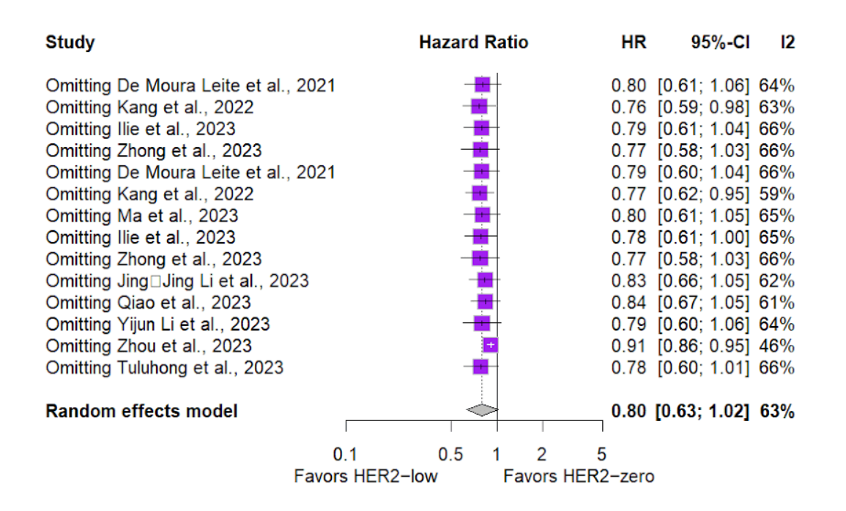
B. Sensitivity analysis of Overall survival (OS) - Multivariate analysis
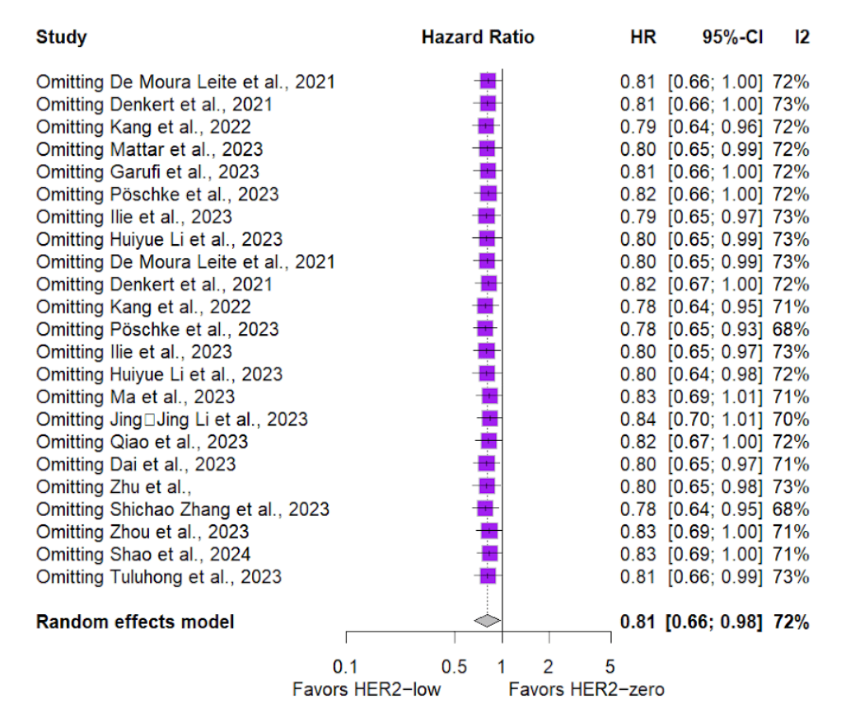
C. Sensitivity analysis of Disease-free survival (DFS) - Univariate analysis
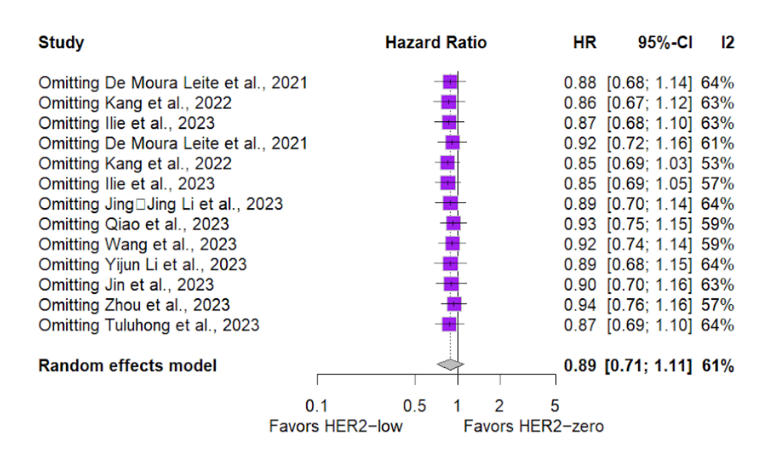
D. Sensitivity analysis of Disease-free survival (DFS) - Multivariate analysis
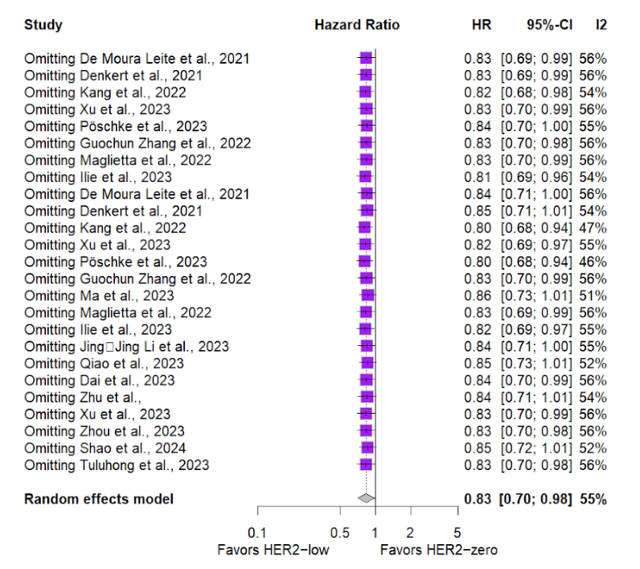

E. Sensitivity analysis of Pathological complete response (pCR)
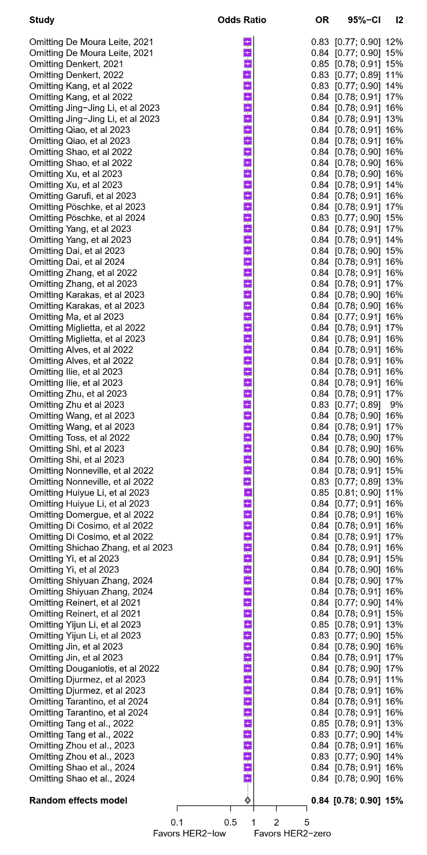
Supplementary Figure 2 Forest plot - Outcomes in the general population. A. Overall survival (OS) - Univariate analysis. B. Overall survival (OS) - Multivariate analysis. C. Disease-free survival (DFS) - Univariate analysis. D. Disease-free survival (DFS) - Multivariate analysis.
A. Overall survival (OS) outcome in general population - Univariate analysis
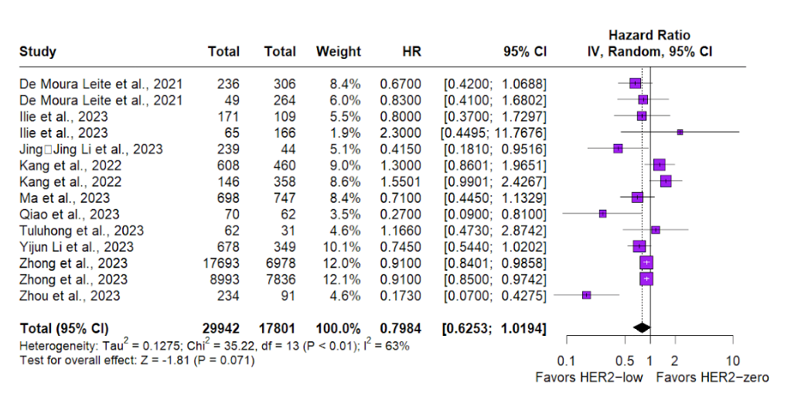
B. Overall survival (OS) outcome in general population - Multivariate analysis
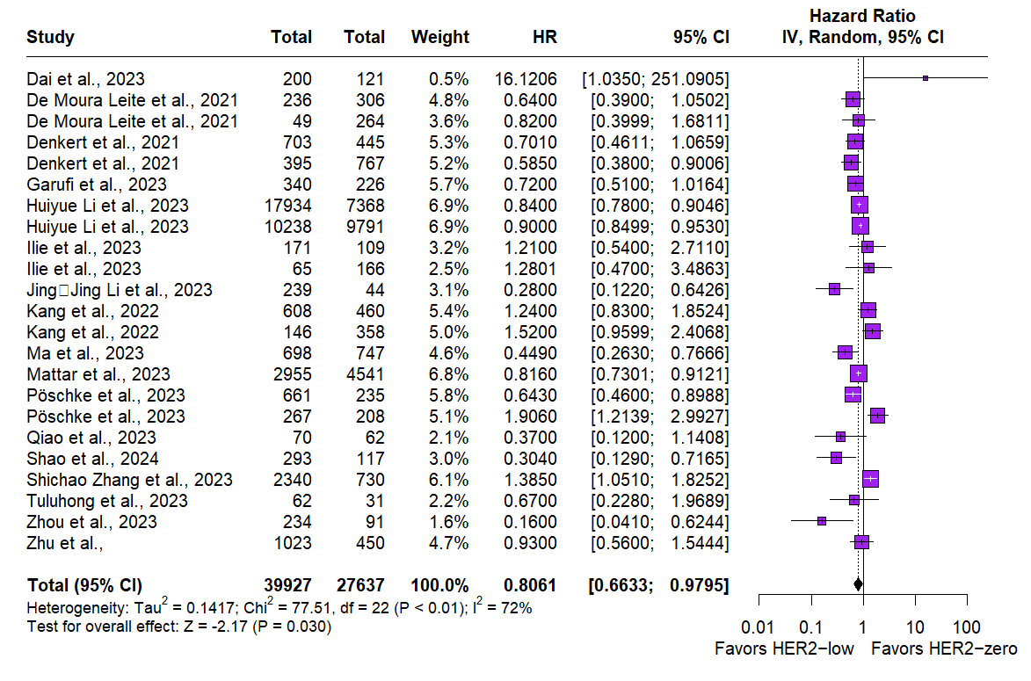
C. Disease-free survival (DFS) outcome in general population - Univariate analysis
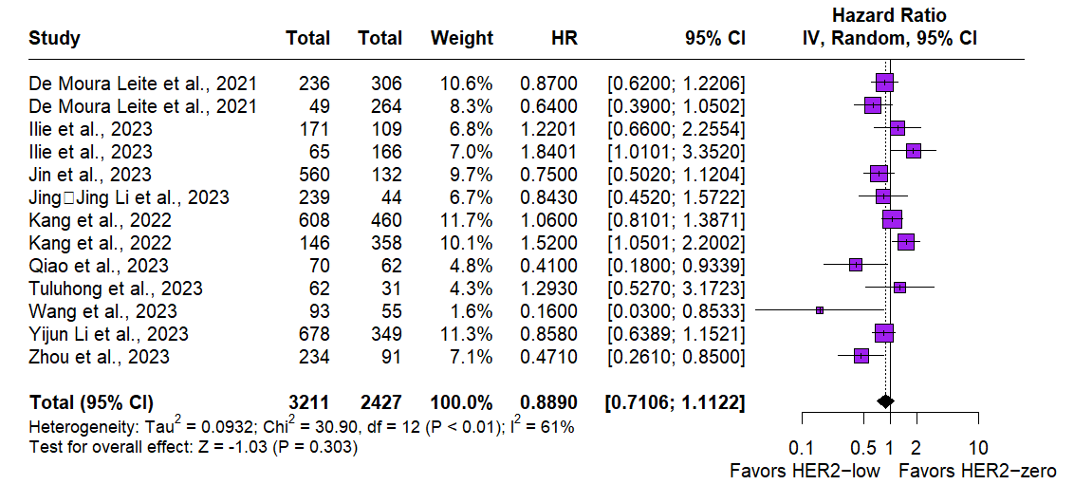
D. Disease-free survival (DFS) outcome in general population - Multivariate analysis
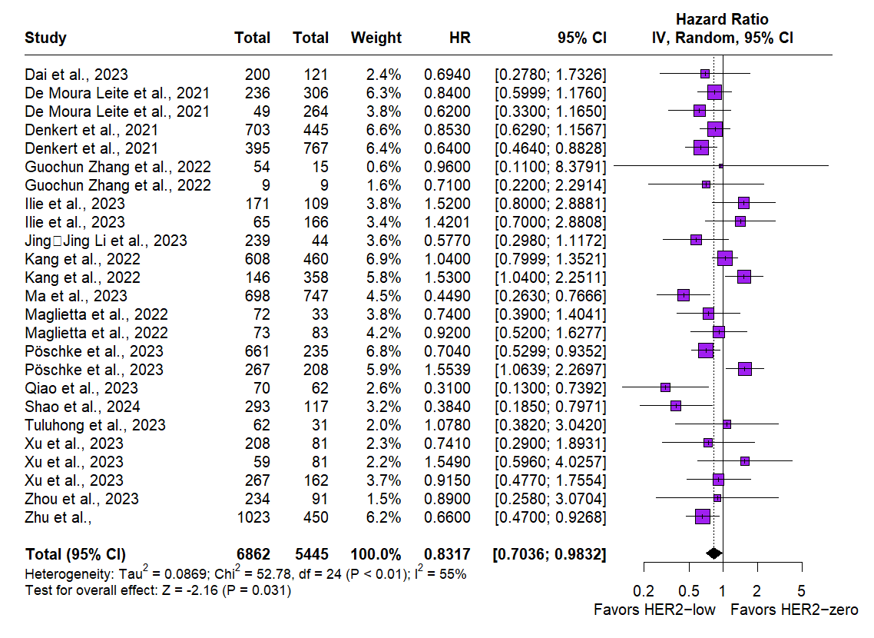

Supplementary Figure 3 Forest plot - Outcomes according to breast cancer subtype. A. Overall survival (OS) - Univariate analysis. B. Overall survival (OS) - Multivariate analysis. C. Disease-free survival (DFS) - Univariate analysis. D. Disease-free survival (DFS) - Multivariate analysis.
A. Overall survival (OS) outcome according to subgroup - Univariate analysis
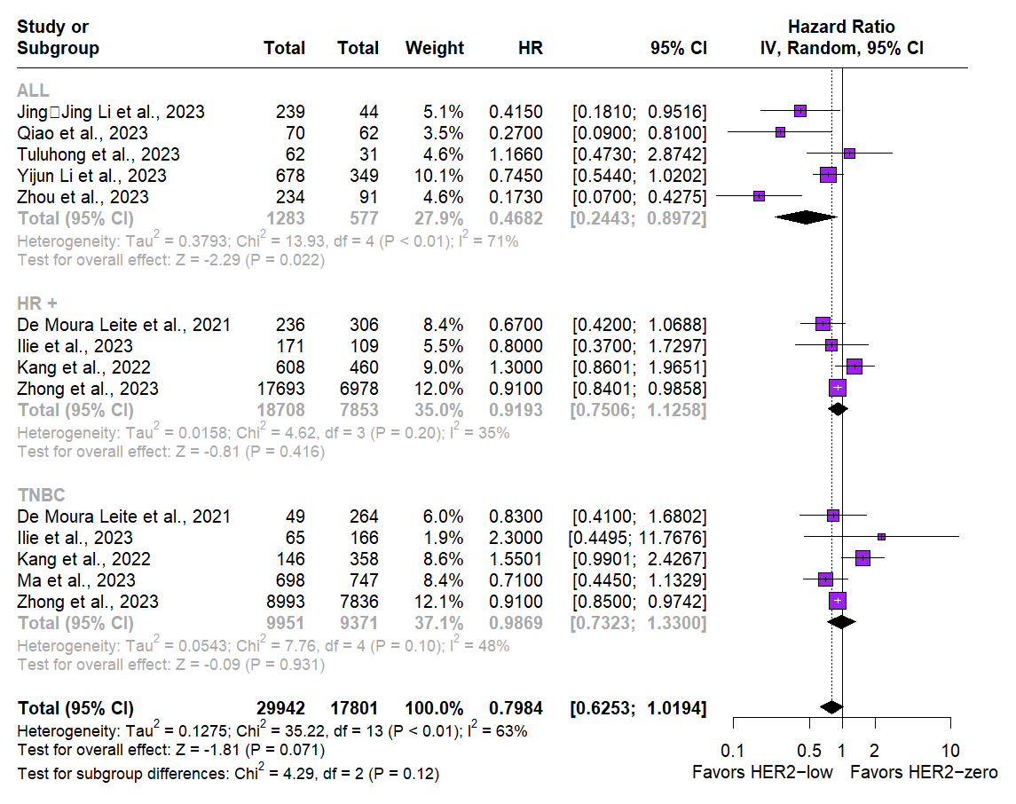
B. Overall survival (OS) outcome according to subgroup - Multivariate analysis
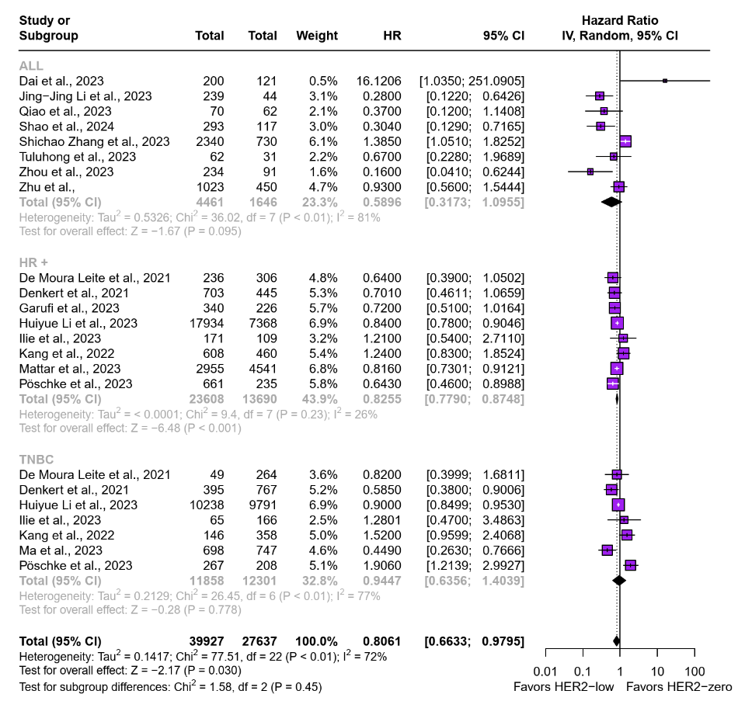
C. Disease-free survival (DFS) outcome according to subgroup - Univariate analysis
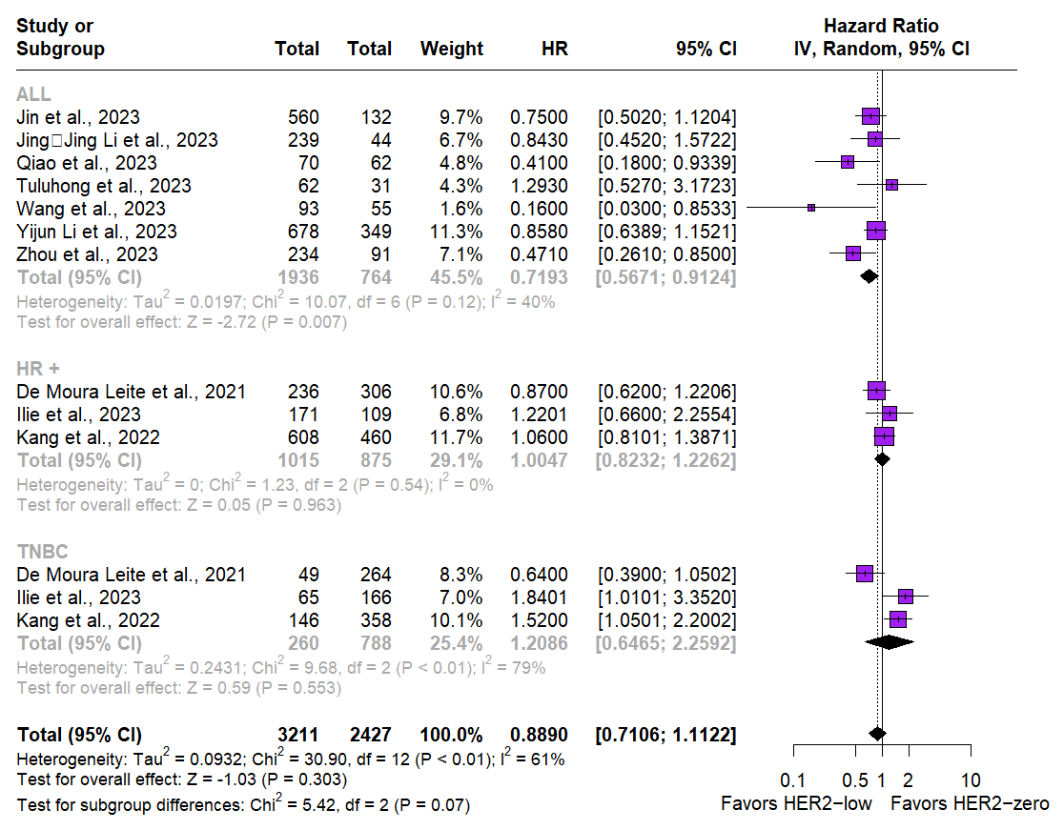
D. Disease-free survival (DFS) outcome according to subgroup - Multivariate analysis
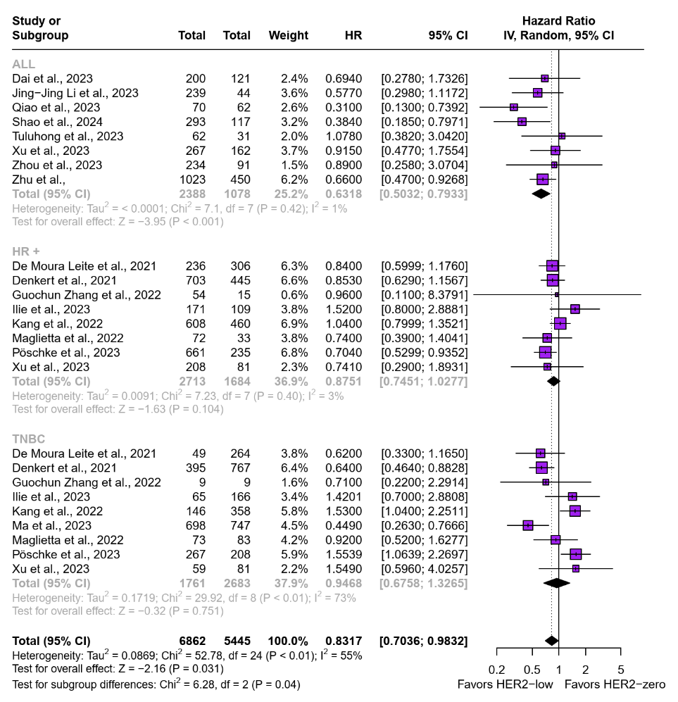

Supplementary Figure 4 Analysis of publication bias (Funnel Plot). A. Overall survival (OS) - Univariate analysis. B. Overall survival (OS) - Multivariate analysis. C. Disease-free survival (DFS) - Univariate analysis. D. Disease-free survival (DFS) - Multivariate analysis.
A. Overall survival (OS) publication bias - Univariate analysis
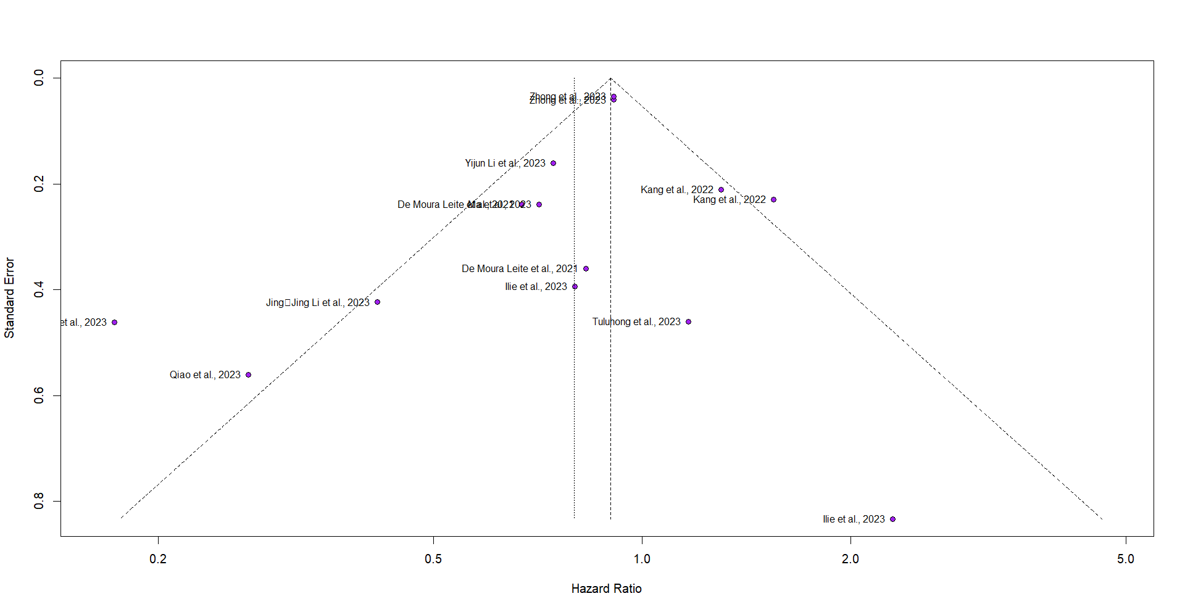

B. Overall survival (OS) publication bias - Multivariate analysis
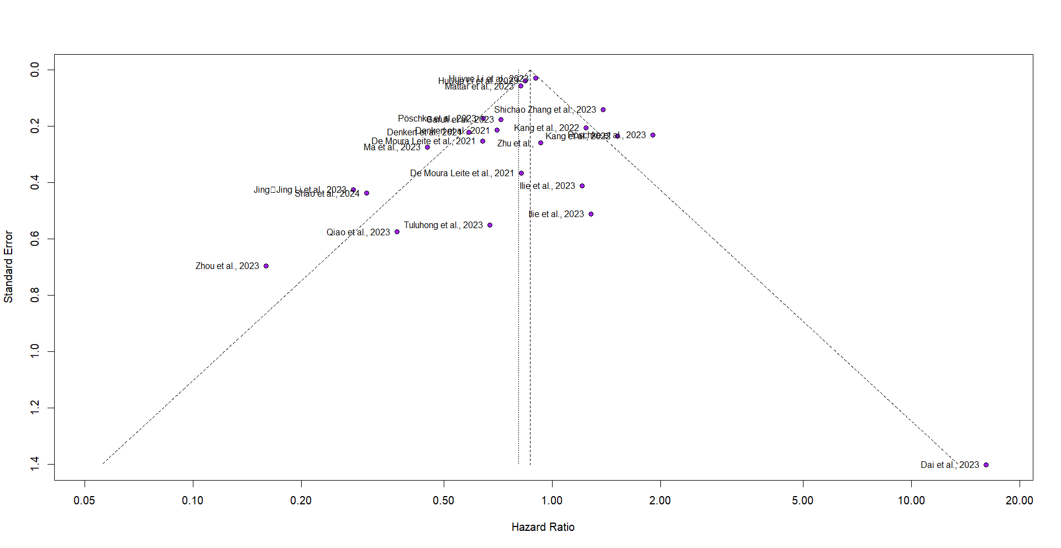

C. Disease-free survival (DFS) publication bias - Univariate analysis
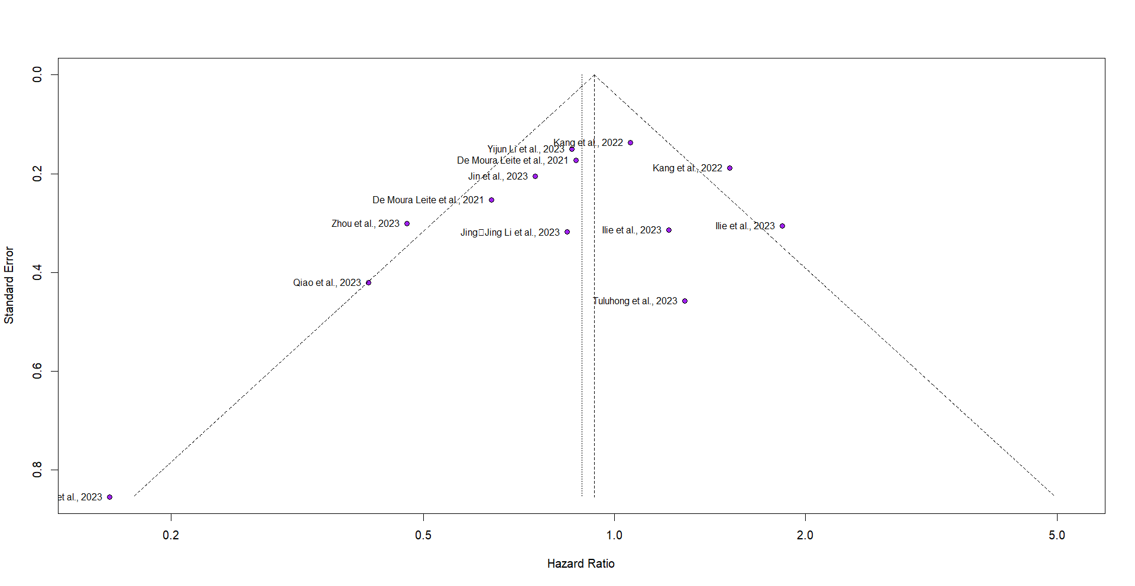
D. Disease-free survival (DFS) publication bias - Multivariate analysis
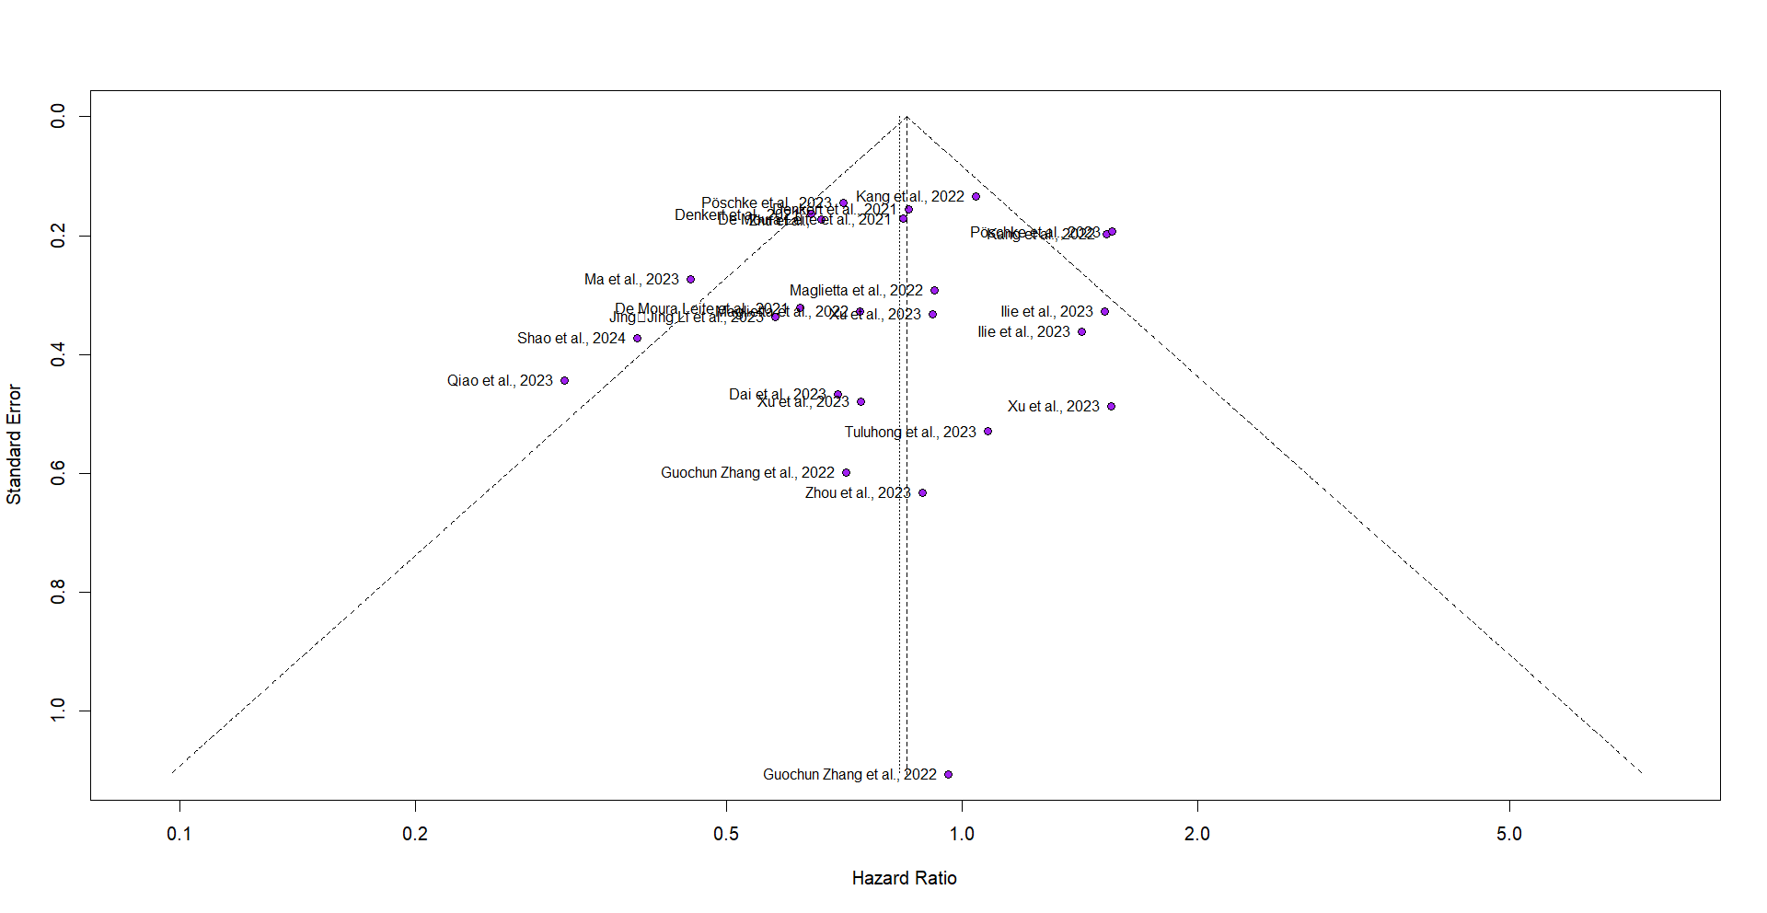

Supplementary Figure 5 Drapery plot - Assessment of heterogeneity between studies. A. Overall survival (OS) - Univariate analysis. B. Overall survival (OS) - Multivariate analysis. C. Disease-free survival (DFS) - Univariate analysis. D. Disease-free survival (DFS) - Multivariate analysis.
A. Overall survival (OS) heterogeneity assessment - Univariate analysis
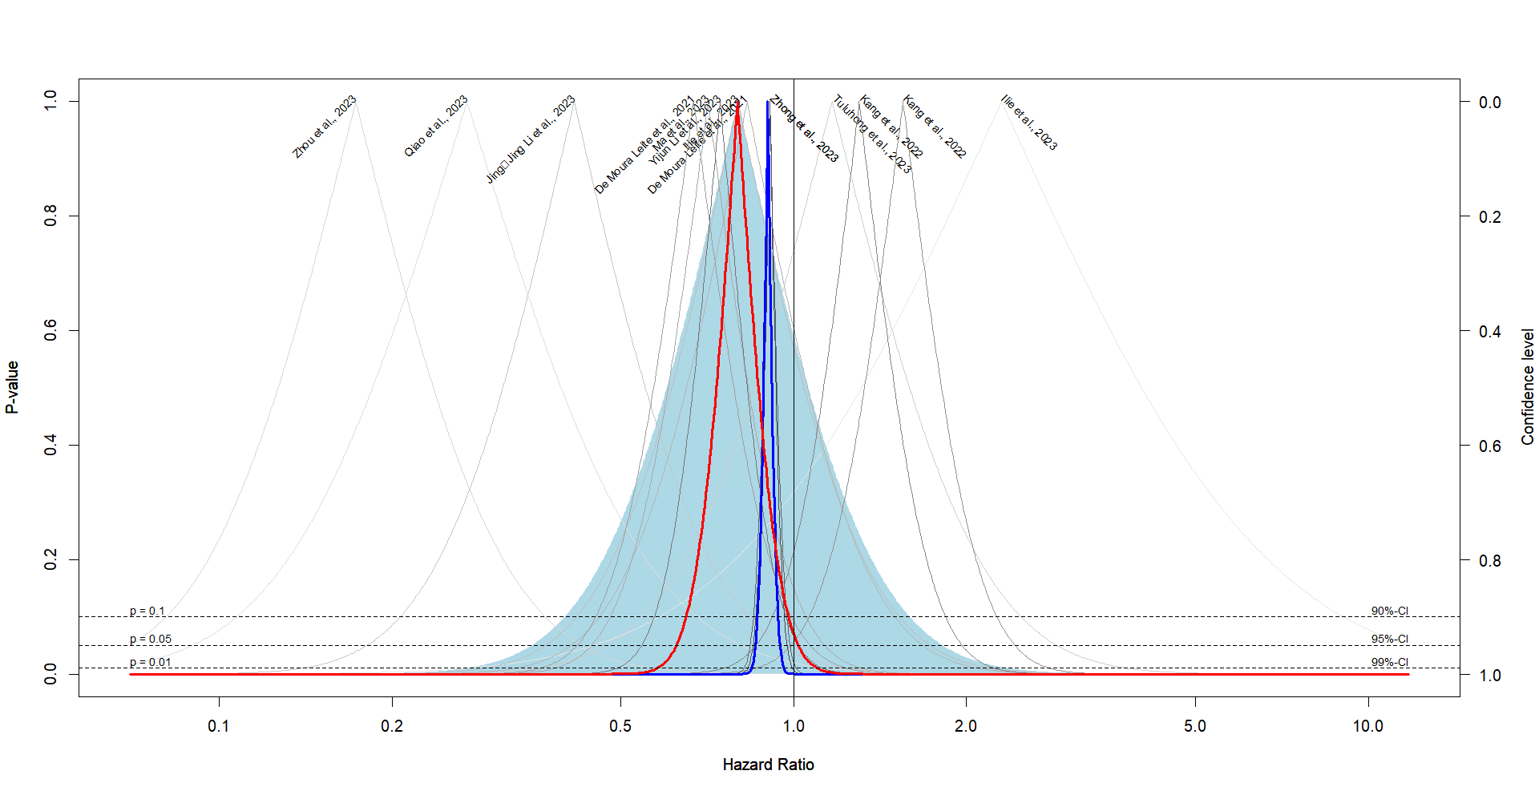
B. Overall survival (OS) heterogeneity assessment - Multivariate analysis
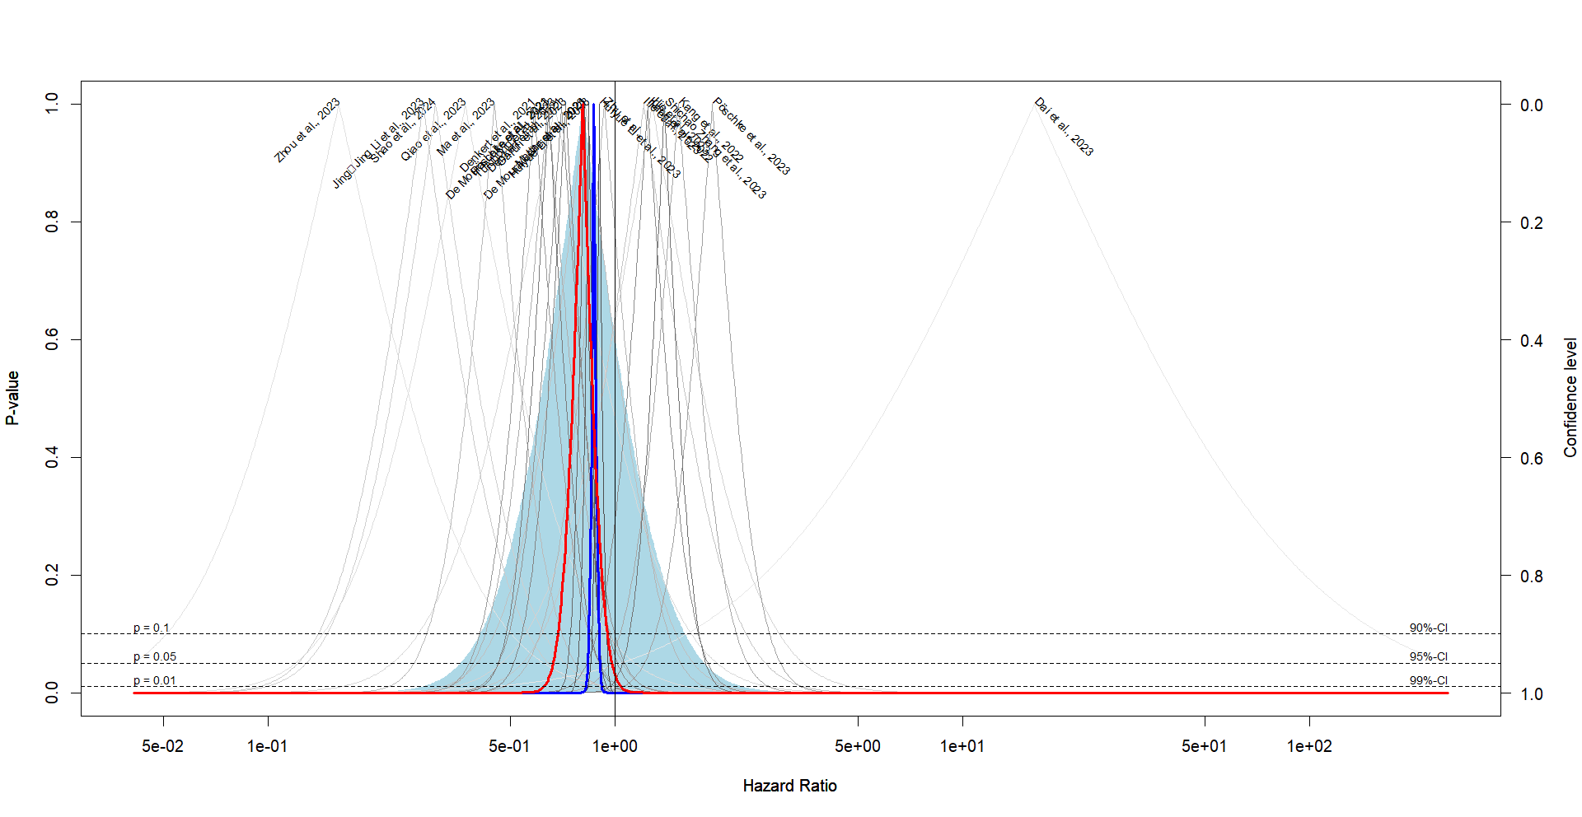
C. Disease-free survival (DFS) heterogeneity assessment - Univariate analysis
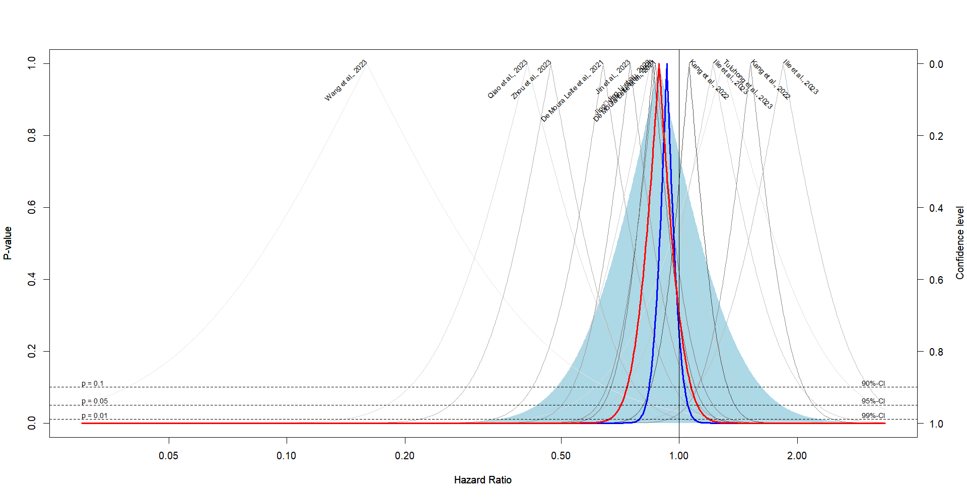
D. Disease-free survival (DFS) heterogeneity assessment - Multivariate analysis
