Figure S1: Histogram for time from consent to death per patient.
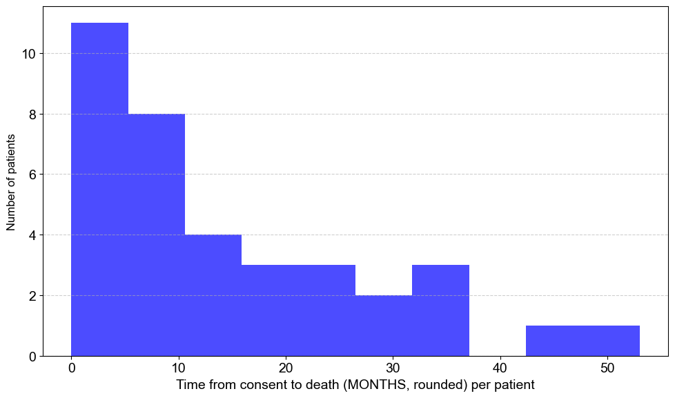
Figure S1: Histogram summarizing our time from consent to death in months, rounded.

Figure S2: Pathway scores comparison between fixed and frozen tissue.

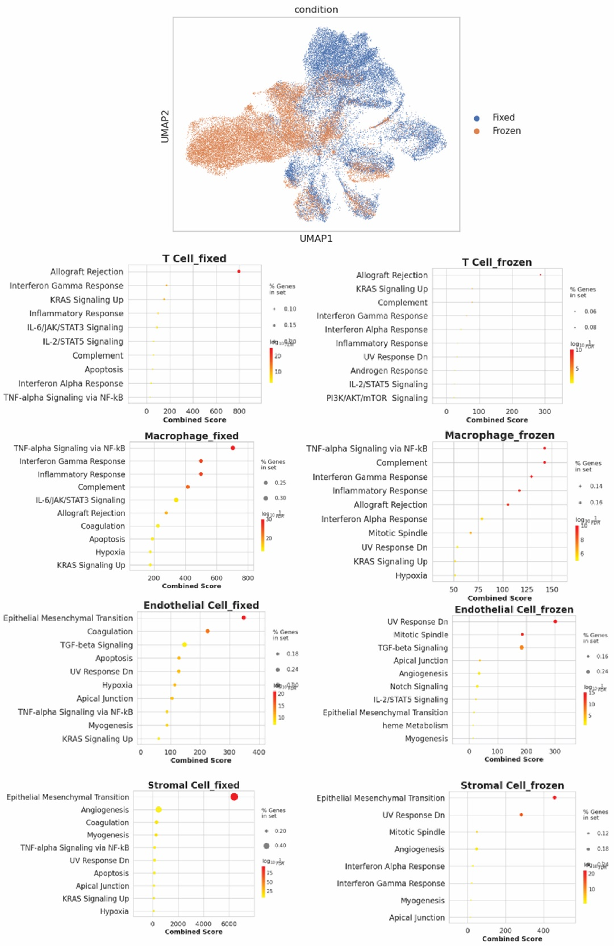
Figure S2. Downstream single cell analysis showing that fixed sequencing has better gene set percentage overlap and higher scores on average.

Figure S3: Illustration of difference between chunked and minced tissue.
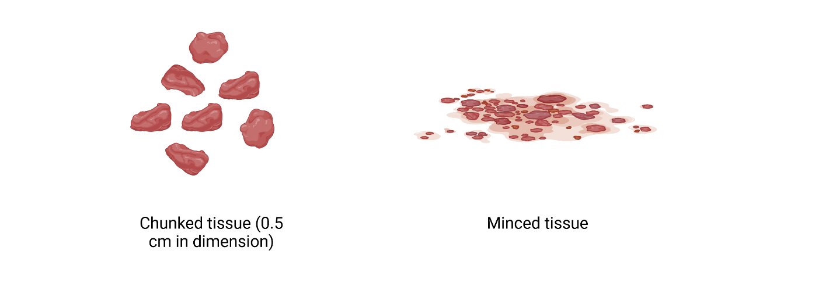
Figure S3. Illustration of the difference between chunked and minced tissue. Chunk tissues are preserved in 0.5cm – 1cm chunks. Minced tissues are chopped finely with a single-edged razor blade from an adjacent site.

