Additional File 1
Supplementary Methods
Criteria for patients enrolled under protocol amendment 6 (PA6)
Patients enrolled under PA6 or subsequent amendments received prior therapy, including at least 1 prior hormonal therapy and a CDK4/6 inhibitor. Up to 1 prior chemotherapy in the metastatic setting was allowed. In addition, after PA6, all eligible patients had clonal ESR1 Y537S mutation at allelic frequency (AF) ≥0.5%, in the absence of ESR1 D538G mutation at AF ≥0.5%, as determined at prescreening by a sponsor-designated central laboratory from a Nucleic Acids Whole Blood (plasma cell-free DNA) sample. Patients with inflammatory breast cancer, those who were currently receiving or had received systemic corticosteroids ≤2 weeks before starting study drug (or had not fully recovered from side effects of such treatment), or those who had received radiotherapy ≤4 weeks or limited field radiation for palliation ≤2 weeks before starting study drug (and had not recovered to grade 1 or better from related side effects of such therapy, except alopecia), were not eligible. Patients were required to have measurable disease to enroll under PA6.

Table A1 Treatment-emergent adverse events of special interest observed in ≥2 patients
AESI group  preferred  term, No. (%) | 100 mg  (n = 6) | 200 mg  (n = 12) | 300 mg  (n = 11) | 450 mg  (n = 115) | 600 mg  (n = 7) | Total  (N = 151)
Any AESI | 4 (66.7) | 12 (100) | 9 (81.8) | 107 (93.0) | 7 (100) | 139 (92.1)
Bradycardia | 0 | 6 (50.0) | 8 (72.7) | 56 (48.7) | 1 (14.3) | 71 (47.0)
Bradycardia | 0 | 0 | 0 | 4 (3.5) | 0 | 4 (2.6)
Sinus  bradycardia | 0 | 6 (50.0) | 8 (72.7) | 52 (45.2) | 1 (14.3) | 67 (44.4)
Cardiotoxicity | 0 | 0 | 0 | 10 (8.7) | 0 | 10 (6.6)
Atrial  fibrillation | 0 | 0 | 0 | 3 (2.6) | 0 | 3 (2.0)
Pulmonary  edema | 0 | 0 | 0 | 2 (1.7) | 0 | 2 (1.3)
Sinus  tachycardia | 0 | 0 | 0 | 2 (1.7) | 0 | 2 (1.3)
Endometrial Hyperplasia | 0 | 0 | 0 | 4 (3.5) | 0 | 4 (2.6)
Endometrial  thickening | 0 | 0 | 0 | 4 (3.5) | 0 | 4 (2.6)
GI toxicity | 4 (66.7) | 5 (41.7) | 5 (45.5) | 82 (71.3) | 5 (71.4) | 101 (66.9)
Diarrhea | 2 (33.3) | 2 (16.7) | 3 (27.3) | 54 (47.0) | 1 (14.3) | 62 (41.1)
Nausea | 2 (33.3) | 4 (33.3) | 4 (36.4) | 55 (47.8) | 4 (57.1) | 69 (45.7)
Vomiting | 3 (50.0) | 2 (16.7) | 2 (18.2) | 30 (26.1) | 2 (28.6) | 39 (25.8)
Hepatotoxicity | 2 (33.3) | 7 (58.3) | 4 (36.4) | 32 (27.8) | 5 (71.4) | 50 (33.1)
ALT increased | 2 (33.3) | 5 (41.7) | 2 (18.2) | 16 (13.9) | 2 (28.6) | 27 (17.9)
Ascites | 0 | 1 (8.3) | 0 | 2 (1.7) | 1 (14.3) | 4 (2.6)
AST increased | 2 (33.3) | 5 (41.7) | 3 (27.3) | 18 (15.7) | 4 (57.1) | 32 (21.2)
Blood bilirubin  increased | 0 | 2 (16.7) | 0 | 10 (8.7) | 3 (42.9) | 15 (9.9)
GGT increased | 0 | 0 | 0 | 2 (1.7) | 0 | 2 (1.3)
Hyperbilirubinemia | 0 | 1 (8.3) | 1 (9.1) | 4 (3.5) | 0 | 6 (4.0)
International  normalized ratio  increased | 0 | 0 | 0 | 5 (4.3) | 0 | 5 (3.3)
Rash | 0 | 2 (16.7) | 0 | 20 (17.4) | 1 (14.3) | 23 (15.2)
Rash | 0 | 1 (8.3) | 0 | 10 (8.7) | 0 | 11 (7.3)
Rash maculo-papular | 0 | 1 (8.3) | 0 | 8 (7.0) | 0 | 9 (6.0)
Rash pruiritic | 0 | 0 | 0 | 1 (0.9) | 1 (14.3) | 2 (1.3)
Torsade De Pointes/QT  Prolongation | 0 | 0 | 1 (9.1) | 14 (12.2) | 0 | 15 (9.9)
Electrocardiogram QT  prolonged | 0 | 0 | 1 (9.1) | 14 (12.2) | 0 | 15 (9.9)
Abbreviations: AESI, adverse event of special interest; ALT, alanine aminotransferace; AST, aspartate aminotransferace increased; GGT, gamma-glutamyltransferase; MedDRA, Medical Dictionary for Regulatory Activities.
A patient with 2 or more adverse events in the same AESI group (or with the same preferred term) is counted only once for that AESI group (or preferred term). Adverse events terms were coded using MedDRA version 25.1.

Table A2 Efficacy by key subgroups in all patients treated with 450 mg
Efficacy group | Median PFS, months  (95% CI)ª | ORR, %  (95% CI)^{b} | CBR^{c}, %  (95% CI)^{b}
Prior treatment
Fulvestrant (N = 81; n = 64) | 5.06 (3.52, 6.67) | 21.9 (12.5, 34.0) | 43.8 (31.4, 56.7)
Novel SERD/SERM^{d} (N = 11; n = 10) | 7.33 (1.64, NE) | 30.0 (6.7, 65.2) | 60.0 (26.2, 87.8)
Chemotherapy (N = 54; n = 42) | 6.18 (3.65, 7.36) | 21.4 (10.3, 36.8) | 52.4 (36.4, 68.0)
CDK4/6 inhibitor (N = 102; n = 82) | 5.06 (3.52, 7.20) | 22.0 (13.6, 32.5) | 41.5 (30.7, 52.9)
≥3 regimens (N = 45; n = 37) | 7.20 (3.52, 8.87) | 29.7 (15.9, 47.0) | 51.4 (34.4, 68.1)
ESR1 clonal Y537S: 2 regimens  (N = 9; n = 9) | 7.52 (0.76, NE) | 44.4 (13.7, 78.8) | 44.4 (13.7, 78.8)
ESR1 clonal Y537S: ≥3 regimens  (N = 13; n = 13) | 8.87 (3.52, 12.94) | 38.5 (13.9, 68.4) | 76.9 (46.2, 95.0)
Tumor characteristics
ESR1 clonal Y537S (N = 28; n = 28) | 7.33 (3.12, 11.07) | 32.1 (15.9, 52.4) | 57.1 (37.2, 75.5)
ESR1 clonal D538G (N = 19; n = 17) | 3.55 (1.71, 7.20) | 0.0 (0.0, 19.5) | 29.4 (10.3, 56.0)
ESR1 clonal Y537S or D538G (N = 47, n = 45) | 6.67 (3.48, 8.57) | 20.0 (9.6, 34.6) | 46.7 (31.7, 62.1)
Polyclonal Y537S and D538G (N = 5, n = 3) | 2.61 (1.64, NE) | 0.0 (0.0, 70.8) | 33.3 (0.8, 90.6)
ESR1 clonal Y537S and D538G negatives (N = 61, n = 44) | 5.06 (2.04, 7.26) | 22.7 (11.5, 37.8) | 38.6 (24.4, 54.5)
PIK3CA mutant (N = 39; n = 32) | 3.52 (1.71, 7.26) | 15.6 (5.3, 32.8) | 31.3 (16.1, 50.0)
Liver and/or lung metastases (N = 89; n = 76) | 5.39 (1.84, 7.26) | 21.1 (12.5, 31.9) | 43.4 (32.1, 55.3)
Abbreviations: CBR, clinical benefit rate; CDK4/6, cyclin-dependent kinase 4/6; CI, confidence interval; CR, complete response; ESR1, estrogen receptor 1 gene; NE, not estimable; ORR, objective response rate; PFS, progression-free survival; PIK3CA, phosphatidylinositol-4,5-bisphosphate 3-kinase catalytic subunit alpha; PR, partial response; RECIST v1.1, Response Evaluation Criteria in Solid Tumors version 1.1; SD, stable disease; SERD, selective estrogen receptor degrader; SERM, selective estrogen receptor modulator.
PFS was calculated for patients in the full analysis set (N = 115 for the 450 mg group), which included all patients who received at least 1 dose of the study drug. ORR and CBR were calculated for response-evaluable patients (n = 94 for the 450 mg group), which included those who received at least 1 dose of the study drug and had measurable disease at baseline and at least 1 postbaseline evaluation. Tumors were assessed by the investigator per RECIST v1.1 criteria.
ªCalculated using Kaplan-Meier product-limit method
^{b}Calculated using exact (Clopper-Pearson) 2-sided 95% confidence limits
^{c}CBR = CR, PR, or durable SD (SD with duration ≥23 weeks); ^{d}Includes investigational SERD or SERM and excludes fulvestrant
Table A3 PK parameters of H3B-6545 in patients treated in phase 1
Day | PK parameter | 100 mg  (n = 6) | 200 mg  (n = 12) | 300 mg  (n = 11) | 450 mg  (n = 11) | 600 mg  (n = 7)
Cycle 1  Day 1 | t_{max} (h) | 3.05 (2.00−6.00) | 3.00 (2.00−6.17) | 3.97 (2.00−6.00) | 4.00 (2.00−10.00) | 4.00 (2.00−6.00)
Cycle 1  Day 1 | C_{max} (ng/mL) | 215 (116) | 439 (219) | 991 (424) | 1690 (973) | 2160 (1490)
Cycle 1  Day 1 | AUC_{(0-24h)} (ng•h/mL) | 2060 (1280) | 4550 (2400)ª | 9480 (4250)^{b} | 17400 (6470) | 27800 (15000)^{c}
Cycle 1  Day 15 | t_{max} (h) | 2.00 (2.00−8.03) | 2.17 (2.00−6.00)^{b} | 4.00 (2.00−5.95) | 4.00 (1.00−8.00)^{b} | 6.00, 4.00e
Cycle 1  Day 15 | C_{max} (ng/mL) | 298 (89.1) | 676 (305)^{b} | 1270 (437) | 1570 (713)^{b} | 650, 2640e
Cycle 1  Day 15 | AUC_{(0-24h)} (ng•h/mL) | 2850 (1350) | 7070 (3010)^{d} | 11600 (5530)ª | 15500 (6800)^{b} | 8280, 27000e
Cycle 1  Day 15 | CL/F (L/h) | 43.9 (23.2) | 36.2 (24.7)^{d} | 30.6 (11.6)ª | 36.0 (19.0)^{b} | 72.5, 22.2e
Cycle 1  Day 15 | R_{ac} (C_{max}) | 1.91 (1.24) | 1.95 (1.60)^{b} | 1.44 (0.512) | 1.13 (0.469)^{b} | 0.335, 1.07e
Cycle 1  Day 15 | R_{ac} (AUC_{(0-24h)}) | 1.77 (1.29) | 1.89 (1.20)^{d} | 1.27 (0.383)ª | 1.00 (0.448)^{b} | 0.500, 0.835e
Abbreviations: AUC_{(0-24h)}, area under the plasma concentration-time curve from zero time to 24 hours postdose; CL/F, apparent total clearance following oral administration; C_{max}, maximum observed plasma concentration; R_{ac}, accumulation ratio; t_{max}, time at which C_{max} occurs.
Data are shown as mean (standard deviation) except t_{max}. For t_{max}, median (minimum−maximum) is shown. R_{ac} was calculated by dividing the values of C_{max} or AUC_{(0-24h)} on C1D15 by those on C1D1.
ªn = 9; ^{b}n = 10; ^{c}n = 6; ^{d}n = 8; ^{e}Individual values are shown (n = 2).

Table A4 PK parameters of H3B-6545 in patients treated in the food-effect cohort of phase 2
PK parameter | 450 mg Fed (N = 18) | 450 mg Fasted (N =18)
t_{max} (h) | 6.00 (4.00−10.00) | 4.00 (1.00−6.15)
C_{max} (ng/mL) | 1840 (828) | 1310 (687)
AUC_{(0-24h)} (ng•h/mL) | 24200 (10500)ª | 14300 (6690)^{b}
CL/F (L/h) | 22.0 (9.36)ª | 45.7 (47.5)^{b}
Abbreviations: AUC_{(0-24h)}, area under the plasma concentration-time curve from zero time to 24 hours postdose; CL/F, apparent total clearance following oral administration; C_{max}, maximum observed plasma concentration; t_{max}, time at which C_{max} occurs.
Data are shown as mean (standard deviation) except t_{max}. For t_{max}, median (minimum−maximum) is shown.
ªn = 13; ^{b}n = 16.

Table A5 Relative bioavailability of H3B-6545 to assess the food effect in patients treated in the food-effect cohort of phase 2
PK parameter | Geometric LS Means |  | Geometric LS Mean Ratio  Fed / Fasted  (90% CI)
PK parameter | 450 mg Fed  (N = 18) | 450 mg Fasted  (N =18) | Geometric LS Mean Ratio  Fed / Fasted  (90% CI)
C_{max} (ng/mL) | 1650 | 1090 | 1.51 (1.20, 1.90)
AUC_{(0-24h)} (ng•h/mL)ª | 22300 | 14500 | 1.53 (1.19, 1.98)
Abbreviations: AUC_{(0-24h)}, area under the plasma concentration-time curve from zero time to 24 hours postdose; C_{max}, maximum observed plasma concentration; CI, confidence interval; LS, least squares.
ªPatients with AUC_{(0-24h)} values for both fed and fasted conditions were included in the statistical analysis (n = 13).

Fig A1 Enrollment criteria, study design, and endpoints. ªOther enrollment criteria under PA6 included receipt of at least 1 prior hormonal therapy. Patients who were currently receiving or had received systemic corticosteroids ≤2 weeks before starting study drug (or had not fully recovered from side effects of such treatment), or those who had received radiotherapy ≤4 weeks or limited field radiation for palliation ≤2 weeks before starting study drug (and had not recovered to grade 1 or better from related side effects of such therapy, except for alopecia), were not eligible. DOR, duration of response; ECOG PS, Eastern Cooperative Oncology Group performance status; ER, estrogen receptor; ESR1, estrogen receptor 1 gene; mBC, metastatic breast cancer; ORR, objective response rate; PD, pharmacodynamics; PFS, progression-free survival; PK, pharmacokinetics; RP2D, recommended phase 2 dosage; QD, once daily
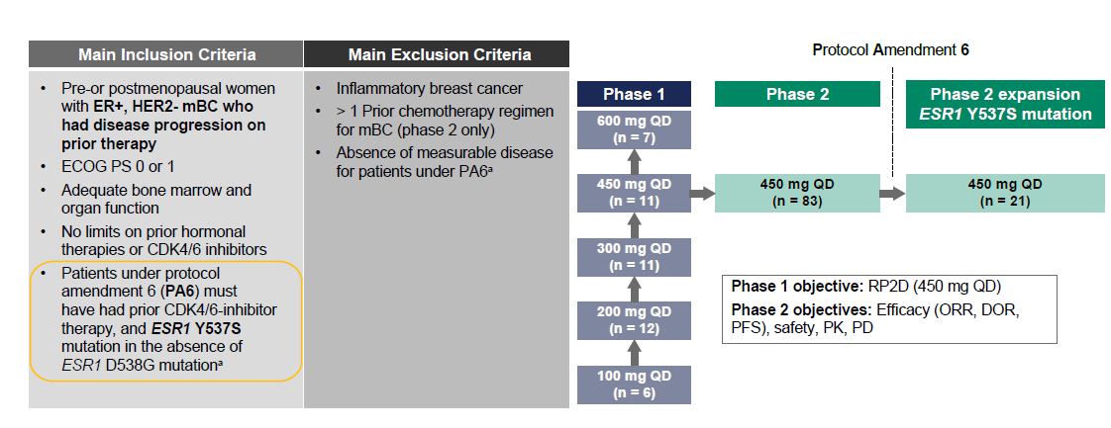

Fig. A2 Patient disposition and the primary reason for discontinuation from study drug: phases 1 and 2. ªBased on primary reason reported on the Screening Disposition CRF; ^{b}percentages are based on the total number of subjects in the full analysis set within the relevant dose groups; ^{c}in 450-mg dose group, 11 and 104 patients were included in phase 1 and phase 2, respectively. DCO, data cutoff; CRF, case report form
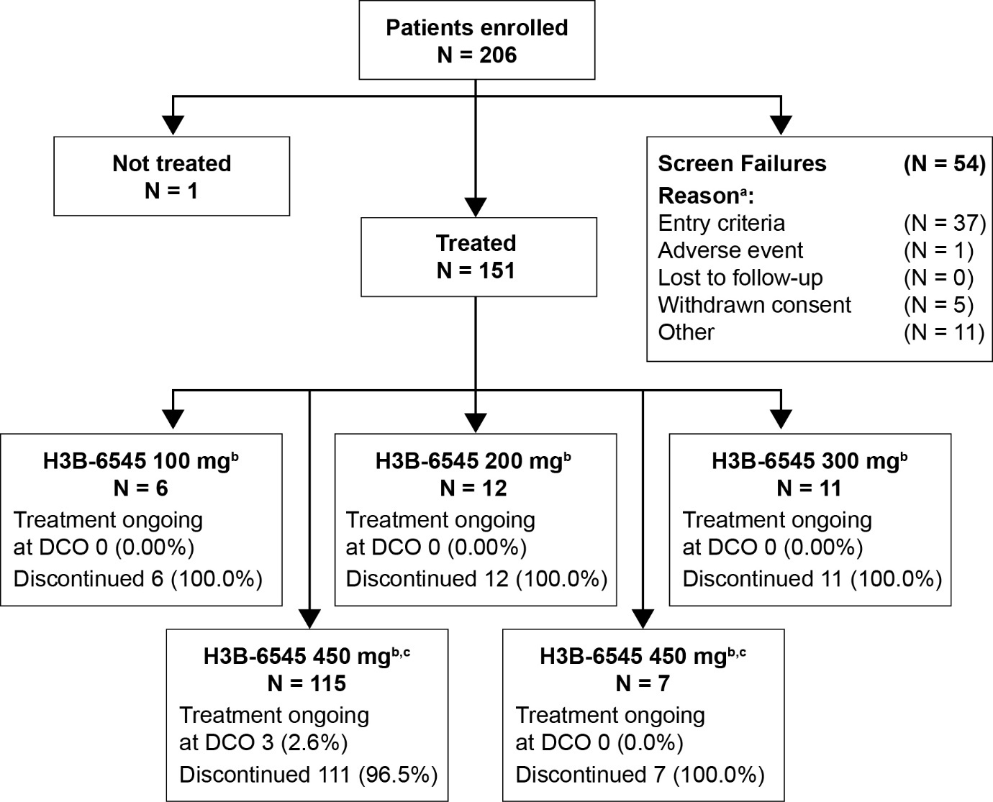

Fig. A3 PFS (A) and OS (B) by dose group: phases 1 and 2. CI, confidence interval; OS, overall survival; PA6, protocol amendment 6; PFS, progression-free survival
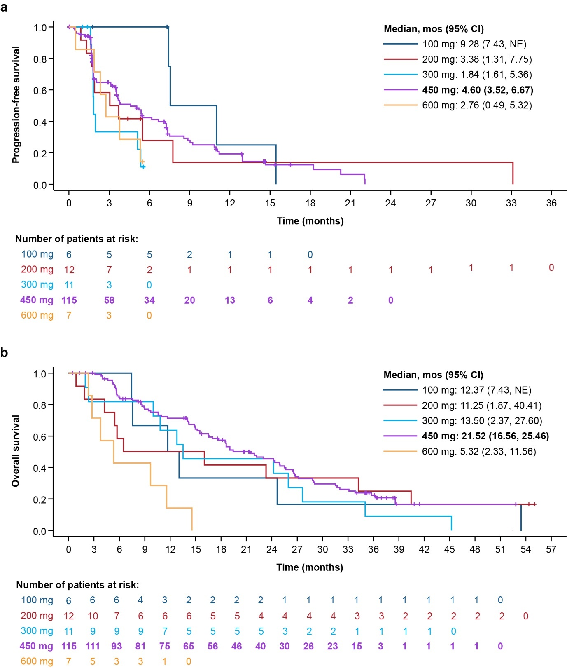

Fig. A4 Semilogarithmic plots of the mean (+SD) plasma H3B-6545 concentration in patients treated in the food-effect cohort of phase 2. Plasma H3B-6545 concentrations were summarized based on the fasted or fed conditions. h, hours; QD, once daily; SD, standard deviation
