Pathway | Predictor | Weight
Apoptotic balance | BAK | 1
 | BAX | 1
 | BID | 1
 | BIM | 1
 | MCL-1 | -1
 | BAD_pS112 | -1
 | BCL-2 | -1
 | BCL-XL | -1
EMT | Fibronectin | 1
 | N-Cadherin | 1
 | Collagen-VI | 1
 | Claudin-7 | -1
 | E-Cadherin | -1
 | b-Catenin | -1
 | PAI-1 | 1
Notch | Notch1 | 1
 | TAZ | 1
 | YAP | 1
 | YAP_pS127 | -1
G1-S checkpoint | 53BP1 | 1
 | ATM_pS1981 | -1
 | Cyclin-E1 | 1
DNA damage response | 53BP1 | 1
 | ERCC1 | 1
 | PARP1 | 1
 | Rad50 | 1
 | Rad51 | 1
 | XRCC1 | 1

Supplemental Figure 1: Kaplan Meier DFS curves for NeoAva patients with ER+/HER2- RDA-assessable disease, based on the level of RNA disruption at 12 weeks. Patients with tumour RDI values >1.1 experienced significantly higher DFS than patients with tumour RDI values ≤ 1.1 (p=0.02, HR 3.2, 95% CI 0.9-10.8).
Supplemental Figure 2: Kaplan Meier BCSS curves for NeoAva patients with ER+/HER2- RDA-assessable disease, based on the level of RNA disruption at 12 weeks. Patients with tumour RDI values >1.1 experienced significantly higher BCSS than patients with tumour RDI values ≤ 1.1 (p=0.008, HR 4.7, 95% CI 1.1-19.8).With regards to the effects of bevacizumab , the median tumour RDI value for patients with ER+/HER2- tumours was significantly higher for bevacizumab-treated patients (2.4) compared to non-bevacizumab-treated patients (1.4), p=0.002, Mann Whitney test. The pCR rate for patients with ER+/HER2- tumours was also significantly higher for bevacizumab-treated patients (22%) compared to non-bevacizumab-treated patients (6.7%).

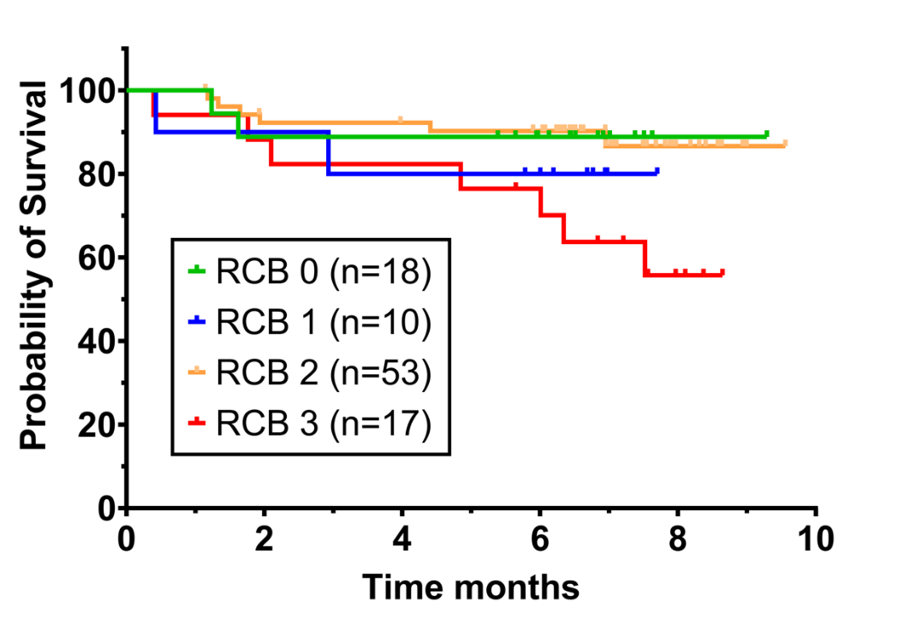
Supplemental Figure 3: DFS curves for all NeoAva patients with RDA-assessable biopsies after 12 weeks of treatment, based on the extent of residual cancer burden (RCB) in these patients’ post-treatment. Patients in RCB 0 had no residual disease, while patients in RCB 3 had the highest level of residual disease.

