Supplementary material

Title: Efficacy of everolimus in patients with hormone receptor positive, HER2 negative, metastatic breast cancer pretreated with CDK4/6 inhibitors

Authors :
Justine Dutheil¹, Victor Pereira^{1,2}, Cyril Boisson^{2,3}, Laura Mansi, Marie-Justine Paillard, Fernando Bazan,
Loic Chaigneau, Erion Dobi, Julien Viot, Guillaume Meynard, Morgan Goujon, Lorraine Dalens, Clément Dubourd, Sophie Marchi, Nathalie Meneveau, Dewi Vernerey³, Olivier Adotévi^{1,2}, Aurélia Meurisse³, Elsa Curtit^{1,2}

Supplementary Figure 1: 95% CI: 95% Confidence Interval
A. Kaplan-Meier estimates of PFS for all patients
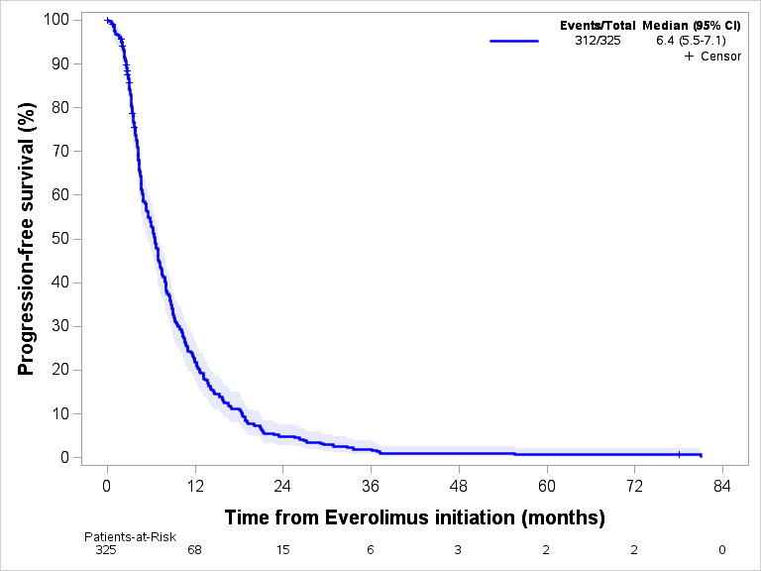

B. Kaplan-Meier estimates of OS for all patients
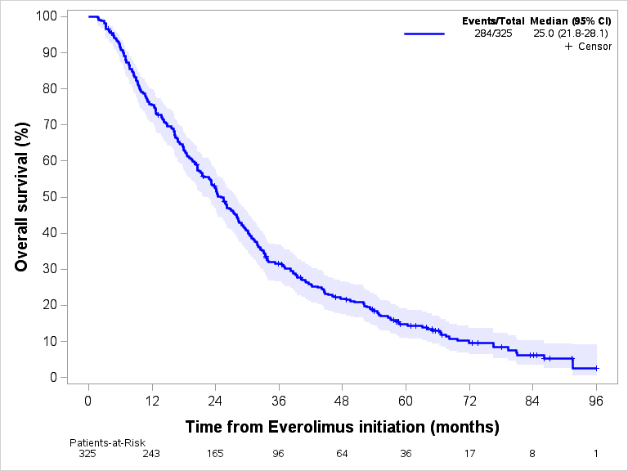

Supplementary Figure 2: Kaplan-Meier estimates of OS according to exposure to CDK 4/6 inhibitors

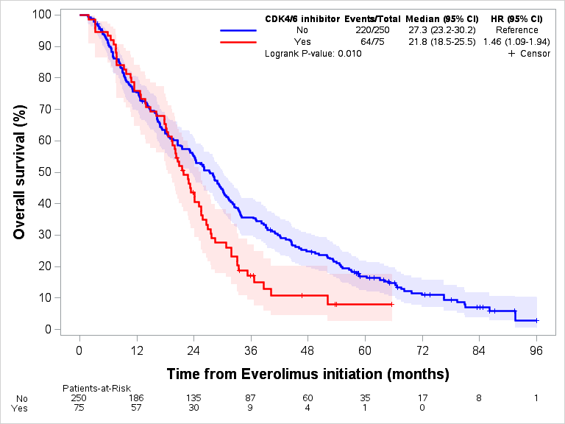

Supplementary Table 1: Description of patients’s characteristics according to Everolimus long responder (PFS >12 months)
Global characteristics | All patients | Everolimus no long responder | Everolimus long responder
Global characteristics | n=325 (%) | n=245 (%) | n=68 (%) | p-value
Socio-demographic data
Age |  |  |  | 0.433
Median | 67 | 66 | 68
Range | 59 - 74 | 58 - 74 | 61 – 75
Characteristics at diagnosis
ER+ (%) | 95% | 95% | 95% | 0.910
PR + (%) | 63% | 66% | 70% | 0.195
Primary metastatic diagnosis | 103 (32) | 77 (32) | 20 (29) | 0.462
Bone only | 74 (23) | 51 (21) | 21 (31) | 0.081
Bone | 261 (80) | 201 (82) | 51 (75) | 0.195
Liver | 111 (34) | 91 (37) | 16 (24) | 0.036
Lung | 131 (40) | 94 (38) | 28 (41) | 0.674
Brain | 16 (5) | 14 (6) | 1 (2) | 0.147
Lymph node | 73 (23) | 54 (22) | 17 (25) | 0.606
Other | 89 (27) | 71 (29) | 16 (24) | 0.375
Exposure to treatment before Everolimus
Adjuvant endocrine therapy | 170 (52%) | 128 (52%) | 36 (53%) | 0.535
Metastatic chemotherapy | 117 (36) | 97 (40) | 17 (25) | 0.027
Line
1 | 40 (34) | 30 (31) | 10 (59) | 0.016
2 | 26 (22) | 20 (21) | 5 (29)
≥3 | 51 (44) | 47 (48) | 2 (12)
Metastatic endocrine therapy | 288 (89) | 220 (90) | 59 (87) | 0.477
Line
1 | 128 (44) | 96 (44) | 26 (44) | 0.946
2 | 102 (35) | 79 (36) | 20 (34)
≥3 | 58 (21) | 45 (20) | 13 (22)
CDK4/6 inhibitor | 75 (23) | 62 (25) | 12 (18) | 0.188
Last news
Death | 284 (89) | 219 (91) | 54 (83) | 0.072
Delay initiation of Everolimus - death (m) | 21.7 | 18.0 | 37.9 | <0.001
Range | 10.8 - 33.7 | 9.1 - 29.6 | 28 - 55.2
m: months ; n: number of patients ; OMS: Performance status score from World Health Organization ; ; ER+: positive oestrogen receptor ; PR+: positive progesterone receptor

