Supplementary materials
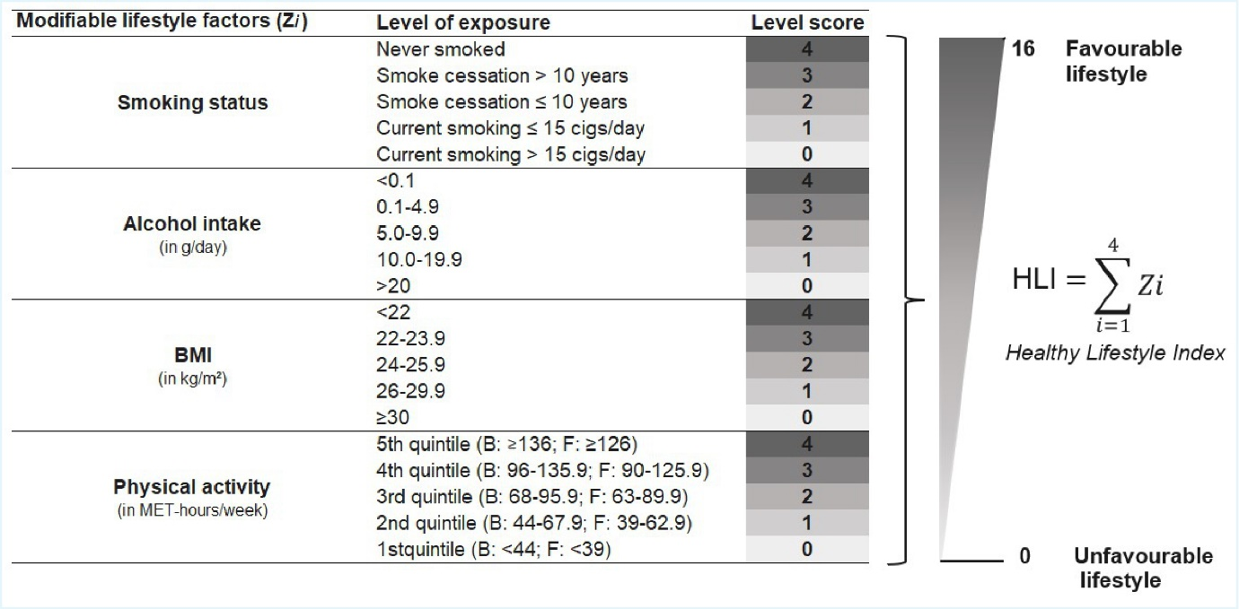
Supplementary Figure 1. Definition of the HLI
B, baseline; F, follow-up; cigs, cigarettes; MET, metabolic equivalent of task

Supplementary Figure 2. Mean HLI and individual component score changes by country (overall)
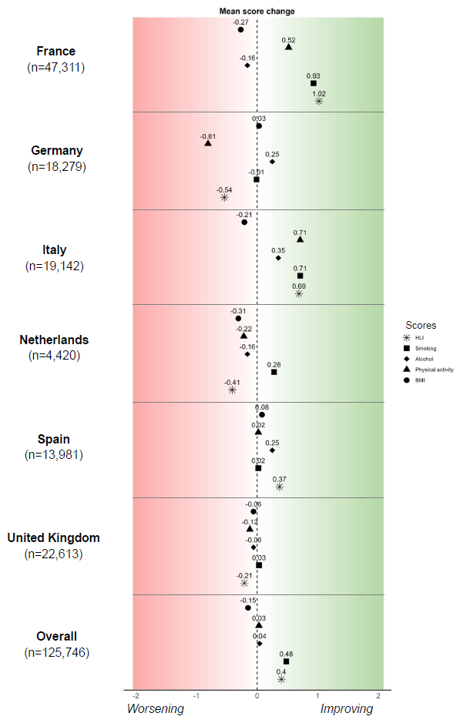

Negative mean values indicate a deterioration in the corresponding component score (e.g., increased alcohol consumption, higher BMI, or more smoking, and reduced physical activity), whereas positive mean values indicate an improvement.

Outcome |  | Overall BC | ER + | ER - | Unknown ER status | Phet  ER+ vs. ER-
Breast cancer events, n |  | 1,605 | 1,129 | 192 | 284
Difference in continuous  HLI score | 1-unit increase* | 0.987 (0.961-1.015) | 0.980 (0.950-1.012) | 1.052 (0.979-1.131) | 0.972 (0.914-1.035) | P=0.073
Difference in categorical  HLI score | Worsen vs Stable | 1.087 (0.953-1.239) | 1.115 (0.953-1.305) | 1.061 (0.723-1.558) | 1.038 (0.774-1.391) | P=0.816
Difference in categorical  HLI score | Improve vs Stable | 1.000 (0.880-1.136) | 0.996 (0.858-1.156) | 1.161 (0.821-1.641) | 0.876 (0.637-1.205) | P=0.421
Difference in categorical  HLI score | Improve vs Worsen | 0.920 (0.781-1.084) | 0.893 (0.738-1.082) | 1.094 (0.701-1.708) | 0.844 (0.577-1.234) | P= 0.406
Difference in continuous  HLI score, without smoking | 1-unit increase* | 0.979 (0.951-1.008) | 0.970 (0.937-1.003) | 1.056 (0.976-1.142) | 0.966 (0.905-1.032) | P=0.049
Difference in continuous  HLI score, without alcohol | 1-unit increase* | 0.969 (0.939-1.001) | 0.966 (0.931-1.002) | 1.013 (0.930-1.103) | 0.951 (0.883-1.024) | P=0.307
Difference in continuous  HLI score, without BMI | 1-unit increase* | 1.005 (0.975-1.035) | 0.998 (0.964-1.033) | 1.072 (0.991-1.159) | 0.987 (0.923-1.056) | P=0.095
Difference in continuous  HLI score, without physical activity | 1-unit increase* | 0.998 (0.962-1.035) | 0.988 (0.947-1.031) | 1.064 (0.965-1.173) | 0.992 (0.911-1.080) | P=0.162
Continuous difference  in smoking score | 1-unit increase* | 1.054 (0.971-1.143) | 1.055 (0.965-1.153) | 1.055 (0.871-1.278) | 1.039 (0.851-1.270) | P=0.999
Continuous difference  in alcohol score | 1-unit increase* | 1.033 (0.980-1.089) | 1.020 (0.959-1.085) | 1.154 (1.003-1.327) | 1.019 (0.907-1.144) | P=0.106
Continuous difference  in BMI score | 1-unit increase* | 0.906 (0.842-0.974) | 0.895 (0.822-0.975) | 0.956 (0.780-1.172) | 0.901 (0.758-1.072) | P=0.557
Continuous difference  in physical activity score | 1-unit increase* | 0.982 (0.940-1.026) | 0.977 (0.930-1.026) | 1.043 (0.936-1.163) | 0.963 (0.878-1.056) | P=0.264
Supplementary Table 1. Association between lifestyle changes from baseline to follow-up and postmenopausal breast cancer risk (n=89,735 women)
*1-unit increase, one-unit increase towards a healthier lifestyle. Bold font indicates statistical significance (P<0.05). All models are stratified by age at recruitment – rounded to one year - and study centre, and adjusted for height, relative inequality index, oral contraceptive intake, menopausal hormone therapy intake, age at first menses, age at first full-term pregnancy, number of full-term pregnancies, HLI score at baseline, diet score at baseline, and the time in between baseline and follow-up questionnaires (log-transformed). Differences in individual HLI components were estimated simultaneously in a single model, with mutual adjustment for the other components.

Supplementary Table 2. Association between categorised follow-up HLI score by categories of baseline HLI (n=89,735 women)
Categorical HLI score
at follow-up
Categorical HLI score  at baseline | n (BC* events) | "0-9" | "9-11" | "11+"
"0-9" | 30,217 (516) | ref | 0.807 (0.661-0.985) | 1.013 (0.698-1.469)
"9-11" | 31,079 (520) | 0.982 (0.792-1.217) | ref | 1.031 (0.814-1.306)
"11+" | 28,439 (569) | 1.089 (0.757-1.568) | 1.045 (0.873-1.252) | ref

Bold font indicates statistical significance (P<0.05). All models are stratified by age at recruitment – rounded to one year - and study centre, and adjusted for height, relative inequality index, oral contraceptive intake, menopausal hormone therapy intake, age at first menses, age at first full-term pregnancy, number of full-term pregnancies, HLI score at baseline, diet score at baseline, and the time in between baseline and follow-up questionnaires (log-transformed).

Outcome |  | Overall BC | ER + | ER - | Unknown ER status | Phet ER+ vs ER-
Cases after 1-year washout, n |  | 1,787 | 1,230 | 220 | 337
Difference in continuous  HLI score (1-year washout) | 1-unit increase | 1.003 (0.978-1.030) | 0.991 (0.961-1.022) | 1.074 (1.002-1.151) | 1.007 (0.951-1.065) | P=0.034
Cases after 2-year washout, n |  | 1,411 | 962 | 165 | 284
Difference in continuous  HLI score (2-year washout) | 1-unit increase | 0.998 (0.969-1.029) | 0.987 (0.953-1.023) | 1.039 (0.959-1.127) | 1.013 (0.952-1.078) | P=0.248
Cases after 3-year washout, n |  | 1,095 | 723 | 124 | 248
Difference in continuous  HLI score (3-year washout) | 1-unit increase | 0.996 (0.962-1.031) | 0.979 (0.939-1.020) | 1.058 (0.962-1.163) | 1.017 (0.951-1.087) | P=0.136
Supplementary Table 3. Lifestyle changes and postmenopausal breast cancer risk after excluding early cases (imputed data, n=125,746 women)
*1-unit increase, one-unit increase towards a healthier lifestyle. This table is based on the imputed data used in the main analyses. Bold font indicates statistical significance (P<0.05). All models are stratified by age at recruitment – rounded to one year - and study centre, and adjusted for height, relative inequality index, oral contraceptive intake, menopausal hormone therapy intake, age at first menses, age at first full-term pregnancy, number of full-term pregnancies, HLI score at baseline, diet score at baseline, and the time in between baseline and follow-up questionnaires (log-transformed).

Outcome |  | Overall BC | ER + | ER - | Unknown ER status | Phet ER+ vs ER-
Cases after 1-year washout, n |  | 1,341 | 928 | 165 | 248
Difference in continuous  HLI score (1-year washout) | 1-unit increase | 0.997 (0.967-1.027) | 0.989 (0.955-1.024) | 1.048 (0.969-1.134) | 0.991 (0.927-1.059) | P=0.179
Cases after 2-year washout, n |  | 1,063 | 729 | 124 | 210
Difference in continuous  HLI score (2-year washout) | 1-unit increase | 0.990 (0.957-1.025) | 0.987 (0.948-1.028) | 0.998 (0.909-1.096) | 0.996 (0.926-1.072) | P=0.827
Cases after 3-year washout, n |  | 848 | 565 | 96 | 187
Difference in continuous  HLI score (3-year washout) | 1-unit increase | 0.985 (0.948-1.025) | 0.971 (0.926-1.018) | 1.041 (0.933-1.161) | 1.001 (0.926-1.083) | P=0.244
Supplementary Table 4. Lifestyle changes and postmenopausal breast cancer risk after excluding early cases (complete-case data, n=89,735 women)
*1-unit increase, one-unit increase towards a healthier lifestyle. This table is based on the complete-case data used in the secondary analyses. Bold font indicates statistical significance (P<0.05). All models are stratified by age at recruitment – rounded to one year - and study centre, and adjusted for height, relative inequality index, oral contraceptive intake, menopausal hormone therapy intake, age at first menses, age at first full-term pregnancy, number of full-term pregnancies, HLI score at baseline, diet score at baseline, and the time in between baseline and follow-up questionnaires (log-transformed).

Outcome |  | Overall BC | ER + | ER - | Unknown ER status | Phet  ER+ vs. ER-
Breast cancer events, n |  | 920 | 639 | 109 | 172
Difference in continuous  HLI score | 1-unit increase* | 0.988 (0.952-1.025) | 0.972 (0.932-1.014) | 1.130 (1.023-1.249) | 0.965 (0.891-1.045) | P=0.005
Difference in categorical  HLI score | Worsen vs Stable | 1.065 (0.883-1.285) | 1.086 (0.867-1.359) | 0.934 (0.508-1.718) | 1.058 (0.705-1.588) | P=0.818
Difference in categorical  HLI score | Improve vs Stable | 1.010 (0.855-1.195) | 0.967 (0.793-1.179) | 1.402 (0.888-2.213) | 0.944 (0.634-1.405) | P=0.179
Difference in categorical  HLI score | Improve vs Worsen | 0.949 (0.758-1.187) | 0.891 (0.684-1.160) | 1.501 (0.787-2.860) | 0.892 (0.545-1.458) | P= 0.213
Difference in continuous  HLI score, without smoking | 1-unit increase* | 0.985 (0.947-1.024) | 0.967 (0.924-1.012) | 1.114 (1.001-1.241) | 0.976 (0.896-1.063) | P=0.016
Difference in continuous  HLI score, without alcohol | 1-unit increase* | 0.974 (0.933-1.017) | 0.960 (0.913-1.008) | 1.128 (1.005-1.265) | 0.938 (0.853-1.031) | P=0.009
Difference in continuous  HLI score, without BMI | 1-unit increase* | 0.998 (0.958-1.039) | 0.984 (0.939-1.031) | 1.131 (1.015-1.260) | 0.972 (0.891-1.060) | P=0.017
Difference in continuous  HLI score, without physical activity | 1-unit increase* | 0.994 (0.947-1.044) | 0.975 (0.922-1.032) | 1.155 (1.008-1.324) | 0.972 (0.869-1.087) | P=0.022
Continuous difference  in smoking score | 1-unit increase* | 0.996 (0.896-1.109) | 1.026 (0.904-1.164) | 1.402 (0.888-2.213) | 0.877 (0.647-1.189) | P=0.132
Continuous difference  in alcohol score | 1-unit increase* | 1.022 (0.955-1.096) | 1.003 (0.925-1.088) | 1.126 (0.928-1.367) | 1.034 (0.890-1.202) | P=0.271
Continuous difference  in BMI score | 1-unit increase* | 0.941 (0.854-1.037) | 0.911 (0.812-1.021) | 0.939 (0.705-1.249) | 0.932 (0.741-1.171) | P=0.100
Continuous difference  in physical activity score | 1-unit increase* | 0.988 (0.932-1.047) | 0.974 (0.912-1.041) | 1.008 (0.997-1.020) | 0.968 (0.860-1.089) | P=0.108
Supplementary Table 5. Association between lifestyle changes and postmenopausal breast cancer risk in non-MHT women (n=54,068)
*1-unit increase, one-unit increase towards a healthier lifestyle. Bold font indicates statistical significance (P<0.05). All models are stratified by age at recruitment – rounded to one year - and study centre, and adjusted for height, relative inequality index, oral contraceptive intake, age at first menses, age at first full-term pregnancy, number of full-term pregnancies, HLI score at baseline, diet score at baseline, and the time in between baseline and follow-up questionnaires (log-transformed). Differences in individual HLI components were estimated simultaneously in a single model, with mutual adjustment for the other components.

