Supplemental Figures
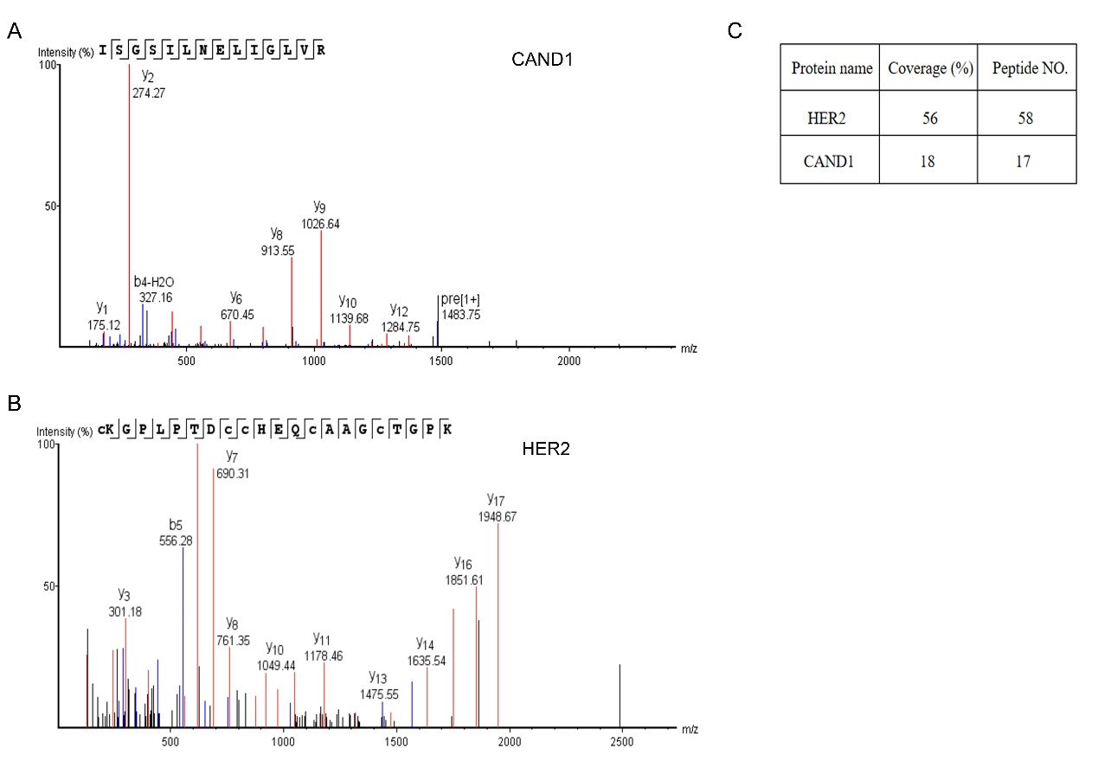
Fig. S1. CAND1 Interacts with HER2
(A, B) Ion peaks of CAND1 and HER2 were shown in polar and ambipolar modes. (C) The coverage and number of unique peptides for HER2 and CAND1 were analyzed.

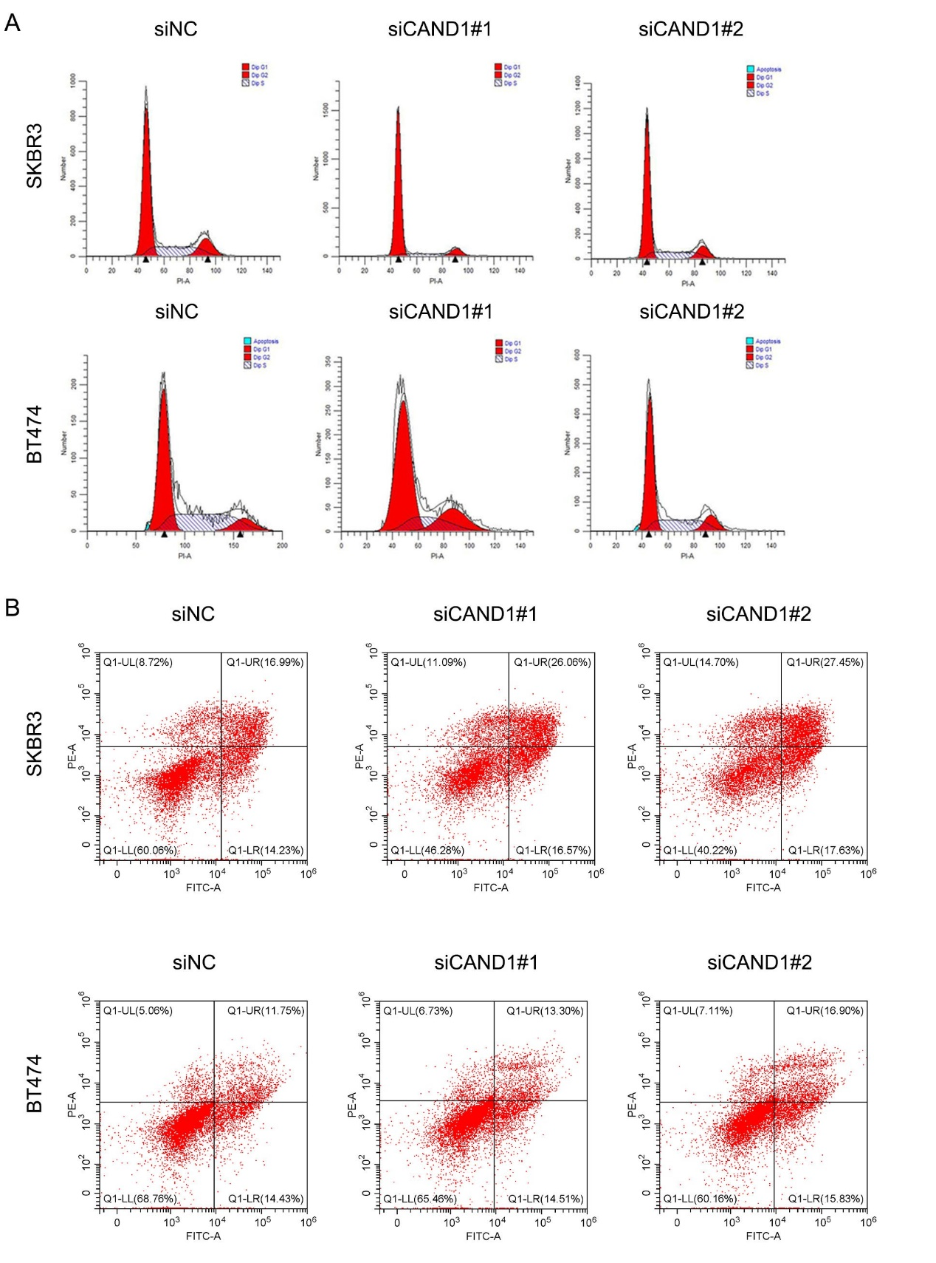
Fig. S2. CAND1 loss suppresses proliferation of HER2⁺ breast cancer cells
(A) Cell cycle analysis was performed using flow cytometry in cells treated with CAND1 siRNA for 72 hours. (B) Apoptosis was analyzed using flow cytometry in cells treated with CAND1 siRNA for 72 hours.

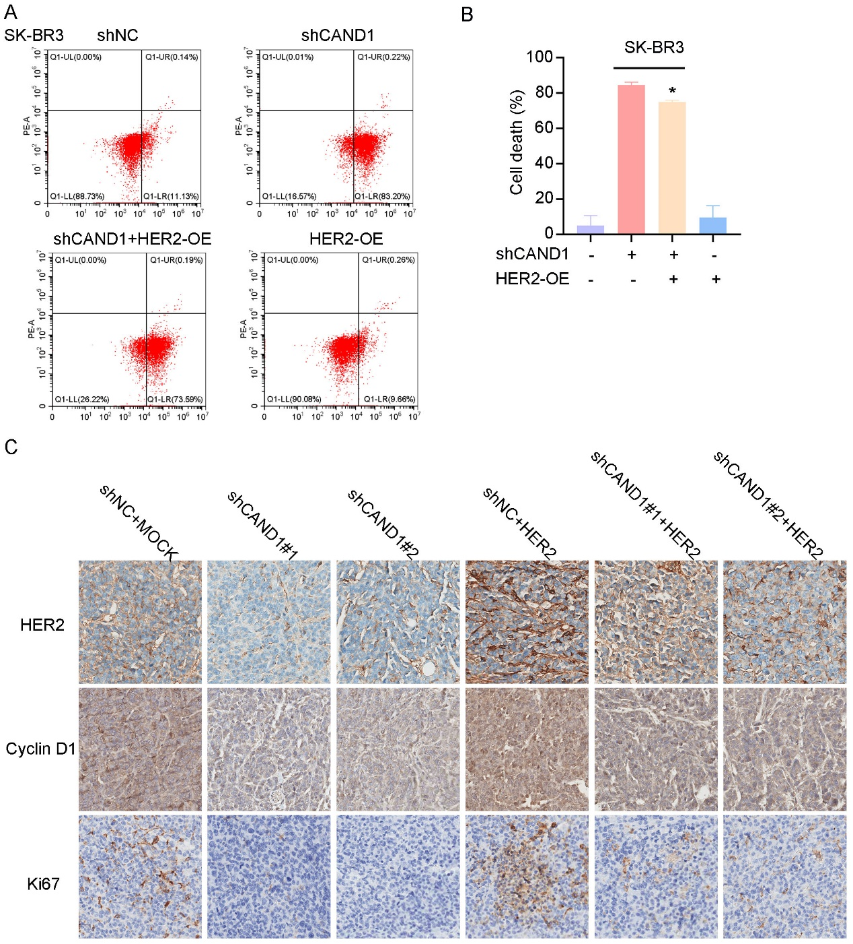
Fig. S3. CAND1 promotes cell proliferation by stabilizing HER2 protein expression
(A) Apoptosis was detected using flow cytometry in SK-BR3 cells stably expressing CAND1 shRNA with or without GFP-HER2 plasmids. (B) The number of apoptotic cells was quantified (*p<0.05). (C) Immunohistochemical staining of tumor tissues was performed using HER2, Cyclin D1, and Ki67 antibodies.

Table S1. Information of antibodies used in the study.
Antibodies | Manufacturer | Catalog number | Application | Dilution
anti-CAND1 | Cell Signaling Technology | #8759 | WB | 1:1000
anti-CAND1 | Cell Signaling Technology | #8759 | IP | 1:50
anti-HER2 | Cell Signaling Technology | #2165 | WB | 1:1000
anti-HER2 | Cell Signaling Technology | #2165 | IP | 1:50
anti-HER2 | Cell Signaling Technology | #2165 | IF | 1:200
anti-Bcl-2 | Cell Signaling Technology | #15071 | WB | 1:1000
anti-DYKDDDDK | Cell Signaling Technology | #14793 | WB | 1:1000
anti-DYKDDDDK | Cell Signaling Technology | #14793 | IP | 1:50
anti-His | Cell Signaling Technology | #12698 | WB | 1:1000
anti-His | Cell Signaling Technology | #12698 | IF | 1:200
anti-His | Cell Signaling Technology | #12698 | IP | 1:50
anti-HA | Cell Signaling Technology | #3724 | WB | 1:1000
anti-GAPDH | Cell Signaling Technology | #5174 | WB | 1:1000
anti-CUL4A | Cell Signaling Technology | #2699 | WB | 1:1000
anti-Myc | Cell Signaling Technology | #2276 | WB | 1:1000
anti-Myc | Cell Signaling Technology | #2276 | IF | 1:200
K48-linkage Specific Polyubiquitin | Cell Signaling Technology | #12805 | WB | 1:1000
anti-IgG | Cell Signaling Technology | #3900 | IP | 1:50
anti-PARP | Cell Signaling Technology | #9532 | WB | 1:1000
anti-P21 | Cell Signaling Technology | #2947 | WB | 1:1000
anti-CUL1 | Hua Bio | #ET1705-82 | WB | 1:1000
anti-CUL3 | Hua Bio | #HA721882 | WB | 1:1000
anti-CUL4B | Hua Bio | #ER2001-65 | WB | 1:1000
anti-CUL7 | Santa Cruze | #sc-53810 | WB | 1:1000
anti-CUL7 | Santa Cruze | #sc-53810 | IP | 1:50
anti-CUL5 | Bioworld Technology | #BS7559 | WB | 1:1000
anti-CUL2 | Proteintech | #67175-1-lg | WB | 1:1000
Anti-Ki67 | Abcam | #ab15580 | IHC | 1:200

Table S2. Information of chemicals used in the study.
Chemicals | Manufacturer | Catalog number
MG132 | Selleck | #S2619
Cycloheximide | Cell Signaling Technology | #2112

Table S3. Information of reagents used in the study.
Reagents | Manufacturer | Catalog number
Dynabeads™ Co-immunoprecipitation Kit | Invitrogen | #14311D
Primary Antibody Dilution | KeyGEN BioTECH | #KGP106
Annexin V-FITC/PI Double Staining Apoptosis Detection Kit | KeyGEN BioTECH | #KGA108
Cell cycle assay kit | KeyGEN BioTECH | # KGA9101-100

Table S4. The target sequences of primers used in study.
Primer | Target sequence
ERBB2- Forward primer: | 5'AACTGCACCCACTCCTGTGT3'
ERBB2- Reverse primer: | 5'TGATGAGGATCCCAAAGACC3'
CAND1- Forward primer: | 5'GCTGATATGTTGAGCAGGCAA3'
CAND1- Reverse primer: | 5'ACTGGGGAAGTAGACAGGTCA3'
GAPDH- Forward primer: | 5'TCCCATCACCATCTTCCA3'
GAPDH- Reverse primer: | 5'CATCACGCCACAGTTTCC3'

