Supplementary Materials: Tumor heterogeneity Index from DCE-MRI for AKT-inhibition Responder Identification and reveals hot immune microenvironment for patients with breast cancer: A multi-omics analysis of I-SPY2 Trial

Other studies with overlapping clinical data
Treatment outcome of all patients within the manuscript has been published. The outcome of MK2206 arm is published in https://pubmed.ncbi.nlm.nih.gov/32031889/. The outcome of other arms are separately published in following publications: https://ascopubs.org/doi/10.1200/PO.18.00024 , https://pubmed.ncbi.nlm.nih.gov/32031889/, https://www.nature.com/articles/s41523-021-00337-2, https://pubmed.ncbi.nlm.nih.gov/36456573/, https://pubmed.ncbi.nlm.nih.gov/32053137/, https://aacrjournals.org/cancerres/article/76/4_Supplement/P1-14-03/614639/Abstract-P1-14-03-The-evaluation-of-trebananib, https://pubmed.ncbi.nlm.nih.gov/34741023/, and https://pubmed.ncbi.nlm.nih.gov/28948212/.

Material – Flowchart of cohort formation
This is a secondary analysis of I-SPY2 cohort 1 [1], and the included patients were mainly based on the availability of the baseline DCE-MRI. The patient inclusion flowchart for tumor heterogeneity index (THI) development cohort (N=301), THI validation cohort (N=803) and radio-genomic cohort (N=979) were shown in Figure S1.
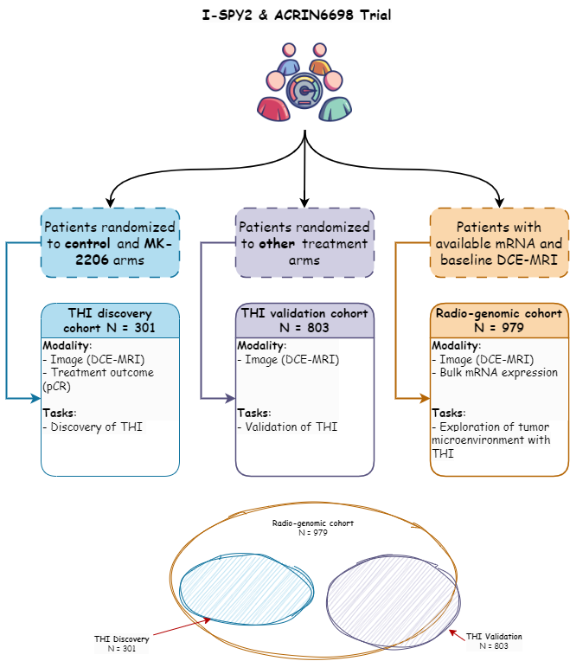
Figure S1. Flowchart of patient inclusion and exclusion for THI discovery cohort.

Material -- Treatments
All patients in the image discovery cohort would receive 12 weekly cycles of paclitaxel 80 mg/m² followed by 4 cycles of doxorubicin 60 ml/m² and cyclophosphamide 600 mg/m² intravenously every 2 or 3 weeks. Patients with HER2-positive tumors also received weekly trastuzumab (4 mg/kg loading dose then 2mg/kg during week 2 - 12) in combination with paclitaxel. Patients in MK2206 arm (N = 94) received oral MK2206 135 mg/week in combination with paclitaxel for 12 weeks.

Material -- DCE-MRI acquisition parameters
DCE-MRI were obtained using a 3D T1W gradient echo sequence in axial orientation. The imaging scope cover the bi-lateral whole breast. Pre-contrast enhanced T1-w images were obtained first. After the injection of gadolium-based contrast agent, multiple post-contrast T1-w images with an interval of 80s to 100s were obtained for at least 8 minutes. The parameters of the sequence are as listed: https://wiki.cancerimagingarchive.net/pages/viewpage.action?pageId=70230072 and https://wiki.cancerimagingarchive.net/pages/viewpage.action?pageId=50135447.
Table S1. The detailed imaging parameters of DCE-MRI acquisition.
Parameter | Value
Scanner Brand | GE, SIEMENS, Philips
Field Strength | 1.5T or 3.0T
Sequence type | 3D Gradient echo
Slice orientation | Axial
Laterality | Bi-lateral
Frequency direction and FOV | A/P, 100-440 mm
Phase direction and FOV | R/L, 100-440 mm
Matrix (frequency) | 128-448
In-plane resolution | 0.3-1.4 mm
Fat suppression | Required
TR | 3-10 ms
TE | 1-5 ms
Flip angle | 10-20 degrees
Slice thickness | 0.8-3.0 mm
Slice number | At least 50, adjusted to cover the whole breast
Spacing between slices | 0.8-2.6 mm
Number of excitations | 0.7-3
Scan time for each phase | 80-100 s
Total acquisition time | At least 8 minutes after contrast injection
Total phase | 4-11
Contrast agent | Gadolium-based

Method – Image feature extraction
The radiomic-based features were extracted from baseline DCE-MRI within the functional tumor volume (FTV). For each set of features, 14 shape features were extracted from FTV, and 18 first-order features and 70 texture features were extracted from DCE-MRI and three-dimensional Laplacian-of-Gaussian filtered DCE-MRI, respectively, resulting a 190 total radiomic-based image features for analysis.
Image preprocessing
MRI were preprocessed by an isotropic resampling (1x1x1 mm³) with BSpline interpolation and discretize into 32 fixed bin counts. The three-dimensional Laplacian-of-Gaussian filtered image was also generated for feature extraction.
Functional tumor volume calculation
The FTV were automatically defined with DCE-MRI by using the signal enhancement ratio method [2]. Early percentage enhancement and signal enhancement ratio maps were derived according to PE = (S1-S0)/S0 x 100% and SER = (S1-S0)/(S2-S0), where S0, S1, and S2 are signal intensities at pre-contrast, early-contrast (approximately 2.5 minutes), and late-contrast (approximately 7.5 minutes) phases, respectively. The FTV volume was defined by the voxels with PE > 70% and SER > 0.
Image feature extraction
The definitions of image features were compliant to image biomarker standardization initiative [3].

Method -- Repeatability and reproducibility assessment of Radiomic-based image feature
Repeatability assessment with perturbations
The repeatability of radiomic features against random error were assessed using perturbation method [4], and it defines the absolute agreement of radiomics feature values between perturbed images across subjects. The perturbed images were generated by translation and rotation for 30 times with the random choice of translation distance of 0, 0.4, or 0.8 pixel and rotation angle of -10, 0, or 10 degrees. The repeatability is evaluated with one-way random effects, absolute agreement, and single measurement intra-class coefficient of correlation.
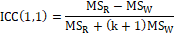
where MS_{R} is the mean square for patients, and MS_{W} is the averaged inter-perturbation variance, and k is number of perturbations.
Reproducibility assessment with inter-observer variability
The reproducibility of radiomic features against inter-observer variability was defined as the absolute agreement of image feature values between FTVs from different readers. We compared two readers in this case: (1) automatically generated FTV referring to functional tumor volume calculation and (2) semi-automatic generated FTV [2]. The reproducibility of radiomic features was evaluated with two-way mixed effects intra-class coefficient of correlation
$$ICC(2,1)=\frac{{MS}_{R}-{MS}_{E}}{{MS}_{R}+\left(k-1\right){MS}_{E}+\frac{k}{n}(MS_{C}-MS_{E})}$$
where MS_{R} is the mean square for patients, and MS_{E} is the means square of error, MS_{C} is the mean square of observers, k is the number of raters, and n is the number of subjects.
The reproducibility assessment with inter-phase variability
The reproducibility of radiomic features against inter-phase variability was defined as consistency of image values between FTVs from different contrast-enhanced phases. We took contrast-enhanced phases as raters, the value of image features as scores and the patients as subject. The reproducibility of radiomic features was evaluated with two-way random effects intra-class coefficient of correlation
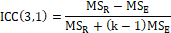
The MS_{R} is the mean square of patients, MS_{E} is the mean square of error, and k is the number of raters.

Method – THI development
The image features were firstly selected by robustness to ensure their generalizability [5]. The high robust image features were defined as the excellent repeatable against random error (ICC(1,1) > 0.9), good reproducible against inter-observer variability (ICC(2,1) > 0.75) and good reproducibility against contrast-enhanced phases (ICC(3,1) > 0.75). They were then analyzed for their specific and independent associations with pCR with a three-step quantifying biomarker evaluation methodology, 1) significant univariable pCR association in the MK2206 arm, 2) insignificant univariable pCR association in control arm, and 3) significant treatment interactions associations with adjusting existing clinical biomarkers [6]. The treatment interaction is defined as (Image feature x treatment) and evaluated by multivariable logistic regression: pCR ~ HER2 + HR + Image feature + HER2 x treatment + HR x treatment + Image feature x treatment + treatment. Furthermore, adjust P-value is calculated with multiple test correction by Benjamini-Hochberg method. The image feature satisfied with all criteria is considered to be a robust THI that selectively and independently predict the efficacy of MK-2206.

The final selected image features were normalized along patient by z-score to ensure the consistent mean and standard deviation before clustering and THI development:
$$Z=\frac{X-μ}{σ}$$
where $Z$ is the feature value after normalization, $X$ is the feature value before normalization, $μ$ is the mean value across patients, and $σ$ is the standard deviation across patients. Consensus clustering of patients was performed using the selected image features where patients were randomly downsampled by 0.8 and repeatedly clustered by agglomerative clustering by 1000 times, each performed with a different number of clusters. A consensus matrix was constructed by recording the frequency of sample pair (i, j) that was clustered together during the repeated agglomerative clustering. The optimum number of clusters was determined when the proportion of ambiguous clustering (PAC) score reaches minimum [7]. PAC measures the stability of clustering and is calculated as the proportion of consensus matrix with value between 0.1 and 0.9. A lower PAC indicates a sharper change of consensus across sample pairs, suggesting more stable clustering results.

The continuous THI score was developed by logistic regression on the consensus clustering label that has the highest pCR rate in the MK2206 arm. Specifically, the patient cluster with the highest treatment pCR rate was assigned the label 1 and the rest of the patients were assigned to the label 0. A logistic regression model was built using the selected image features on the labels, and the decision function was directly used as the THI score. The dichotomized THI was determined by using the threshold of 0, which is also the default threshold for the classification in a logistic regression model.

Method -- Clinical utility evaluation of THI
The THI are comprehensively evaluated under HR/HER2 and MP1/2 signatures for its 1) specific response prediction in MK-2206 arm than in control arm and 2) independent prediction value in MK-2206 arm. The explicit HR/HER2 and MP pre-defined signatures were overall patients, HR-, HR+, HER2-, HER2+, HR-HER2- (TN), HR-HER2+, HR+HER2-, HR+HER2+, MP1 and MP2.
For specific response prediction in MK-2206 arm, the overall strategy is to compare the association of THI and pCR in MK-2206 arm to control arm. We compared univariable association between THI and pCR in experiment arm and control arm under pre-defined signatures, and compared multi-variable logistic regression adjusted with HER2, HR and MP fitting to pCR between experiment arm and control arm respectively. The posterior probability distribution of estimated pCR yielded from bayesian logistic regression was compared between MK-2206 arm and control arm respectively under new signatures defined by THI, HER2/HR and MP.
For independent prediction value in MK-2206 arm, the overall strategy is to compare the association of signatures in presence and in absence of image signature. The multivariable logistic regressions in presence of THI and absence of THI fitting to predict pCR in MK-2206 arms were compared. The posterior probability distribution of estimated pCR from newly defined signatures with THI and HER2/HR and MP defined signatures were compared. The pre-defined signatures that demonstrated significant specific treatment response to MK-2206 + T → AC and additional response prediction value to MK2206 + T → AC were reported as THI sensitive-signatures. The tumor microenvironment (TME) was explored in dichotomous THI groups within THI-sensitive-signatures.

Methods – Exploration on the association between image-related TME and MK2206 response
To explain the relationship between THI and the response to MK2206, the associations between pCR and TME characterizations, including DEGs, single-sample abundance of immune-related cells, and single-sample pathway enrichment scores in the MK2206 arm were also evaluated using multivariate logistic regression with the presence of HR and HER2.

Methods – Reproducibility analysis
The reproducibility of radiomic features can be influenced by several factors. First, image acquisition parameters have been recognized to potentially affect the reproducibility of radiomic features. To evaluate potential bias, different parameter values were compared for their effect on the image biomarker. Second, the method of segmentation is known to influence the value of image features. The absolute agreement between two segmentation methods—semi-automatic and automatic—was quantified using the concordance correlation coefficient (CCC). Third, the phase of contrast enhancement is another factor that could influence the value of radiomic features. Therefore, the absolute agreement of image feature values across different contrast enhancement phases were evaluated.

Results – THI development
Two clusters were generated by consensus clustering using the seven identified features, shown in Figure 2(c). The THI model achieved an accuracy of 1 when fitting the cluster label in the discovery cohort. It was validated in the remaining ISPY2 patients after a separate consensus clustering and achieved an AUC of 0.99 on the cluster label. The definitions of the selected image features and THI calculation formula can be found in the Supplementary Material.
The THI model was constructed using 7 features with formula: THI = 2.03*Entropy-2.63*Uniformity-0.28*GLCM_JE+4.34*GLCM_SE+3.37*GLCM_SS-2.79*GLRLM_GLNUN-2.48*GLSZM_GLNUN-0.18. The image filter, feature class, and feature name of the abbreviated feature names can be found in Table S2.

Table S2. The image filter, feature class, and feature name of the selected radiomics features for THI development.
Abbreviation | Filter | Feature class | Feature name
Entropy | Laplacian-of-Gaussian (3D, 3mm) | First-order | Entropy
Uniformity | Laplacian-of-Gaussian (3D, 3mm) | First-order | Uniformity
GLCM_JE | Laplacian-of-Gaussian (3D, 3mm) | Gray-level cooccurrence matrix | Joint entropy
GLCM_SE | Laplacian-of-Gaussian (3D, 3mm) | Gray-level cooccurrence matrix | Sum entropy
GLCM_SS | Laplacian-of-Gaussian (3D, 3mm) | Gray-level cooccurrence matrix | Sum squares
GLRLM_GLNUN | Laplacian-of-Gaussian (3D, 3mm) | Gray-level run length matrix | Gray level nonuniformity normalized
GLSZM_GLNUN | Laplacian-of-Gaussian (3D, 3mm) | Gray-level size zone matrix | Gray level nonuniformity normalized

Results -- Associations between THI-related TME characteristics and MK2206 treatment response
Six DEGs, including GZMK, BANK1, CD27, CD19, TCL1A, and M28170, were significantly associated with the response to MK2206 in the imaging biomarker discovery cohort (Table 2). Notably, GZMK, CD27, and CD19 were highlighted as hub genes, emphasizing their potential pivotal role in the mechanism of response prediction. The association analysis also revealed similar trends in the differential expression of cells and pathway abundance, as summarized in Table 2. The presence of differentially expressed immune cells, specifically activated B cells and activated CD8+ T cells, showed significant correlations with the therapeutic response to MK2206. Additionally, certain metabolic and hypoxic pathways, including "central carbon metabolism in cancer," "HALLMARK_GLYCOLYSIS," and "HALLMARK_HYPOXIA," were significantly enriched and associated with the MK2206 response. These associations were also pronounced in specific tumor subtypes, namely TN and HR-HER2+ tumors.
Table S3. The results of association between THI-related TME and response of MK2206.
Category | Subtype | Features | OR/SD | LR p
DEGs | All | GZMK | 1.74 | 0.0128
DEGs | All | BANK1 | 1.57 | 0.0354
DEGs | All | CD27 | 1.68 | 0.0352
DEGs | All | CD19 | 1.77 | 0.0149
DEGs | All | TCL1A | 1.66 | 0.0228
DEGs | All | M28170 | 1.76 | 0.0164
DEGs | TN | SUSD3 | 4.71 | 0.0390
DEGs | HR-HER2+ | FBP1 | 5.19 | 0.0416
DEGs | HR+HER2- | GZMK | 2.37 | 0.0492
DEGs | HR+HER2- | CCL19 | 3.92 | 0.0178
DEGs | HR+HER2- | LTB | 2.68 | 0.0465
DEGs | HR+HER2- | CCR7 | 2.87 | 0.0345
DEGs |  | BANK1 | 5.05 | 0.0183
DEGs | HR+HER2+ | CD19 | 3.85 | 0.0478
DEGs |  | M28170 | 4.12 | 0.0402
Immune cells | All | Activated B cell | 1.73 | 0.0173
Immune cells | All | Activated CD8 T cell | 1.69 | 0.0331
Immune cells | HR+HER2- | Effector memory CD4 T cell | 3.18 | 0.0416
Pathways | All | Central carbon metabolism in cancer | 0.53 | 0.004
Pathways | All | CURSONS_NATURAL_KILLER_CELLS | 1.6 | 0.0423
Pathways | All | HALLMARK_GLYCOLYSIS | 0.56 | 0.0081
Pathways | All | HALLMARK_HYPOXIA | 0.57 | 0.0166
Pathways | TN | Central carbon metabolism in cancer | 0.42 | 0.0188
Pathways | HR-HER2+ | Central carbon metabolism in cancer | 0.02 | 0.0007
Pathways | HR-HER2+ | HALLMARK_GLYCOLYSIS | 0.17 | 0.0078
Pathways | HR-HER2+ | HALLMARK_HYPOXIA | 0.03 | 0.0037
Pathways | HR+HER2+ | Fatty acid degradation | 5.72 | 0.0477
Pathways | HR+HER2+ | KEGG_FATTY_ACID_METABOLISM | 6.9 | 0.0411

Results -- THI evaluation
Table S4. The Area under Receiver Operating curve for THI for control and MK-2206 arm within HR/HER2 and MP defined subtypes.
 | Model Type | AUC | 95% CI lower | 95% CI upper | p-value | Patient number | DeLong P
All control | univariable | 0.46 | 0.35 | 0.56 | 0.425 | 209 | ref
All MK-2206 | univariable | 0.73 | 0.63 | 0.83 | 0.000 | 92 | 0.005
All control | multivariable | 0.64 | 0.54 | 0.74 |  | 209 | ref
All MK-2206 | multivariable | 0.80 | 0.71 | 0.89 |  | 92 | 0.009
All MK-2206 w/o THI | multivariable | 0.69 | 0.58 | 0.80 |  | 92 | ref
All MK-2206 w/ THI | multivariable | 0.80 | 0.71 | 0.89 |  | 92 | 0.009
HER2+ control | univariable | 0.45 | 0.20 | 0.70 | 0.685 | 31 | ref
HER2+ MK-2206 | univariable | 0.75 | 0.58 | 0.92 | 0.014 | 33 | 0.101
HER2- control | univariable | 0.45 | 0.33 | 0.57 | 0.419 | 178 | ref
HER2- MK-2206 | univariable | 0.73 | 0.60 | 0.85 | 0.006 | 59 | 0.022
HR+ control | univariable | 0.50 | 0.33 | 0.85 | 0.959 | 114 | ref
HR+ MK-2206 | univariable | 0.68 | 0.52 | 0.84 | 0.090 | 43 | 0.069
HR- control | univariable | 0.45 | 0.30 | 0.60 | 0.497 | 95 | ref
HR- MK-2206 | univariable | 0.85 | 0.73 | 0.96 | 0.000 | 49 | 0.000
HER2+HR+ control | univariable | 0.35 | -0.17 | 0.88 | 0.434 | 19 | ref
HER2+HR+ MK-2206 | univariable | 0.72 | 0.45 | 0.99 | 0.178 | 15 | 0.403
HER2+HR- control | univariable | 0.66 | 0.32 | 1.00 | 0.372 | 12 | ref
HER2+HR- MK-2206 | univariable | 0.79 | 0.55 | 1.00 | 0.049 | 18 | 0.268
HER2-HR+ control | univariable | 0.51 | 0.34 | 0.69 | 0.875 | 95 | ref
HER2-HR+ MK-2206 | univariable | 0.70 | 0.47 | 0.92 | 0.177 | 28 | 0.078
HER2-HR- control | univariable | 0.41 | 0.24 | 0.59 | 0.269 | 83 | ref
HER2-HR- MK-2206 | univariable | 0.87 | 0.73 | 1.00 | 0.001 | 31 | 0.008
MP1 control | univariable | 0.47 | 0.30 | 0.65 | 0.733 | 117 | ref
MP1 MK-2206 | univariable | 0.64 | 0.46 | 0.81 | 0.134 | 44 | 0.185
MP2 control | univariable | 0.47 | 0.32 | 0.61 | 0.617 | 92 | ref
MP2 MK-2206 | univariable | 0.83 | 0.71 | 0.96 | 0.000 | 48 | 0.000

Table S5. The odds ratio (OR) of pCR achieved in MK-2206 arm than in control arm under HR/HER2 and MP2 defined subtype and HR/HER2/MP and THI defined subtypes.
 | OR | 95%CI lower | 95%CI higher | P-value | Patient number
All_THI+ | 6.69 | 3.07 | 14.58 | 0.000 | 151
All_THI- | 0.92 | 0.39 | 2.21 | 1.000 | 150
All | 2.68 | 1.55 | 4.62 | 0.000 | 301
HER2+_THI+ | 6.60 | 1.40 | 31.05 | 0.032 | 32
HER2+_THI- | 1.36 | 0.29 | 6.42 | 1.000 | 32
HER2+ | 3.05 | 1.06 | 8.77 | 0.043 | 64
HER2-_THI+ | 5.50 | 2.16 | 14.00 | 0.001 | 119
HER2-_THI- | 0.61 | 0.19 | 1.98 | 0.586 | 118
HER2- | 2.08 | 1.06 | 4.09 | 0.041 | 237
HR+_THI+ | 4.34 | 1.36 | 13.89 | 0.020 | 87
HR+_THI- | 0.44 | 0.09 | 2.24 | 0.487 | 70
HR+ | 1.73 | 0.72 | 4.15 | 0.240 | 157
HR-_THI+ | 12.68 | 3.51 | 45.76 | 0.000 | 64
HR-_THI- | 1.34 | 0.45 | 3.96 | 0.586 | 80
HR- | 3.46 | 1.66 | 7.21 | 0.001 | 144
HER2+HR+_THI+ | 12.00 | 0.94 | 153.89 | 0.101 | 17
HER2+HR+_THI- | 0.50 | 0.04 | 6.86 | 1.000 | 17
HER2+HR+ | 2.67 | 0.52 | 13.68 | 0.417 | 34
HER2+HR-_THI+ | 2.67 | 0.25 | 28.44 | 0.560 | 15
HER2+HR-_THI- | 2.50 | 0.29 | 21.40 | 0.608 | 15
HER2+HR- | 2.80 | 0.62 | 12.66 | 0.264 | 30
HER2-HR+_THI+ | 2.67 | 0.65 | 10.97 | 0.221 | 70
HER2-HR+_THI- | 0.38 | 0.04 | 3.34 | 0.665 | 53
HER2-HR+ | 1.26 | 0.41 | 3.86 | 0.767 | 123
HER2-HR-_THI+ | 18.13 | 3.28 | 100.02 | 0.000 | 49
HER2-HR-_THI- | 0.77 | 0.18 | 3.23 | 1.000 | 65
HER2-HR- | 2.80 | 1.15 | 6.83 | 0.031 | 114
MP-_THI+ | 7.07 | 2.23 | 22.45 | 0.001 | 85
MP-_THI- | 1.25 | 0.34 | 4.59 | 0.740 | 76
MP- | 3.27 | 1.44 | 7.39 | 0.006 | 161
MP+_THI+ | 8.50 | 2.54 | 28.43 | 0.000 | 66
MP+_THI- | 0.69 | 0.21 | 2.25 | 0.772 | 74
MP+ | 2.14 | 1.02 | 4.50 | 0.054 | 140

Table S6. The estimated pCR rate for control and MK-2206 arm evaluated under various subgroups defined by HR/HER2/MP and THI.
 | Control mean | Control lower PI | Control higher PI | Treatment mean | Treatment lower PI | Treatment higher PI | Higher pCR probability | Trial success rate
All | 18.7% | 13.5% | 24.4% | 38.1% | 28.2% | 48.3% | 100.0% | 89.4%
THI+ | 17.8% | 11.4% | 25.3% | 56.1% | 42.6% | 69.4% | 100.0% | 99.9%
THI- | 19.7% | 12.8% | 27.8% | 20.6% | 10.8% | 32.6% | 54.7% | 15.0%
HR+ | 13.8% | 8.4% | 20.5% | 26.3% | 15.1% | 39.8% | 97.1% | 66.1%
HR- | 24.5% | 16.6% | 33.2% | 48.4% | 34.9% | 62.0% | 99.9% | 91.4%
HR+THI+ | 41.1% | 24.5% | 58.7% | 13.3% | 7.3% | 21.1% | 99.9% | 96.1%
HR-THI+ | 71.2% | 54.5% | 85.1% | 24.6% | 14.7% | 36.2% | 100.0% | 99.9%
HR+THI- | 13.8% | 7.4% | 22.3% | 10.5% | 3.8% | 21.0% | 26.3% | 5.8%
HR-THI- | 25.3% | 15.8% | 36.3% | 28.9% | 15.5% | 44.7% | 67.4% | 27.3%
HER2+ | 24.6% | 12.1% | 39.9% | 52.4% | 36.6% | 68.4% | 99.7% | 93.2%
HER2- | 17.7% | 12.3% | 23.4% | 29.8% | 19.1% | 41.9% | 98.2% | 62.3%
HER2+THI+ | 23.6% | 11.1% | 40.6% | 71.0% | 52.7% | 85.3% | 100.0% | 99.8%
HER2-THI+ | 16.7% | 10.2% | 24.4% | 46.7% | 30.8% | 62.6% | 100.0% | 97.9%
HER2+THI- | 25.8% | 12.3% | 42.8% | 32.7% | 16.9% | 51.4% | 74.1% | 41.0%
HER2-THI- | 18.5% | 11.6% | 26.4% | 14.6% | 6.6% | 25.5% | 26.7% | 5.7%
MP+ | 23.9% | 15.9% | 33.3% | 43.8% | 30.7% | 57.0% | 99.6% | 83.8%
MP- | 14.6% | 9.0% | 21.1% | 31.5% | 19.7% | 45.1% | 99.4% | 82.8%
MP+THI+ | 23.1% | 13.6% | 34.0% | 67.2% | 50.1% | 81.8% | 100.0% | 99.8%
MP-THI+ | 13.8% | 7.4% | 22.5% | 46.7% | 29.6% | 63.5% | 100.0% | 99.0%
MP+THI- | 25.1% | 15.4% | 36.8% | 26.3% | 13.6% | 41.7% | 54.1% | 18.5%
MP-THI- | 15.1% | 8.5% | 24.1% | 13.4% | 5.2% | 25.4% | 37.6% | 9.7%
HR+HER2- | 12.7% | 7.4% | 19.3% | 19.1% | 9.0% | 32.2% | 85.2% | 38.8%
HR-HER2+ | 32.7% | 16.3% | 52.4% | 63.7% | 45.2% | 80.5% | 99.3% | 93.0%
HR-HER2- | 23.4% | 15.8% | 32.4% | 39.4% | 24.5% | 55.5% | 97.0% | 71.4%
HR+HER2+ | 19.0% | 8.3% | 33.7% | 39.1% | 21.3% | 58.3% | 97.4% | 80.9%
HR+HER2-THI+ | 12.4% | 6.3% | 20.2% | 32.4% | 16.8% | 50.6% | 99.1% | 85.8%
HR-HER2+THI+ | 33.3% | 15.1% | 54.3% | 83.1% | 66.3% | 93.9% | 100.0% | 99.8%
HR-HER2-THI+ | 23.4% | 13.8% | 35.1% | 63.1% | 43.0% | 80.3% | 100.0% | 99.2%
HR+HER2+THI+ | 19.0% | 7.7% | 35.0% | 58.2% | 34.8% | 78.5% | 99.7% | 97.7%
HR+HER2-THI- | 12.6% | 6.4% | 21.3% | 7.0% | 2.3% | 15.3% | 12.3% | 1.9%
HR-HER2+THI- | 33.5% | 15.8% | 54.7% | 44.0% | 22.7% | 66.4% | 79.4% | 51.2%
HR-HER2-THI- | 23.5% | 14.3% | 34.5% | 21.2% | 9.5% | 37.5% | 37.9% | 10.9%
HR+HER2+THI- | 19.2% | 7.8% | 36.1% | 18.4% | 6.3% | 37.3% | 46.9% | 19.2%

Reproducibility evaluation

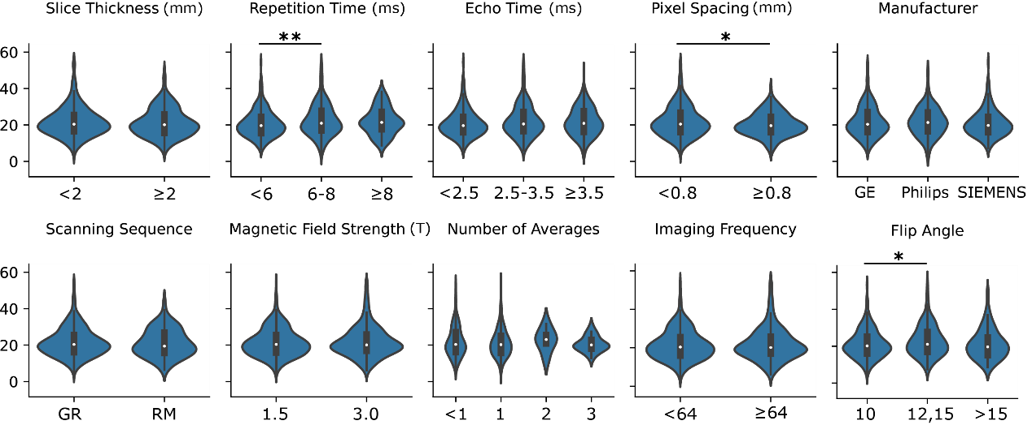
Figure S2. Violin plots of THI values under different scanning parameter values. The Mann-Whitney U test was performed between each two categories for statistical comparison (*: p-value < 0.05, **: p-value < 0.01). Some continuous and categorical parameters were re-categorized to increase and balance the number of cases in each category for more reliable statistical comparisons. THI only demonstrated significant differences on repetition time (<6 vs. 6-8 ms), pixel spacing (<0.8 vs. 0.8 mm), and flip angle (10 vs. 12,15).

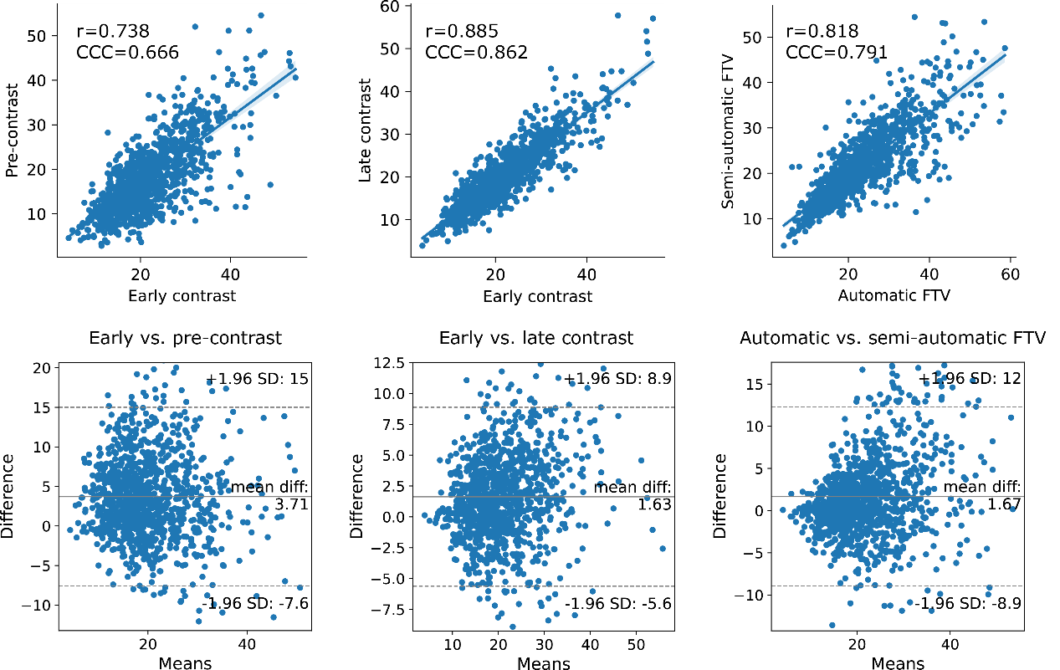
Figure S3. Comparisons of THI between early and pre-contrast phase(left), early and late contrast phase (middle), and automatic and semi-automatic FTV segmentation (right). We calculated the Pearson correlation coefficient r and Concordance Correlation Coefficient (CCC) to evaluate the correlations (upper plots) and drew the Bland-Altman plots (lower plots) to visualize the differences. THI from the early contrast phase had a stronger correlation with and lower differences to the late contrast phase than the pre-contrast phase. A strong correlation and minimum differences between the two FTV segmentation methods were also observed.

Methods -- Reproducibility of THI
Varying degrees of bias of the THI measurements were observed due to variations in scanning parameters, contrast phases, and FTV segmentation methods. Different repetition times (<6 vs. 6-8 ms), pixel spacings (<0.8 vs. 0.8 mm), and flip angles (10 vs. 12,15) resulted in statistically significant different THI values, but with minimum mean difference, as shown in Figure S3. The remaining parameters, including slice thickness, echo time, scanner manufacturer, scanning sequence, field strength, number of averages, and imaging frequency, demonstrated insignificant differences. Further analysis of the effect of contrast phases on the THI values (Figure S4, left and middle) revealed a higher Pearson r of 0.885 (p-value < 0.001) and CCC of 0.862 between the early and late contrast phases than the 0.738 (p-value < 0.001) and 0.666 between the early and pre-contrast phase. A smaller range of absolute THI differences was also observed for the late contrast phase (SD=7.27) than the pre-contrast phase (SD=11.29). The Pearson r between the THI values obtained by the two segmentation methods was 0.818 (p-value < 0.001), and the CCC was 0.791, indicating a high degree of agreement (Figure S4, right).
Additionally, THI maintained similar predictive values when measured from other contrast phases and the semi-automatic FTV segmentation. THI achieved an AUC of 0.69 (p-value < 0.001) within the MK2206 arm in the late contrast phase (acquired approximately 450s after contrast agent administration), which was similar to the 0.74 in the early contrast phase. In addition, the predictive value of MK2206 response was consistent across segmentation methods, with THI calculated from the semi-automatic FTV segmentation showing an AUC = 0.72 (p-value < 0.001). Detailed results are presented in Supplementary Material Table S5

Results Validation of Association between GLCM_SS and MK2206 response under influence of FTV definition and contrast enhanced phases
Table S7. The prediction performance of ROC-AUC of association between THI and pCR in MK2206 cohort.
 | Model type | early-DCE phase |  |  | pre-DCE phase |  |  | late-DCE phase |  |  | early-DCE phase |  |  | Number of patients
 | Model type | FTV (automatic) |  |  | FTV (automatic) |  |  | FTV (automatic) |  |  | FTV (semi-automatic) |  |  | Number of patients
 | Model type | AUC | p-value | DeLong P | AUC | p-value | DeLong P | AUC | p-value | DeLong P | AUC | p-value | DeLong P | Number of patients
All control | univariable | 0.46 | 0.454 | ref | 0.53 | 0.551 | ref | 0.45 | 0.346 | ref | 0.48 | 0.636 | ref | 209
All MK-2206 | univariable | 0.74 | 0.000 | 0.000 | 0.73 | 0.000 | 0.004 | 0.69 | 0.003 | 0.035 | 0.72 | 0.000 | 0.004 | 92
All control | multivariable | 0.64 |  | ref | 0.63 |  | ref | 0.64 |  | ref | 0.64 |  | ref | 209
All MK-2206 | multivariable | 0.83 |  | 0.002 | 0.81 |  | 0.002 | 0.79 |  | 0.014 | 0.80 |  | 0.008 | 92
All MK-2206 w/o GLCM_SS | multivariable | 0.69 |  | ref | 0.69 |  | ref | 0.69 |  | ref | 0.69 |  | ref | 92
All MK-2206 w/ GLCM_SS | multivariable | 0.83 |  | 0.003 | 0.81 |  | 0.007 | 0.79 |  | 0.018 | 0.80 |  | 0.011 | 92
HER2+ control | univariable | 0.35 | 0.206 | ref | 0.50 | 1.000 | ref | 0.34 | 0.190 | ref | 0.47 | 0.821 | ref | 31
HER2+ MK-2206 | univariable | 0.71 | 0.044 | 0.354 | 0.77 | 0.009 | 0.028 | 0.67 | 0.090 | 0.459 | 0.72 | 0.031 | 0.111 | 33
HER2- control | univariable | 0.49 | 0.828 | ref | 0.54 | 0.521 | ref | 0.48 | 0.666 | ref | 0.47 | 0.647 | ref | 178
HER2- MK-2206 | univariable | 0.76 | 0.001 | 0.001 | 0.71 | 0.010 | 0.037 | 0.70 | 0.014 | 0.026 | 0.72 | 0.007 | 0.015 | 59
HR+ control | univariable | 0.48 | 0.802 | ref | 0.60 | 0.196 | ref | 0.47 | 0.723 | ref | 0.50 | 0.959 | ref | 114
HR+ MK-2206 | univariable | 0.66 | 0.135 | 0.142 | 0.74 | 0.021 | 0.079 | 0.64 | 0.196 | 0.181 | 0.66 | 0.128 | 0.095 | 43
HR- control | univariable | 0.47 | 0.666 | ref | 0.49 | 0.839 | ref | 0.44 | 0.422 | ref | 0.46 | 0.578 | ref | 95
HR- MK-2206 | univariable | 0.88 | 0.000 | 0.000 | 0.80 | 0.000 | 0.002 | 0.81 | 0.000 | 0.005 | 0.84 | 0.000 | 0.000 | 49
HER2+HR+ control | univariable | 0.29 | 0.264 | ref | 0.54 | 0.823 | ref | 0.35 | 0.434 | ref | 0.35 | 0.434 | ref | 19
HER2+HR+ MK-2206 | univariable | 0.62 | 0.462 | 0.629 | 0.82 | 0.050 | 0.064 | 0.58 | 0.624 | 0.816 | 0.72 | 0.178 | 0.396 | 15
HER2+HR- control | univariable | 0.46 | 0.808 | ref | 0.51 | 0.935 | ref | 0.37 | 0.465 | ref | 0.63 | 0.465 | ref | 12
HER2+HR- MK-2206 | univariable | 0.81 | 0.039 | 0.060 | 0.76 | 0.075 | 0.112 | 0.82 | 0.031 | 0.186 | 0.74 | 0.111 | 0.322 | 18
HER2-HR+ control | univariable | 0.51 | 0.900 | ref | 0.62 | 0.159 | ref | 0.49 | 0.908 | ref | 0.51 | 0.867 | ref | 95
HER2-HR+ MK-2206 | univariable | 0.70 | 0.159 | 0.100 | 0.68 | 0.219 | 0.336 | 0.65 | 0.294 | 0.186 | 0.66 | 0.267 | 0.131 | 28
HER2-HR- control | univariable | 0.48 | 0.830 | ref | 0.47 | 0.685 | ref | 0.47 | 0.676 | ref | 0.43 | 0.361 | ref | 83
HER2-HR- MK-2206 | univariable | 0.90 | 0.000 | 0.000 | 0.80 | 0.004 | 0.019 | 0.82 | 0.003 | 0.009 | 0.88 | 0.000 | 0.004 | 31
MP- control | univariable | 0.48 | 0.787 | ref | 0.52 | 0.769 | ref | 0.49 | 0.880 | ref | 0.48 | 0.806 | ref | 117
MP- MK-2206 | univariable | 0.66 | 0.085 | 0.137 | 0.69 | 0.036 | 0.064 | 0.61 | 0.220 | 0.149 | 0.63 | 0.162 | 0.190 | 44
MP+ control | univariable | 0.47 | 0.642 | ref | 0.54 | 0.549 | ref | 0.44 | 0.384 | ref | 0.48 | 0.783 | ref | 92
MP+ MK-2206 | univariable | 0.85 | 0.000 | 0.001 | 0.78 | 0.001 | 0.014 | 0.78 | 0.001 | 0.015 | 0.83 | 0.000 | 0.000 | 48
control: The evaluation took in control arm; MK-2206: the evaluation took in MK-2206 arm; p-value: compare the AUC with AUC of 0.5; DeLong P: comparison between AUC in MK-2206 arm and control arm; univariable: pCR ~ GLCM_SS, multivariable: pCR ~ GLCM_SS + HER2 + HR; pre-DCE phase: the phase of DCE-MRI acquired prior contrast agent administration; early-DCE phase: the phase of DCE-MRI acquired approximately 150s after contrast agent administration; late-DCE phase: the phase of DCE-MRI acquired approximately 450s after contrast agent administration

Results DEG
All the DEGs and common DEGs were tabulated in a separate excel file due to its large size.
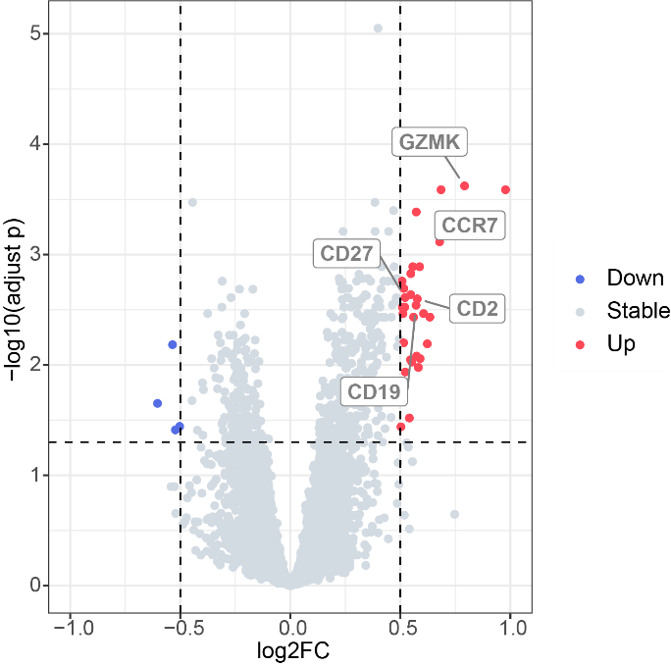
Figure S4. Volcano plot for DEGs and annotated hub genes.

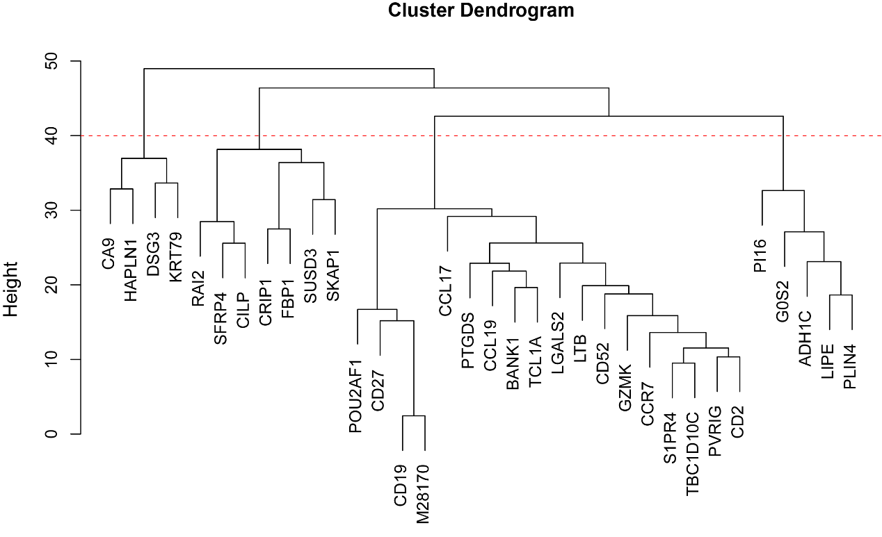
Figure S5. Four gene clusters identified with hierarchical clustering.

Results of Differentially Expressed Protein
The DEP results were for preliminary exploration.
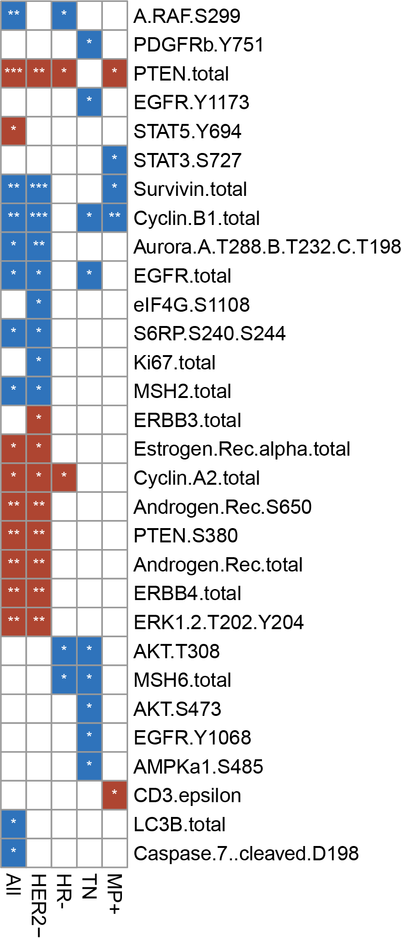
Figure S6. Differentially expressed RPPA. P-value <0.05.

Method -- GSEA and ssGSEA for TME exploration in THI subtypes
To explore the biologic mechanisms of THI+ tumors, the GSEA were conducted to explore the enrichment of biological pathways using ranking genes by annotated gene sets from KEGG (Kyoto Encyclopedia of Genes and Genomes) and the H and C2 collection of the MsigDB. To explore the tumor immune microenvironment, firstly, ssGSEA (”GSVA” package, R) were conducted with panels of adaptive immune cells [8], innate immune cells [8], endothelial cells [9] and fibroblasts [9,10]. Consistent with a previous publication [11,12], activated B cell, activated CD4+ T cell, activated CD8+ T cell, central memory CD4+ T cell, central memory CD8+ T cell, effector memory CD4+ T cell, effector memory CD8+ T cell, type 1 T helper cell, type 17 T helper cell, activated dendritic cell, CD56bright natural killer cell, natural killer cell, and natural killer T cell were defined as “antitumor immunity”. Regulatory T cell, type 2 T helper cell, CD56dim natural killer cell, immature dendritic cell, macrophage, MDSC, neutrophil, and plasmacytoid dendritic cell were considered as "protumor suppression”. Secondly, we explored the heterogeneity of the immune escape mechanism between THI subtypes, and the immune escape mechanism include extrinsic and intrinsic immune escape mechanism. Extrinsic immune escape mechanism refers to microenvironment components (other than tumor cells) contributing to the immune escape of tumor cells, and the extrinsic immune escape mechanism consists of four major aspects: 1) lack of immune cells, 2) presence of immunoinhibitory cells, 3) high concentrations of immunoinhibitory cytokines, and fibrosis. So based on these factors, apart from to comparing the differences in immune cell infiltration including the infiltration of cells with protumor and immune suppressive functions, we also explore compared 122 cytokines (including 46 chemokines and receptors, 42 interleukins and receptors, 7 interferons and receptor and 27 other important cytokines). The intrinsic escape mechanisms indicates that tumor cells directly mediate their own immune escape and there are at least two aspects of intrinsic immune escape: 1) tumor immunogenicity and 2) immune checkpoint molecules expression. So we also compared 36 immune checkpoints (including 22 costimulators and 14 coinhibitors), and 20 human immune antigens (MHC, including 6 MHC-Is, 10 MHC-II and 4 other MHCs) between THI subtypes [9].

Results – Patient characteristics
The comparison of patient characteristics of THI discovery cohort and radio-genomic cohort was shown in Table S6.
Table S8. Clinical characteristics and treatment response within THI discovery cohort and radio-genomic cohort.
Characteristics |  | THI discovery cohort (N=301) | Radio-genomic cohort (N=979) | p-value
Age | Mean (range) | 48.59 (24-77) | 48.76 (23-77) | 0.8155
HR | HR- | 144 (47.84%) | 446 (45.56%) | 0.5088
HR | HR+ | 157 (52.16%) | 533 (54.44%)
HER2 | HER2- | 237 (78.74%) | 737 (75.28%) | 0.2464
HER2 | HER2+ | 64 (21.26%) | 242 (24.72%)
MP | MP1 | 161 (53.49%) | 499 (50.97%) | 0.4685
MP | MP2 | 140 (46.51%) | 480 (49.03%)
pCR | pCR- | 228 (75.75%) | 663 (67.72%) | 0.0080
pCR | pCR+ | 73 (24.25%) | 316 (32.28%)

The comparison of patient characteristics of THI+ and THI- in THI discovery cohort and radio-genomic cohort was shown in Table S7 and Table S8 respectively.
Table S9. Clinical characteristics and treatment response within THI+ and THI- in THI discovery cohort.
Characteristics |  | THI+ (N=150) | THI- (N=151) | p-value
Age | Mean (range) | 49.35 (25-73) | 47.82 (24-77) | 0.2441
HR | HR- | 61 (40.67%) | 83 (54.97%) | 0.0154
HR | HR+ | 89 (59.33%) | 68 (45.03%)
HER2 | HER2- | 115 (76.67%) | 122 (80.79%) | 0.4010
HER2 | HER2+ | 35 (23.33%) | 29 (19.21%)
MP | MP1 | 92 (61.33%) | 69 (45.70%) | 0.0078
MP | MP2 | 58 (38.67%) | 82 (54.30%)
pCR | pCR- | 106 (70.67%) | 122 (80.79%) | 0.0443
pCR | pCR+ | 44 (29.33%) | 29 (19.21%)

Table S10. Clinical characteristics and treatment response within THI+ and THI- in radio-genomic cohort.
Characteristics |  | THI+ (N=459) | THI- (N=520) | p-value
Age | Mean (range) | 50.00 (25-73) | 47.66 (23-77) | <0.001
HR | HR- | 188 (40.96%) | 258 (49.62%) | 0.0070
HR | HR+ | 271 (59.04%) | 262 (50.38%)
HER2 | HER2- | 341 (74.29%) | 396 (76.15%) | 0.5051
HER2 | HER2+ | 118 (25.71%) | 124 (23.85%)
MP | MP1 | 255 (55.56%) | 244 (46.92%) | 0.0072
MP | MP2 | 204 (44.44%) | 276 (53.08%)
pCR | pCR- | 285 (62.09%) | 378 (72.69%) | <0.001
pCR | pCR+ | 174 (37.91%) | 142 (27.31%)

Table S11. The patient characteristics of radio-genomics cohort.
Characteristics |  | radio-genomic cohort (N = 979)
Age | Mean (range) | 48.76 (23-77)
HR | HR- | 446
HR | HR+ | 533
HER2 | HER2- | 737
HER2 | HER2+ | 242
MP | MP1 | 499
MP | MP2 | 480
pCR | pCR- | 663
pCR | pCR+ | 316
Race | American Indian or Alaska Native | 4
Race | American Indian or Alaska Native;White | 1
Race | Asian | 68
Race | Asian,White | 5
Race | Black or African American | 117
Race | Native Hawaiian or Other Pacific Islande | 1
Race | Native Hawaiian or Pacific Islander | 4
Race | Native Hawaiian or Pacific Islander;White | 1
Race | White | 775
Race | N/A | 3
Menopausal status | Above categories not applicable AND Age < 50 | 134
Menopausal status | Perimenopausal | 35
Menopausal status | Postmenopausal | 297
Menopausal status | Premenopausal | 476
Menopausal status | N/A | 37
Ethnicity | Hispanic or Latino | 121
Ethnicity | Not Hispanic or Latino | 858

Results – Comparison of early and late contrast phase image of one example patients.

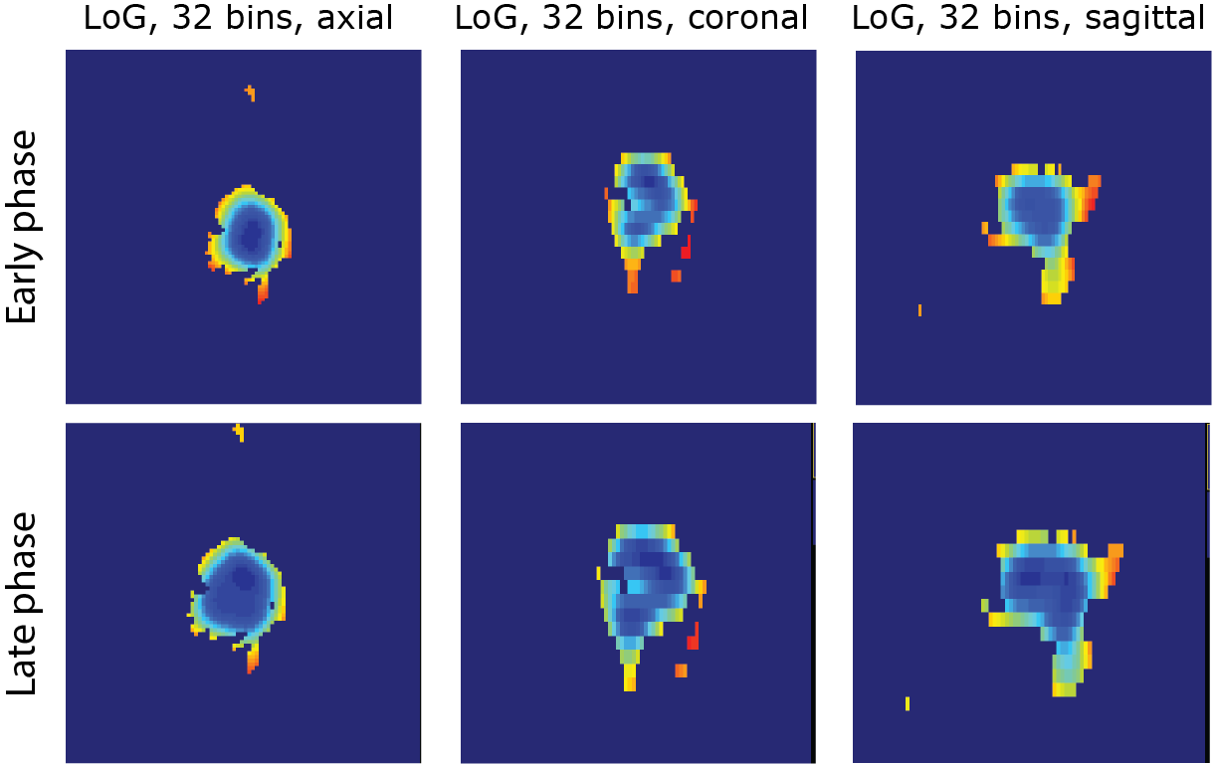
Figure S7. Comparisons of the early and late contrast phase images of one example patient after Laplacian-of-Gaussian (sigma=3mm) filtering and 32 fixed bin number discretization. A red color indicates a large value, while a blue color indicates a low value.

Results – Validation of the THI
We have recalculated the THI within the FTV on the contralateral breast by mirroring the FTV segmentations. We then assessed the association with treatment response in the MK2206 arm using both univariable and multivariable logistic regression models, and we evaluated the predictive value by comparing the area under the receiver operating characteristic curve (AUC-ROC) using the DeLong test. The result was shown in following table
Table S12. The Univariable and multivariable analysis between THI and treatment response in MK2206 arm.
 | Univariable |  |  | Multivariable
 | OR/SD | p-value | Delong p | OR/SD | p-value | Delong p
THI
ours | 2.39 | 0.001 | 0.000 | 3.04 | 0.000 | 0.000
THI
flipped | 1.12 | 0.602 | ref. | 1.16 | 0.512 | ref.
OR/SD: the odds of achieving pathologic complete response by every 1 standard deviation increase in the measurement.
The univariable OR/SD calculated by fitting (pCR ~ variable)
The multivariable OR/SD was calculated by fitting (pCR ~ HR + HER2 + THI)
Delong p was the comparison of ROC-curve of two models.

We have conducted a thorough analysis to determine the impact of Functional Tumor Volume (FTV) on the specific and independent prediction of treatment response by THI. To this end, we employed both univariable and multivariable logistic regression models to calculate the odds ratio per standard deviation for THI and FTV, adjusting for HER2 and HR status in the MK2206 arm. The results of the multivariable logistic regression are presented in Table S11.
Table S13. The univariable and multivariable analysis of association between treatment response and THI/FTV in MK2206 arm.
 | Univariable |  |  |  | Multivariable
 | OR/SD | p-value | AUC | Delong p | OR/SD | p-value | Patient number
THI
 | 3.04 | 0.000 | 0.83 | ref. | 2.88 | 0.0018 | 92
FTV
 | 0.35 | 0.043 | 0.76 | 0.035 | 0.88 | 0.728 | 92
OR/SD: the odds of achieving pathologic complete response by every 1 standard deviation increase in the measurement.
The univariable OR/SD calculated by fitting (pCR ~ HR + HER2 + variable)
The multivariable OR/SD was calculated by fitting (pCR ~ HR + HER2 + THI + FTV)
Delong p was the comparison of ROC-curve of two models.

Table S14. The Comparison of Clinical model and the Clinical model combined the THI.
Model | AUC | 95%CI | DeLong p-value
pCR ~ HR+HER2+MP | 0.69 | 0.59-0.80
pCR ~ THI+HR+HER2+MP | 0.83 | 0.77-0.89 | <0.001

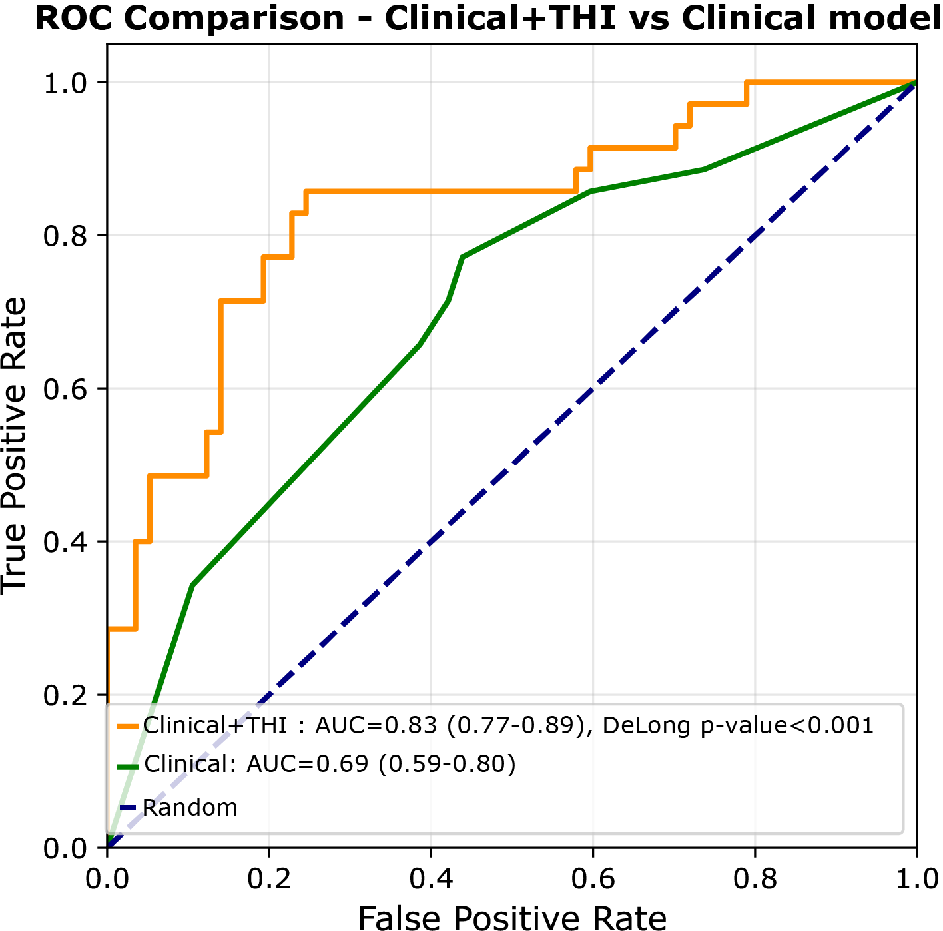
Figure S8. Comparison of the predictive performance between the Clinical+THI model and Clinical model for pCR response to the AKT inhibitor. The AUCs and 95% confidence intervals (CI) are displayed. The DeLong p-value (calculated by DeLong’s test) indicates the significant improvement in pCR response to the AKT inhibitor achieved by incorporating THI.

References:
[1] D.C. Newitt, S.C. Partridge, Z. Zhang, J. Gibbs, T. Chenevert, M. Rosen, P. Bolan, H. Marques, J. Romanoff, L. Cimino, B.N. Joe, H. Umphrey, H. Ojeda-Fournier, B. Dogan, K.Y. Oh, H. Abe, J. Drukteinis, L.J. Esserman, N.M. Hylton, ACRIN 6698/I-SPY2 Breast DWI, (2021). https://doi.org/10.7937/TCIA.KK02-6D95.
[2] N.M. Hylton, C.A. Gatsonis, M.A. Rosen, C.D. Lehman, D.C. Newitt, S.C. Partridge, W.K. Bernreuter, E.D. Pisano, E.A. Morris, P.T. Weatherall, S.M. Polin, G.M. Newstead, H.S. Marques, L.J. Esserman, M.D. Schnall, Neoadjuvant Chemotherapy for Breast Cancer: Functional Tumor Volume by MR Imaging Predicts Recurrence-free Survival—Results from the ACRIN 6657/CALGB 150007 I-SPY 1 TRIAL, Radiology 279 (2016) 44–55. https://doi.org/10.1148/radiol.2015150013.
[3] A. Zwanenburg, M. Vallières, M.A. Abdalah, H.J.W.L. Aerts, V. Andrearczyk, A. Apte, S. Ashrafinia, S. Bakas, R.J. Beukinga, R. Boellaard, M. Bogowicz, L. Boldrini, I. Buvat, G.J.R. Cook, C. Davatzikos, A. Depeursinge, M.-C. Desseroit, N. Dinapoli, C.V. Dinh, S. Echegaray, I. El Naqa, A.Y. Fedorov, R. Gatta, R.J. Gillies, V. Goh, M. Götz, M. Guckenberger, S.M. Ha, M. Hatt, F. Isensee, P. Lambin, S. Leger, R.T.H. Leijenaar, J. Lenkowicz, F. Lippert, A. Losnegård, K.H. Maier-Hein, O. Morin, H. Müller, S. Napel, C. Nioche, F. Orlhac, S. Pati, E.A.G. Pfaehler, A. Rahmim, A.U.K. Rao, J. Scherer, M.M. Siddique, N.M. Sijtsema, J. Socarras Fernandez, E. Spezi, R.J.H.M. Steenbakkers, S. Tanadini-Lang, D. Thorwarth, E.G.C. Troost, T. Upadhaya, V. Valentini, L.V. van Dijk, J. van Griethuysen, F.H.P. van Velden, P. Whybra, C. Richter, S. Löck, The Image Biomarker Standardization Initiative: Standardized Quantitative Radiomics for High-Throughput Image-based Phenotyping, Radiology 295 (2020) 328–338. https://doi.org/10.1148/radiol.2020191145.
[4] A. Zwanenburg, S. Leger, L. Agolli, K. Pilz, E.G.C. Troost, C. Richter, S. Löck, Assessing robustness of radiomic features by image perturbation, Sci Rep 9 (2019) 614. https://doi.org/10.1038/s41598-018-36938-4.
[5] X. Teng, J. Zhang, Z. Ma, Y. Zhang, S. Lam, W. Li, H. Xiao, T. Li, B. Li, T. Zhou, G. Ren, F.K.-H. Lee, K.-H. Au, V.H.-F. Lee, A.T.Y. Chang, J. Cai, Improving radiomic model reliability using robust features from perturbations for head-and-neck carcinoma, Front Oncol 12 (2022) 974467. https://doi.org/10.3389/fonc.2022.974467.
[6] D.M. Wolf, C. Yau, A. Sanil, A. Glas, E. Petricoin, J. Wulfkuhle, T.M. Severson, S. Linn, L. Brown-Swigart, G. Hirst, M. Buxton, A. DeMichele, N. Hylton, F. Symmans, D. Yee, M. Paoloni, L. Esserman, D. Berry, H. Rugo, O. Olopade, L. van ‘t Veer, DNA repair deficiency biomarkers and the 70-gene ultra-high risk signature as predictors of veliparib/carboplatin response in the I-SPY 2 breast cancer trial, NPJ Breast Cancer 3 (2017) 31. https://doi.org/10.1038/s41523-017-0025-7.
[7] Y. Șenbabaoğlu, G. Michailidis, J.Z. Li, Critical limitations of consensus clustering in class discovery, Sci Rep 4 (2014) 6207. https://doi.org/10.1038/srep06207.
[8] P. Charoentong, F. Finotello, M. Angelova, C. Mayer, M. Efremova, D. Rieder, H. Hackl, Z. Trajanoski, Pan-cancer Immunogenomic Analyses Reveal Genotype-Immunophenotype Relationships and Predictors of Response to Checkpoint Blockade, Cell Rep 18 (2017) 248–262. https://doi.org/10.1016/j.celrep.2016.12.019.
[9] Y. Xiao, D. Ma, S. Zhao, C. Suo, J. Shi, M.-Z. Xue, M. Ruan, H. Wang, J. Zhao, Q. Li, P. Wang, L. Shi, W.-T. Yang, W. Huang, X. Hu, K.-D. Yu, S. Huang, F. Bertucci, Y.-Z. Jiang, Z.-M. Shao, on behalf of AME Breast Cancer Collaborative Group, Multi-Omics Profiling Reveals Distinct Microenvironment Characterization and Suggests Immune Escape Mechanisms of Triple-Negative Breast Cancer, Clinical Cancer Research 25 (2019) 5002–5014. https://doi.org/10.1158/1078-0432.CCR-18-3524.
[10] E. Becht, N.A. Giraldo, L. Lacroix, B. Buttard, N. Elarouci, F. Petitprez, J. Selves, P. Laurent-Puig, C. Sautès-Fridman, W.H. Fridman, A. de Reyniès, Estimating the population abundance of tissue-infiltrating immune and stromal cell populations using gene expression, Genome Biol 17 (2016) 218. https://doi.org/10.1186/s13059-016-1070-5.
[11] Q. Jia, W. Wu, Y. Wang, P.B. Alexander, C. Sun, Z. Gong, J.-N. Cheng, H. Sun, Y. Guan, X. Xia, L. Yang, X. Yi, Y.Y. Wan, H. Wang, J. He, P.A. Futreal, Q.-J. Li, B. Zhu, Local mutational diversity drives intratumoral immune heterogeneity in non-small cell lung cancer, Nat Commun 9 (2018) 5361. https://doi.org/10.1038/s41467-018-07767-w.
[12] M. Peng, Immune landscape of distinct subtypes in urothelial carcinoma based on immune gene profile, Frontiers in Immunology 13 (2022). https://www.frontiersin.org/articles/10.3389/fimmu.2022.970885 (accessed September 20, 2023).

