Tilorone reduces breast cancer metastasis through promotion of type 1 interferon signaling in triple-negative breast cancer

Alastair A.E. Saunders¹, Kellie A. Mouchemore^{2,3}, Laura Vojtech⁴, Lauren S. James¹, Thomas B. Chadwick^{4,5}, Lap Hing Chi^{2,3,4}, Chris Karagiannis¹, Miriam Fuentes-Guirado^{4,5}, Caroline Bell^{2,3}, Rachel E. Thomson¹, Belinda S. Parker^{4,5}, Robin L. Anderson^{2,3,6}, Paul Gregorevic^{1,7}

¹ Centre for Muscle Research, and Department of Anatomy and Physiology, The University of Melbourne, Parkville, Victoria, Australia
² Olivia Newton-John Cancer Research Institute, Heidelberg, Victoria, Australia
³ School of Cancer Medicine, La Trobe University, Bundoora, Victoria, Australia
⁴ Cancer Evolution & Metastasis Program, Peter MacCallum Cancer Centre, Parkville, Victoria, Australia.
⁵ Sir Peter MacCallum Department of Oncology, The University of Melbourne, Parkville, Victoria, Australia
⁶ Department of Clinical Pathology, The University of Melbourne, Parkville, Victoria, Australia
⁷ Department of Neurology, The University of Washington School of Medicine, Seattle, Washington, USA

Corresponding Author: Paul Gregorevic
The University of Melbourne, Parkville, Victoria, 3010, Australia
Email: pgre@unimelb.edu.au

Supplemental Tables S1-S2

Supplemental Figures S1-S6

Supplemental Table 1: Primers used in this study

Gene | Species | Supplier | Sequence:
Bmp2 | Mouse | Sigma | F: TATATGCTAGATCTGTACCGC
Bmp2 | Mouse | Sigma | R: TAAATTGAAGAAGAAGCGCC
Bmp4 | Mouse | Sigma | F: TTTCCATCACGAAGAACATC
Bmp4 | Mouse | Sigma | R: GAGATCACCTCATTCTCTGG
Bmp7 | Mouse | Sigma | F: AGCTTCGTCAACCTACTGGAAC
Bmp7 | Mouse | Sigma | R: CTGGAGCACCTGATAGACTGTG
Id1 | Mouse | Invitrogen | F: AGTGAGCAAGGTGGAGATCC
Id1 | Mouse | Invitrogen | R: GATCGTCGGCTGGAACAC
Id3 | Mouse | Sigma | F: CCCTGACTCAAGTCTAAAAG
Id3 | Mouse | Sigma | R: GAAGAACAGCTCTTATGCTG
Irf7 | Mouse | Sigma | F: TAAGGTGTACGAACTTAGCC
Irf7 | Mouse | Sigma | R: TACTGCAGAACCTGTGTG
Irf9 | Mouse | Sigma | F: CTACTTCTGTAGAGATTTGGC
Irf9 | Mouse | Sigma | R: GATGAGATTCTCTTGGCTATG
Oas1 | Mouse | IDT | F: CAGCCTTTGATGTCCTGGGTCATGT
Oas1 | Mouse | IDT | R: AGAACTCGCCATCCTTCCCCA
Pan-Actin | Mouse | Invitrogen | F: CTGGCTCCTAGCACCATGAAGAT
Pan-Actin | Mouse | Invitrogen | R: GGTGAACAGTGAGGCCAGGAT
Psmb1 | Mouse | Sigma | F: AAGCATTCCAATAACAAGGC
Psmb1 | Mouse | Sigma | R: CCTTTCCTTCTTCATCAAGTC
Psmb9 | Mouse | IDT | F: TCCACACCGGGACAACCATCA
Psmb9 | Mouse | IDT | R. TCACCACTGCTGTTCCCGCT
Stat1 | Mouse | Geneworks | F: TGGTGAAATTGCAAGAGCTG
Stat1 | Mouse | Geneworks | R: TGTGTGCGTACCCAAGATGT
Socs1 | Mouse | Geneworks | F: CTTAACCCGGTACTCCGTGA
Socs1 | Mouse | Geneworks | R: GAGGTCTCCAGCCAGAAGTG
Vimentin | Mouse | IDT | F: AGCTGCTAACTACCAGGACACTATTG
Vimentin | Mouse | IDT | Probe: CGAAGGTGACGAGCCATCTC
Vimentin | Mouse | IDT | R: CCTTCATGTTTTGGATCTCATCCTGCAGG
mCherry | Discosoma sp. | IDT | F: GACCACCTACAAGGCCAAGAAG
mCherry | Discosoma sp. | IDT | Probe: AGGTGATGTCCAACTTGATGTTGA
mCherry | Discosoma sp. | IDT | R: CAGCTGCCCGGCGCCTACA

Supplemental Table 2: Antibodies used in this study

Protein | Fluorophore | Clone | Host | Supplier | Catalog # | FACS dilutions
CD16/CD32 | - | 2.4G2 | Rat | BD Biosciences | 553141 | 1:100
CD45.2 | APC | 104 | Mouse | eBioscience | 17-0454-82 | 1:300
TCRβ | PerCP-Cy5.5 | H57-597 | Hamster | eBioscience | 45-5961-82 | 1:100
CD8⍺ | APC-Cy7 | 53-6.7 | Rat | BD Biosciences | 561097 | 1:400
CD4 | BUV496 | GK1.5 | Rat | BD Biosciences | 612952 | 1:200
CD69 | BV650 | H1.2F3 | Hamster | BioLegend | 104541 | 1:100
CD49b | BV421 | Dx5 | Rat | BD Biosciences | 563063 | 1:100
CD11b | R718 | M1/70 | Rat | BD Biosciences | 567469 | 1:1000
Ly6C | AF-488 | HK1.4 | Rat | BioLegend | 128022 | 1:1000
Ly6G | PE-Cy7 | 1A8 | Rat | BD Biosciences | 560601 | 1:1000
F4/80 | PE-Cy5 | BM8 | Rat | eBioscience | 15-4801-80 | 1:200
CD27 | PE | LG.3A10 | Hamster | BD Biosciences | 561785 | 1:100
Fixable Viability Stain | 440UV | - | - | BD Biosciences | 566332 | 1:1000

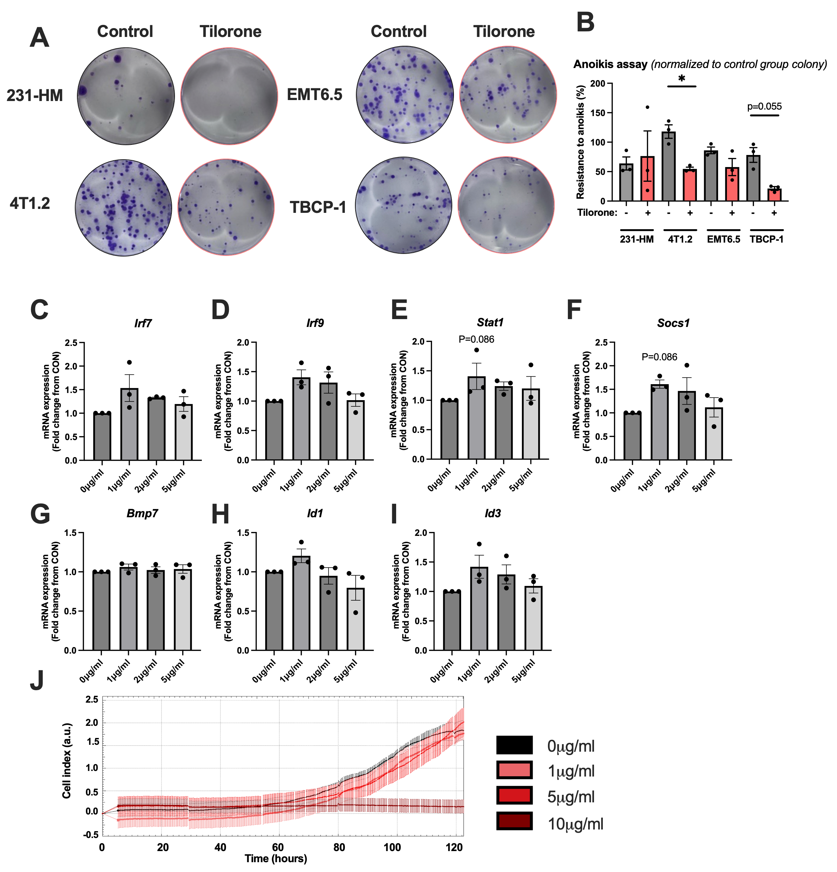
Supplemental Figure 1. Anoikis was not altered by Tilorone and IFN signaling peaks at 1μg/ml Tilorone. (A) MDA-MB-231-HM (231-HM), 4T1.2 and EMT6.5 cells were treated with 1μg/ml Tilorone or vehicle for 24 hours before being subjected to non-adherent conditions with mild agitation for 6 hours. Cells were then plated out for colony formation. (B) Resistance to anoikis was expressed as a percentage of control group colony formation. 4T1.2 cells were treated with Tilorone for 4 hours and mRNA expression of (C) Irf7, (D) Irf9, (E) Stat1, (F) Socs1, (G) Bmp7, (H) Id1, and (I) Id3 was determined by qRT-PCR. n =3 biological replicates, one-way ANOVA with Dunn’s test. (J) 4T1.2 cells were treated with 1μg/ml, 5μg/ml or 10μg/ml Tilorone or vehicle and bioimpedance was measured using an xCelligence RTCA, mean ± SD. *p<0.05.
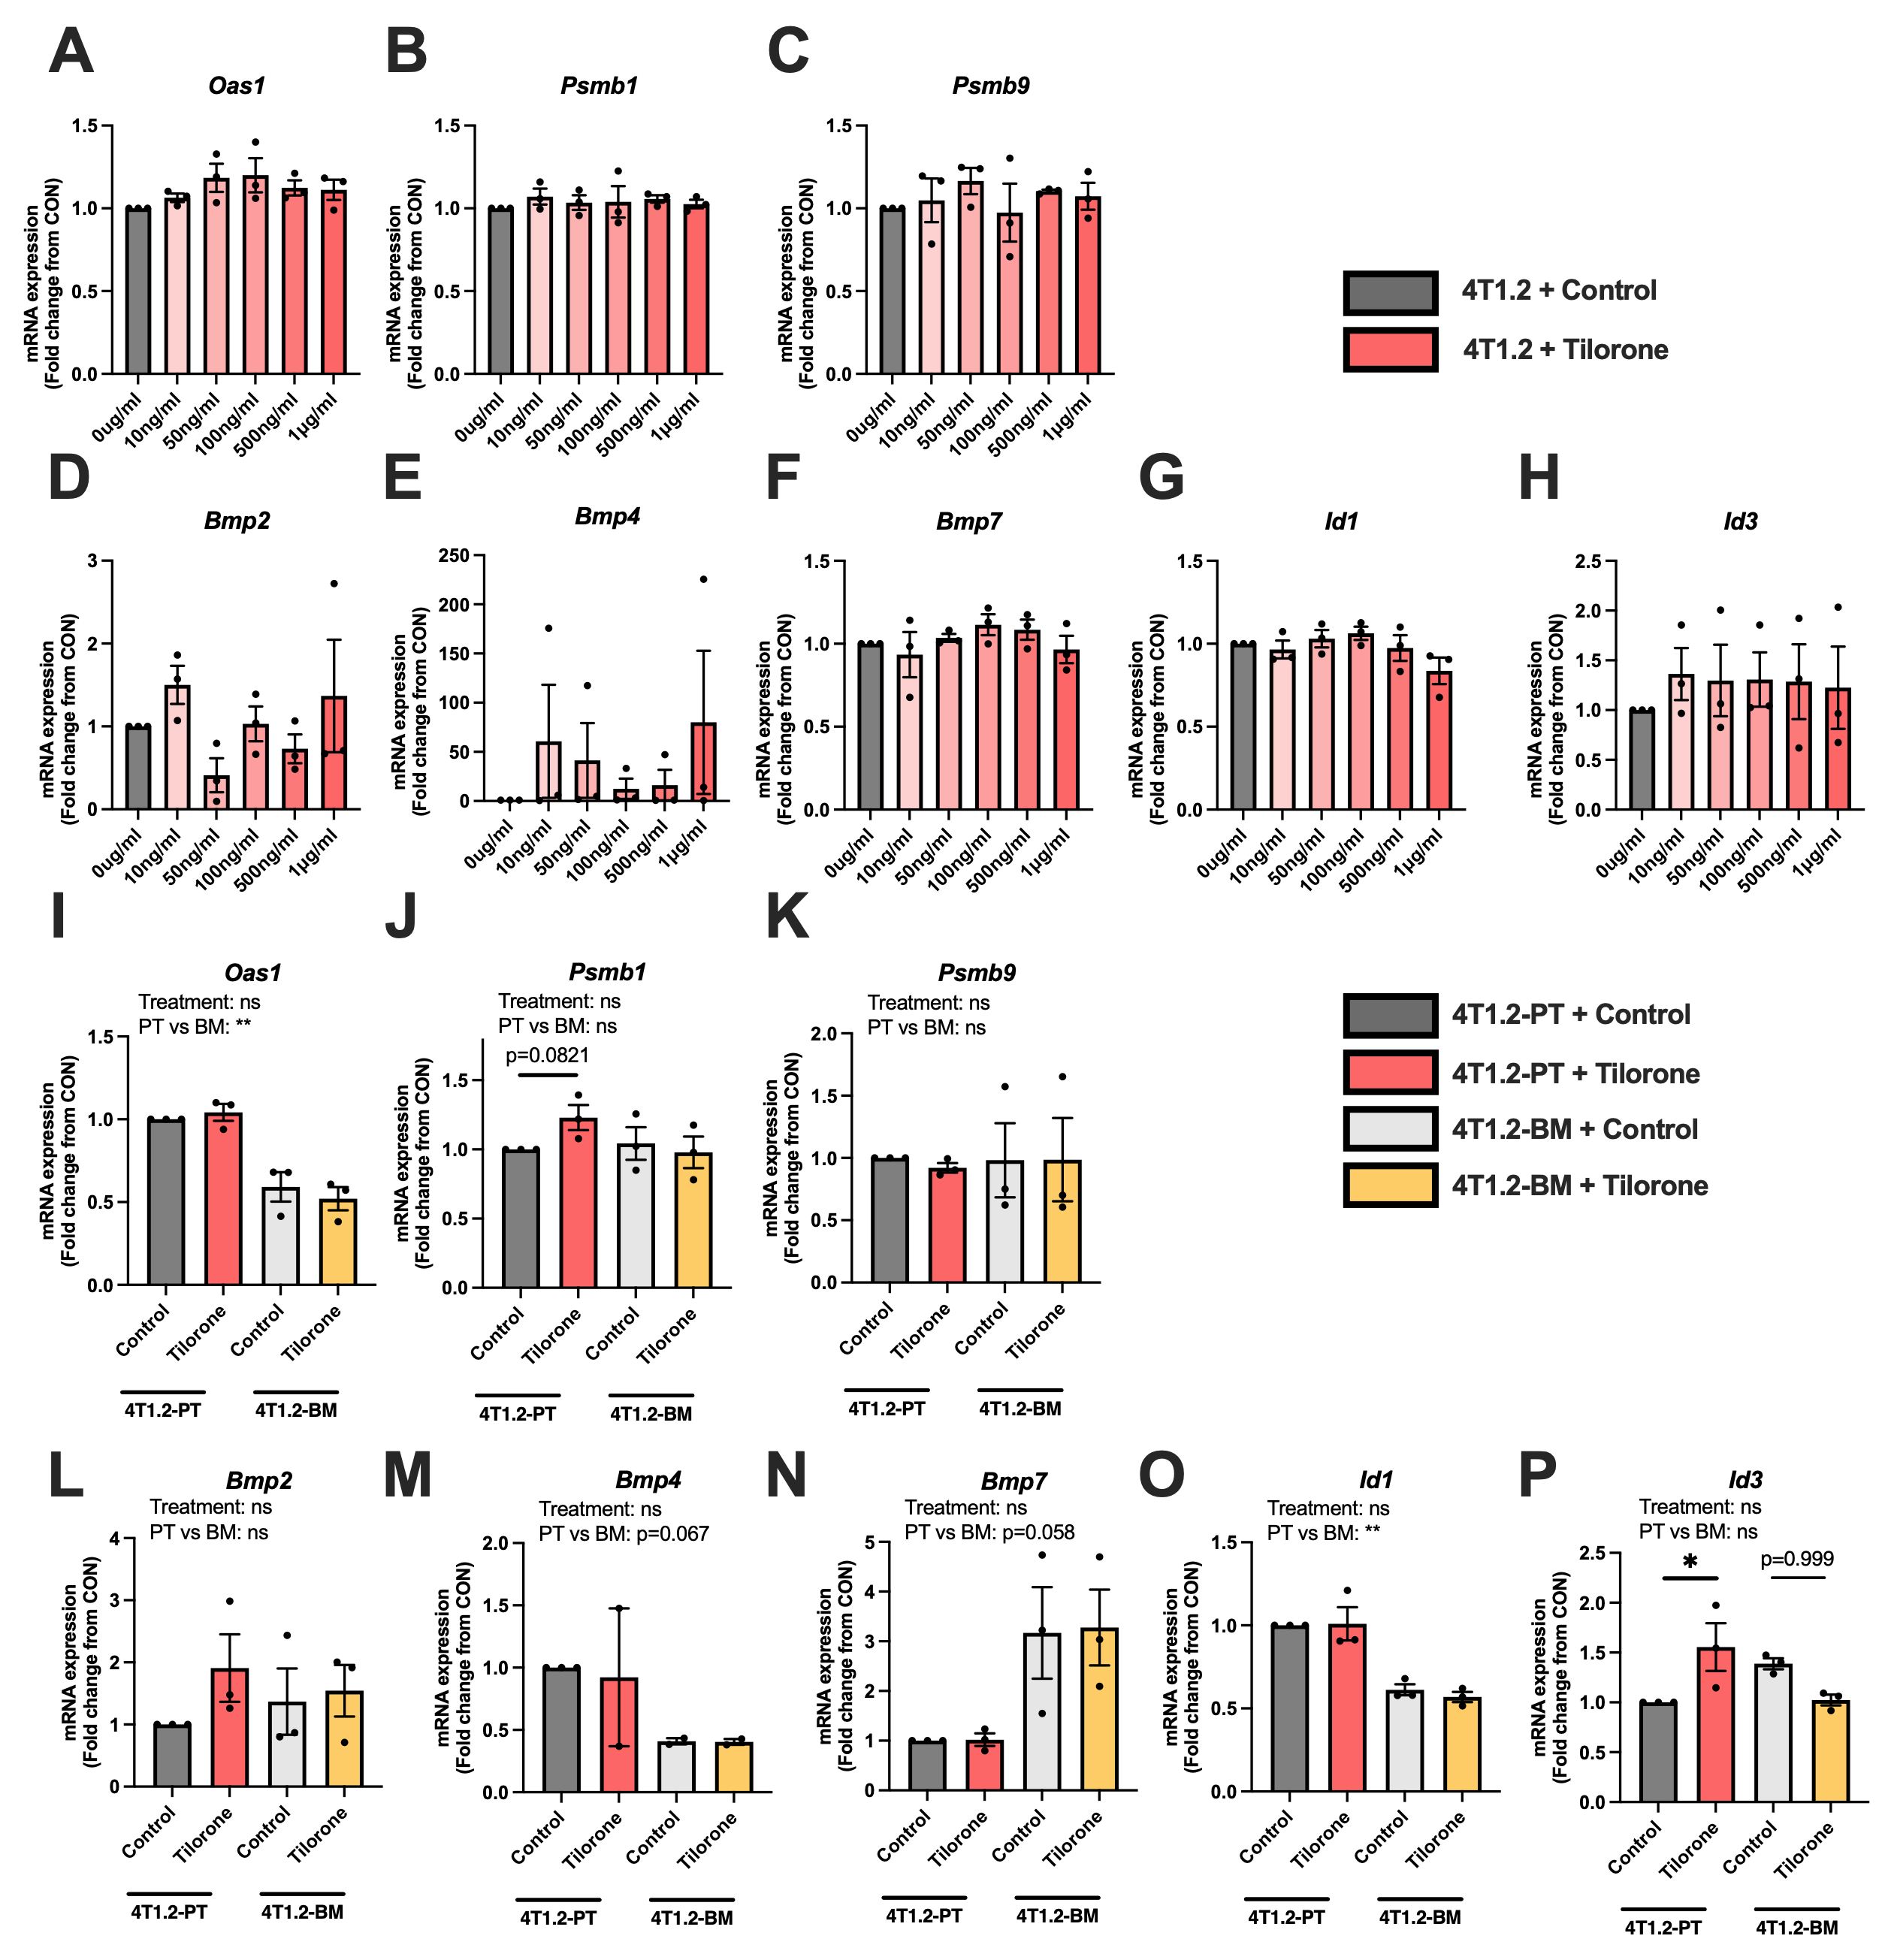
Supplemental Figure 2. Tilorone does not alter Oas1, Psmb1, Psmb9 or BMP related genes. 4T1.2 cells were treated with varying concentrations of tilorone for 4 hours and mRNA expression of (A) Oas1, (B) Psmb1, (C) Psmb9, (D) Bmp2, (E) Bmp4, (F) Bmp7, (G) Id1 and (H) Id3 was determined by qRT-PCR, one-way ANOVA and Holm-Sidak test. Cells isolated from 4T1.2-Primary tumor (4T1.2-PT) and 4T1.2-Bone metastasis (4T1.2-BM) were treated with 1μg/ml tilorone and expression of (I) Oas1, (J) Psmb1, (K) Psmb9, (L) Bmp2, (M) Bmp4, (N) Bmp7, (O) Id1 and (P) Id3 was determined by qRT-PCR. n=3/biological replicates, two-way ANOVA with Tukey’s test, mean ± SEM. *, p<0.05, **p<0.01.
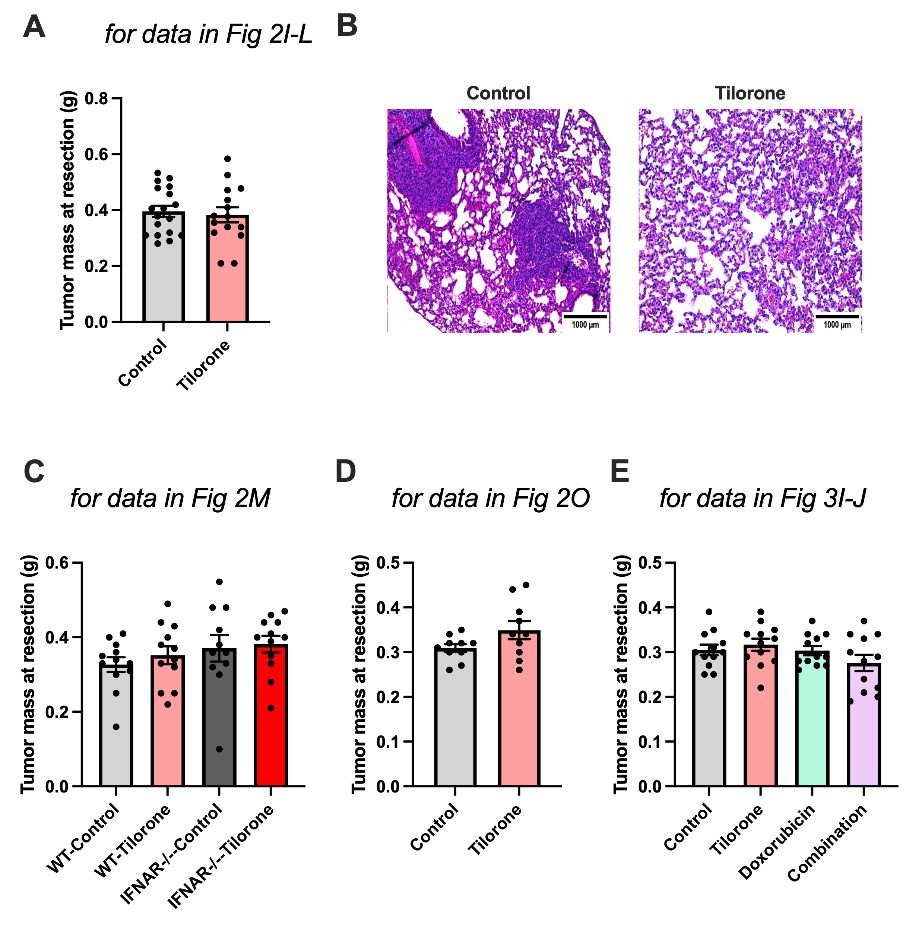
Supplemental Figure 3. Primary tumor mass was not altered at resection. (A) Primary tumor weights at resection were not altered when tilorone treatment commenced at palpation (n=15-18/group). (B) Representative hematoxylin and eosin stain of lung tissue. (C) Tumor mass at resection of wild type (WT) and IFNAR null mice, (n=12/group), (D) Tumour mass at resection when treatment commenced after primary tumour resection (n=10/group). (E) Mass of primary tumours of mice treated with tilorone plus doxorubicin (n=10/group). mean ± SEM. Statistical analysis performed by an unpaired t-test or two-way ANOVA and Tukey’s post hoc test.
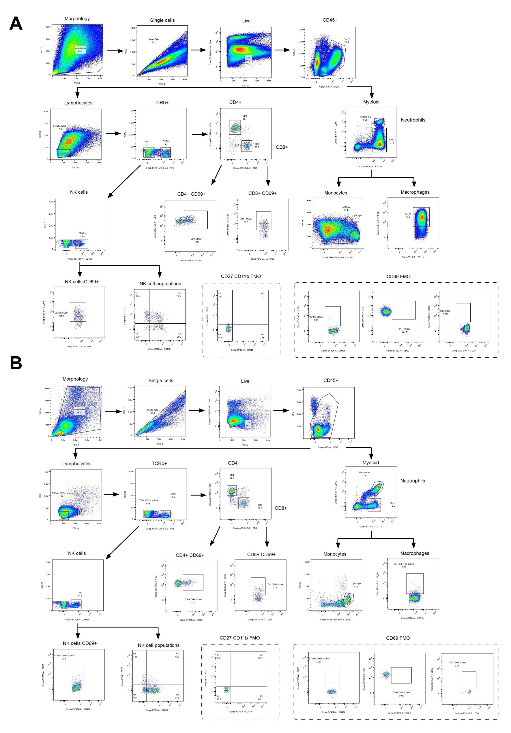
Supplemental Figure 4. Flow cytometry gating strategy. Gating strategies for identifying immune cell populations in the (A) primary tumor and (B) pre-metastatic lung. Antibodies used can be found in Supplemental Table 2.

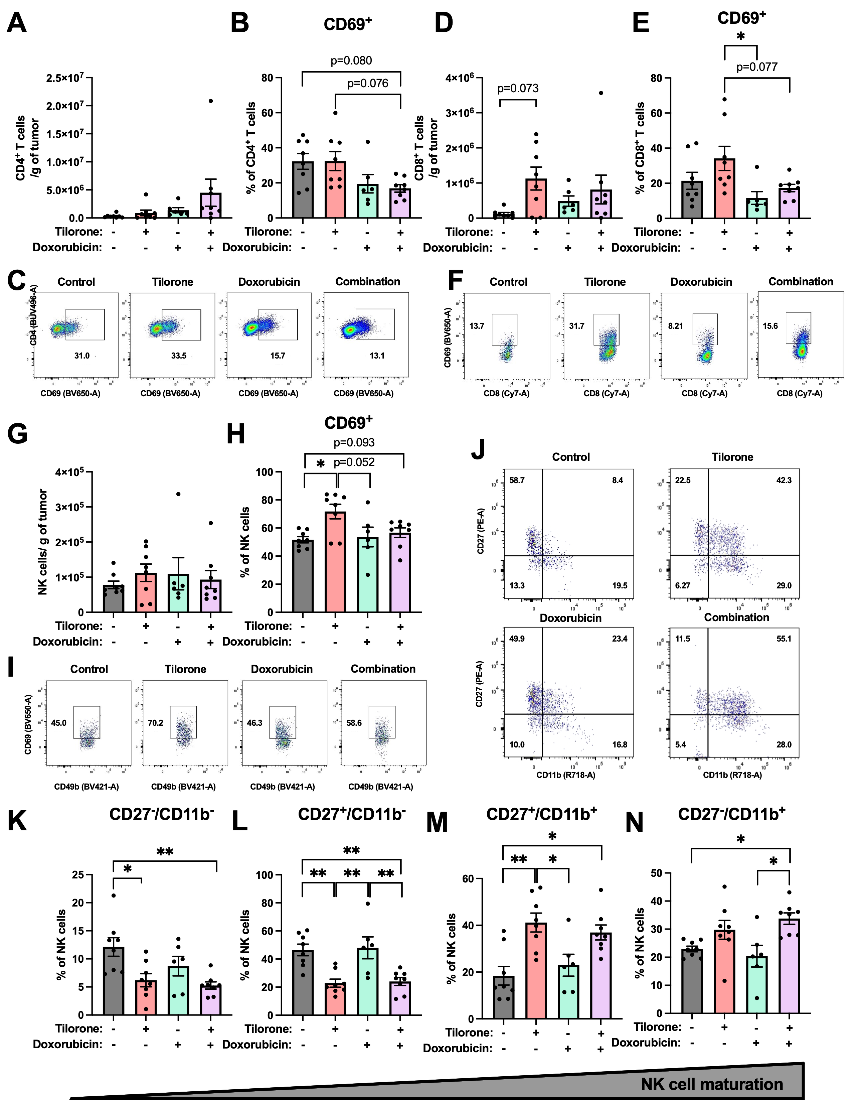

Supplemental Figure 5. Combination of tilorone and doxorubicin activates CD4⁺ T cells, CD8⁺ T cells and NK cells in the primary tumor. (A) Treatment with Tilorone (50 mg/kg, every 3 days) commenced 7 days after inoculation of 4T1.2 tumors, when tumors were first palpable. Doxorubicin treatment occurred on days 5,9 and 13. FACS gating strategies can be found in Supplemental Figure 4. Tumors were recovered 14 days after tumor cell inoculation and 7 days after commencement of treatment . Representative FACS blot of total CD4+ (A) and (B, C) CD69⁺ CD4⁺ T cells. Representative FACS blot of total CD8+ (D) and (E, F) CD69⁺ CD8⁺ T cells. Representative FACS blot of total NK (G) and (H, I) CD69⁺ NK cells. (J) Representative FACS blot of maturation state of NK cells, quantified in K-N. n=8/group, mean ± SEM. Statistical analysis performed by a two-way ANOVA and Tukey’s post hoc test. *, p<0.05; **, p<0.01.

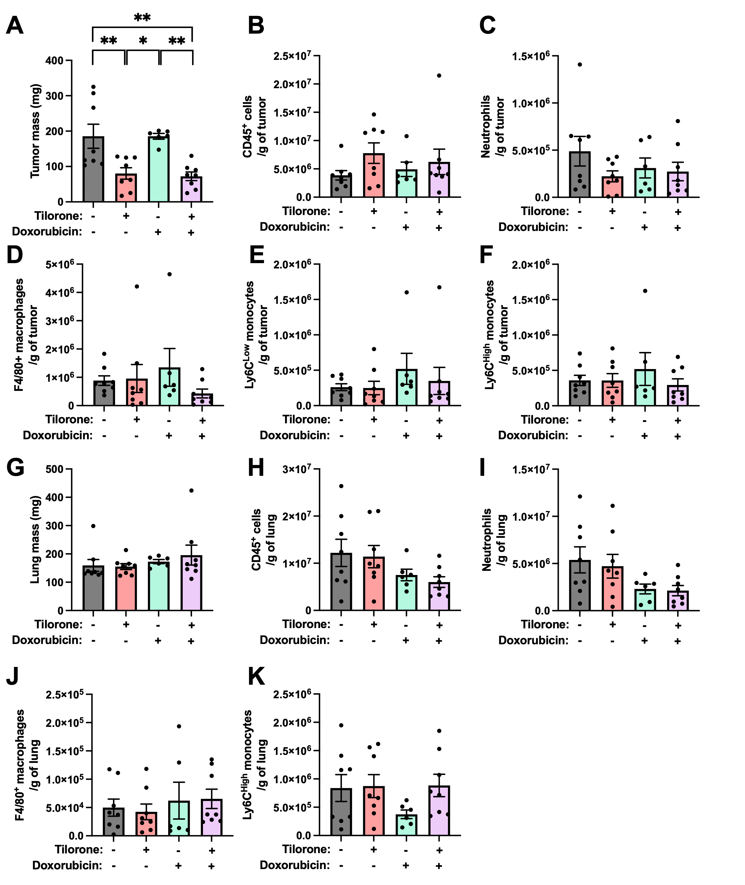

Supplemental Figure 6. Tilorone and Doxorubicin did not alter myeloid cell numbers in the primary tumor or lung. A) Treatment with Tilorone (50 mg/kg, every 3 days) commenced 7 days after inoculation of 4T1.2 tumors, when tumors were first palpable. Doxorubicin treatment occurred on days 5,9 and 13. FACS gating strategies can be found in Supplemental Figure 4. Primary tumors and lungs were recovered 14 days after tumor cell inoculation and 7 days after commencement of treatment. (A) Mass of tumors analyzed for FACS. Total numbers of (B) CD45⁺ cells, (C) neutrophils, (D), macrophages (by F4/80), (E) Ly6C^{Low} monocytes and (F) Ly6C^{High} monocytes in tumors. (G) Mass of lungs analyzed for FACS.. Total numbers of CD45⁺ cells (H), neutrophils (I), macrophages (by F4/80) (J) and Ly6C^{High} monocytes (K) in lungs. n=8/group, mean ± SEM. Statistical analysis performed by a two-way ANOVA and Tukey’s post hoc test. *, p<0.05; **, p<0.01.

