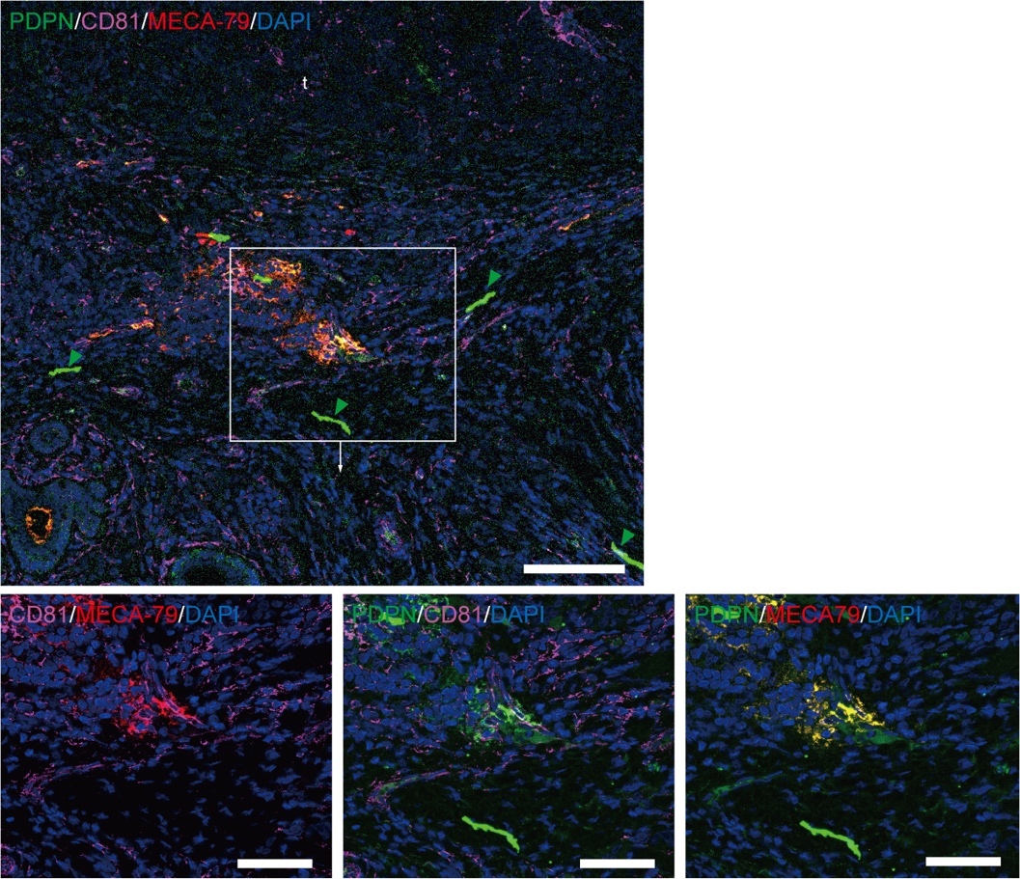
Fig. S6. Spatial distribution of CD81-high and PDPN-positive CAFs as well as high endothelial venules (MECA-79⁺ cells). Green arrowheads indicate lymphatic vessels. Scale bars: 100 μm (upper panel), and 50 μm (lower panels). The lower panels correspond to the same region as the left panel of Figure 6A. Green arrowheads represent lymph vessels.

